James Madison University
Desktop Management: Informational Document

Project:  macOS Big Sur Upgrade | Date:  4/20/2021 | Author(s):  Dave Jahne, Endpoint Management
Title:
Informing JMU employees of the macOS Big Sur upgrade process and deadlines
Consensus Participants:
Desktop Management Team
Description:
JMU IT will be updating macOS on managed, JMU-owned computers so they may continue to receive security patches from Apple. This update is larger than the typical monthly patches and will take anywhere from 60 to 180 minutes for the installation. You will have the option to start this installation at a convenient time prior to the deadline. We recommend you save and close all of your work and start the installer as you leave for the day since your computer will be unavailable for use during the process and will restart several times.

Important Information:
The upgrade requires the computer to have 36 GB of free space before the installer application is downloaded.
Current versions of macOS (Big Sur and above) no longer support 32bit applications. https://support.apple.com/en-us/HT208436 JMU IT has collected inventory of known 32bit applications for computers in JAMF. Please refer to the following report to see if computers in your area still have 32bit applications. Non-compatible applications may be relocated into a folder on your desktop after the upgrade.
Common applications noticed in inventory:
- Older Adobe products or Adobe updater applications that have not been removed.
- Printer drivers/application for multi-function printers
- IBM’s SPSS (versions below 26)

It is highly recommended any work-related data/documents/photos/etc. be backed up prior to running the upgrade. As with any upgrade process, there is a risk of data loss, and per JMU policy, any data stored on the local hard drive is the responsibility of the user. Network file storage (N: drive) is available.

Notes & User Actions
- Upgrade will work from either the JMU wired or wireless network, as well as off campus/home internet connection.
- Plug in power supply for laptops
- Instructions:
  - Click Spotlight search and type JMU App Store
  - Select macOS Big Sur Upgrade then click Install. If you do not see macOS Big Sur Upgrade as a choice, please contact the IT Help Desk (568-3555)
- Do not interrupt the upgrade once it has started, do not force a restart or power off your computer during the upgrade
- Contact the IT Help Desk (568-3555) with any questions or concerns during the installation
- The process is complete when the login is displayed again
- To verify a successful upgrade: From the Apple menu in the corner of your screen, choose About This Mac. You should see the macOS name, Big Sur, followed by the version number. If a version number lower than Version 11.x.x is displayed, please contact the IT Help Desk (568-3555)

Schedule for self-service availability
- IT: Immediately
- Pilot Group: July 12
- Production Group: July 15

Schedule for Deadline (upgrade will be forcibly installed on this date)
- All Pilot Groups & Production: October 20, 4:00 PM

Click Spotlight  Type JMU App Store  Click Operating System | 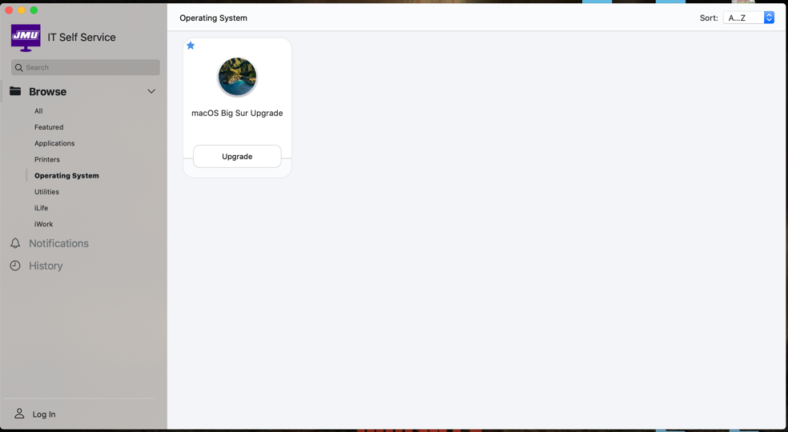
Click Upgrade | 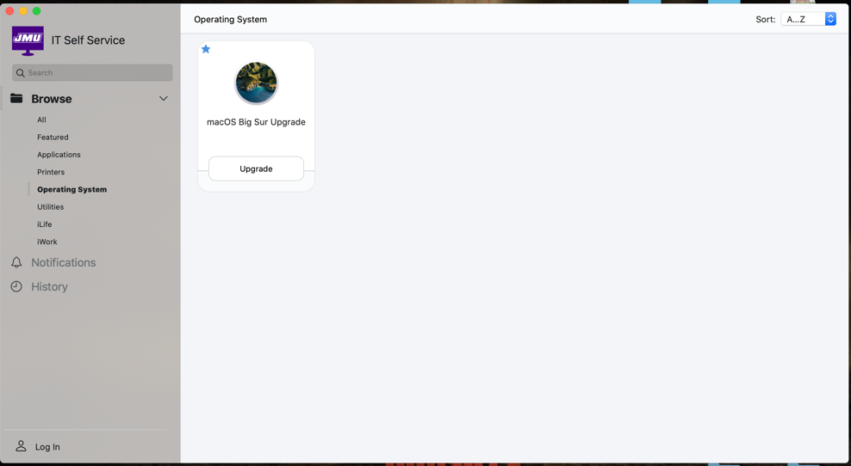
Informational message displayed  Click Upgrade | 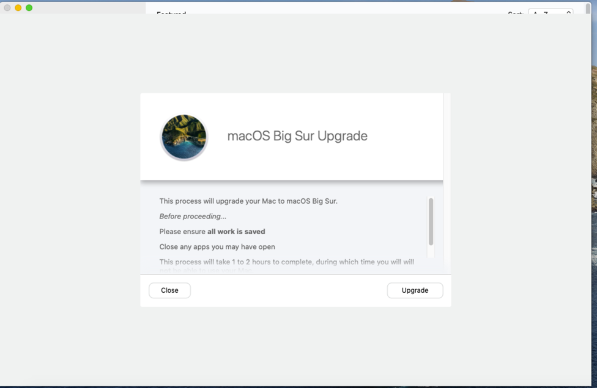
Progress Screen | 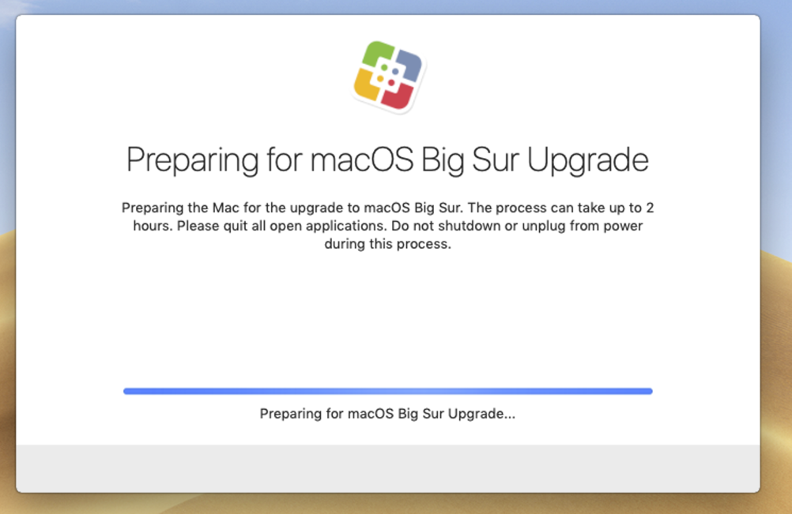
OS Download Progress Screen | 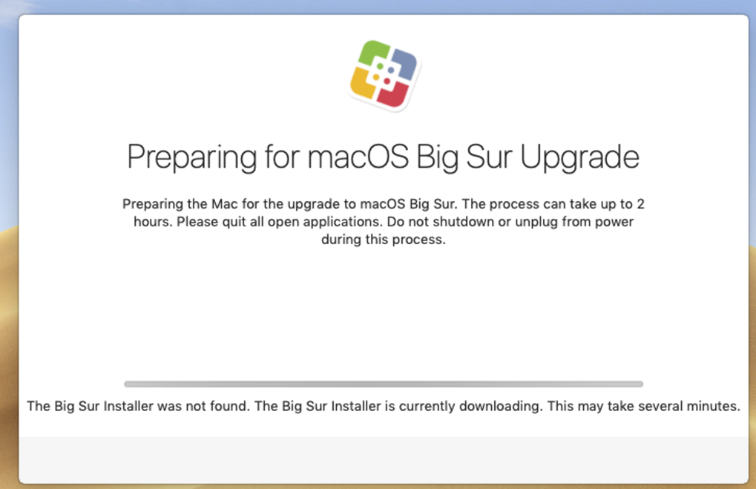
Progress Screen | 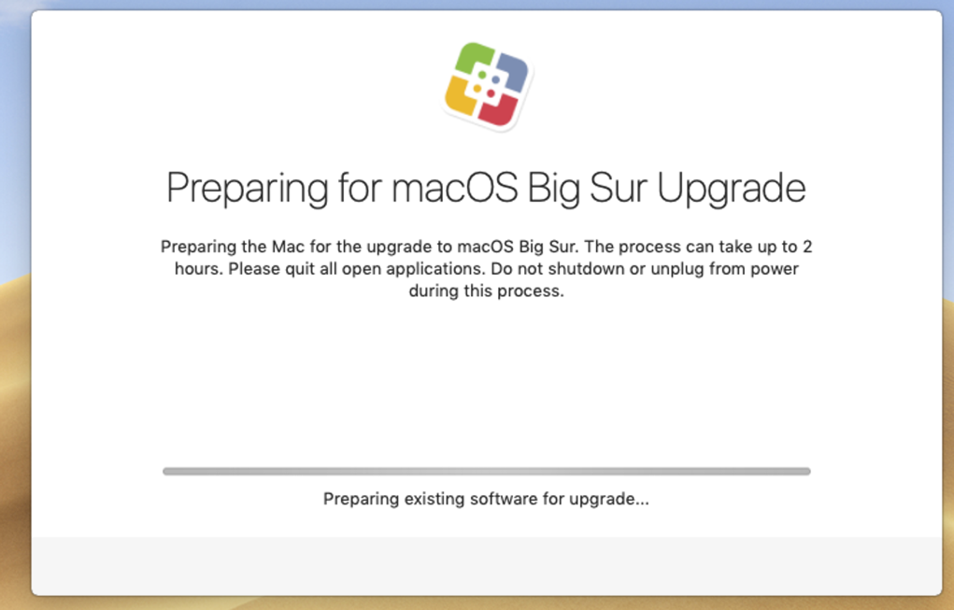
Restart Screen | 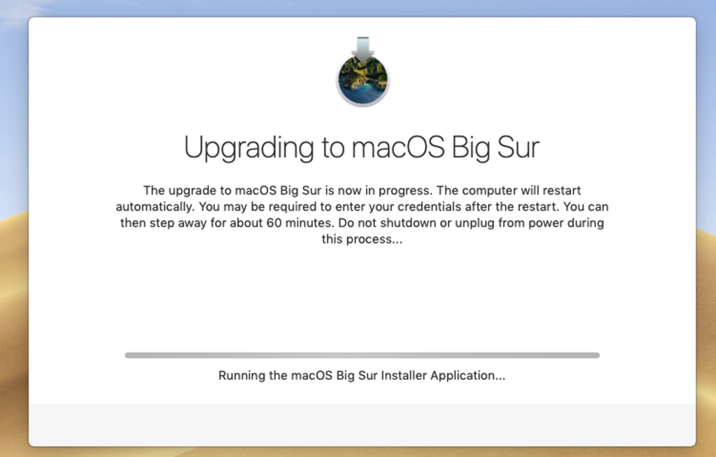
Post Restart Progress Screen
After upgrade completes, macOS returns to the login screen. Log in | 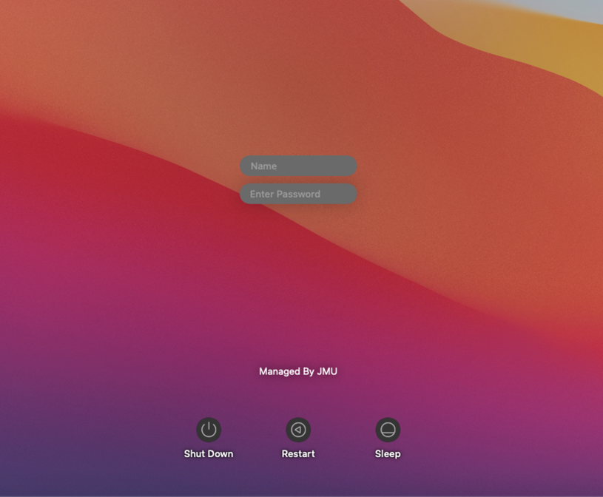
Post log in progress screen | 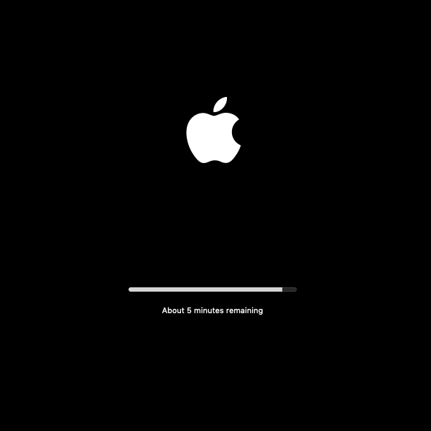
macOS returns to the log in screen | 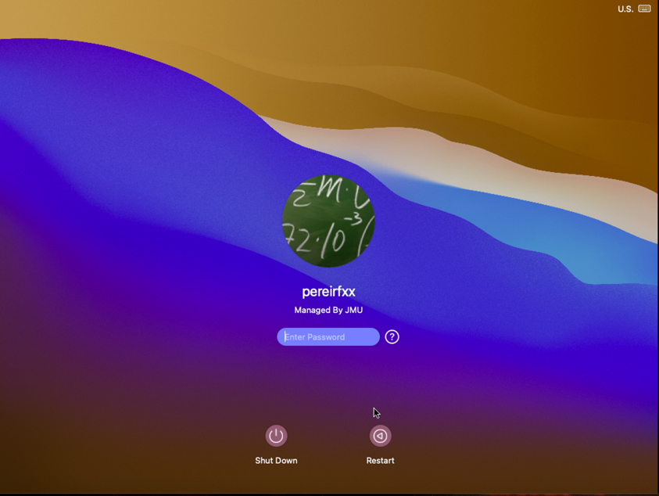
Verify macOS Version:  Log in to macOS  Click Apple logo  Click About This Mac  If macOS Big Sur Version 11.x is displayed, the upgrade was successful  If a lower version number is displayed, contact the IT Help Desk | 