WRTC 103, PSYC 160, EDUC 200 (if not taken already will need to be taken during the program)
Fall 2022:  LED 300: Reading Instruction and Assistance for Diverse Learners PK-6 (3)  ELED 333: Children and Mathematics I (3)  ELED 321: Practicum: Focus on Learners and Learning (1) | 7 week synchronous  7 week synchronous  All semester
Spring 2023:  ELED 332: Children and Science (3)  ELED 343: Children and Mathematics II (3)  ELED 322: Practicum: Focus on Curriculum Instruction and Guided Behavior (1) | 7 week synchronous  7 week synchronous  All semester
Summer 2023:  ELED 272: Intro to Early and Elementary Education (3)  ELED 310: Diversity, Equity, and Justice in ELED (3)  ELED 334: Children and Social Studies (3) | 7 week synchronous  7 week synchronous  7 week synchronous
Fall 2023:  ELED 450: Planning Instruction and Assistance (3)  LED 462: Literacy Across the Curriculum (3)  ELED 400: Final Practicum (1) | 7 week synchronous  7 week synchronous  All semester
Spring 2024:  ELED 485: Guiding Student Behavior (3)  ELED 455: Home, School, Communities (3)  ELED 479: Seminar on Special Topics (4)  ELED 480: Student Teaching in Elementary Education (8) | 7 week synchronous  7 week synchronous  All semester  All semester
Summer 2024:  LED 350: Writing Instruction and Assistance for Diverse Learners PK-6 (3)  EXED 490: Special Studies in Special Education (3)  IS 498: Senior Research Project (3)  Elective course (if needed) | 7 week synchronous  7 week synchronous  7 week synchronous

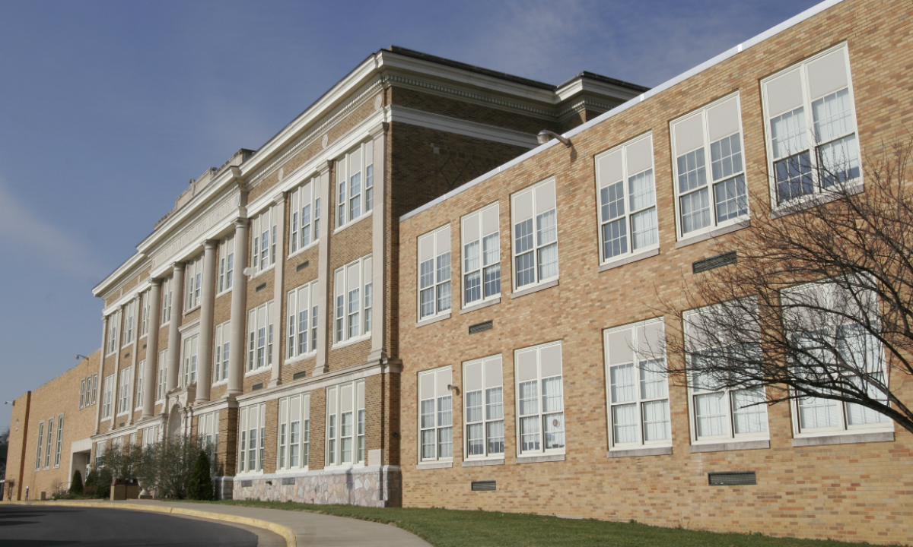
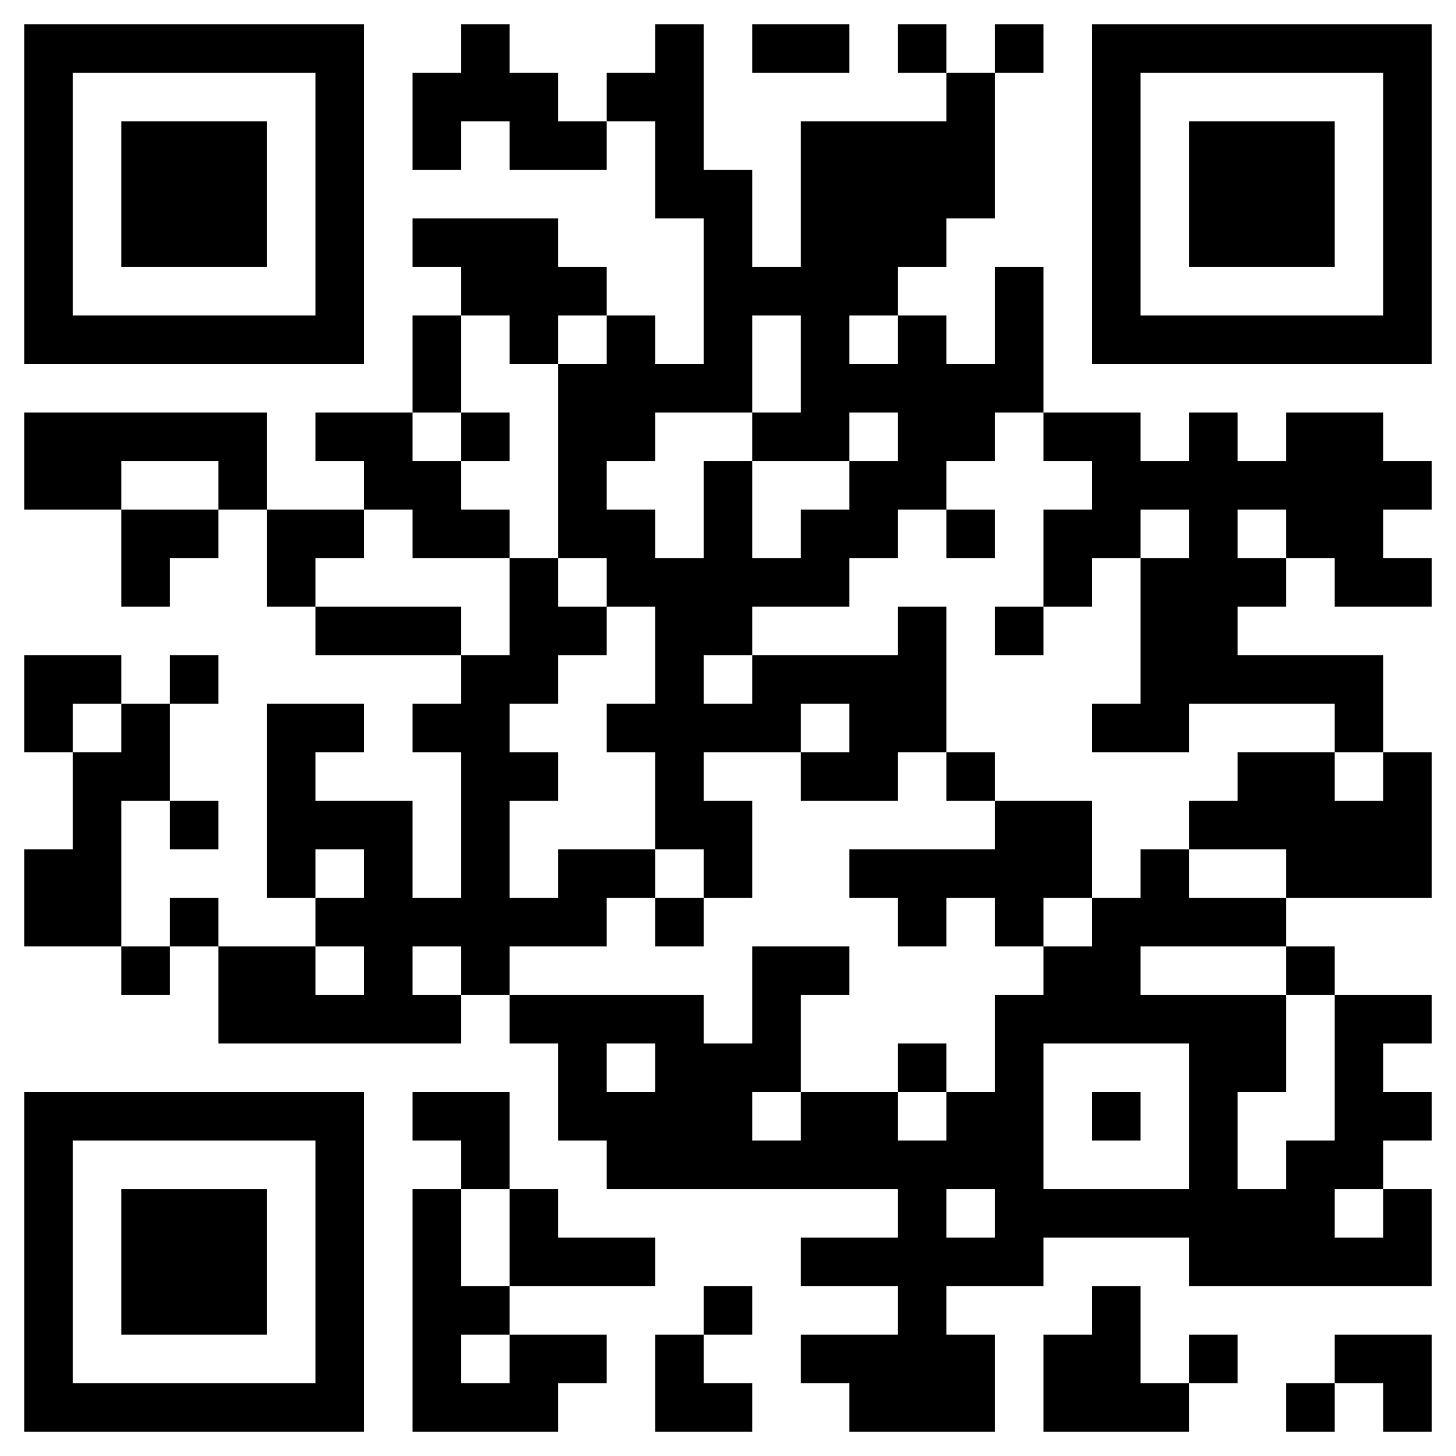
James Madison University’s College of Education is distinguished through faculty and study achievements, academic rigor, excellence in teaching, student and faculty interactions and relationships, technological innovations, and national recognition. The College prepares students to become professionals who are able to knowledgeably integrate diverse perspectives and positively impact the lives of all they serve.

This program is a Bachelor’s of Individualized Study with a concentration in Elementary Education is designed for students who have earned their Associate’s Degree and are working as instructional assistants. Completers of this program earn a four degree and are eligible for a Virginia teaching license in PK-6th grades.

Who is eligible?
- Students with an AA degree from a VCCS
- Students who want to become elementary teachers in VA (PK-6)
- Students who need an online program ad are working as an instructional assistants in PK-6 school

Field Experiences
- Typically in a public school PK-6th grade classroom
- Student teach the final semester in a public school PK-6th grade classroom

Degree & Licensure
- About 60 credit hours at JMU plus your AA degree will meet the 120 credit hours required for a 4-year degree

Entry Assessments | Licensure Assessments
- VCLA passing composite score of 470  - ALEKS passing score of 46 or higher or substitute:  - ACT math score of 22  - SAT Math score of 560 (if taken on or after 3/1/16) or SAT Math score of 530 (if taken between 4/1/95 – 2/29/16)- must be submitted from testing agency to JMU  - Praxis Core Math 5733 (score of 150) | - Praxis Elementary Subject test- taken during the JMU program  - Reading for Virginia Educators (RVE)- taken during the JMU program

For information about the BIS-ELED program, go to
https://www.jmu.edu/coe/eere/eled-bis/index.shtml
or contact: Kristi Peery at peerykm@jmu.edu
Phone: 540-568-6255
Fax: 540-568-4849
Memorial Hall
MSC 6909
395 S. High
Room 3100
Harrisonburg, VA 22807

