Pathways to Resilience
RESILIENCE, LEADERSHIP AND PEER SUPPORT TRAINING WORKSHOP

Hammana, Lebanon
7 —15 May 2011

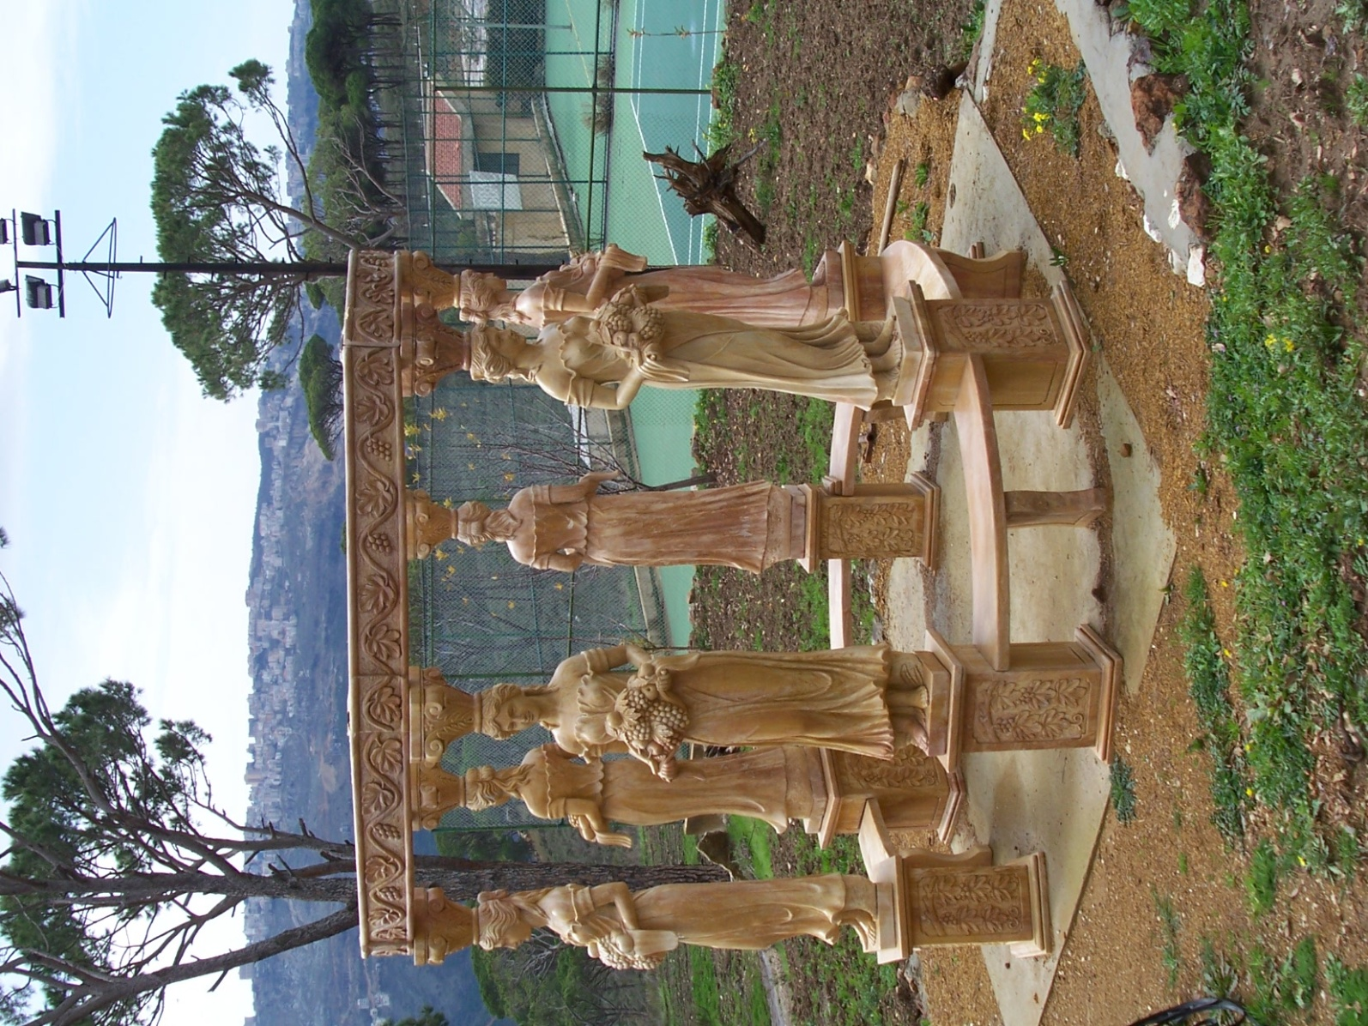

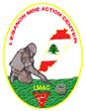

P2R Training Workshop Schedule

Preparatory Session: Saturday, May 7

Time | Activity |  | Materials & People
8:00 – 9:00 | Breakfast
9:00 - 11:00 | Recreational activities: (Participants)  - Swimming  - Hiking | - Preparatory Session for Staff and Facilitators  (All staff)
11:00 – 6:00 | Trip to:  - Geitta Grotto  - Lunch at Jounieh Officer Mess  - Visit to Jbeil archeologial sit and the old city |  | All Staff  Survivors Facilitators and Trainers
6:00 – 7:00 | Opening Dinner

Day 1: Sunday, May 8

Time | Activity | Materials & People
8:00 – 9:00 | Breakfast
9: 00 – 10:00 | Welcome and Introductions  - Activity – “Getting To Know You”  - Pre-evaluations | All staff
10:00 – 12:00 | Recreational activities:  - Swimming  - Hiking | All staff
12:00 – 1:00 | Lunch
1:00 – 2:00 | Workshop Overview and Opening | Anne, Lennie, Cameron Ghannam
2:00 – 2:45 | Learning Objectives, Dreams and Goals:  • As a result of this training, you will be able to:  1. Know the four pathways to resilience; and  2. Help victims become survivors who can go on to thrive.  • What are your goals for this training?  • What dream do you have for a Project to carry out after training? | Anne, Lennie, Cameron
2:45 – 3:15 | Troubled Times and Resilience | Anne, Lennie
3:15 – 3:30 | Break
3:30 – 4:30 | Light Physical Activity | Anne
4:30 – 5:00 | Daily Evaluations and Closing Ritual | Cameron, Ghannam
6:00 – 7:00 | Dinner / Staff reflections
7:00 - 9:00 |  | Ghannam

Day 2: Monday, May 9

Time | Activity | Materials
7:00 – 8:00 | Meditation, Reading, and Light Physical Activity | Ghannam, Anne
8:00 – 9:00 | Breakfast
9:00 – 9:30 | Opening | Ghannam
9:30 - 10:00 | Personal Project Development | Cameron
10:00 – 10:30 | Resilience Theory and Research:  • Personality Trait  • Learning Process | Anne, Lennie
10:30 – 10:45 | Break
10:45 – 11:30 | Circle of Security  • Activity – “Heartfelt Pal” | Anne, Lennie
11:30 – 12:00 | Pathways to Resilience – Social Support  • Activity - Original work | Anne, Lennie
12:00 – 1:00 | Lunch
1:00 – 2:00 | Pathways to Resilience – Making Meaning  • Activity – “An Object Lesson” | Anne, Lennie
2:00 – 3:00 | Pathways to Resilience – Regulating Emotions  • Activity – “Sharing Hopes and Worries” | Anne, Lennie
3:00 – 3:15 | Break
3:15 – 4:00 | Pathways to Resilience – Successful Coping  • Activity – “Out of the Ashes” | Anne, Lennie
4:30 – 5:00 | Daily Evaluations and Closing Ritual | Cameron, Ghannam
6:00 – 7:00 | Dinner / Staff reflections
7:00 - 9:00 |  | Ghannam

Day 3: Tuesday, May 10

Time | Activity | Materials
7:00 – 8:00 | Meditation, Reading, and Light Physical Activity | Ghannam, Anne
8:00 – 9:00 | Breakfast
9:00 – 9:30 | Opening | Ghannam
9:30 – 10:00 | Personal Project Development | Cameron
10:00 – 10:30 | Helping Skills for Reaching Out – Offering LUV  • Activity – “Helping Hands”  • Listen  • Face and give the person your undivided attention.  • Lean toward the person and make eye contact.  • Use both your eyes and ears.  • Understand  • Repeat or paraphrase what the person is saying.  • Check your understanding.  • Offer heart-felt empathy.  • Validate  • Show your acceptance in your face.  • Have faith in the person by not giving glib advice.  • Respect, honor and value the person. | Anne, Lennie
10:30 – 10:45 | Break
10:45 – 12:00 | Practice LUV | Anne, Lennie
12:00 – 1:00 | Lunch
1:00 – 2:00 | Finding the Survivor – Looking for Strengths and Resources  • Activity – “A Coping Heart” | Anne, Lennie
2:00 – 3:00 | Helping Skills for Finding the Survivor  • Ask “Getting Through” Questions  "How did you get yourself to do that?"  "What did you draw from inside yourself to make it through that?"  • Ask “Making Meaning” Questions  “As you make more sense of this, what have you learned so far?”  “What advice would you give somebody else?” | Anne, Lennie
3:00 – 3:15 | Break
3:15 – 4:00 | Practice Finding the Survivor | Anne, Lennie
4:00 – 4:30 | Light Physical Activity | Anne
4:30 – 5:00 | Daily Evaluations and Closing Ritual | Cameron, Ghannam
6:00 – 7:00 | Dinner / Staff reflections
7:00 - 9:00 |  | Ghannam

Day 4: Wednesday, May 11

Time | Activity | Materials
7:00 – 8:00 | Meditation, Reading, and Light Physical Activity | Ghannam, Anne
8:00 – 9:00 | Breakfast
9:00 – 9:30 | Opening | Ghannam
9:30 – 10:00 | Personal Project Development | Cameron
10:00 – 10:30 | Peer Support in Practice  - What is Peer Support?  - Activity: “Helps, Doesn’t Help”  - Individual peer support  - Peer support groups | Cameron
10:30 – 10:45 | Break
10:45 – 12:00 | What does a peer support worker do?  - Building resilience  - Practical support for  - Health care  - Benefits  - Employment  - Rights | Cameron
12:00 – 1:00 | Lunch
1:00 – 2:00 | Managing a peer support program  - Staff and supervision  - Logistics  - Funding | Cameron, Nicole
2:00 – 3:00 | Helping Skills for Moving On  • Hint at possibilities  • Create positive goals  • Keep the goals simple  • Ask “Moving On” Questions:  “As you start to make a difference, what’s your next step?” | Anne, Lennie
3:00 – 3:15 | Break
3:15 – 4:00 | Practice Skills for Moving On | Anne, Lennie
4:30 – 5:00 | Daily Evaluations and Closing Ritual | Cameron, Ghannam
6:00 – 7:00 | Dinner / Staff reflections
7:00 - 9:00 |  | Ghannam

Day 5: Thursday, May 12

Time | Activity | Materials
7:00 – 8:00 | Meditation, Reading, and Light Physical Activity | Ghannam, Anne
8:00 – 9:00 | Breakfast
9:00 – 9:30 | Opening | Ghannam
9:30 – 10:00 | Personal Project Development | Cameron
10:00 – 10:15 | Break
10:15 – 12:00 | Activity – Creating a Resource Map | Cameron
12:00 – 1:00 | Lunch
1:00 – 4:00 | Role playing | Cameron
4:00 – 4:30 | Light Physical Activity | Anne
4:30 – 5:00 | Daily Evaluations and Closing Ritual | Cameron, Ghannam
6:00 – 7:00 | Dinner / Staff reflections
7:00 - 9:00 | Presentation: “Rights of People with Disabilities” | Adnan Al Alboudy

Day 6: Friday, May 13

Time | Activity | Materials
8:00 – 9:00 | Breakfast
9:00 – 11:00 | Project Presentations | Participants
11:00- 12:00 | Daily Evaluations and Closing Ritual | Cameron, Ghannam
12:00 – 1:30 | Friday prayer (Free for religious observations). | Hamana Mosque (transportation will be provided)
1:30 – 2:00 | Lunch
2:00 – 6:00 | Trip to Beirut  Raoucheh  Downtown  Bourj Hamoud / or Barbour | Participants
6:00 – 7:00 | Dinner
7:00 - 9:00 |  | Ghannam

Day 7: Saturday, May 14

On this day local and international journalists will be present to take photos and videos and to do interviews with staff and participants.

Participants are free to decline interviews or photographs.

Time | Activity | Materials
7:00 – 8:00 | Meditation, Reading, and Light Physical Activity | Ghannam
8:00 – 9:00 | Breakfast
9:00 – 10:00 | Final preparations for Theatrical Presentation | Ghannam
10:00 – 10:15 | Break
10:15 – 12:00 | Final preparations for Theatrical Presentation | Ghannam
12:00 – 1:00 | Lunch
1:00 – 3:00  Covered by Media | Theatrical Presentation: “Our Pathways to Resilience” | Participants
3:00 – 3:15 | Break
3:15 – 4:00 | Final Workshop Participant Evaluations | Cameron, Anne
4:00 – 5:00 | Closing Ritual  Celebrating Resilience  • Activity – Compose a poem (or song) of resilience | Ghannam
5:30 – 8:30  Covered by Media | Closing Dinner  Presentation: “Pathways to Resilience”  Graduation ceremony | Dr. Ken Rutherford

Debriefing Session: Sunday Afternoon, May 15

Time | Activity | Materials & People
8:00 – 9:00 | Breakfast
9:00 - 12:00 | Recreational activities:  - Swimming  - Hiking  Meet with Lebanese Amputee Soccer Team
12:00 – 1:00 | Lunch
Afternoon | Participants depart
4:00 - 6:00 pm | Debriefing for Staff and Facilitators – Workshop Evaluation & Discussion  - Overall impressions of workshop  - Individual comments on exercises  - What worked, what didn’t  - Recommendations for changes  - Thanks and acknowledgements  - Written evaluations | All staff

