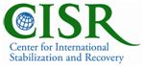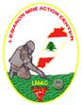

Pathways to Resilience
RESILIENCE, LEADERSHIP AND PEER SUPPORT TRAINING WORKSHOP

Hammana, Lebanon
8 —15 May 2011

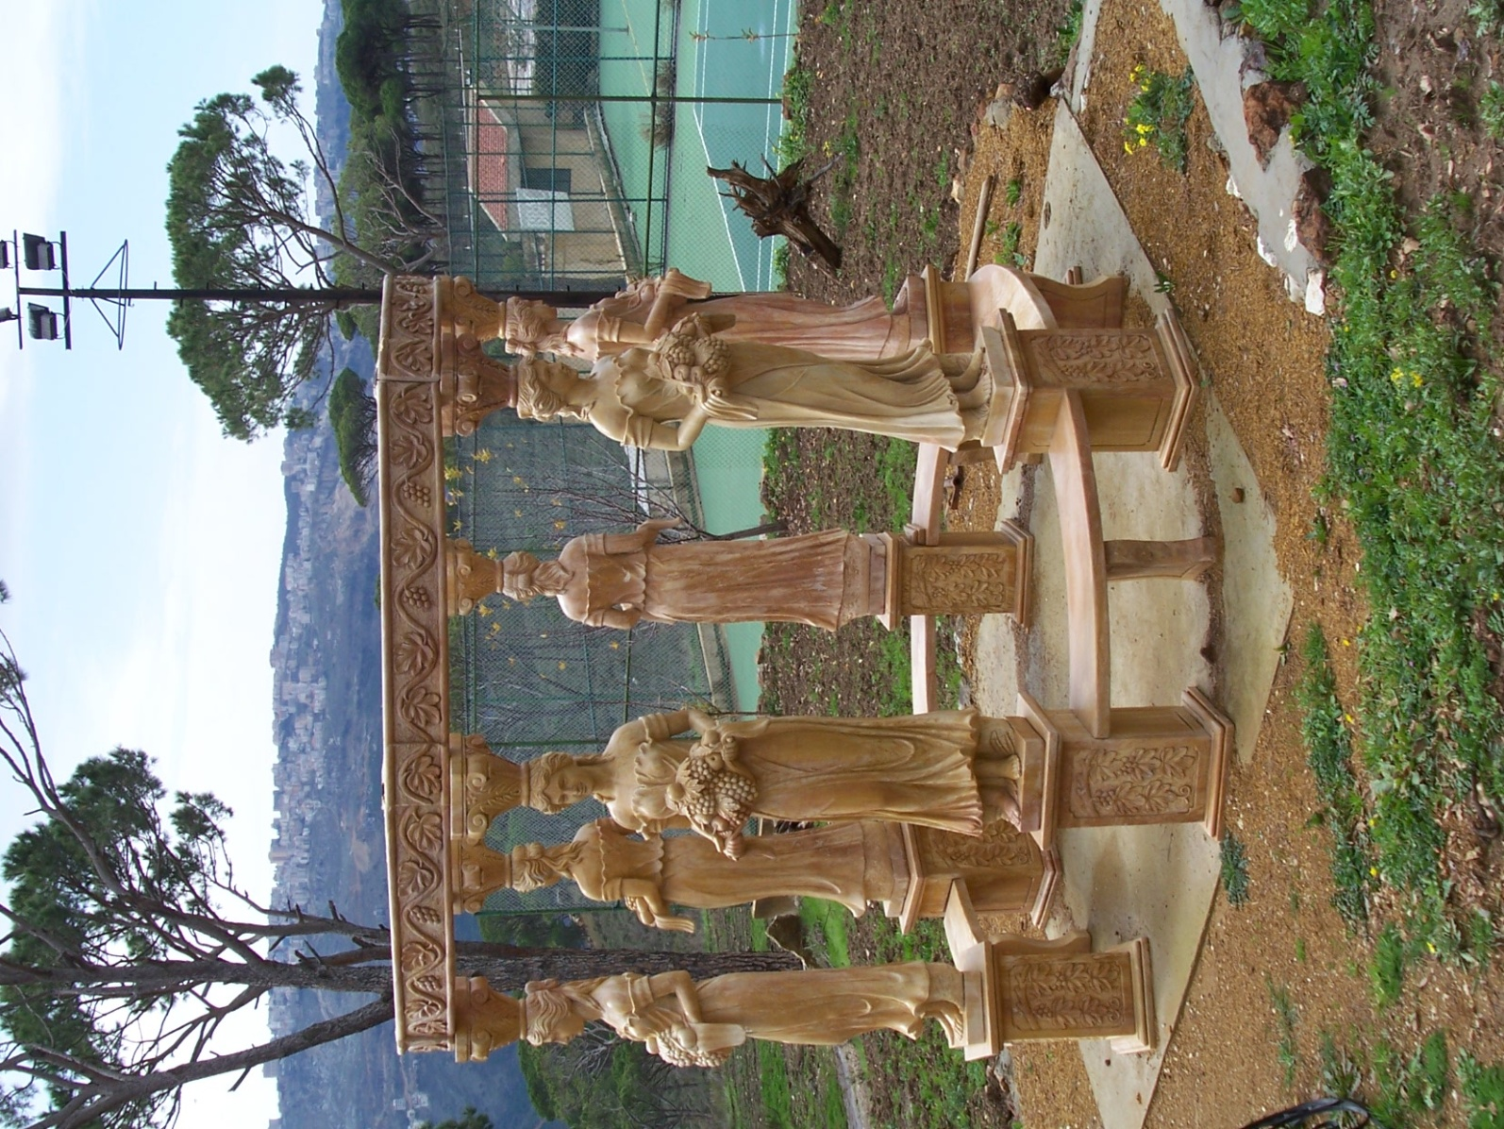

INVITATION TO APPLICANTS

RESILIENCE, LEADERSHIP and PEER SUPPORT TRAINING WORKSHOP
DESCRIPTION and OBJECTIVES

The P2R Training workshop will host survivors of landmines/UXO and professionals working with landmine/UXO survivors to Lebanon for a 7-day resilience, leadership and peer support training workshop. Participants are invited from Iraq, Jordan, Lebanon, and Yemen. Up to 25 landmine/UXO survivors and representatives from landmine/UXO survivor assistance programs will be participating.

TRAINING WORKSHOP CONTENT

THIS WORKSHOP WILL HELP PARTICIPANTS BUILD:

- RESILIENCE: The capacity to face life’s challenges with greater resolve, determination and self-confidence by making meaning and managing emotions. Participants will learn how to help others interpret their experiences and channel their energy into positive activities.
- PEER SUPPORT: The ability to help others build resilience and understanding through conversation and problem-solving. Practical instruction will be provided on how to establish and run a peer support program for survivors of war-related violence.
- LEADERSHIP: Capability in providing direction to achieve goals. Participants will engage in activities to develop their own personal strengths in guiding others and will design a project for survivors of war-related violence, which can be implemented in their country of origin.
During the workshop participants will discuss new approaches to psychosocial support for landmine/UXO survivors as well as peer support project planning and implementation. Training workshop activities have been developed by international and regional experts on resilience, survivor assistance, and disability. The training workshop's success and lessons learned will be used to support future psychosocial workshops in the Middle East and peer-support initiatives.

The training workshop’s focus will be on promoting resilience, leadership and peer support in landmine/UXO survivors. Workshop activities will show participants how to encourage survivors of trauma to:

- Make meaning of past events
- Learn to manage emotions in new ways
- Create new networks of social support
- Develop personal strengths and resilience
The training workshop's activities are based on experiential learning in which the learning process begins with a concrete experience and is followed by reflective observation. Activities will include exercise and meditation in a relaxing and invigorating environment to assist mental and spiritual healing. In addition to learning about and participating in energizing activities, participants will engage in individual learning, small-group work and expressive arts such as writing, storytelling and music.

The training workshop will also have sessions on peer support and leadership skills. All participants will receive training for project planning and implementation so they can develop an action plan to share P2R activities and peer support concepts in their home countries with other landmine/UXO survivors or persons recovering from traumatic events.

The 2011 training workshop will include

Training sessions on:

- Program leadership skills
- Project description and planning
- Counseling skills
Activities:

- to build mental acuity and fortitude through meditation and self-reflection.
- to develop spiritual vitality through interpretation of the experiences of oneself and others.
- to encourage new understanding and new choices through creative expression in poetry, drawing, story-telling and drama.
- to promote positive interactions with others through group discussions, sharing reflections and contemplating different perspectives.
- to enhance physical strength and stamina through regular exercise, swimming and walking in a calm, restorative atmosphere. Physical activities can include horseback riding, exercising, hiking, and other recreational activities.
EXPECTED PARTICIPATION OF PARTICIPANTS WILL BE THROUGH:

- Participating in discussions and skills-based learning activities
- Creating an action plan to develop peer support using new leadership and planning skills in home country
- Providing feedback and evaluation on all parts of this program to help improve it for the future

PROGRAM STRUCTURE

Date and place: P2R will take place over 7 days in Hammana, Lebanon. The training workshop will occur from Sunday, 8 May to Sunday, 15 May 2011. Participants will need to arrive on Friday 6 May and depart on Sunday PM 15 May (or Monday AM 16 May). They should arrive and depart from Beirut Rafic Hariri International Airport. A P2R Program coordinator will assist with your flight details. Lebanon Mine Action Center (LMAC) will provide ground transportation to Pine Land Hotel and Resort, Hammana.

In the implementation of the P2R, psychology faculty from James Madison University (USA) with support from LMAC and professional Middle Eastern consultants has developed the curriculum and training workshop structure. The team behind P2R:

Mrs. Daniele Ressler, Program Manager for CISR

Mr. Cameron Macauley, Trauma Rehabilitation Specialist

Dr. Lennis Echterling, Professor of Counselling at James Madison University.

Dr. Anne Stewart, Professor in the Combined-Integrated Doctoral Program in Clinical and School Psychology at James Madison University.

Dr. Hasan Hamdan, Associate Professor at the Department of Mathematics and Statistics at James Madison University.

Mrs. Diar Kaussler, Research Associate and Assistant Project Manager.

Mrs. Lina A. Khalifeh Rawass, Project Coordinator

Mr. Kamel Saadi, Regional Program Support

For more information about each individual team member, please refer to P2R website.

APPLICATION PROCESS

Applications should be typed into the special form attached and returned to Lina A. Khalifeh Rawass via e-mail p2rcoordinatorleb2011@gmail.com. The application form can be found on the P2R website: http://maic.jmu.edu/p2r/index.html.

The application deadline is the 21st of March 2011.

The complete application must be accompanied by a recent color photograph of the applicant plus a colored copy of the first page of passport. Applicant’s passport MUST be valid for AT LEAST six (6) months following the end of the training workshop. Please attach long-answered questions on a separate document.

Applicants selected to participate in the training workshop will be notified via e-mail by the 31st of March 2011. They should confirm their acceptance to attend by e-mail by latest the 7th of April.

Applicants are reviewed by a selection committee consisting of CISR staff, JMU Faculty, LMAC, P2R Coordinator and Regional Program Support Consultant.

Because of the short time in which to select participants and process the required visas, preference will be given to those applicants who submit a fully complete application by the deadline. Care needs to be taken in reading and completing the application and providing the required supporting documents.

Applications should be submitted no later than 21st of March 2011 to:
Mrs. Lina A. Khalifeh Rawass, P2R Coordinator, e-mail: p2rcoordinatorleb2011@gmail.com or by fax: +961 5 956192 and clearly marked for Att: MVA

COST OF PARTICIPATION

If selected as a participant of the P2R training workshop, the entire cost of travel to Lebanon, transportation within the Lebanon, hotel stay for the duration of the training workshop, all meals as well as any physical activities and excursions are covered, free of charge. Participants will also receive a small per diem for incidental expenses.

ACCOMMODATIONS and MEALS

All meals and lodging will be provided to participants free of charge during the
training workshop. Participants will be housed in Pineland Hotel and Resort in Hammana, Lebanon. Hotel amenities include private room with bath, daily meals, internet service, and exercise facilities. Daily meals will also be provided through the hotel service.

LEBANON ENTRY VISA

LMAC and the P2R Coordinator will assist applicants accepted into the training workshop with applying for the required visa. Please note that it is very important that participants traveling from Iraq meet all deadlines in time due to visa requirements. Contact the P2R Coordinator with questions.

HEALTH and INSURANCE

Participants must attest to their medical ability to attend and participate in this training workshop.

They must be free of any communicable/infectious diseases (for example, tuberculosis or trachoma) or any other illnesses that could present risks to persons that they will come in contact with. They must also be free of any medical conditions that would prevent them from carrying out training away from home.

All participants will be covered with short-term medical insurance to cover emergency care while in Lebanon for illness and injury that develop during the time period of the training workshop. The medical insurance will NOT cover any kind of sickness or illness with previous history.

Please contact the P2R Coordinator for questions or more information.

TRAINING WORKSHOP CERTIFICATE

Participants that complete the P2R will be given a Certificate of Completion at the end of the training workshop.

Please contact the P2R Coordinator if you require a Letter of Support to assist with permission from your supervisor to participate in the training workshop.

OUR FUNDING PARTNER

The Pathways to Resilience Program is funded by a grant from the US Department of State, Office of Weapons Removal and Abatement. The P2R program is being held in Lebanon with the cooperation of the Lebanon Mine Action Center, a governmental agency.

QUESTIONS?

Any questions about the Pathways to Resilience training workshop should be directed to the P2R Coordinator by email: p2rcoordinatorleb2011@gmail.com or by phone: +961 3 295880. The P2R website contains more information about the training workshop and its history. You can find the P2R website at http://maic.jmu.edu/p2r/index.html. This website will be updated periodically with information for participants.

