ALPHA CHI SIGMA SEMINAR
Friday, March 6, 2026

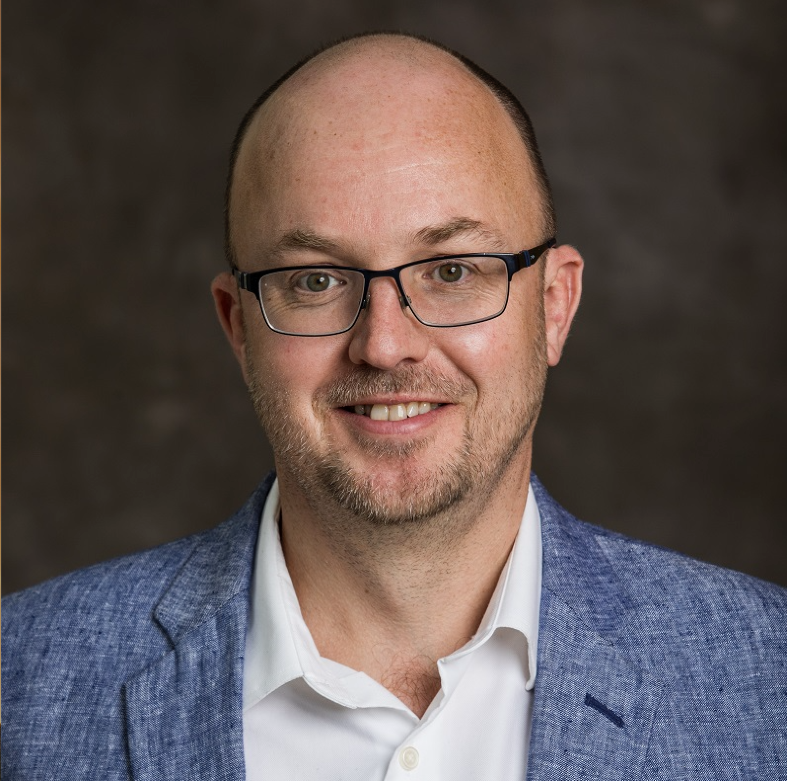
Dr. E. Charles H. Sykes
Department of Chemistry
Tufts University
A Short History of Single-Atom Alloy Catalysts; From Birth in a Chilly Vacuum to Application in a Fiery Reactor
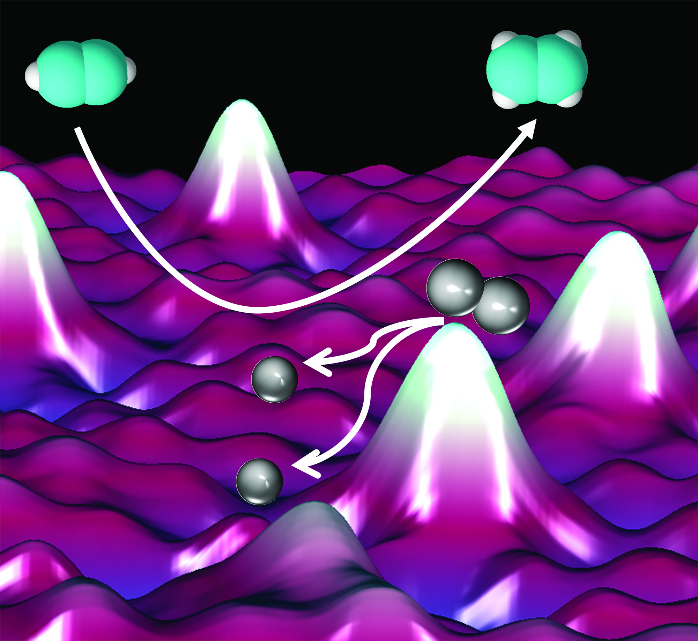
Abstract: In this talk I will discuss a new class of heterogeneous catalysts called Single-Atom Alloys in which precious, reactive metals are utilized at the ultimate limit of efficiency. These catalysts were discovered by combining low-temperature scanning tunneling microscopy with more traditional ultra-high vacuum surface science approaches to study surface-catalyzed chemical reactions. This research provided links between atomic-scale surface structure and reactivity which are key to understanding and ultimately controlling important catalytic processes. In collaboration with Maria Flytzani-Stephanopoulos these concepts derived from our surface science and theoretical calculations were first used to design Single-Atom Alloy nanoparticle catalysts that are shown to perform industrially relevant reactions at realistic reaction conditions. For example, alloying elements like platinum, palladium and rhodium with cheaper, less reactive host metals like copper enables 1) dramatic cost savings in catalyst manufacture, 2) more selective hydrogenation, dehydrogenation and oxidation reactions, 3) reduced susceptibility to CO poisoning, and 4) higher resistance to deactivation by coking. I go on to describe very recent theory work by collaborators Stamatakis (Oxford University), Michaelides (Cambridge University) and Montemore (Tulane University) that predicts reactivity trends for a wide range of Single-Atom Alloy combinations for important reaction steps like H-H, C-H, N-H, O-H, and CO₂ activation. I end with two demonstrations of new nonintuitive Single-Atom Alloy nanoparticle formulations that were predicted a priori and proven in reactors. Overall, I hope to highlight that this combined surface science, theoretical prediction, synthesis and testing approach provides a new and somewhat general method for the design of new heterogeneous catalysts.

Meet the Speaker 2:00 pm, PCB 3144
Seminar 3:30 pm, King 159

References
- Kyriakou et al. Science 335, 1209 (2012)
- Marcinkowski et al. Nature Materials 12, 523 (2013)
- Lucci et al. Nature Communications 6, 8550 (2015)
- Liu et al. JACS 138, 6396 (2016)
- Marcinkowski et al. Nature Chemistry 10, 325 (2018)
- Hannagan et al. Science 372, 1444 (2021)
- Jalil et al. Science 387, 869 (2025)

Biography
E. Charles H. Sykes is the John Wade Professor of Chemistry and Professor of Chemical and Biological Engineering at Tufts University. Charles got his B.S. and M.S. from Oxford University before moving to Cambridge University for a Ph.D. under the supervision of Professor Richard Lambert. He then relocated to the U.S. for a postdoctoral fellowship with Professor Paul Weiss at Penn State before starting his independent career at Tufts University in 2005.

Sykes has been named a Beckman Young Investigator, Research Corporation Cottrell Scholar, IUPAC young observer and the Usen Family Career Development Professor. He was also the recipient of a 2009 NSF CAREER award, a 2011 Camille Dreyfus Teacher-Scholar Award and the 2012 AVS Peter Mark Memorial Award. Charles received the Young Talented Scientist Award at Chirality 2014 and was named a Fellow of the Royal Society of Chemistry in 2015. In 2018 Charles was named a Fellow of the AVS and, together with Maria Flytzani-Stephanopoulos, was awarded the 2019 ACS Catalysis Lectureship for the Advancement of Catalytic Sciences. In 2022 Charles was named a AAAS fellow and awarded the Royal Society of Chemistry, Faraday Division, Horizon Prize for the development of single-atom alloy catalysts. Charles is the 2023 winner of the International Precious Metals Institute, Henry J. Albert Award. He was awarded the Ipatieff Lectureship in Chemistry at Northwestern in 2025 and the Bernstein Lectureship in Chemistry at UW-Madison in 2026.

He is the author of over 200 peer-reviewed publications and has given over 180 invited talks at conferences and universities.

Website: http://ase.tufts.edu/chemistry/sykes/index.html

