SAACS SEMINAR
Friday, February 20, 2026

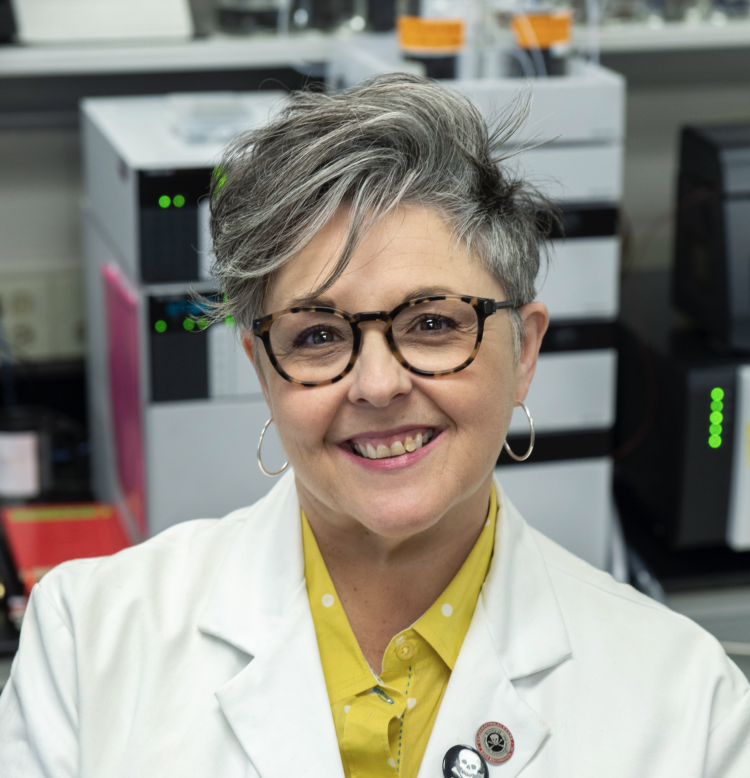
Dr. Michelle R. Peace
Department of Forensic Science
Virginia Commonwealth University

Science is Needed in Policy to Manage the Unregulated Cannabis and Nicotine Vaping Industries
Abstract: Electronic cigarettes (e-cigs) were created as an alternative nicotine delivery system. They were co-opted by the cannabis industry and altered expressly for discreet consumption of tetrahydrocannabinol (THC). Devices evolved rapidly in the absence of federal oversight and continue to proliferate despite regulations being promulgated since 2016. Vapes deliver the drug from formulation by way of a condensation aerosol, made up of droplets of different sizes that determine the depth of lung deposition. The liquid formulations are made of a pharmacologically active ingredient, humectants, flavoring chemicals, terpenes, solvents, stabilizers, thickeners, and other additives of unknown purpose. The cannabis industry uses vapes as the initial final product to launch "hemp-derived" THC analogs to gain market interest under the guise of natural, safe, and legal alternatives to THC. Quality and safety of nicotine and cannabinoid vapes have been oversold to the public. As a result, adverse events in consumers using one or the other or both vaping product have proliferated quietly across the United States and are not adequately described. Surveillance studies and community partnerships are needed to fully characterize the public health threats and educate communities.

Meet the Speaker 2:00 pm, PCB 3144
Seminar 3:30 pm, King 159

Michelle R. Peace, Ph.D.
Forensic Toxicologist

Dr. Peace is a forensic toxicologist and a Full Professor in the Department of Forensic Science at VCU. She is one of the founding faculty for the Department and served as Associate Chair and Chair for nearly a decade. Dr. Peace has also served as a manager in a private forensic drug testing laboratory and has worked as a scientist for Procter & Gamble, where she holds 3 patents.
Dr. Peace has been funded by the National Institute of Justice to study the efficacy of electronic cigarettes, particularly as they pertain to substance use and abuse. Her research has highlighted emerging issues of electronic cigarettes as a tool for vaping drugs other than nicotine, the impact of vaping on drug testing and roadside impairment evaluations, the emerging synthetic cannabinoid analogs in unregulated cannabis marketplaces, and the assessment of physiological variability on the calculation of blood alcohol concentration. She is also funded by the Virginia Foundation for Healthy Youth to analyze vaping products confiscated and collected on school properties across Virginia.
Dr. Peace serves on the Board for Virginia’s Cannabis Control Authority, is a Past President of the Society of Forensic Toxicologists, is a member of The International Association of Forensic Toxicologists and is a Fellow in the American Academy of Forensic Sciences. She is a member of the National Safety Council’s Alcohol, Drugs, and Impairment Division. She has provided testimony and opinions to develop scientifically relevant and robust policy and legislation at the state and federal levels. Her work has also informed substance use treatment programs, improved highway safety, and protected consumers.
Dr. Peace has been featured in the New York Times, CNN, Consumer Reports, and AARP. The American Chemical Society and Discover Magazine featured her research in 2018 and 2019 as some of the most timely, interesting, and influential research in the nation. She has been nationally recognized for Excellence in Teaching and Mentoring by the Society of Forensic Toxicologists and the Rolla N. Harger Award for Outstanding Contributions to Forensic Toxicology by the American Academy of Forensic Sciences, and as a Distinguished Mentor by VCU’s College of Humanities and is one of VCU’s 2025 Uncommon Heroes.

