SEMINAR
Friday, February 6, 2026

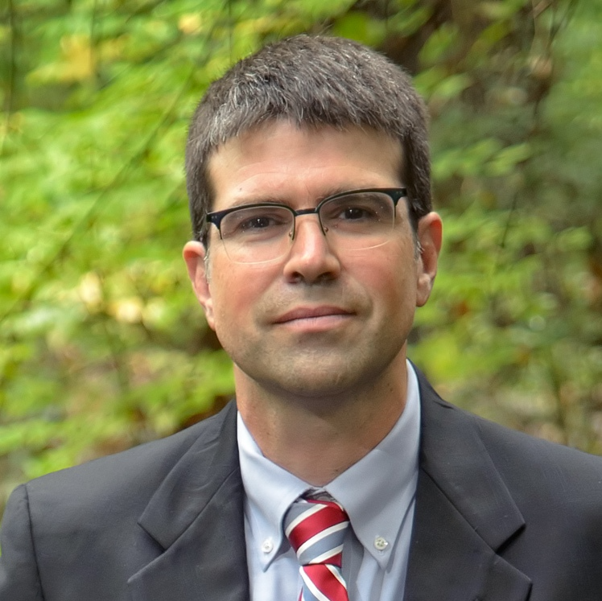
Dr. Nick Oberlies
Department of Chemistry & Biochemistry
University of North Carolina - Greensboro
Fungal Fist Fights
to Source New Chemical Diversity
Abstract: A familiar question in the field of natural products research is: why did that organism choose to biosynthesize those compounds? The common postulate is that the secondary metabolites give the organism some sort of advantage, particularly with respect to chemical defense. Historically, most natural products lab experiments only examine the chemistry of organisms in isolation. However, using some newly developed tools, it is now possible to examine in situ the chemistry of organisms in co-culture, documenting how the chemistry changes as these organisms fight for resources. In doing so, we can force the production of secondary metabolites by stimulating otherwise silent biosynthetic gene clusters.
Using a series of tools that profile the chemistry of fungal cultures in situ, our team has been pursuing these questions, both to probe some of the basics of fungal ecology and biology, as well as, to generate new chemical diversity. This talk will explain some of the underlying tools used to assess the chemistry of fungal cultures and then go through examples where doing so has led to the generation of new chemical diversity.

Meet the Speaker 2:00 pm, PCB 3144
Seminar 3:25 pm, King 159

