
GUIDELINES AND SPENDING REGULATIONS
Table of Contents
Introduction 2
Hiring, Wages and Salaries, Payments 3 The Affordable Care Act 3
Faculty and Staff Additional Pay…………………………………………………………………………………………3
Hiring Undergraduate Students 3
Hiring Graduate Level Students 3-4
Hiring Part-Time Wage/Hourly 4
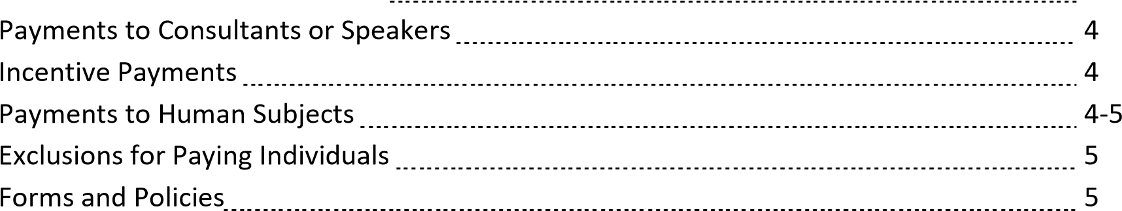

Equipment and Software 5
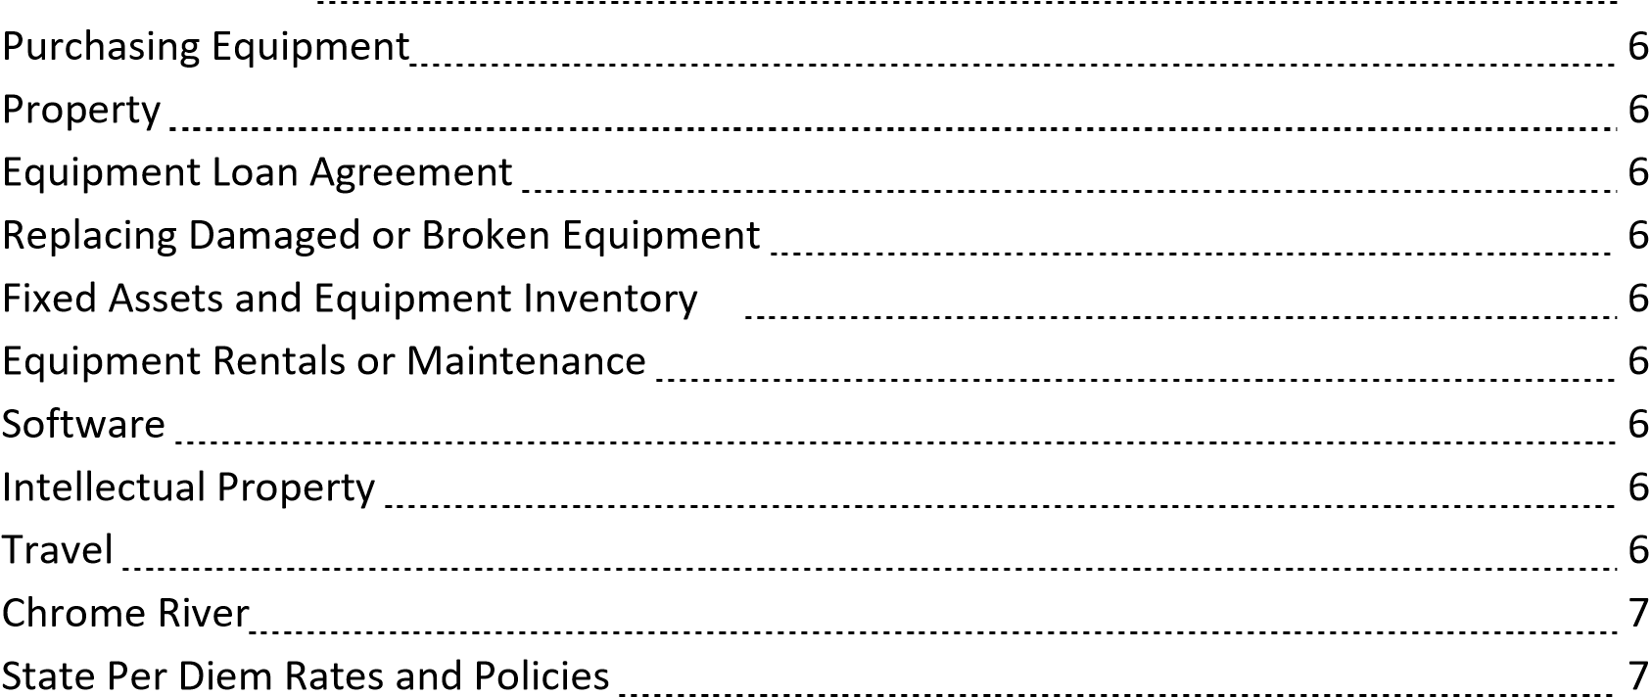

Materials and Supplies 7
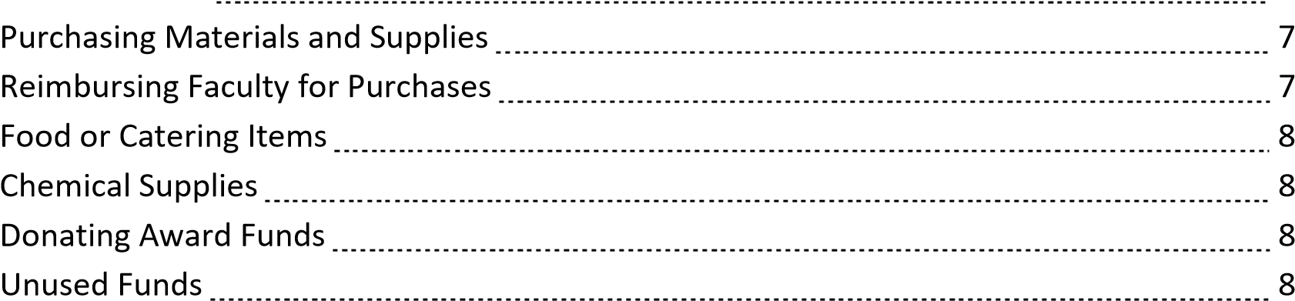

___________

___ INTRODUCTION

The following guidelines are intended to assist the College of Health and Behavioral Studies faculty as they plan budgets associated with Collaborative Grants, Teaching and Research Grants and Mini-Grant application submissions. These guidelines address regulations regarding hiring, expenditures allowed, policies and forms, and deadlines for purchases.
All expenditures from award funds must adhere to the University finance and procurement compliance guidelines. According to compliance guidelines, expenditures from award funds must be necessary, reasonable, and directly related to the goals and mission of the College and University.
All award funds must be spent during a determined timeframe or fiscal year. We are not allowed to roll funds over from one fiscal year to another, thus the deadlines by which all award funds must be spent. Spending deadlines will be provided in the recipient’s award letter as well as being addressed in these guidelines.
Unless otherwise agreed upon, all awarded funds will be expended through the CHBS Dean’s Office budget.

CHBS Mission, Vision and Values
Awards and Grants Listing of past CHBS Recipients

HIRING, WAGES AND SALARIES, PAYMENTS

- THE AFFORDABLE CARE ACT – The Commonwealth of Virginia has adopted a provision in the 2013 Appropriation Act that limits all state wage employees to working no more than 29 hours per week, on average, over the course of 12 months (52 weeks). According to the Department of Human Resource Management (DHRM), the amendment is necessary to ensure compliance with the Patient Protection and Affordable Care Act (PPACA), commonly called the Affordable Care Act, for which most of the law takes effect in 2014. As indicated by DHRM, the state health plan currently does not permit participation by wage employees.

- FACULTY AND STAFF ADDITIONAL PAY – If the award funds are approved to be used to pay JMU faculty members, or others an ePAR must be processed. Award funds must also be used to pay FICA (7.65% x salary) with the faculty pay. All faculty payrolls for this award must be completed no later than May 1, 2026.

  - Full-Time Faculty 10-month – If approved by the CHBS Dean, faculty may receive additional pay for awards or research if they are within the university guidelines of additional pay not to exceed 33.3% of their salary within a calendar year (Jan-Dec).

  - Full-Time Faculty 12-month or A/P – If approved by the CHBS Dean, faculty may receive additional pay if the duties of the assignment are considered an overload and performed outside of the normal working hours (Monday – Friday, 8:00 am – 5:00 pm). An overload does not have to be teaching. The supervisor of the 12month employee must approve the additional assignment and pay. Award funds must also be used to pay FICA (7.65%) with the employees’ pay.

  - Full-Time Classified Employee – If approved by the CHBS Dean, classified employees may receive additional pay only in the form of overtime. The duties of the assignment must be performed outside of the normal working hours (Monday – Friday, 8:00 am – 5:00 pm). The supervisor of the classified employee must approve the additional assignment and pay. Please discuss this type of payment with Julie Love as you put together your proposal. Julie can help with calculating the overtime payment and explain the rules and regulations set by Human Resources. Award funds must also be used to pay FICA (7.65%) with the employees’ pay.

- HIRING UNDERGRADUATE STUDENTS – If the award funds involve hiring undergraduate students, please discuss with Julie Love to determine the best way to pay them (hourly or lump sum). Be aware that, depending on the timing of the students’ work, FICA (7.65%) may need to be calculated with the students’ pay. The award funds would be responsible for covering this. Students may not begin work on any projects until they have completed their hiring paperwork. If a student begins work without completing an I-9, we are subject to a $100 fine by the university. If we are fined, the award funds will need to be charged. All student payrolls for this award must be completed no later than May 1, 2026.

- HIRING GRADUATE LEVEL STUDENTS - Graduate level students who have been awarded a Graduate Assistantship (paid stipend and tuition) may be hired for additional work during the academic year only after approval through the Graduate School (contact Rebecca Lipscomb). If the graduate student holds a GA or TA position that pays a stipend and tuition, the Graduate School will need to review the student’s financial aid package to make sure the additional pay does not harm the student’s financials. If the graduate student does hold an assistantship, the student must fill out the “Approval of Additional Employment Form” located on the Graduate School website and obtain all signatures before submitting the form to the Graduate School. Once hiring is approved by the Graduate School, the hiring ePAR can be processed. If the graduate level student does not hold a paid assistantship, we can usually hire them as a student assistant as an hourly wage employee or pay in one lump at the end of the assignment. All student payroll for must be completed no later than May 1, 2026.

- HIRING PART-TIME WAGE/HOURLY – If the award funds are used to pay someone that is not a JMU employee, please discuss with Julie Love to determine the best way to pay them (hourly or lump sum). The award funds will be responsible for covering FICA (7.65%) if applicable. Please allow enough time for recruitment keeping in mind the final payroll date listed below. If you wish to pay a current hourly wage employee to perform a task, you must make sure the task is not part of the individual’s regular duties. For instance, if you need graphic work done and the employee already does graphic work as part of their part-time duties, most likely they would not be able to receive additional pay. If the work caused overtime for the individual, that might be acceptable. All of this would need to be discussed with the supervisor. All part-time payroll for this award must be completed no later than May 1, 2026.

- PAYMENTS TO CONSULTANTS OR SPEAKERS – If the award funds are used to hire an outside consultant or speaker, we need to develop a contract of services document before a commitment is made. Signatures must be obtained and Procurement or the University Legal Services may possibly need to review the contract, depending on the terms. Please discuss with Julie Love to determine the contract and the best way to make the payment to the individual. If the consultant or speaker is a JMU employee, we must assess how to pay the current employee and it depends on how they are currently employed (part-time, adjunct, full-time faculty or full-time classified).

- INCENTIVE PAYMENTS – If the award funds involve incentives for individuals to participate in a survey, focus group or a competition, please discuss this with Julie Love. Most incentive payments or items must be approved by IRB and assigned a protocol number. Some incentive items need to be pre-approved by Financial Accounting. We may not purchase any type of “gift card” (i.e., Wal-Mart, Target, Amazon, etc.) to use as an incentive.

Financial Procedures Manual .391 Incentives
- To encourage participation in campus surveys, focus groups and other student engagement activities, a nonmonetary incentive with a fair market value of less than $100 per item may be awarded. Prepaid cards represent monetary recognition and are not allowed. Written approval for non-monetary incentives of $100 or more is required prior to purchase, email iis.finance@jmu.edu.
- Incentive based surveys may be used as assessment tools for obtaining data considered mission-critical to the University, colleges and/or approved centers. Appropriate survey instruments, outcomes, and incentive distribution documentation is to be maintained by the department to support incentive expenditures. Nonmonetary incentives with a de Minimis value and average cost to the University of no more than $25 per item, excluding setup charges and shipping costs may be purchased. These incentives, when associated with the documented survey instruments and outcomes analysis, may be provided to all participants completing the documented requirements.
- If approved, all incentive payments must be paid or given no later than May 16, 2026.

- PAYMENTS TO HUMAN SUBJECTS – If the award includes human subjects for research, please make sure you review IRB Policy # 1104 before you begin working with your subjects. We may not purchase any type of “gift card” (i.e., Wal-Mart, Target, Amazon, etc.) to use to pay a subject. There are two options for paying subjects:

      - Option #1: Pay participant by giving a pre-paid card. This works like a Visa card and can be used at any place that accepts Visa. Faculty applicants for a grant (CHBS Collaborative, Mini-Grant or Teaching and Research) will need to go through online training that is required: https://www.jmu.edu/financeoffice/accountingoperations-disbursements/cash-investments/prepaid-card-training.shtml Please read through the instructions and click on the training at the above link.
      - Option #2: Cash to the faculty member to distribute to participants. Some studies might require a cash payment at the time that the subject is participating in the study.

      - If applicable, you will be asked to submit the IRB protocol document that includes the IRB number as well as the award letter to the Dean’s Office if awarded funds. The Dean’s Office will have to follow the IRB for amounts or increments in which to pay the participants. Please contact Julie Love to explain your research so we can discuss which option is best for paying for subjects. All payments to subjects must be completed no later than May 16, 2026.

• EXCLUSIONS FOR PAYING INDIVIDUALS OR DONATIONS o We may not purchase gift cards from any vendor (Wal-Mart, Target, JMU Bookstore etc.) to pay subjects or give incentives. See the two options listed above for paying subjects.
        - JMU is not allowed to “donate” any state funds to communities or charities.
        - We may not donate any food, personal items, equipment or supplies to participants once the research is completed. This is considered a gift which we are prohibited to give using state funds. Items may be provided to the participants during the study if required as part of the study; however, unused supplies and all equipment must be returned to the researcher upon completion of the study. See Equipment Loan
Agreement on page 6.
        - Policy 1301: Nepotism and Employment of Family Members. We are prohibited from involving subjects, students and faculty members who are related to the researcher(s) for research or competitions.

- FORMS AND POLICIES
Affordable Care Act Guidance
IRB Policy #1104
Participant Payment Procedures Section 4205 Expenditures and .390 – .395
Participant Worksheet (scroll through forms index)
W-9 Tax form using Adobe Sign (scroll through forms index for instructions)

EQUIPMENT AND SOFTWARE

- PURCHASING EQUIPMENT - The University requires that we use eVA or a unit small purchase card to purchase equipment or software. Any equipment or software that is over $10,000 must be considered for bid. We should choose registered eVA vendors when possible. If the award funds involve Procurement putting out bids, please allow time for the bidding process (30 days) and the order to be placed. Please refer to the Governor’s Executive Order 35: Advancing Equity for Small-, Women-, Minority-, and Serviced Disabled Veteran-Owned Businesses in State Contracting. https://www.jmu.edu/news/procurement/2019/09-09-2019-delegation-swameo35.shtml. All items must be received and paid for before May 16, 2026.

ANNOUNCEMENT FROM PROCUREMENT - Amazon.com is not a registered vendor with eVA. Any purchases from Amazon will cause the university to be out of compliance. Any item that is originally priced on Amazon should be researched to find a registered eVA vendor. Please contact Julie Love or Procurement staff when needing to find items from other vendors instead of Amazon. Using Amazon prices in a research budget proposal may cause the award funds to go over budget due to higher costs at other vendors and the award recipient may have to ask their AUH to help split the cost with the award funds. Contact Julie Love if you have any questions about searching for costs for the budget proposal.

  - PROPERTY - Any equipment purchased with these award funds remains the property of CHBS. We are prohibited from donating any equipment or software to an outside entity not associated with JMU.

  - EQUIPMENT LOAN AGREEMENTS – Effective June 1, 2015 all units engaged in loaning equipment must adhere to the guidelines in Financial Policy 4115.230. Use the appropriate Equipment Loan Agreement template(s) when loaning university materials and/or equipment to community members, employees or students. If loaned items are not returned as agreed, use the standard JMU Invoice to bill the named borrower for the replacement costs per the completed Equipment Loan Agreement.
Equipment Loan Agreement Form (scroll through form index) JMU Invoice Template (scroll through form index)

  - REPLACING DAMAGED OR BROKEN EQUIPMENT - Award funds are not available for equipment repair or replacement after the initial purchase.

  - FIXED ASSETS AND EQUIPMENT INVENTORY – All equipment must be on the university inventory list and decaled. Once the equipment is ordered and delivered to your unit, please notify your Administrative Assistant who handles the unit’s Fixed Assets inventory that there is a new piece of equipment and where it is located. Your Fixed Assets Coordinator will notify PC Services that a piece of equipment needs to be decaled.

  - EQUIPMENT RENTALS OR MAINTENANCE - Award funds cannot be used for renting equipment or future maintenance of equipment purchased. If the award involves buying equipment and the equipment requires future maintenance, please discuss the cost plan with your Academic Unit Head.

- SOFTWARE - Funds for software can only be for a one-time cost. IT requires that before any software is purchased a Technology Solution Request (TSR) must be filled out. The faculty member should submit this request using the IT Portal. If the purchase involves renewal fees or maintenance, it will be the responsibility of the faculty member to work with their unit to cover those costs. Software must be purchased and paid for before May 16, 2026.

- INTELLECTUAL PROPERTY - Please be familiar with university Policy 1107 regarding Intellectual Property and be sure to complete appropriate forms if applicable and/or consult with the IP Committee regarding questions or advice.

TRAVEL

- CHROME RIVER – Chrome River is the university’s electronic travel and expense reimbursement system. All travel expenses using award funds must be submitted through this system.

  - Any travel that is over $500 must have a Pre-Approval Request processed through Chrome River prior to making any travel arrangements.

  - The travelers may not use their personal funds to purchase transportation (i.e., airline, train, etc.) and conference registrations. All transportation and conference registrations must be purchased using the Dean’s Office small purchase credit card. Using personal funds to make these purchases may cause the traveler to not receive reimbursement in a timely manner or may not be reimbursed if trips are cancelled.

  - If the traveler is a JMU employee, they will need to make Julie Love or Melissa Goodloe a delegate in Chrome River to get a reimbursement processed.

  - Alternative lodging accommodation are those not involving a traditional hotel/motel. Examples include AirBnB, VRBO, and cabin/house/apartment rentals. Alternative lodging accommodation are not permitted, however, exceptions can be requested, in advance, via the Alternative Lodging Request Form. Common exceptions include large group travel (involving students) and international lodging for extended periods of time (i.e. 7 days or more).
All travel MUST BE COMPLETE AND REIMBURSED NO LATER THAN MAY 16, 2026. Please see Julie Love before you travel to get the rules and regulations of travel.
- STATE PER DIEM RATES AND POLICIES
Travel Per Diem Rates M&IE Portal
Travel Reimbursement Policy

MATERIALS AND SUPPLIES

- PURCHASING MATERIALS AND SUPPLIES - The University requires that we use eVA or a unit small purchase card to purchase materials and supplies. JMU has contracted with The Supply Room (TSRC) and RGH for purchasing office supplies and materials. We are prohibited to buy office supply type items from any other vendor. When you are ready to spend your award funds, please give your order and vendor information to Julie Love. You may email that in the form of quotes or website links. Please reference the Procurement User Sourcing Guide for a listing of products and available vendors. All materials and supplies must be received and paid for before May 16, 2026.

- REIMBURSING FACULTY FOR PURCHASES - The preferred method of any purchase is using eVA or the units small purchase card. Employees should not make purchases with their personal funds and request reimbursement. Please contact Julie Love to discuss purchasing items.

- FOOD OR CATERING ITEMS – When planning an event involving food on campus, we must use our state contract vendor, Aramark. To ensure that the food purchase is allowed and in compliance, please discuss this with Julie Love when planning your event.

- CHEMICAL SUPPLIES – If chemicals are purchased with these funds, please be sure to follow the CHBS Laboratory/Facility Safety Guidelines. Some chemicals may need a barcode for tracking. All chemicals and supplies must be received and paid for before May 16, 2026.

- DONATING AWARD FUNDS - We are not allowed to donate state funds to another organization or individual outside of JMU. We are also prohibited from transferring state funds to internal grant accounts for the purpose of donating to a grant. It is possible to match state funds with grant funds to make a legitimate purchase. Please discuss with Julie Love for further information about matching funds.

- UNUSED FUNDS - If you find that your award funds cannot be used as your original proposed budget indicated, please notify the Dean’s Office, through Julie Love, before April 1, 2026. Any unused funds will stay within the Dean’s budget. It is not possible to roll over unused funds from one fiscal year to the next.

