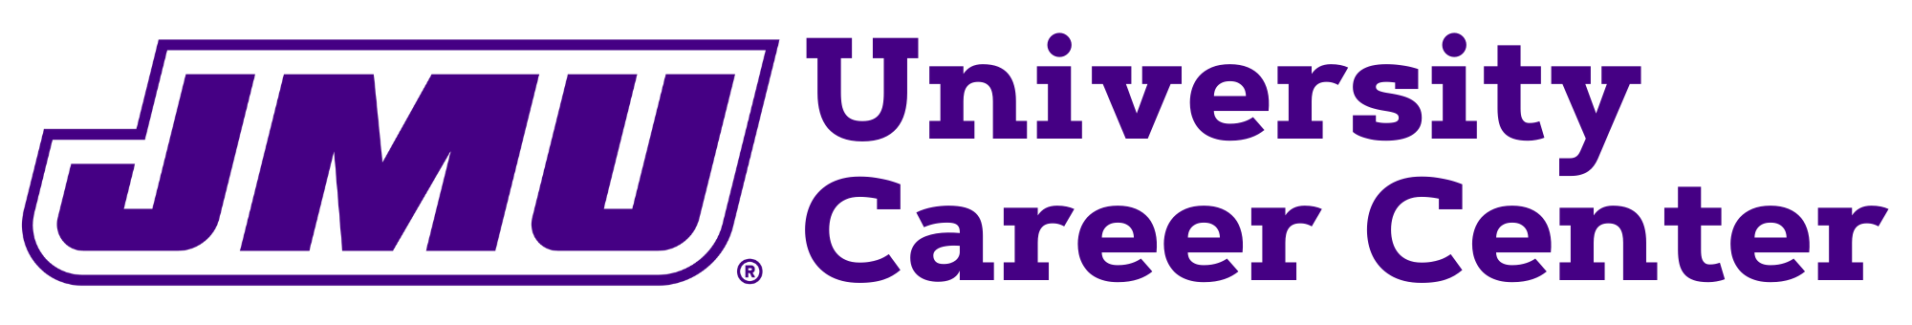
Part 1

Unpaid Internship Scholarship Application

Please complete parts 1-4 of this form and upload to the Madison Scholarship Hub, by Friday, April 14, 2023 by 5pm. For more information on the application process, see https://www.jmu.edu/career. If you have any questions, please contact the Employer Services Team at handshake@jmu.edu.

 |  |  |  |  | Date:
Full Name:
Last |  |  | First | Middle
Name of Company/Organization offering internship:
Organization’s website:
Name of Intern Supervisor:
Email of Intern Supervisor:
Time frame of internship (include start and end date):
Please include the total minimum number of hours you plan to work (this must be verified on the employer verification form):
Is this internship abroad through JMU? |  | Yes No  If yes, you will need employment authorization through the Center for Global Engagement (formerly OIP)
If internship is abroad through JMU, please include the name and link to the description of the program. If not, enter “N/A”
Please describe the types of duties, responsibilities, etc. required by your internship. You can copy and paste the job description responsibilities if available. (300 word limit):

How do you see this internship impacting your career decision making and goals? (300 word limit)

Students receiving the unpaid internship scholarship must register for at least one credit hour of internship credit over the summer. It can be through UNST 480 for one credit hour (administered by the University Career Center for the summer of 2023) or through an internship course offered through your academic department for at least one credit. If your major offers a course, you are encouraged to choose that option.

Which class will you be registering for during the summer? | UNST 480 (online class) Internship class within my major
If you receive the unpaid internship scholarship, which JMU internship class will you be registering for:  Summer 2022 Tuition (2023 not published yet):  In state per credit hour: $410 On-line: $460  Out of state per credit hour: $981 On-line: $1,031 | Internship Class within my major (1 credit hour) $460 in state/ $1,031 out of state  Internship Class within my major (2 credit hours) $920 in state/ $2,062 out of state  Internship Class within my major (3 credit hours) $1,380 in state/ $3,093 out of state  UNST 480, 1 credit internship class offered through the University Career Center ($460 in state/ $1,031 out of state)  other, please explain:
Are you an international student? | Yes No  If yes, you will need employment authorization through the Center for Global Engagement (formerly OIP)

Part 2

Faculty/Staff Recommendation Letter

Please request a recommendation letter from a Faculty or Staff member of JMU to include as part of your Unpaid Internship Scholarship application.
Part 3

Prospective Budget

Utilize the budge template linked on the website to create your prospective budget and financial statement. The unpaid internship scholarships offered through the University Career Center are meant to assist with cost-of-living expenses and are not to be considered wage replacement.

Allowable expenses include tuition for internship course, travel, transportation, housing, utilities and food during the summer when you will be interning. Please do not include future semester expenses such as tuition or books as these are costs not applicable the summer. Scholarship amount is set at $3,000 maximum. We realize housing and food costs will vary depending on where you are interning. Your budget should be honest, thorough and well-researched to describe costs associated with the summer.
Please include amounts for the duration of your internship.

Part 4
Employer Verification Form

The Employer Verification form is linked on the website to be downloaded and sent to the internship supervisor to be completed. Once completed it will need to be sent back to the student to be uploaded to the Madison Scholarship Hub as a piece of the application. Please make sure the internship supervisor is aware of the application deadline, completed applications are due by Friday, April 14, 2023 at 5pm.

Questions: Please reach out to handshake@jmu.edu with any questions.

