Table of Contents

What is a budget revision? 2
Access to the Budget Workflow System (electronic budget revision) 3
Signature Authority - Budget 4
The Budget Workflow system 5
The Electronic Workflow 5
Workflow Restrictions 6
Accessing / Viewing 6
Revision restrictions 7
Layout 8
Submit a revision for an expense transfer or NPS recovery 9
Submit a revision for personal service transfer (PS) 13
Additional Info on PS revisions 17
View an Existing Budget Revision 19
Approving a budget revision 22
Approve a revision in MyMadison. 22
Denying a transaction 24
Approve a budget revision in Finance System 25
Duplicate a Budget Revision 26
Budget Revisions in Financial Reports 28

Production Site: http://isapps.jmu.edu/prod/
Office of Budget Management Website: www.jmu.edu/budgetmgmt/

What is a budget revision?
A budget revision is used to temporarily or permanently revise E&G and Auxiliary budgets. Budget revisions may be completed to transfer funds from one Department ID to another Department ID with like-funding sources. Budget revisions can also be used to move money from one expense account to another within the same department.

Budget Revision vs Agency Transaction Voucher (ATV)?
Funds can only be transferred between like-funding sources using a budget revision (E&G to E&G and Auxiliary to Auxiliary). ATV’s allow additional latitude.
ATV’s are often used to transfer or reclassify an expenditure (something that has already been paid for) whereas a budget revision is often used to move budgeted amounts (funds that have not yet been spent). Budget revisions impact funding; ATV’s impact actual dollars spent.
Budget Revisions are used by one department to support another department.
ATV’s may be used by one department to reimburse another department for an expense that has already been processed.
When should you do a budget revision?

- To move recoveries. If money has been placed in a recovery account a budget revision would be used to move the funds to an expense account. When giving money to another department it is best to avoid placing into their recovery account.
- To provide departmental support. When transferring funds from one department to another within like divisions (100XXX to 100XXX or 300XXX to 300XXX).
- To correct expense accounts within a department. If an expense account has a negative amount a budget revision can be used to move account funds within the same department (131200-Office Supplies to 226300-Office Incidentals).
- To resolve a budget exception or budget error. OBM would contact a department when this is required.

Access to the Budget Workflow System (electronic budget revision)

Users responsible for inputting revisions into the system (Initiators) will need Peoplesoft Finance with Budget Workflow System access. This access is granted following the attendance of a training session (IT615) and the completion of an IS Access request form (on the form select Submit Budget Revision).

Users responsible for approving revisions (Approvers) will need Signature Authority - Budget over the department(s) for which they are approving. Since the ability to approve a revision is a feature also available in MyMadison, PS Finance access is not required for Approvers unless they will be an Initiator as well. A short elearning has been created for approvers if they would like additional instruction:
www.jmu.edu/computing/ittraining/e-training/budget-revision/

Users will access the Budget Workflow System through the Peoplesoft Finance system using their eID and password. Approvers can also access certain features of the system through MyMadison, using their eID and password.

Note: The Information Systems Applications homepage serves as the single access point for the various Information Systems Applications. Clicking on a link takes the user to the login page for the corresponding system. This is a valuable page to make a favorite.

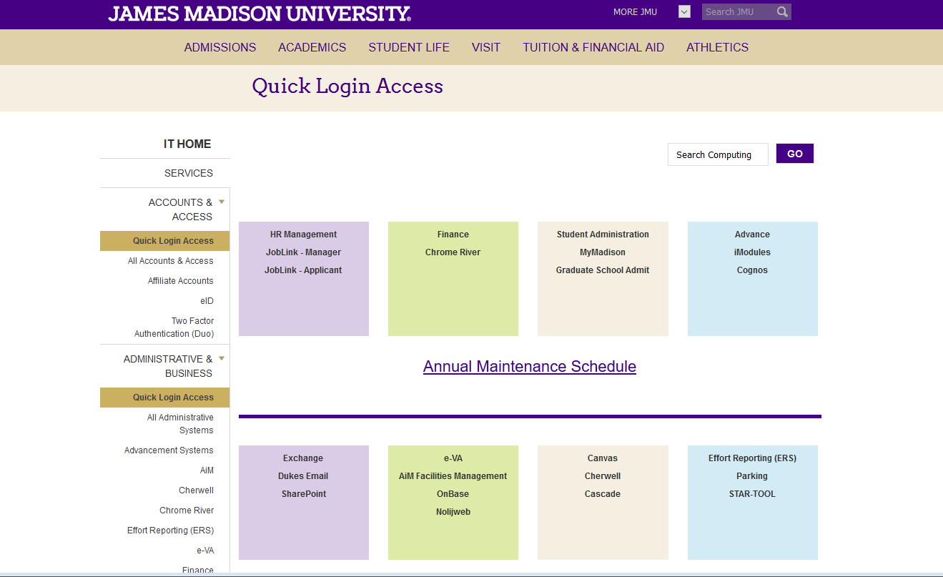

Signature Authority - Budget
The Budget Workflow System is powered by Signature Authority.

A complete list of Signature Authority for departments and individuals, can be reviewed online: www.jmu.edu/financeoffice/signature.shtml

Signature Authority - Budget or “budget authority” is denoted by a “Y” in the Budget column.
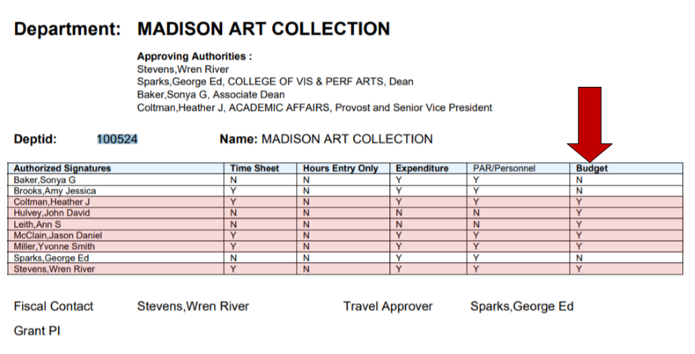

The Budget Workflow system

The Electronic Workflow

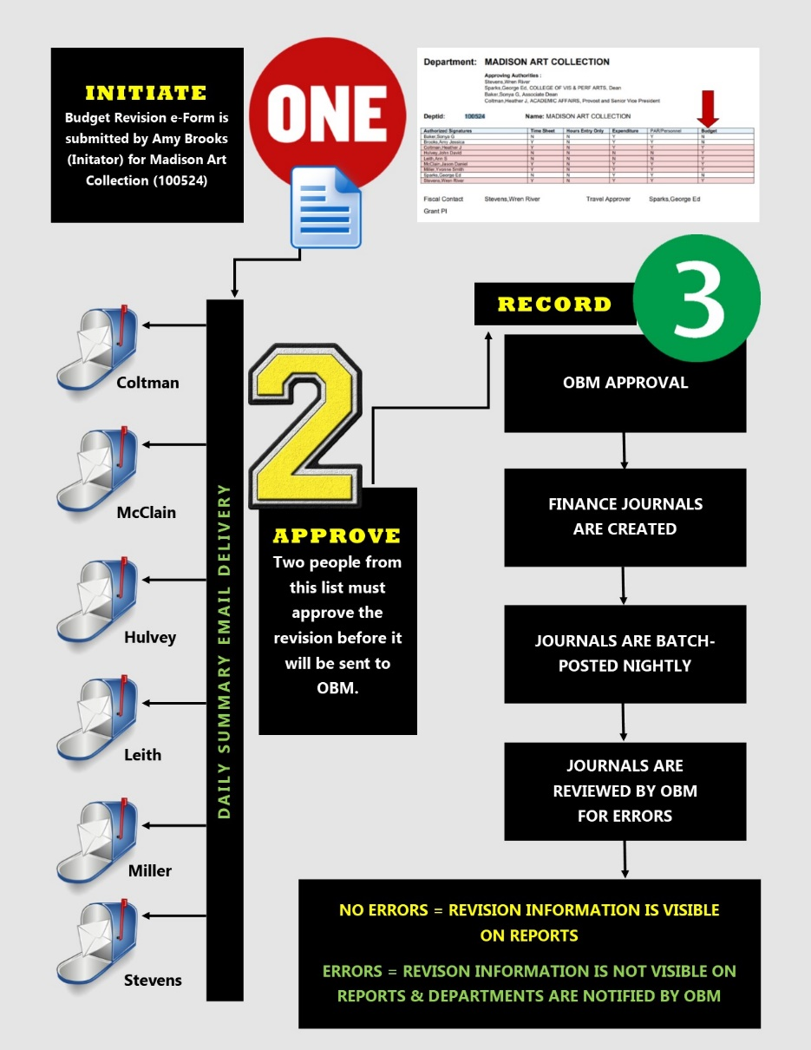
- Initiate
Anyone with access to PeopleSoft Finance with Budget Workflow System can initiate a revision.

- Approve
Approval signatures are determined by the Signature Authority - Budget of the department “losing” budget and are gathered electronically.

All revisions must have two electronic signatures (with the exception of departments within Academic Affairs, which, per AA internal policy, requires three).

One signature (or two for AA) is provided by the department, college, unit, or division and the second is provided by OBM at the final approval.

- Record
OBM is the final approver for all revisions. These approved revisions will be batch-posted in automatic nightly accounting processes. The next morning, posted journals are reviewed by OBM. Those without errors will be available to view on departmental financial reports. Those with errors will need to be corrected before a final post is allowed.

Workflow Restrictions

If the Signature Authority – Budget lists more than one person as a Budget Authority, it is up to the department, college, unit, or division internally to determine who will approve revisions. The system allows the flexibility of a strict approval flow or a more lenient one. Every person who has a Y under budget will receive an email alerting them of the Budget Revision.

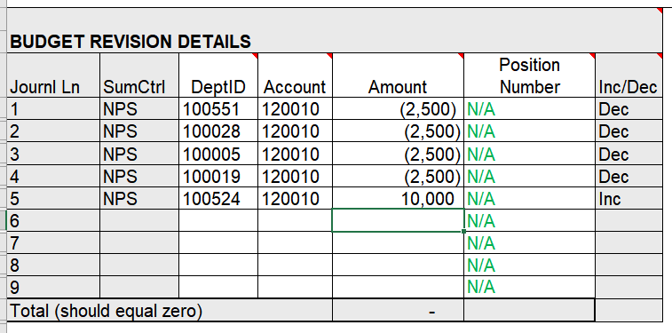
If a revision contains more than one department “losing” budget, the system will search the Signature Authority - Budget for the person or persons who have authority over ALL listed departments. If there isn’t one, the user will receive an error message and the revision cannot be submitted.

In this example, the system will search for an authority over 100551, 100028, 100005, and 100019. In this specific case, the dean and the associate dean fit that condition.

Accessing / Viewing

Initiators can only access/view revisions they have entered.

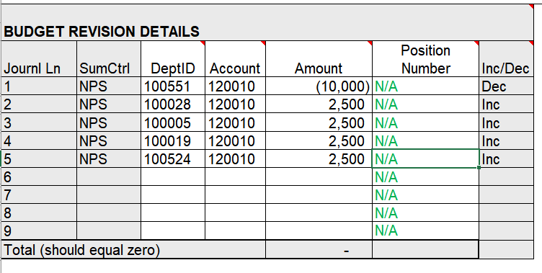
Approvers can access/view any revisions containing departments for which they have Signature Authority - Budget.
In this example, the Initiator will be able to access and view the full revision. In addition, the individuals with Signature Authority – Budget for 100551, 100028, 100005, 100019, 100524 will be able to access and view this entire revision.

Note: If an Initiator of the revision does not want 100524 to be aware of funds transferred to 100028, then they must do separate revisions.

Revisions can be accessed and/or viewed any time after the Initiator submits.

Revision restrictions

Budget revisions must be in whole dollar amounts. A budget revision for $10 is allowed but not $10.50

Revisions are limited to 50 rows.

The system will uphold all of the policies and procedures that were in place for paper forms; i.e. no transfers between E &G to Aux, no transfers from full-time personal service to NPS, budget revisions must net zero, etc. In some cases, the Initiator will be prompted with a message and in other cases, the revision will not be allowed to be submitted at all.

The system will prompt the Initiator to calculate benefits for all full-time salaried positions, including medical insurance. Benefits are required for all full-time salaried positions. Position numbers are required as well.

Notifications

A daily summary email will be distributed to all Approvers. The email will contain the revision number, the Initiator name, and a brief summary.

An email will be distributed to Initiators who have submitted a revision that has been denied. The email will contain a reason for denial.

The ability to notify of submitted revisions is available via a link within the electronic revision form. Only transaction number and description will be visible within the email and recipients will have to log into the system to see the full details. Signature Authority rules apply.

Note: Signature Authority-Budget rules will still apply. E-mail recipients can access/view only revisions they have entered (if they are an Initiator) and Approvers can access/view only revisions containing departments for which they have budget authority.

Layout
- Revision type: denotes the type of revision; OBM uses this field for internal queries.
- Long description: used to describe the revision’s purpose; box will accommodate 250 characters; however, only 40 characters will be seen on detail finance reports.
- Transaction number: unique number assigned to revision
- Budget year: defaults to current budget year; close to the end of the current fiscal year (old year), OBM will allow users to access the next fiscal year (new year); after approvals are collected, these revisions will be stored in the budget workflow until finance opens the new year within the PeopleSoft system; at this time, stored new year revisions will be automatically posted with the nightly batch.
- Budget exception flag: initiators will click this box only if their department has received an email from OBM regarding budget errors.
- Permanent flag: initiators will click this box if they are entering a revision for budget changes they wish to be permanent; permanent revisions change the current fiscal year and future fiscal years; permanent revisions are denoted on finance reports by a “p”.
- Department description: will automatically populate when the initiator enters a department ID
- Account description: automatically populates when the initiator enters an account number.
- Email link - allows Initiators to send a notification(s) of the revision to another JMU employee(s). Email(s) must utilize an @jmu.edu domain and all rules of Signature Authority – Budget apply. Feature must be utilized before the revision is submitted (after clicking save, before clicking submit).
- Attachments: most files (pdf, excel, jpeg) are supported; attachments will remain with the revision attachments can be added at any stage and will remain with the revision within the system; one attachment per revision.
- Clear : button will clear all information and rows on the current revision
- Duplicate: button will duplicate all information on the revision and use it to create a new revisions; all of the information in the header, as well as the line amounts will be able to be edited with new figures. You will not be able to edit the department of the account code.
- Calculate benefits - initiator will be able to click this button to automatically calculate salary benefits based on the salary account code used. Benefit rates will be maintained in the system by OBM. Correct benefit rates will be added to new fiscal years.
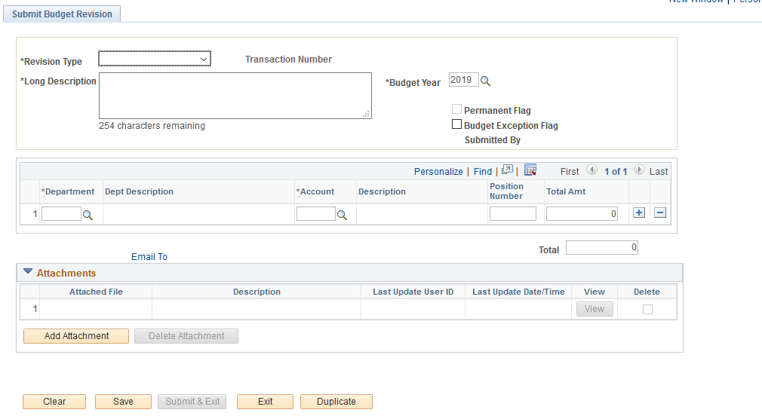
4
10
11
12
9
8
7
5
6
3
2
1

Submit a revision for an expense transfer or NPS recovery
JMU Budgets Tile>Submit Budget Revision

To enter a budget revision, the Initiator will need to Add a New Value.

- Click Add.
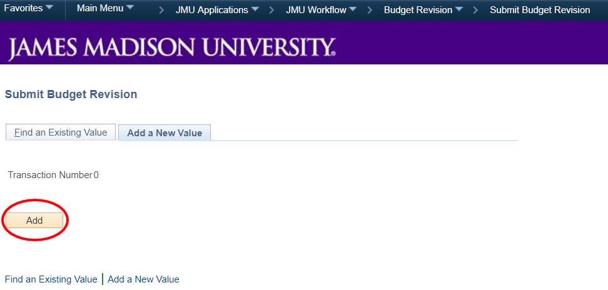

- Select revision type.

Revision Types

Includes FT PS: The revision includes a full-time personal service transfer; do not use if using any wage or part-time account codes. Initiator will be prompted to enter a position number for this revision and to calculate benefits.

Other Funds Transfer: The revision does not fall into the other categories.

Record Recoveries: The revision includes any recovery account codes.

Revenue Adjustment: The revision includes any revenue account codes (revenue account codes begin with 0).

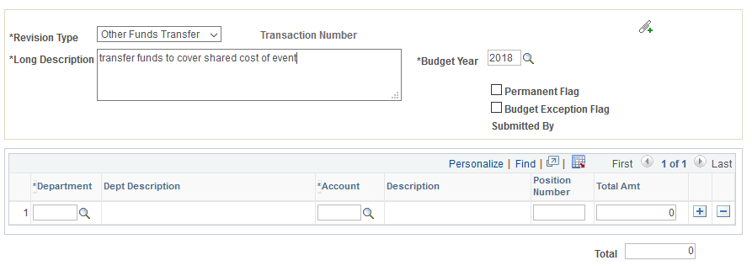
- Enter long description and budget year (defaulted to current fiscal year).

- Add an attachment and check the flags if applicable.
Flags

Permanent Flag: The revision will revise the current budget AND revise all future budgets. Most permanent revisions to expense will be allowed. Any permanent changes to revenues, salaries, and/or wages will be reviewed by OBM.

Budget Exception Flag: The department has been notified via email of a departmental budget error. Revisions with this flag will be given priority status. DO NOT use this flag if an email has not been received.

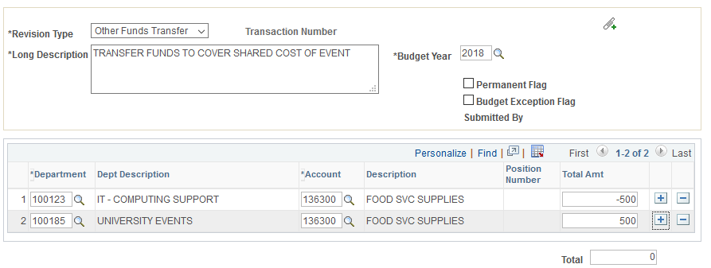
5. Enter the department ID and the account code from the budget where funds will be lost and the amount. Enter negative amount(s) for departments that are “losing” budget. Upon submission, approval will be needed by an approver with signature authority for all departments losing budget.)
6. Add an additional line(s) (use the plus sign) and enter the department and account code that will receive the budget transfer. Amounts that are withdrawn and added should always net to zero.
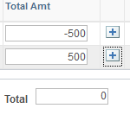
7. Select Save after the revision is completed.

- Select Submit & Exit. Another option is to exit without submitting in order to submit at a later date.

Note: Revisions that are saved can still be edited. Revisions that are submitted cannot.

Summary steps for NPS revision.
- Click Add to create a new revision.
- Select the revision type.
- Enter the description and select flags if needed.
- Enter the department and account code “losing” budget.
- Enter amount.
- Add an additional line(s).
- Enter the department and account code “gaining” budget.
- Enter the amount.
- Ensure the revisions nets to zero.
- Save.
- Submit & Exit.

You try it!
Exercise 1
Your department has spent money out of the Office Incidentals account but your department did not have any money in that account. Your supervisor asks you to do a revision to “zero that account out so that the reports look cleaner.” You decide to take the money from office supplies to cover the charges to office incidentals.

Revision Type: Other Funds Transfer
Your Department number: 100123
Account losing money: 131200
Account getting money: 226300
Amount to transfer: $150

Submit a revision for personal service transfer (PS)
JMU Budgets Tile>Submit Budget Revision

To enter a budget revision, the Initiator will need to Add a New Value.

- Click Add.

- Select revision type - Includes FT PS.

Revision Types

Includes FT PS: The revision includes a full-time personal service transfer; do not use if using any wage or part-time account codes. Initiator will be prompted to enter a position number for this revision and to calculate benefits.

Other Funds Transfer: The revision does not fall into the other categories.

Record Recoveries: The revision includes any recovery account codes.

Revenue Adjustment: The revision includes any revenue account codes (revenue account codes begin with 0).

- Enter long description and budget year (defaulted to current fiscal year).
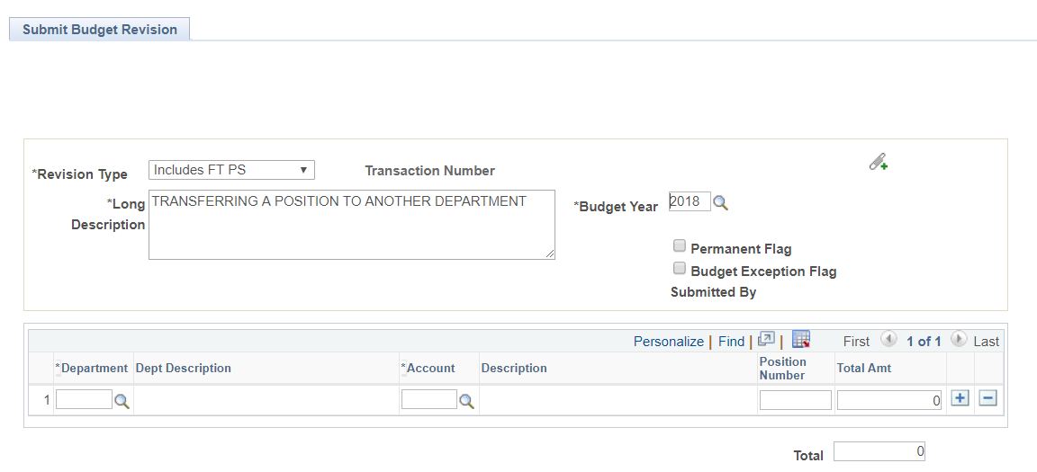
- Add an attachment and check the flags if applicable.
Flags

Permanent Flag: The revision will revise the current budget AND revise all future budgets. Most permanent revisions to expense will be allowed. Any permanent changes to revenues, salaries, and/or wages will be reviewed by OBM.

Budget Exception Flag: The department has been notified via email of a departmental budget error. Revisions with this flag will be given priority status. DO NOT use this flag if the email has not been received.

- Enter the department and the account code from which salary budget will be lost and the amount.

- Add the position number. Since the account code is a salary code, the position number box will be accessible and the system will prompt the user to enter a position number. If the user doesn’t know the position number, contact OBM or the department’s HR representative. The revision will not post without a position number. Revisions are not only used to generate journal numbers, but are also used as reference in OBM. Please do not guess the position number or use a fake number.
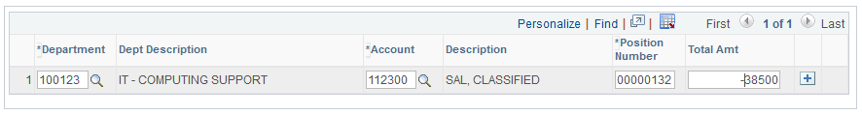
Note: Ensure that the correct position number is entered. The system does not check this upon submission but the revision will get denied if the number is incorrect upon submission.


- Click calculate benefits.

Note: The system will automatically calculate all the necessary fringe benefits according to the salary code except medical benefits. Medical insurance expense cannot be calculated by the system and must be calculated and entered by the Initiator.


- If the medical insurance calculation is unknown, select the Medical Insurance Calculation link to visit the worksheet on the OBM website.

- Add an amount for medical insurance (this should be a negative number).

- Add an additional line and enter the department and account code that will receive the salary budget. Enter the position number and the amount (this should be a positive number).
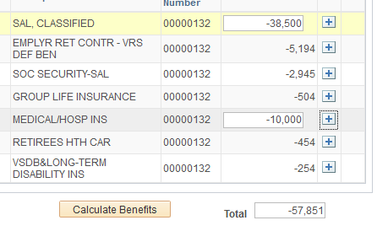
- Click calculate benefits.

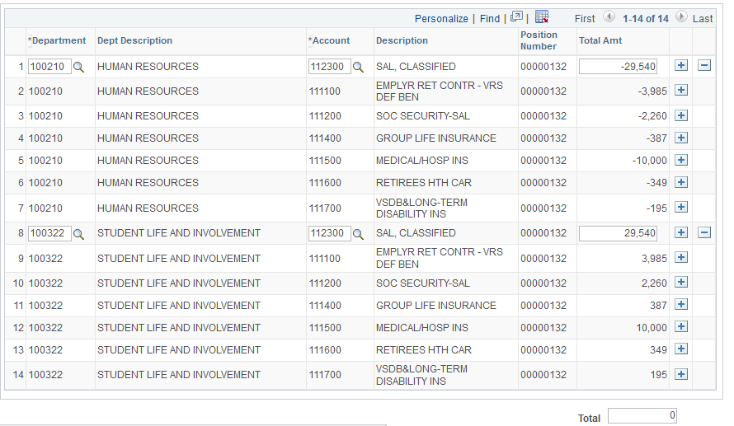
- Enter the amount for health insurance (this number should be positive and equal the amount subtracted previously).

Select Save after the revision is completed.

- Select Submit & Exit. Another option is to exit without submitting in order to submit at a later date.

Note: Once a revision has been submitted it cannot be edited or deleted.

Additional Info on PS revisions
Budget revisions that include full-time personal services increases, adjustments, additions or abolishment’s for the CURRENT fiscal year:
- Complete a TEMPORARY budget revision and do not check the PERMENANT check box. This will revise current year budgets only.

Budget revisions that include full-time personal services increases, adjustments, additions or abolishment’s for FUTURE fiscal years can be addressed via several options depending on the timing of the change:
- PERMANENT full-time personal services budget changes may be included in that fiscal year’s Budget Development Process whereby OBM will make the change on the department’s behalf with NO Budget Revision required.
- PERMENENT budget revisions may be submitted by choosing the next fiscal year (if open) and checking the PERMENANT check box. This will be included in next fiscal year’s budgets when the Budget Development Process for that fiscal year has not yet been completed or as a new year revised budget if that year’s Budget Development has been completed.
- If no future fiscal year is open, and the change was not submitted as part of that year’s Budget Development Process, please contact the Office of Budget Management for guidance.

Please note that in many cases, a current year temporary budget revision AND a permanent future year budget revision will be necessary.

Contact David Rourke (roukede@jmu.edu), Jeff Souder (souderjl@jmu.edu) or any OBM staff for assistance or questions
Summary steps for PS revision.
- Click Add to create a new revision.
- Select revision type – Includes FT PS
- Enter description and select flags if needed.
- Enter the department and account code losing salary budget.
- Enter the amount.
- Select calculate benefits.
- Calculate and enter the health insurance value.
- Add an additional line.
- Enter the department and account code gaining the salary budget.
- Enter the amount.
- Enter health insurance value used in Step 7.
- Ensure that the revision nets to zero.
- Save.
- Submit and Exit.

You try it!
Exercise 2
A position (006532) that has previously been paid out of department 100125 is being moved into your department 100123. This will be not be a permanent change for this position that includes benefits. You are moving this position with 9 months left in the fiscal year so you will need to use the link to discover the correct amount for health insurance.

Revision Type: Includes FT PS
Your Department number: 100123
Account code: 112300
Position number: 006532
Salary transfer: 29,550
Medical Insurance: 9 month range on chart

View an Existing Budget Revision
JMU Budgets Tile>Submit Budget Revision>Find an Existing Value

- A revision can be viewed by Approvers after the Initiator has submitted.
- Saved (without submitting) revisions can only be viewed by the Initiator.
- An Initiator will only have access to view budget revision forms that they have submitted.
- Approvers with Signature Authority - Budget can view all revisions of departments for which they have authority.

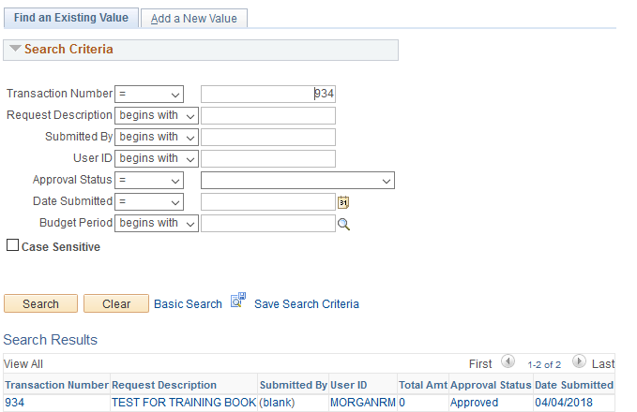
- Click Find An Existing Value.

Note: Users can search by transaction number, description, user ID of the Initiator, approval status, or date submitted. Selecting only SEARCH, with no criteria, will reveal all revisions the User has the budget authority to view.

Within the revision, all people who have viewed the revisions, regardless of whether or not action was taken, are recorded in the Viewed Box. This feature allows, for example, Approvers to confirm that other Approvers have viewed the revision before they issue a final departmental approval.
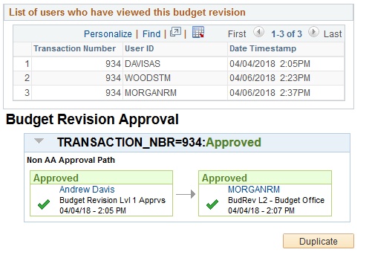

This is the Approval Flow of a fully approved revision.

This is the Approval Flow of a revision in progress.
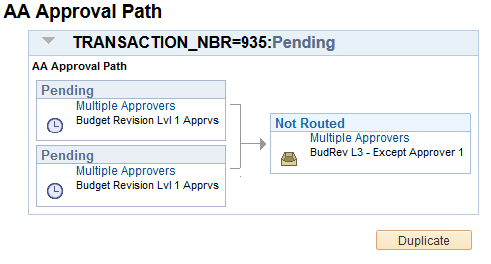

Approving a budget revision

Approve a revision in MyMadison.
Approvers will receive a daily summary email indicating that they have a pending revision(s) to approve.

Approvers will approve via MyMadison; accessible on-campus or off.

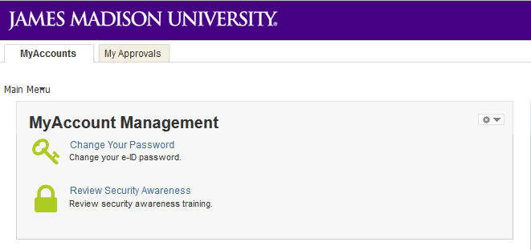
- Login to MyMadison and select My Approvals.

- Select Finance Workflow Approval Center.
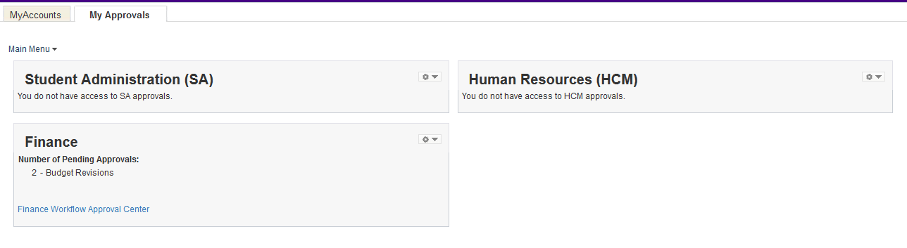
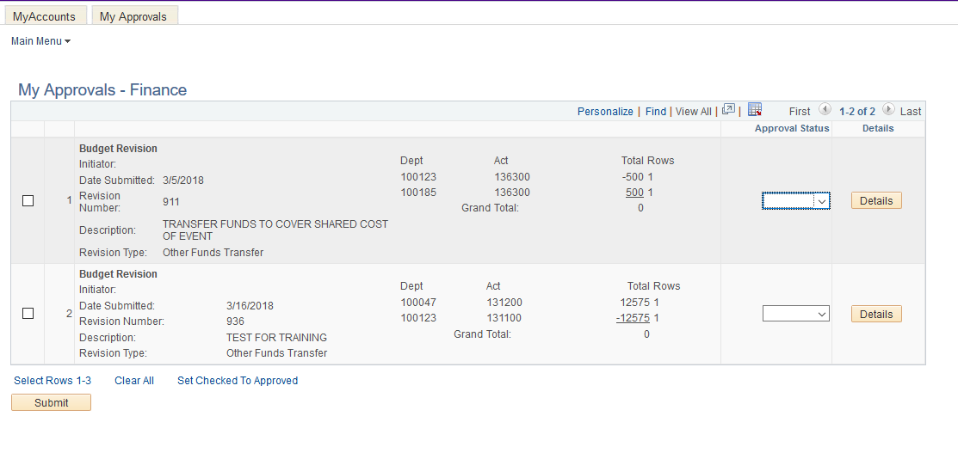
- All transactions awaiting an Approver’s attention will be viewable.

- Click details to view additional information about the transaction.

- Select the box next to a revision and select approve or denied. If denied is selected, a reason box will appear. Enter denial information.

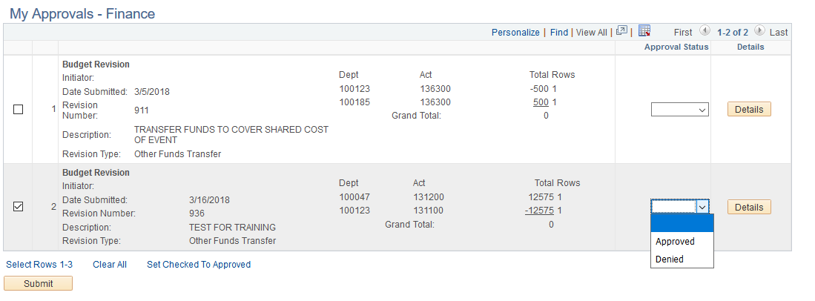
- Select submit.

Note: Revisions are not approved unless the box next to the revision is checked AND either Approve or Denied is selected. Use the functions above the Submit box to select and approve multiple revisions. Only three revisions will be visible at a time. Use the navigation tools to view all revisions.

Reminder: Transactions that transfer budget from a department in Academic Affairs will require two departmental approvers.
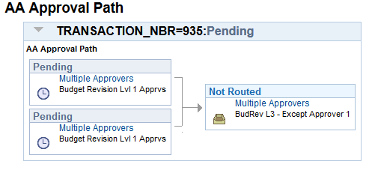

Denying a transaction

If an Approver wishes to deny a transaction, the system will require a denial reason or an explanation to why the transaction is being denied.
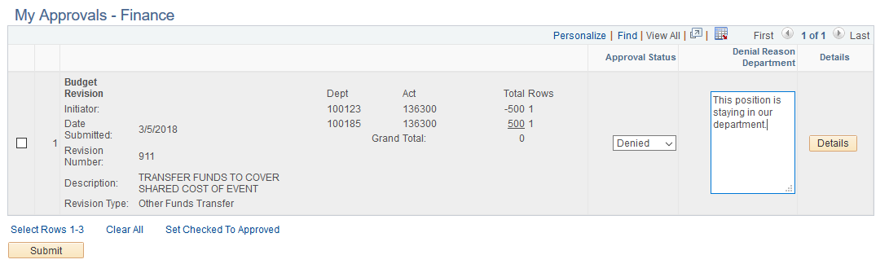

The Initiator will receive an email that the revision was denied and the reason why it was denied. Denied revisions will have to be re-entered with the correct information as initiators cannot edit revisions after submission.

Approve a budget revision in Finance System

JMU Budgets Tile>Submit Budget Revision>Find an Existing Value

Approvers will only see revisions that they have Signature Authority - Budget to approve or revisions that they have initiated.

Approving via PS Finance requires Peoplesoft Finance with Budget Workflow System access. If the Approver does not have finance access, approvals must be completed via MyMadison.
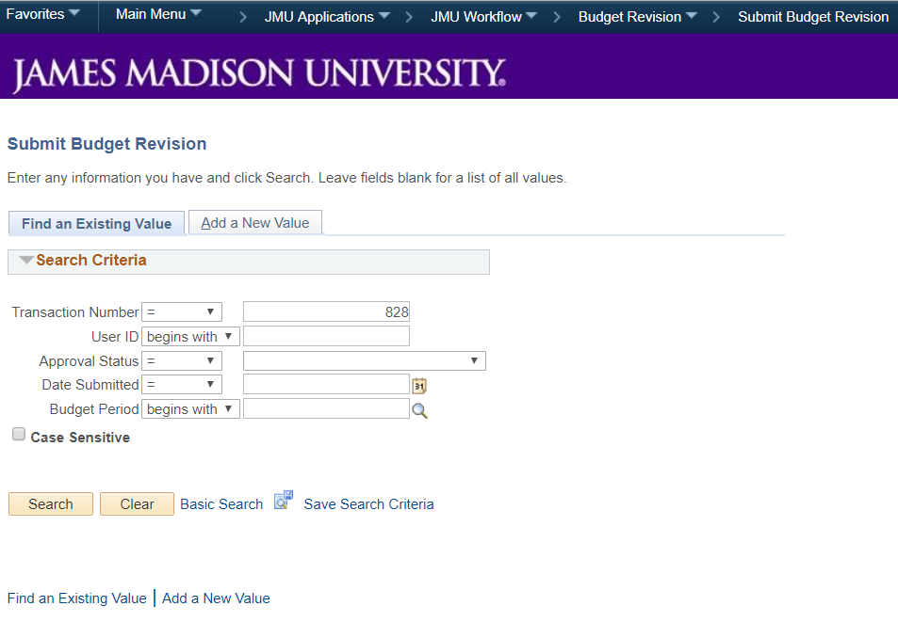
- Search for the budget revision (enter the transaction number for a specific revision or leave fields blank and click search to view all revisions in the queue) and click the link to open it.
- At the bottom of the screen select approve or deny.
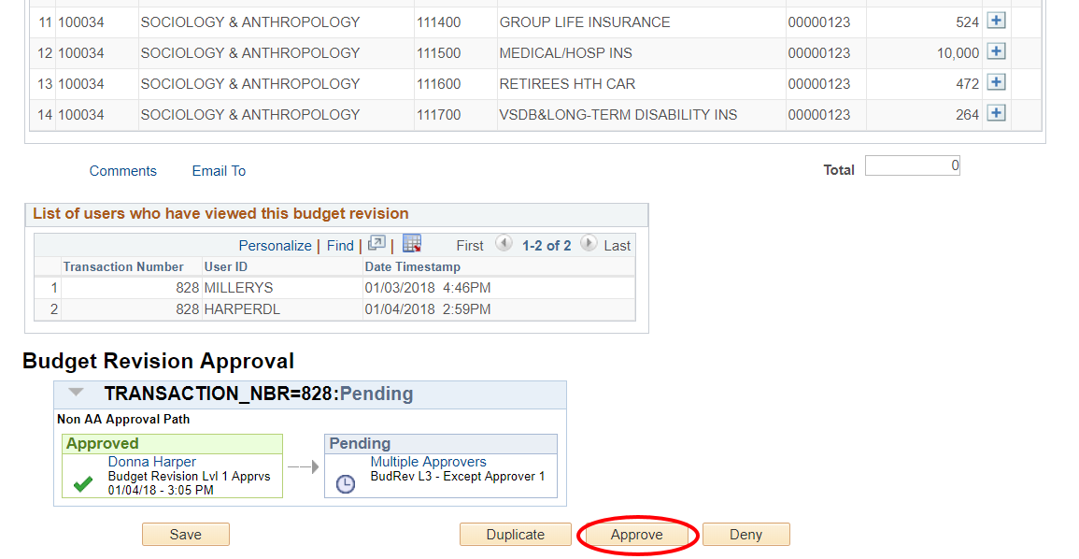

Duplicate a Budget Revision
JMU Budgets Tile>Submit Budget Revision>Find an Existing Value

If an Initiator needs to create a similar revision to one that was created in the past, there is an option to duplicate the original and change the details as needed.

- Search for the budget revision (enter the transaction number for a specific revision or leave fields blank and click search to view all revisions in the queue) and click the link to open it.

- Select Duplicate.
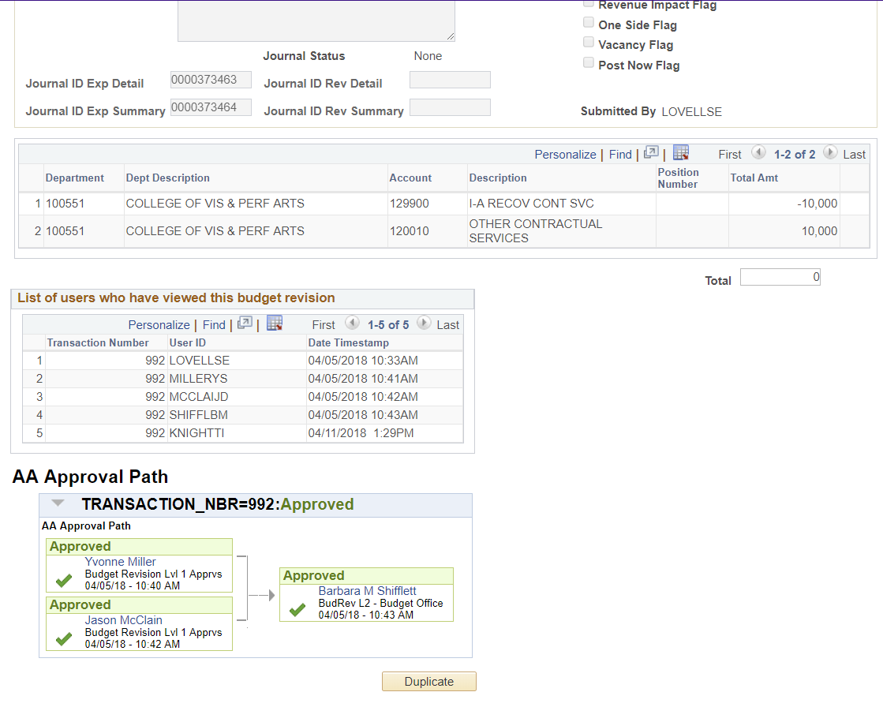

The new revision will open and all values will be duplicated from the last revision. These values include: revision type, description, budget year, permanent flag, budget exception flag, and all line details. Lines can be added or deleted as well.

- Select Save after the revision is complete.

- Select Submit & Exit. Another option is to exit without submitting in order to submit at a later date.

Note: Once a revision has been submitted it cannot be edited or deleted.

Budget Revisions in Financial Reports
Once a budget revision has gone through its final approval and the nightly posting has occurred, the revision will be visible on departmental financial reports.

Monthly Detail Report for department losing budget:

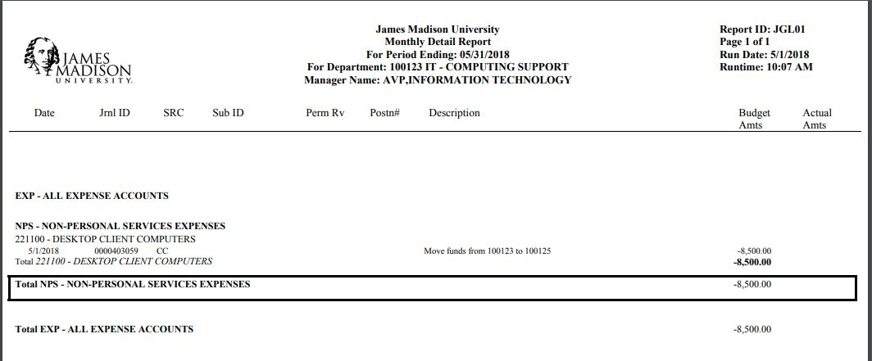
Summary Financial Report for department losing budget:

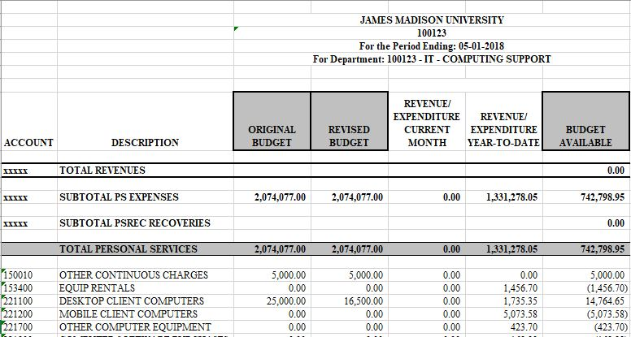

Monthly Detail Report of department receiving budget:

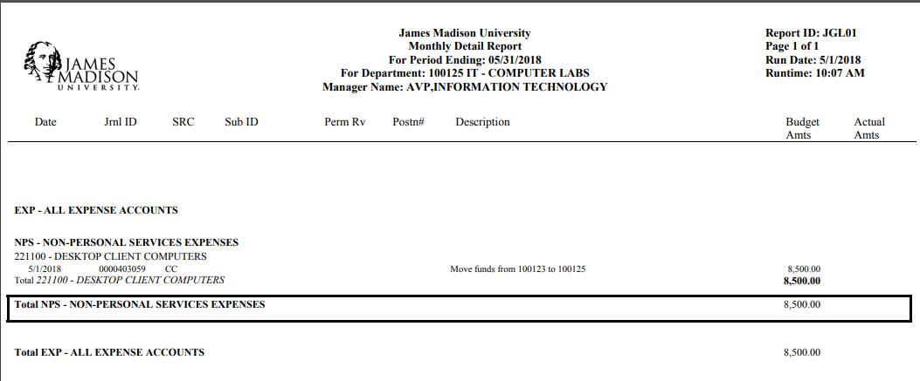
Summary Financial Report for department receiving budget:

