Student Affairs Learning Improvement Application
Please complete the application below to apply for the learning improvement initiative with Student Affairs Support Services (SASS) within the Center for Assessment and Research Studies (CARS). This initiative is a partnership between SASS and the Division of Student Affairs to focus on the improvement of student learning and development.
At Madison, we value improvement of learning and development, which can be accomplished by well-thought-out programming and assessment. In turn, a complete and coherent application is a first step to making such initiatives successful. Applications are due May 15th.
There are two options for when programs may begin the project: Summer or Fall. In the application, you will be asked to indicate whether you plan to begin the project in the Summer or Fall. Please select a starting date that best aligns with your office schedule. Selected programs will be notified by May 31st.
Please select one starting date: _X__ Summer
Fall Semester
Although several application questions will ask you to describe previous assessment results and previous improvement efforts, programs will not be selected based on the number of years they have conducted assessment or demonstrated improvement. Rather, programs will be selected based on readiness and commitment to a long-term improvement process. Up to 2 programs will be selected per year based on their readiness and commitment.
Should any questions arise while completing this application, you may contact SASS (SASS@jmu.edu).
Once completed, submit your application to the co-chairs (Sarah Sunde, sundesa@jmu.edu; Kathleen Campbell, campbekl@jmu.edu) of the Student Affairs Assessment Advisory Council for review.
- Program Overview
In this section, please provide general information about your program. Responses are meant to be short, as you will have opportunities to provide more detail in sections below.
- Name of applicant’s office:
Office of Student Success Services
- Name of program of interest:
Strategies for Academic Success (SAS) Program
- Purpose of the program (1 paragraph max):
The purpose of the Strategies for Academic Success (SAS) Program is to help students who have faced academic difficulty employ strategies and skills needed to be successful in college. The (non-cognitive) skills learned in this program are essential for academic success at JMU, but also support the mission of JMU by supporting the development of students into educated and enlightened citizens who will lead productive and meaningful lives.
- Number of students who complete the program:
80 – 100 students per year who are on academic probation and mandated to attend
- Number of staff members who facilitate the program:
1 Graduate Student Coordinator & 8 Peer Instructors (graduate/undergraduate students)
- Point person/primary overseer of the program:
Aaren Bare, Strategies for Academic Success (SAS) Program Coordinator
- Current Assessment of Student Learning Outcomes
The goal of this section is to ensure your office is well acquainted with the assessment process. We find that offices that have carefully thought about programming and assessment are in a better position to make improvements. In the space below, please provide a brief summary of the program of interest. In your summary, please include 1) your student learning and development outcomes; 2) a general/broad description of the programming in which students are provided the opportunity to learn or develop; and 3) the procedures used to assess whether the desired outcomes are actually being met. Careful consideration of these questions is crucial to the success of a learning improvement project. Please address 1, 2, and 3 within 1 to 2 pages maximum:
- STUDENT LEARNING & DEVELOPMENT OUTCOMES
SAS Program Broad Goals
The broad goals of this program are to:
- help students who have faced academic difficulty employ the academic strategies and personal skills that are needed to be successful at JMU.
- increase students’ cumulative GPA to a minimum of 2.0 by the end of the academic school year.
- graduate participants from JMU.
Student Learning Outcomes
As a result of completing the SAS program, students will:
Academic Skills
- be able to apply at least 1 organizational strategy that promotes the ability to organize academic assignments and manage time effectively.
- achieve a satisfactory score* on the Organization subscale of SuccessNavigator.
- be able to list 3 general class expectations that promote academic success.
- be able to list 2 resources that clarify specific expectations for each course.
- achieve a satisfactory score* on the Meeting Class Expectations subscale of SuccessNavigator.
*SAS program recognizes a satisfactory score as a “moderate” rating or higher on ETS SuccessNavigator assessment.
Commitment
- be able to identify their personal motivations for pursuing a college education.
- be able to develop 3 academic SMART goals to help them succeed.
- achieve a satisfactory score* on the Commitment to College Goals subscale of SuccessNavigator.
- be able to identify 2 sources of institutional pride they hold for JMU.
- achieve a satisfactory score* on the Institutional Commitment subscale of SuccessNavigator.
*SAS program recognizes a satisfactory score as a “moderate” rating or higher on ETS SuccessNavigator assessment.
Self-Management
- be able to identify 2 stress management techniques to help minimize the effects of stress.
- achieve a satisfactory score* on the Sensitivity to Stress subscale of SuccessNavigator.
- achieve a satisfactory score* on the Academic Self-Efficacy subscale of SuccessNavigator.
- be able to identify 3 symptoms of test anxiety and list 3 strategies to minimize its effects.
- achieve a satisfactory score* on the Test Anxiety subscale of SuccessNavigator.
*SAS program recognizes a satisfactory score as a “moderate” rating or higher on ETS SuccessNavigator assessment.
Social Support
- be able to articulate 3 strategies that support effective group collaboration.
- achieve a satisfactory score* on the Connectedness subscale of SuccessNavigator.
- be able to list 2 new campus resources they were unaware of prior to the SAS program.
- be able to demonstrate the ability to find new institutional support resources.
- achieve a satisfactory score* on the Institutional Support subscale of SuccessNavigator.
- be able to describe 2 personal barriers to academic success and how those barriers can be addressed by identifying and using institutional support resources.
*SAS program recognizes a satisfactory score as a “moderate” rating or higher on ETS SuccessNavigator assessment.
2) A GENERAL/BROAD DESCRIPTION OF THE PROGRAMMING
The 8-week SAS program created by JMU’s Office of Student Success Services provides support for students who have been academically suspended or placed on academic probation. Currently taught in the fall, SAS facilitators teach academic and personal skills/strategies that are needed to be a successful student at JMU. Topics include time management, campus resources, test-taking strategies, positive professor relationships, public speaking, goal setting, academic motivation, collaborative group skills, study strategies, and strengths identification (i.e., StrengthsFinder assessment).
There are 4 SAS class sections per fall, usually serving 15-25 students per section. Each of the 4 sections meets for 1 hour and 15 minutes per week and is taught by two undergraduate and/or graduate students (i.e., Peer Instructors) who co-facilitate the class. The Peer Instructors review a semi-detailed lesson plan each week, that was designed by the SAS program coordinator from the previous year that covers one of the topics above. Thus, the person who created the lesson plans is not implementing the program. After reviewing lesson plans, Peer Instructors ask any questions to the current SAS program coordinator (who did not create the program). Peer Instructors can then modify activities slightly (with approval of current program coordinator) if they feel it will better accommodate student needs.
In the past, the lesson plans have not been explicitly tied to student learning or development outcomes. That is, it was unclear what learning, attitudes, or behavior these activities were supposed to impact (i.e., outcomes were not stated) and why these activities should result in these outcomes (i.e., program logic or theory was not stated). The student learning outcomes stated above are newly developed for this application. Moreover, as discussed below, assessment of the program was deficient due to lack of explicitly stated outcomes and intentional programming.
Students in the program receive a Satisfactory Compliance (attends/participates in every class and completes all assignments) or Unsatisfactory Compliance (any unexcused absences or does not complete assignments/participate in the course) score. If students receive an Unsatisfactory score, their college is made aware and it impacts whether they can continue enrollment at JMU. No feedback is provided to students or faculty regarding skill development over the 8-week period. Students may have the same strategies upon entering and exiting the program.
Our goal via this initiative is to improve the SAS program in the following ways:
- Establish clear student learning outcomes (drafts of outcomes are listed above as a start).
- Develop a program that is grounded in theory (draft is below, but needs attention).
- Map our theory-based program to our learning outcomes (draft is below, but needs attention).
- Select or create measures of student learning.
- Increase the fidelity of implementation across facilitators.
- Assess the extent to which the programming is effective (i.e., outcomes are achieved).
- Use data to improve program effectiveness.
The SAS program will remain an 8-week course taught each fall to students on academic probation and suspension but will change in the following ways: 1) extend to 1 hour and 30 minutes per week to better implement the program and 2) accept up to 20 students who voluntarily enroll in the program to build their skills.
The SAS programming is based on resources and research provided by ETS and their SuccessNavigator program. ETS SuccessNavigator is based on research regarding how to increase student retention and academic success. The research identified 4 general strategies, attitudes, and skills linked to student success and retention, then articulated more specific strategies/attitudes/skills that clarify the needs of each of the 4 general categories (Figure 1).
- Academic Skills: Organization and Meeting Class Expectations
- Commitment: Commitment to College Goals and Institutional Commitment
- Self-Management: Sensitivity to Stress, Academic Self-Efficacy, and Text Anxiety
- Social Support: Connectedness, Institutional Support, and Barriers to Success.
The SAS program will be intentionally built and linked to use four strategies, attitudes, and skills. Recall, we drafted 21 specific outcomes (above) associated with the agreed upon desires of what students should know, think, and do as a result of the SAS program. We mapped each of the 21 outcomes to the 4 general outcomes associated with SuccessNavigator (see Table 1). We realize that additional outcomes may be developed during the learning improvement initiative.
We also provide an initial mapping of each of these outcomes to our program via program logic visuals (see Figures 2 and 3). Figure 2 provides the mapping/logic for the full program. Figure 3 focuses on the outcomes for this learning improvement initiative.
3) PROCEDURES USED TO ASSESS WHETHER DESIRED OUTCOMES ARE BEING MET Current Assessment
Historically, the program has not had a strong assessment process. The following text outlines assessment processes used in the past.
- We did not administer pretests to students to obtain a baseline of skills to inform programming.
- We did use midterm and post-program assessments to measure what students had learned in the programming. However, these take-home and open-book/open-note assessments simply required students to recite information or reflect on their experiences in the program. Moreover, assessments were not always linked to programming.
  - For example, we might provide a visual depiction of a brainstorming strategy and ask, “What type of brainstorming strategy does this image represent?” This did not assess whether it was a strategy students intended to use, if they understood the value of the strategy, or if they were actually able to use the strategy.
  - As another example, students must score an 80% or above to pass both the midterm and post-program assessments. If they do not pass with an 80%, they are given a writing prompt as an extra assignment to gain the extra points needed. However, there are no rubrics to grade the short answer/essay questions on the midterm/post- program assessments or the written assignment. The person grading the assessment determines whether answers are acceptable or not.
We also engaged in program satisfaction assessment. Students reported their satisfaction with the program and Peer Instructors. In this satisfaction assessment, students used a Likert-type response scale to rate lessons from “Most Helpful” to “Least Helpful.” They also answered questions designed to provide self-reported evidence of learning such as:
- What did you learn from the SAS program?
- Have your study habits changed?
- What new skills have you gained through the SAS program?
- Do you believe your academic performance this semester has improved?
Students also suggested program changes and rated their Peer Instructors on Planning, Adaptability, Preparedness, Engagement, Presentation Skills, and Positive Attitude.
We used these satisfaction data to create a report, however, students did not appear to take the satisfaction assessment seriously, results were widely varied, and we did not feel the data was useful to make program improvements.
Future Assessment
As the program continues to develop learning outcomes and theory-based programming, we need consultation regarding identifying and/or creating reliable and valid measures of our learning outcomes. Given many of the student learning outcomes align with ETS SuccessNavigator’s resources, we want to use the ETS SuccessNavigator assessment as a pretest when students begin the program (prior to their first class) and as a posttest to evaluate if students change as a function of the program.
The pre-assessment, which includes scores on the 10 general outcomes above, will:
- Provide a personal report to the student with their scores to identify areas of academic strength and weakness, an advisor report to the Graduate Assistant (GA), and a synthesized report with the averages of scores from all students participating in the SAS program.
- Minimize our students’ need to self-assess the source of their academic difficulties and allow us to see where they specifically need support.
- Give the GA and instructors the ability to see what areas of the program need to be emphasized in the course.
Students will also complete the SuccessNavigator assessment after completing the SAS program to assess if they improved with respect to the 10 general outcomes. However, we do not know if it would be most helpful to have the students complete this assessment directly after the program ends or at the end of the fall semester. We need consultation from SASS to help us make this decision.
Moreover, although the SuccessNavigator assessment provides high-quality data regarding many of the student learning outcomes, several of the 21 specific outcomes (i.e., 1, 3, 4, 6, 7, 9, 11, 14, 16, 18, 19, 21) are not assessed using SuccessNavigator. We would like to work with SASS to create measures associated with these outcomes (see Table 1 for mapping of the outcomes with SuccessNavigator, which showcases which outcomes are not currently associated with measures).
We would like to incorporate a midterm assessment during the fourth week of programming to assess the learning outcomes we have covered in our program thus far. Due to the nature of our class, these assessments will have to be completed outside of class. However, we would like to create an assessment that students are not able to simply list the answers from their textbooks. We are not sure how to accomplish this and would like SASS consultation.
At the end of the program, students will complete another assessment, similar to the midterm assessment, to assess their learning with respect to outcomes covered after the midterm and to re-assess information covered during first half of the semester. This final assessment will be cumulative. It will be the same format as the midterm. We need consultation regarding its creation.
- Focus of Partnership with SASS
You may want to improve learning/development related to all outcomes. However, for this partnership, you will need to select 1 or 2 learning/development outcomes on which to focus. These outcomes should be sufficiently important to warrant the ample resources that will be devoted to improving all related programming and assessment activities.
The most crucial information you will provide in this section concerns the program theory that guides your program. In other words, how was your programming intentionally designed to achieve the student learning and development outcomes you’ve decided to focus on for this partnership? Programs that have not given this considerable thought will find it difficult to engage in a learning improvement initiative.
- Student learning/development outcome selected for improvement (1 or 2):
As explained above, the assessment of the SAS Program is just beginning with this initiative. Moreover, we have 21 newly drafted outcomes subsumed under 4 general outcomes (see Table 1). Although we would like to tackle the assessment of all of these outcomes, we realize we need to be focused. As such, we have chosen to focus on the following student learning outcome (SLO):
As a result of completing the SAS program, students will achieve a satisfactory score* on
the Academic Self-Efficacy subscale of SuccessNavigator. (SLO 13)
We lay out the importance of this outcome to our office and JMU, along with program theory/logic below.
With that said, we plan on reviewing the data for all 10 of the outcomes measured by SuccessNavigator, as we receive the full suite of outcome measures with the purchase of the assessment. But again, we will focus on a single outcome for this learning improvement initiative.
- Description of why these outcomes were selected for the learning improvement initiative. Why are these outcomes important to your department? (1-2 paragraphs):
The students we serve in the SAS Program have been mandated to participate in the program due to their academic struggles at JMU. The program is often the last chance students have to learn skills that will help them succeed as a JMU student before they are dismissed from college for not consistently meeting academic standards. These students often feel a sense of hopelessness in their ability to succeed, often communicating to program leaders that they do not see how they will be able to achieve the GPA they need to continue as a student. Thus, we want to create an environment that instills confidence in students’ ability to succeed academically (i.e., increase academic self-efficacy).
In addition, the self-efficacy learning outcome is the most heavily addressed outcome in our program, being (theoretically) mapped to 6 of 8 lessons. Thus, we felt the need to better understand how to increase students’ academic self-efficacy because of the prevalence of the programming mapped to this outcome. Also, although we have tools to teach techniques such as time management and test anxiety, we do not have any theoretical basis for how we should go about increasing academic self-efficacy in our struggling students (i.e., we need to spend protected time understanding self-efficacy).
- Description of why these outcomes are important to JMU (1 paragraph):
In order for students who have struggled academically to graduate from JMU, we must help them develop confidence in their ability to succeed academically. As they become more confident in their ability to succeed, they will become more emboldened to build new skills and engage in more challenging work, ultimately creating more engaged and enlightened citizens.
- Description of specific programming (curriculum, intervention, etc.) used to provide students with an opportunity to meet selected outcome(s) only. An objective-to- curriculum map should be included as part of description (may attach as appendix):
Prior to this year, the program has not been based on theory, but rather on what the program coordinator believes will help students succeed. Figures 2 and 3 illustrate the mapping of the newly created outcomes to the current programming.
- Describe how this programming is expected to result in the desired student learning/development outcome(s). In other words, please explain the logic behind why certain program features were chosen to achieve the selected outcomes. This is often referred to as program theory or logic. If you are unfamiliar with these terms, please watch this short introductory video before constructing your response (2 pages max). If you need support using program logic to develop curriculum/programming, please visit JMU’s Center for Faculty Innovation:
As we began to build an evidence-based program to influence students’ academic self-efficacy, we started with Albert Bandura’s theory of self-efficacy. (See Figure 3) Bandura defined selfefficacy as “the belief in one’s ability to influence events that effect one’s life and control over the way these events are experienced (Bandura, 1994). He believed self-efficacy could be influenced, developed, and as it increases can dramatically affect all facets of the human experience (Bandura, 1994). He articulated and tested 4 ways to build self-efficacy in general (this is not specific to students).
- Performance Outcomes (past experiences)
- Vicarious Experiences (modeling by others you see as similar to you)
- Verbal Persuasion (coaching and feedback)
- Physiological Feedback (emotional status)
Additionally, we consulted Brophy’s Motivating Students to Learn (Brophy, 2004, pg. 133), where he cites Schunk (1985) who lists specific practices to increase self-efficacy in students. These specific practices include:
- Cognitive modeling that includes verbalization of task strategies, the intention to persist despite problems, and confidence in achieving eventual success.
- Explicit training in strategies for accomplishing tasks.
- Performance feedback that points out correct operations, remedies errors, and reassures students that they are developing content mastery.
- Attributional feedback that emphasizes the successes being achieved and attributes these to the combination of sufficient ability and reasonable effort.
- Encouraging students to set goals prior to working on tasks (goals that are challenging but attainable, phrased in the terms of specific performance standards and oriented toward immediate short-term outcomes).
- Focusing feedback on how students’ current performance surpasses their prior performance rather than on how they compare with other students.
- Supplying rewards contingent on actual accomplishment and not just task participation.
To apply this empirically-supported theory to our program, we developed a variety of strategies throughout multiple lessons. The activities that we developed are mapped to the practices listed above and are numbered for the specific practice they are targeting (in parentheses).
- Team Spaghetti Tower activity. (1)
- Strengths-Based study strategies to verbalize ability to succeed. (1,2)
- Teaching students the SMART goals development technique to apply broadly to academics and individual tasks/assignments. An example of this in our programming is teaching them how to set goals with their team as they work on a group presentation project. (1,2,5)
- Multiple strategies that increase organization and ability to meet class expectations such as time management, study strategies, utility of office hours, and syllabi. (2)
- Offering vicarious experiences by having SAS graduates return to share how they utilized skills learned in the SAS program to become academically successful and allowing SAS graduates to be Peer Instructors. This models that success is largely based on effort exerted towards tasks. (4)
- “Success Shares” will be a new thing implemented at the end of each class where students have an opportunity to celebrate any academic-related success they have achieved the previous week. Peer Instructors, program coordinator, and classmates will have the opportunity to learn from successes by asking questions such as, “How did you accomplish that?” or “How do you feel you will continue to achieve this success in the future?” (4,5)
- Despite students only receiving Satisfactory or Unsatisfactory compliance for the program, which we are unable to change, we are going to adjust our scoring charts to make assignments worth points based on quality of content versus participation/competition. We will provide feedback based on what students did well, their improvement from past assignments/experiences, and what can be improved on with each assignment (by dividing this up between Peer Instructors and GA). Peer Instructors will have an opportunity to ask the GA any questions they may have during their weekly meetings. (3,4,6,7)
- Summarize results of previous assessment related to selected outcomes (1 page max):
The SAS program does not have previous assessment results, because of the lack of student learning objectives in the past. We have never attempted to assess student’s academic self-efficacy and therefore do not have any results to share.
- Action Plan
In this section, consider why the student learning/development outcomes you selected are not being met and propose possible strategies for addressing these obstacles.
- For each selected outcome, provide an explanation about why current programming is not supporting student learning/development to degree you desire (1 page max):
Given the lack of outcomes assessment in the past, we do not know if previous programming was effective. Our goal with this initiative is to empirically assess the effectiveness of a theory-based program we built using high-quality outcome measures (some of which we will purchase and some of which we need to create).
- Prior to this new partnership with SASS, have you tried to improve student learning/development related to these outcomes? If so, please describe the improvement initiatives. Have those initiatives been successful? (1 page max):
No, we have not tried to improve student learning and development, as we did not have any measures of student learning and development.
- Based on your answers to the questions above, what changes to a) your programming and b) your assessment processes do you believe are necessary to demonstrate improvements in student learning/development?
As detailed above, we adapted the previous programming to align with the newly drafted outcomes (21 specific, 4 general). Thus, there will be many theory-based changes to the programming. Moreover, we have extended the length of the program (1.5 hours per meeting). Our goal with this initiative is to gather data to assess if this new programming results in meeting the new stated outcomes. We expect that at least some outcomes will not be met. Thus, we will use the data from this initiative to identify unmet outcomes, change the program, and assess if the changes result in improved learning.
- Provide a detailed timeline that articulates your plan to improve student learning/development to degree you desire. This timeline should include 1) whether you plan to begin this work in Summer or Fall, 2) plans to initially assess program, 3) plans to make programmatic changes, & 4) plans to re-assess program:
Summer 2018:
- Begin collaboration with SASS consultation team
- Purchase ETS SuccessNavigator assessment
- Schedule a training with ETS to teach the Office of Student Success Services how to utilize the data received most effectively
- Direct our attention to the outcome focused on increasing academic self-efficacy and create interventions informed by research
- Create PowerPoints for Peer Instructors to increase implementation fidelity
- Send SuccessNavigator to participants by August 17; make deadline August 31 September 2018:
- Train Peer Instructors on job responsibilities & implementation fidelity of program
- Develop a midterm assessment to be available to students from Oct. 5-12
October 2018:
- Publish midterm assessment to Canvas and have students complete by Oct. 12
- Analyze results from midterm assessment, create a report to help influence learning improvement for next year, and provide feedback to students
- Develop a final assessment to be available to students from Nov. 2 to 9
November 2018:
- Publish final assessment to Canvas and have students complete by Nov. 9
- Analyze results from final assessment, create a report to help influence learning improvement for next year, and return feedback to students
- Give SuccessNavigator assessment as posttest after completion of program
- Analyze pre and-posttest data to assess students’ growth as a result of programming
- Write results for Assistant Vice Provost of Student Success Services and recommend learning improvement strategies for next year’s program
Spring 2019:
- Consult with SASS about strategy to implement learning improvement initiatives
- Research and apply evidence-based practices to support learning outcomes:
  - As a result of completing the SAS program, students will achieve a satisfactory score* on the Commitment to College Goals subscale of SuccessNavigator.
  - As a result of completing the SAS program, students will achieve a satisfactory score* on the Institutional Commitment subscale of SuccessNavigator.
- Review programming and implement learning improvement strategies
* SAS program recognizes a satisfactory score as a “moderate” rating or higher on ETS SuccessNavigator.
- Commitment to Partnership
One of the most important resources needed to evidence student learning improvement is time. As such, each program will commit 10 hours per week to the initiative. This amount of time is necessary to think critically about the program, collect evidence regarding student learning and development, and engage in evidence-based, intentional program redesign. By committing this time up front, programs will be able to distribute other responsibilities accordingly.
- Weekly Time Commitment (10 hours/week)
Please select a Lead Coordinator who will serve as the primary contact and chief overseer of the initiative. This person may choose to commit all ten hours each week, or assemble a team to share the workload. Note: Graduate assistants may lend support where needed, but most decisions/discussions will require extensive familiarity with the program over several years, an understanding of the program theory/logic behind the program, knowledge of departmental resources, and a level of authority beyond what most graduate students possess. As such, graduate assistants may not serve as lead coordinators and should contribute less than 1/3 of the total hours spent on the initiative each week.
- Support from Direct Supervisor (1 hour/week)
Regular contributions from upper-level administrators are crucial to the long-term success of a learning improvement initiative and, in turn, the future of the program. Direct Supervisor, please sign below to indicate a commitment of 1 hour per week to the learning improvement project detailed in this application. This time may be spent in whatever manner is most helpful to the program.
Lead Coordinator:

(Name) |  | (Signature) |  | (Date)

Other Team Members (names only; no signatures required):

Direct Supervisor (1 hour commitment each week):

(Name) |  | (Signature) |  | (Date)

Director:

(Name) |  | (Signature) |  | (Date)

Table 1. Mapping of Outcomes to Measures

The Student Acdemic Success Program's Student Learning Outcomes Assessment Measure Map
General Skill Subskill Student Learning Outcomes Assessment Measure of Outcome
 |  | As a result of completing the SAS program students will:
Academic Skills  Tools and strategies for academic success | Organization | Be able to apply at least 1 organizational strategy that promotes the ability to organize academic assignments and manage time effectively. | Create measure with SASS
Academic Skills  Tools and strategies for academic success | Organization | Achieve a satisfactory score* on Organization subscale of SuccessNavigator. | ETS SuccessNavigator Assessment Measure
Academic Skills  Tools and strategies for academic success | Meeting Class Expectations | Be able to list 3 general class expectations that promote academic success. | Create measure with SASS
Academic Skills  Tools and strategies for academic success | Meeting Class Expectations | Be able to list 2 resources that clarify specific expectations for each course. | Create measure with SASS
Academic Skills  Tools and strategies for academic success | Meeting Class Expectations | Achieve a satisfactory score* on Meeting Class Expectations subscale of SuccessNavigator. | ETS SuccessNavigator Assessment Measure
Commitment  Active pursuit toward an academic goal | Commitment to College Goals | Be able to identify their personal motivations for pursuing a college education. | Create measure with SASS
Commitment  Active pursuit toward an academic goal | Commitment to College Goals | Be able to develop three academic SMART goals to help them succeed. | Create measure with SASS
Commitment  Active pursuit toward an academic goal | Commitment to College Goals | Achieve a satisfactory score* on Commitment to College Goals subscale of SuccessNavigator. | ETS SuccessNavigator Assessment Measure
Commitment  Active pursuit toward an academic goal | Institutional Commitment | Be able to identify 2 sources of institutional pride they hold for JMU. | Create measure with SASS
Commitment  Active pursuit toward an academic goal | Institutional Commitment | Achieve a satisfactory score* on Institutional Commitment subscale of SuccessNavigator. | ETS SuccessNavigator Assessment Measure
Self-Management  Reactions to academic and daily stress | Sensitivity to Stress | Be able to identify 2 stress management techniques to help minimize the effects of stress. | Create measure with SASS
Self-Management  Reactions to academic and daily stress | Sensitivity to Stress | Achieve a satisfactory score* on Sensitivity to Stress subscale of SuccessNavigator. | ETS SuccessNavigator Assessment Measure
Self-Management  Reactions to academic and daily stress | Academic Self-Efficacy | Achieve a satisfactory score* on Academic Self-Efficacy subscale of SuccessNavigator. | ETS SuccessNavigator Assessment Measure
Self-Management  Reactions to academic and daily stress | Test Anxiety | Be able to identify 3 symptoms of test-anxiety and list 3 strategies to minimize its effects. | Create measure with SASS
Self-Management  Reactions to academic and daily stress | Test Anxiety | Achieve a satisfactory score* on the Test Anxiety subscale of SuccessNavigator. | ETS SuccessNavigator Assessment Measure
Social Support Connecting with people and students resources for success | Connectedness | be able to articulate 3 strategies that support effective group collaboration. | Create measure with SASS
 | Connectedness | Achieve a satisfactory score* on Connectedness subscale of SuccessNavigator. | ETS SuccessNavigator Assessment Measure
 | Institutional Support | Be able to list 2 new resources they were unaware of prior to the SAS program. | Create measure with SASS
 | Institutional Support | Be able to demonstrate the ability to find new institutional support resources. | Create measure with SASS
 | Institutional Support | Achieve a satisfactory score* on Institutional Support subscale of SuccessNavigator. | ETS SuccessNavigator Assessment Measure
 | Barriers to Success | Be able to describe 2 personal barriers to academic success and how those barriers can be addressed by identifying and using institutional support resources. | Create measure with SASS
*The SAS program recognizes a satisfactory score as a “moderate” rating or higher on ETS SuccessNavigator assessment.

Figure 1: SuccessNavigator Mapping to Main Goal
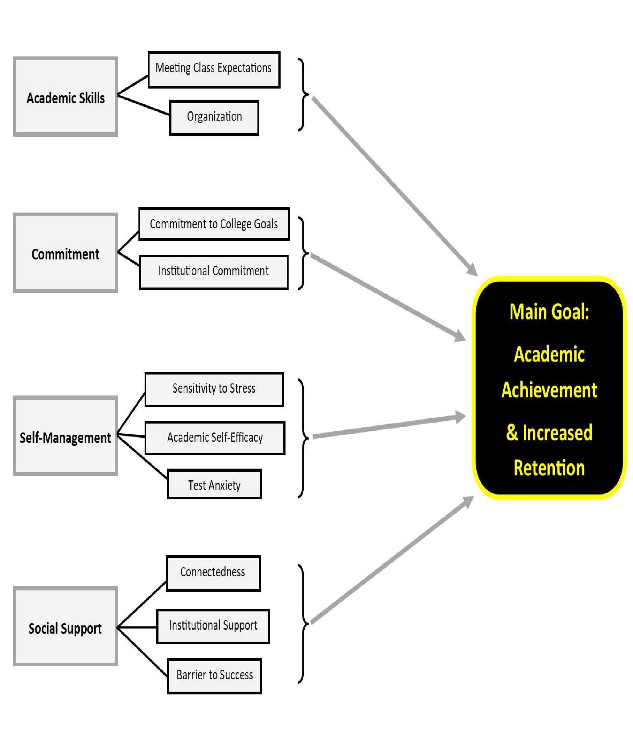
Figure 2. The Student Academic Success (SAS) Program Logic Model

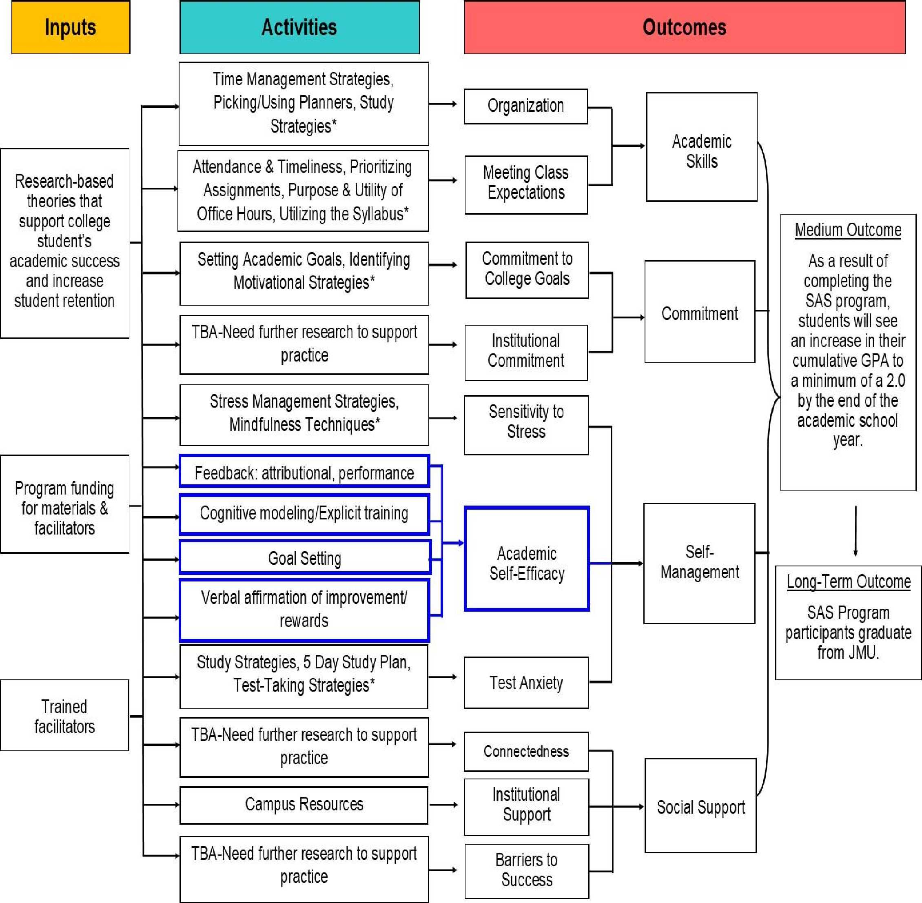

Fi
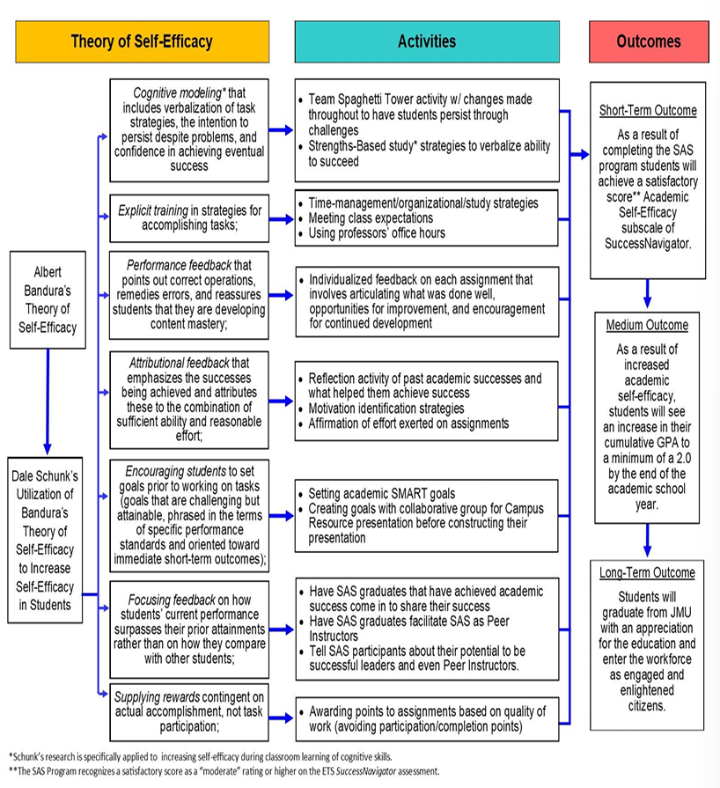
Figure 3. The SAS Program Logic Model for Increasing Self-Efficacy

References
Brophy, J. (2004). Motivating students to learn (2nd ed.). Mahwah, NJ: Lawrence Erlbaum Associates.
Schunk, D. H. (1985). Self-efficacy and classroom learning. Psychology in the Schools, 22(2), 208-223

