
Assessment Toolkit:

Likert Survey Questions
Guidelines for Likert Survey Questions
Likert response survey questions are ubiquitous in assessment, evaluation, and research. In particular, Likert survey questions are commonly used in the field of higher education. There are important considerations for determining when this response method is appropriate and if so, how to formulate questions and responses to mitigate bias and produce valid, reliable results.
What is a Likert Survey Question?
A Likert survey question is a specific type of question that collects rank ordered responses to assess levels of satisfaction, quality, importance, agreement, disagreement, or frequency. Often, we are interested in concepts that cannot be easily captured in a dichotomous variable (yes/no) or in a strictly quantitative way (# of visits, SAT scores). Instead, we expect there is a range of possible levels of our concept of interest (i.e., selfconfidence, satisfaction, agreement, sense of belonging).
Likert survey questions often use a declarative statement followed by a rating scale. Scales can capture two directions of values, such as the bipolar example below.
Option 1: Rate your level of satisfaction with the instructor’s knowledge of the course content.
Very dissatisfied | Slightly dissatisfied | Neutral | Satisfied | Very  Satisfied
Dissatisfaction |  | Bipolar |  | Satisfaction

Other response scales capture values of a concept in a single direction (such as low to high).
Option 2: Rate the instructor’s knowledge of the course content.
Not Slightly Moderately Very Extremely knowledgeable knowledgeable knowledgeable knowledgeable knowledgeable at all
Low level Unipolar High level
Expanded style questions are also an effective question format that reduces bias since survey takers must consider their choices more carefully. A drawback is if you have too many expanded style questions it may take more time for respondents to process and answer them. This has the potential to elicit invalid responses and lower completion rates.
Option 3: Which of the following best describes how you feel about the instructor’s knowledge of the course content:
- I am very satisfied with the instructor’s knowledge of the course content.
- I am satisfied with the instructor’s knowledge of the course content.
- I am dissatisfied with the instructor’s knowledge of the course content.
- I am very dissatisfied with the instructor’s knowledge of the course content.
Writing Effective Survey Questions
It is best practice to pre-test your survey, ideally with your intended target population, to ensure questions are not misleading or misinterpreted. This checklist can help when developing any survey instrument, including Likert style questions.
✔ Why are we asking this question?
✔ What are we trying to measure?
✔ What is the best way to measure that construct?
✔ Are there existing scales or measures used in similar projects we can use?
✔ How will we analyze the data?
Guidelines¹ | No | Yes
Ask about one idea at a time. | The new policy has reduced crime and violence on campus. | The new policy has reduced crime on campus.
Use unambiguous language. | Do you usually attend class? | How many times did you attend class during the past week, if at all?
Be specific when asking about frequency. | Very Often, Often, Sometimes, Rarely, Never | 1 or more times a day, 2-3 times per week, 1 time per week, less than 1 time per week
Avoid leading, non-neutral or culturally specific wording. | How positive was your experience in this course?  Do you agree that the policy should be revoked? | How would you rate your experience in this course?  Which best describes your view on the policy?
Omit qualifying statements that confuse results. | Single religion schools have better quality of education than other schools.  Strongly agree to strongly disagree  Does someone marking disagree think education quality is no better or worse? | Compared to other schools, the quality of education at single religion schools is:  Much better, somewhat better, the same, somewhat worse, much worse.
Use scales with 4-7 categories. | Fewer than 4 may not cover all options. | Strongly agree, agree, undecided, disagree, strongly disagree.
Make sure answer options are mutually exclusive | More than 7 is too complex. | Never, 1, 2-3, 4-5, 5+times
Keep scale categories clear for respondents. | Low High  High Low | Low High  Low High

In some cases, it may be useful to include reverse-worded questions or scales to avoid the bias that occurs when respondents check “agree” to all questions. This strategy should be used thoughtfully to ensure that survey takers notice when questions or response categories are reverse worded.
Use neutral midpoints when necessary | Use neutral responses such as Not Applicable or Neutral, when appropriate. Survey takers may choose this option out of ease, especially on controversial topics, so omit if you want to force them to lean slightly positively or negatively.

Sample Likert Response Scale Categories²
Agreement/ Disagreement | Strongly Agree  Agree  Undecided  Disagree  Strongly Disagree | Agree Strongly  Agree Moderately  Agree Slightly  Disagree Slightly  Disagree Moderately  Disagree Strongly | Completely Agree Mostly Agree Slightly Agree Slightly Disagree Mostly Disagree Completely Disagree
Importance | Very Important  Important  Moderately Important  Not Important | Very Important Moderately Important  Not Important | Not Important at All  Of Little Importance  Of Average Importance  Very Important  Essential
Quality | Very Good Good Acceptable Poor  Very Poor | Excellent  Above Average  Average  Below Average  Very Poor | Good Fair Poor
Likelihood | To a Great Extent Somewhat  Very Little  Not at All | Almost Always True Usually True  Often True  Occasionally True  Rarely True  Usually Not True  Almost Never True | Not Likely Somewhat Likely  Very Likely
Satisfaction | Very Satisfied  Satisfied  Neither Dissatisfied  Very Dissatisfied | Much Better Somewhat Vetter Stayed the Same Somewhat Worse Much Worse | Very High Above Average  Average  Below Average  Very Low

Additional Tutorials and Resources
Survey Design Best Practice Guidelines
Three Tips for Effectively Designing Rating Scales
Choosing the Correct Statistical Test in SAS, STATA, SPSS, and R
The 4, 5, and 7 Point Likert Scale
Visualizing Data using Divergent Stacked Bar Chart
- Adapted from Likert Scale Examples for Surveys from Iowa State University Extension (Brown, 2010).
Analyzing and Reporting the Data
Likert style questions produce ordinal variables which are ranked categorical measures. This means the distance between responses is not numerically meaningful, strictly speaking, even when there are numbers assigned to responses.
In practice, Likert style items with fewer than 5 categories are typically reported as percent frequencies. Depending on the question and the distribution of the data, it may make sense to further collapse categories (% Strongly Agree/Agree). Categorical tests, such as a chi-squared test, can also be used to examine if percentage differences between groups are statistically significant.
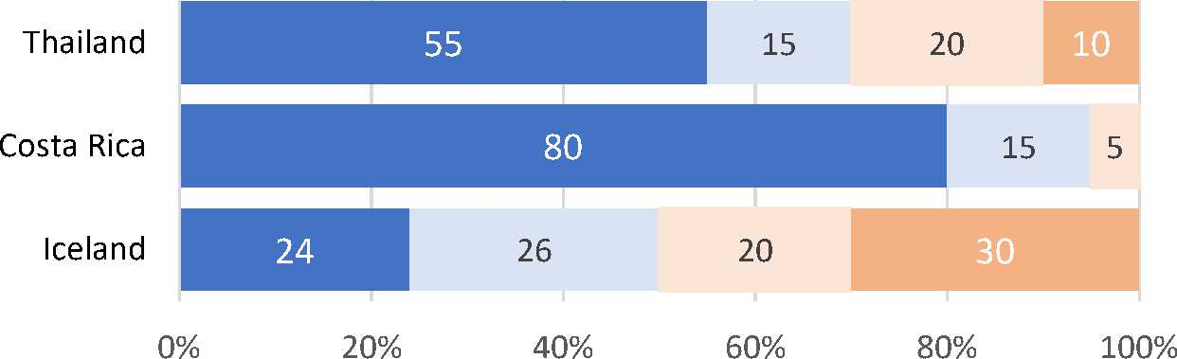
Ideal Location for Spring Break Travel
(% Agree/Strongly Agree)
Ideal Location for Spring Break Travel
Strong Agree Agree Disagree Strongly Disagree
96 94
60
80
Costa Rica
Women Men
Thailand*
*significant difference chi-squared (p<.05)
There are also instances where means, standard deviations, t-tests, ANOVA, and other parametric statistics can be used on Likert style questions and scales. Strictly speaking, interval measures have numerically meaningful differences between values (e.g., number of visits, scores on the SAT test). However, in practice, it can sometimes be useful to include means and standard deviations for Likert questions.
 | Valid Percent
Very Survey Items Much (4) | Quite a Very  Bit ^{Some} Little Mean SD  (3) (1)
Question 1 48.0  Question 2 59.2 | 33.1 15.8 3.1 3.26 .83  31.1 8.0 1.8 3.48 .72

You may also see traditional Likert scales treated as interval data. These scales come from multiple questions developed together to measure a single concept or idea (e.g., self-esteem, depression) which are then scored and collapsed into a single numeric score.
The strongest recommendation is ultimately that the choice of any survey question, statistical test, data graphic or reporting methodology should be guided by the research context and objectives.³ The office of Assessment and Research can provide consultation support in the development and analysis of survey-based data.
- Additional Sources and References:
1. de Winter, Joost C. F., and Dimitra Dodou. 2010. “Five-Point Likert Items: t test versus Mann-Whitney-Wilcoxon.” Practical Assessment, Research, and Evaluation 15(11): 1-16.
3. Kam, Chester Chun Seng. 2020. “Expanded Format Shows Better Response Consistency than Likert-Scale Format in the Measurement of Optimism.” Personality and Individual Difference 152(1): 1-5

Harpe, Spencer E. 2015. “How to Analyze Likert and Other Rating Scale Data.” Currents in Pharmacy Teaching and Learning 7:836-850.

