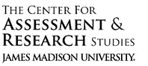

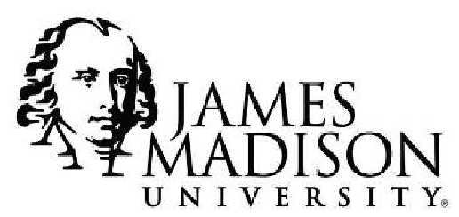

Student Affairs Learning Improvement Application
Please complete the application below to apply for the learning improvement initiative with Student Affairs Support Services (SASS) within the Center for Assessment and Research Studies (CARS). This initiative is a partnership between SASS and the Division of Student Affairs to focus on the improvement of student learning and development.
At Madison, we value improvement of learning and development, which can be accomplished by wellthought-out programming and assessment. In turn, a complete and coherent application is a first step to making such initiatives successful. Applications are due May 15th.
There are two options for when programs may begin the project: Summer or Fall. In the application, you will be asked to indicate whether you plan to begin the project in the Summer or Fall. Please select a starting date that best aligns with your office schedule. Selected programs will be notified by May 31st.
Please select one starting date: __X__ Summer Fall Semester
Although several application questions will ask you to describe previous assessment results and previous improvement efforts, programs will not be selected based on the number of years they have conducted assessment or demonstrated improvement. Rather, programs will be selected based on readiness and commitment to a long-term improvement process. Up to 2 programs will be selected per year based on their readiness and commitment.
Should any questions arise while completing this application, you may contact SASS (SASS@jmu.edu). Once completed, submit your application to the co-chairs (Sarah Sunde, sundesa@jmu.edu; Kathleen Campbell, campbekl@jmu.edu) of the Student Affairs Assessment Advisory Council for review.
Student Affairs Assessment Advisory Council ∙ DIVISION OF STUDENT AFFAIRS ∙ Student Affairs Assessment Support Services
Updated 9.26.17
- Program Overview
In this section, please provide general information about your program. Responses are meant to be short, as you will have the opportunity to provide more detail in the sections below.
- Name of applicant’s office:
Global Community Engagement (GCE)
- Name of program of interest:
Global Citizenship Development Program (GCDP)
- Purpose of the program (1 paragraph max):
The overall purpose of the multi-year co-curricular Global Citizenship Development Program is to foster global citizenship in students at JMU. Engaged global citizens display a concern for all humanity, not just those in their immediate in-group or community, and have the knowledge, understanding, and skills to make a positive impact on a global scale.
- Number of students who complete the program:
~4500 students
- Number of staff members who facilitate the program:
2 staff members and 1 graduate student; partnership & support from First Year Orientation (FYO), Residence Life (Res. Life), Center for Multicultural Student Services (CMSS), Office of Community Service Learning (CSL), General Education, and Academic Degree Programs.
- Point person/primary overseer of the program:
Morgan Crewe, Global Citizenship Initiative Coordinator
- Current Assessment of Student Learning Outcomes
Student learning outcomes for the Global Citizenship Development program are divided into three key areas of the global citizenship development: global awareness, local community engagement, and positive global citizenship-related attitudes.
Global Awareness:
As a result of completing the Global Citizenship Development Program, 85% of the program participants will...
- Cite at least 3 current global issues
- Apply the 8 Key Questions (8KQ) of ethical reasoning to at least one example of global injustice
- Experience a 25% increase in their concern for all humanity
- Experience a 25% increase in interpersonal social interactions with individuals outside of their immediate in-group
Local Community Engagement:
As a result of completing the Global Citizenship Development Program, 85% of program participants will…
- Choose to voluntarily engage in at least 10 additional hours per year of community service
- Cite at least 1 direct impact on the community resulting from their reported community service hours
Global Citizenship Attitudes:
As a result of completing the Global Citizenship Development Program, 85% of program participants will…
- Experience a 25% increase in knowledge and use of global perspective-taking
- Experience a 25% increase in personal value for cultural diversity
- Experience a 25% increase in feelings of responsibility to act for the betterment of others
Overview of the Program
Global citizens are individuals who not only feel that they have rights, but also feel that they have responsibilities as a member of the world—responsibilities to act in cases of injustice and responsibilities to uphold the rights of all humanity. Individuals who exemplify global citizenship value social justice, diversity, and empathy through a global perspective—all attributes our world needs.
There are three main areas of focus for the Global Citizenship Development Program (GCDP) that align with the key attributes and behaviors of an engaged global citizen. These areas of focus are global awareness, local community engagement, and global citizenship-related attitudes (e.g., empathy, value for diversity, and responsibility to act). To foster global citizenship development, GCDP uses a multifaceted programming approach throughout the (typical) four-year education at JMU.
Programming related to global awareness and positive global citizenship-related attitudes focuses on increasing student’s knowledge of global issues and their sense of interconnectedness with individuals of diverse cultural backgrounds. These outcomes are believed to be influenced through hands-on activities and collaboration. Thus, students are first exposed to global awareness education during First- Year Orientation (FYO). As part of the week-long FYO, students engage in a “diversity dialogue.” The Diversity Dialogue Program consists of short presentations aimed at fostering diversity at JMU followed by focused small-group collaborative activities. The Diversity Dialogue Program also includes students’ first introduction to the 8 key questions of ethical reasoning, a key critical thinking framework for our program. FYO primes students for the Residence Life diversity series titled “The Good, Bad, & Ugly: An International Perspective.” Each month, first-year students participate in residence hall activities related to a particular region of the world. These activities highlight each region’s beauty and strengths while also noting major conflicts in each region. In collaboration with the Center for Multicultural Student Services (CMSS), International Education Week is a week-long, campus-wide opportunity for students to engage with different cultures. Each day, a different cultural region is highlighted through traditional dishes available in the dining halls, informational displays at various locations around campus, and other culture-specific activities (e.g., djembe drum concerts, Thai meditation sessions). In addition, faculty within the General Education Program are required to incorporate global citizenship themes into their course-work, including discussion of global conflict and critical thinking exercises.
Much of our programming focuses on critical thinking, a key component of global citizenship development. Our office (GCE) facilitates the annual Global Conflict Program Series, which is presented each fall by individuals of diverse cultural backgrounds. By participating in the Global Conflict Program Series, students explore current global issues via short presentations and small group discussions focused on applying critical-thinking skills to solving global problems. Additionally, our office facilitates the Open Forum on Injustice, which is open to the JMU and Harrisonburg communities. The program seeks to promote critical-thinking skills related to community injustices and is available to all students and community members who wish to attend, but it is particularly targeted at senior-level JMU students.
The GCDP also focuses on local community engagement. This community engagement opportunity is accomplished by implementing a community service learning opportunity in at least one required upper-level course within each major (i.e., degree program) at JMU, targeted at students who are juniorlevel or above. Students are also encouraged to participate in JMU’s “Big Event”, a campus-wide, all day volunteering event. Both the required CSL opportunity and the “Big Event” are followed by focused, critical reflections of the impact of service work. Students are also given feedback on the direct impact of their service work to encourage a sense of value for community service.
Current Assessment
Data Collection Design
Given that the GCDP is implemented throughout students’ four-year career at JMU, our assessment process involves a longitudinal design that measures student progress at three time points. All assessments are administered on a computer via Qualtrics and each student receives the same version of the assessment at all three time points.
Time 1: During August orientation, incoming first year students complete a (pretest) assessment as part of the mandatory Fall Assessment Day. These scores provide a baseline of the outcomes prior to programming.
Time 2: Students then complete a second assessment after completion of their general education program (45-70 credits) as part of Spring Assessment day. These scores evaluate the impact of programming experienced during the first 3 semesters.
Time 3: Students then complete a third assessment as part of the senior exit assessment administered in the Spring to graduating seniors.
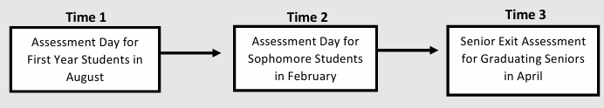
Measures (see Table 1 for a visual map of student learning outcomes and measures)
Free Response Items: two free-response prompts are given to students to assess learning outcomes one (cite at least 3 current global issues) and two (apply the 8 Key Questions (8KQ) of ethical reasoning to at least one example of global injustice). For outcome one, students are asked to list three current global issues. Student responses are scored using a rubric designed by our office. Students must receive a score of 3 or higher to meet learning outcome one. For outcome two, students are given a short prompt that describes an example of global injustice and are asked to construct an essay (no more than one page) applying the 8KQ framework to this example of global injustice. The 8KQs are not provided to the students. Essays are assigned a single score from 1 to 5 by at least two raters using a holistic scoring rubric designed by our office. Students must receive a score of 3 or higher to meet learning outcome two.
Global Perspective Inventory (GPI): a measure of global perspective-taking. Two of the three subscales of the GPI are used in our assessment. The interpersonal subscale consists of six items used to measure an individual’s perceptions of social responsibility (e.g., “I work for the rights of others”) as well as levels of interpersonal social interactions with individuals of diverse backgrounds (e.g., “I frequently interact with students from a race/ethnic group different from my own”). This interpersonal subscale is used to assess learning outcome four (experience a 25% increase in interpersonal social interactions with individuals outside of their immediate ingroup). The cognitive subscale consists of six items used to measure self-perceived knowledge, understanding, and use of global perspective-taking (e.g., “I am informed of current issues that impact international relations”), and is used to assess learning outcome seven (report a 25% increase in knowledge and use of global perspective-taking). All items in the GPI are rated on a scale from 1 (strongly disagree) to 7 (strongly agree). (see the following for more information on GPI theory and items: GIP Theory)
Identification with All Humanity scale (IWAH): a nine-item measure of identification with, interaction with, and concern for others including an individual’s community, all Americans, and all humanity (e.g., “How much do you identify with all humanity?”). The IWAH is used to assess learning outcome three (experience a 25% increase in their concern for all humanity). All items in the IWAH are rated on a scale from 1 (not at all) to 5 (very much). (Link to original article: http://psycnet.apa.org/fulltext/2012-16073-001.pdf)
Community Service Report Form: a reporting form for voluntary community service hours presented in table format. Students are asked to report the location at which the service occurred, to indicate number of hours served, and to identify an individual or group that was directly impacted by the service provided. Information from this report form is used to assess learning outcomes five (choose to voluntarily engage in at least 10 additional hours per year in community service) and six (cite at least 1 direct impact resulting from their reported community service).
Pro-Diversity Beliefs Measure: a seven-item measure assessing the extent to which individuals value and endorse cultural diversity (e.g. “It is easier to solve problems with a high degree of cultural diversity”) used to assess learning outcome eight (experience a 25% increase in personal value for cultural diversity). All items in the Pro-Diversity Beliefs Measure are rated on a scale from 1 (don’t agree at all) to 7 (completely agree). (Link to original article: http://journals.sagepub.com/doi/pdf/10.1177/1948550611435942)
Responsibility Scale: a three-item measure of an individual’s feelings towards responsibility to act for the betterment of others (e.g., “I feel responsible for solving societal problems”) used to assess learning outcome nine (experience a 25% increase in feelings of responsibility to act for the betterment of others). All items in the Responsibility Measure are rated on a scale from 1 (strongly disagree) to 11 (strongly agree). (Link to original article: http://psycnet.apa.org/fulltext/2014-17120-003.html)
- Focus of Partnership with SASS
For this partnership, you will need to select 1 or 2 learning/development outcomes on which to focus. These outcomes should be sufficiently important to warrant the ample resources that will be devoted to improving all related programming and assessment activities.
The most crucial information you will provide in this section concerns the program theory that guides your program. In other words, how was your programming intentionally designed to achieve the student learning and development outcomes you’ve decided to focus on for this partnership? Programs that have not given this considerable thought will find it difficult to engage in a learning improvement initiative.
- Student learning/development outcome(s) selected for the improvement initiative (1 or 2): Global Awareness:
As a result of completing the Global Citizenship Development Program, 85% of program participants will…
      - Cite at least 3 current global issues
      - Apply the 8 Key Questions (8KQ) of ethical reasoning to at least one example of global injustice
- Description of why these outcomes were selected for the learning improvement initiative. Why are these outcomes important to your department? (1-2 paragraphs):
Outcome one (cite at least 3 current global issues) and outcome two (apply the 8 Key Questions (8KQ) of ethical reasoning to at least one example of global injustice) are knowledge and skillbased outcomes that are necessary components of global awareness, and ultimately global citizenship. Although we have seen great results in previous assessment cycles for other outcomes, such as citizenship identity, concern for humanity, and positive attitudes, we cannot expect these attributes alone to produce an engaged global citizen. Therefore, our office is committed to furthering development of students’ knowledge of global issues and critical thinking skills, exemplified by outcome one and outcome two.
More specifically, previous research on global citizenship development has shown that three key components contribute to the development of a global citizen: global awareness, community engagement, and positive global citizenship-related attitudes such as empathy, value for diversity, and responsibility to act (Davies, 2006; Reysen, Larey, & Katzarska-Miller, 2012). Theoretical perspectives and previous research on global citizenship development highlight the importance of the knowledge and understanding of global issues as necessary prerequisites for individuals to feel the need to act on those issues (Reysen & Katzarska-Miller, 2013). Students may display positive attitudes toward global citizenship, but they will not be able to behave as engaged global citizens with the ability to act on global issues without the knowledge and skills to do so (see Section E for a more detailed description of this theory).
- Description of why these outcomes are important to JMU (1 paragraph):
As our world becomes increasingly interconnected, more and more pressure is being placed on institutes of higher education to provide students with the skills, knowledge, and disposition to engage in global issues. In 2016, President Alger signed a 30-year anniversary statement with Campus Compact, a national coalition of civic education and community development. This statement outlined three focus areas of engagement for the university: engaged learning, civic engagement, and community engagement. Our office is focused on encouraging students to apply these three areas of engagement on a global scale. Global citizens contribute to local communities, such as the JMU community or the surrounding Harrisonburg community, while maintaining global awareness and compassion for others. Moreover, global citizenship identity is positively related to intergroup empathy, value for diversity, social justice values, and responsibility to act for the betterment of others (Reysen & Katzarska-Miller, 2013); these are all characteristics that a well-rounded JMU graduate should display.
- Description of the specific programming (curriculum, pedagogy, intervention, etc.) used to provide students with an opportunity to meet the selected outcome(s) only. An outcome-to-curriculum map should be included as part of this description (may be attached as an appendix):
  - GCDP uses a multi-faceted, multi-office, co-curricular approach to programming. Programming designed to provide students with an opportunity to meet outcome one (cite at least 3 current global issues) includes the Residence Life Diversity Series, CMSS’s International Education Week, and the Global Conflict Program Series. Programming designed to provide students with an opportunity to meet outcome two (apply the 8 Key Questions (8KQ) of ethical reasoning to at least one example of global injustice) includes the Orientation’s Diversity Dialogue, the Global Conflict Program Series, and the Challenging Injustice forum. Detailed descriptions of programming can be found below. Moreover, an outcome-to-curriculum map, as well as a program timeline related to the outcomes selected can be found in Table 2 and Figure 1, respectively.
- Orientation Week Diversity Dialogue: The diversity dialogue program occurs as part of the week-long first-year orientation program. This two-hour program consists of four short presentations given by a trained facilitator on critical thinking and fostering diversity at JMU, each followed by an activity. As part of these presentations, students are introduced to the 8KQ of ethical reasoning. During the following activities, students are split up into smaller groups and asked to apply the 8 key questions to examples of potential barriers to fostering diversity on campus. A larger group discussion on the decisions of each group is used to wrap-up the program.
- Residence Life Diversity Series: The diversity series, also known as “The Good, Bad, & Ugly: An International Perspective,” is a year-long program facilitated by residence advisors in all first-year residence halls. Each month, first-year students participate in guided activities used to explore the beauty, strengths, weaknesses, and major issues of a particular region of the world. When possible, short presentations and activities are facilitated by an international student or member of the Harrisonburg community who is from the region of interest to encourage cultural interconnectedness. Throughout the series, students are provided with information about on-campus offices and opportunities related to global education.
- CMSS International Education Week: This week-long, campus-wide program is implemented in collaboration with the Center for Multicultural Student Services each spring. Each day of the week, students engage with a different cultural region of the world through traditional dishes offered in the dining halls, interactive informational displays at various locations around campus, and other culture-specific activities such as African djembe drum concerts, Thai meditation sessions, or Bollywood dance performances.
- Global Conflict Program Series: This five-part program series is offered every fall semester for sophomore-level students and is facilitated by individuals who are from areas experiencing global conflict. The Global Conflict Program Series emphasizes cultural interconnectedness through short presentations followed by hands-on critical thinking activities, collaboration activities, and an online forum designed to encourage reflection and dialogue beyond the completion of the programming.
- Challenging Injustice Forum: The challenging injustice forum is an open forum held each fall for students to discuss injustice in the JMU community, Harrisonburg community, or other communities of concern. The forum is led by faculty and students who have displayed global citizenship and have had training on using critical-thinking skills to challenge injustice, such as with the 8KQ ethical reasoning framework. The open forum is followed by a problem-solving session in which individuals are encouraged to form teams with forum leaders to discuss solutions to situations of injustice. While all students are encouraged to attend Challenging Injustice, the programming is particularly targeted at senior-level students.
- Global Citizenship Focused Coursework: Faculty from the General Education program are required to include global citizenship focused coursework in their curriculum. Global citizenship course-work includes an introduction to what an engaged global citizen looks like, information on current global issues, and critical thinking or discussion activities focused on current global issues. However, because we do not have specific programming or quality control in place for these courses, global citizenship-focused coursework is not typically considered when discussing the impact of our programming.
- Describe how this programming is expected to result in the desired student learning/development outcome(s). In other words, please explain the logic behind why certain program features were chosen to achieve the selected outcomes. This is often referred to as program theory or logic. If you are unfamiliar with these terms, please watch this short introductory video before constructing your response (1 page max). If you need support using program logic to develop curriculum/programming, please visit JMU’s Center for Faculty Innovation (CFI):
As mentioned above, the Global Citizenship Development Program focuses on three key areas of global citizenship development: global awareness, local community engagement, and global citizenship-related attitudes (Reysen & Katzarska-Miller, 2013). The two selected outcomes are components of global awareness. Global awareness is defined as knowledge of the world, including current global issues, and one’s interconnectedness with others, including individuals of different backgrounds and individuals who identify as global citizens (Davies, 2006). According to the Reysen and Katzarska-Miller (2013) model of global citizenship, there are three main antecedents that lead to global awareness: knowledge of current global issues; concern for, or understanding of, the perspective of others; and interconnectedness with others (as shown in figure below).

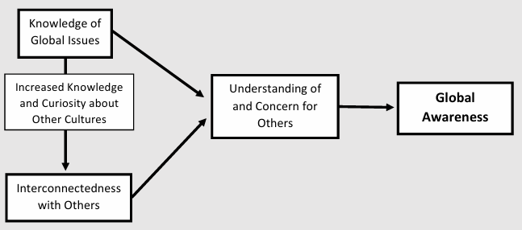
In order for individuals to develop a concern for or understanding of others, individuals first need to develop a connection with others. Further, for individuals to have a desire to develop a connection with others and understand their point of view, they first need to be exposed to knowledge of other cultures or regions and the issues they face. The visual representation of these relationships indicates that if we want to influence the outcome of global awareness, we must provide opportunities to develop an understanding and concern for others. This understanding and concern for others is developed through activities that foster knowledge of global issues, which is a fundamental to increasing interconnectedness with others by increasing knowledge of, and curiosity about, other cultures. In sum, knowledge of global issues and interconnectedness with others leads to an increase in the understanding of others’ perspectives and a concern for the conflicts they are experiencing, which leads to the development of global awareness.
Using a similar framework, Gibson et al. (2008) take this model a step further by identifying the conditions and processes that must be present when educating students on the three main antecedents necessary for an individual to learn and/or develop global awareness. The main conditions for global awareness learning include cultural contrast, teamwork/collaboration, and critical thinking (Gibson, Rimmington, & Brown, 2008). A high degree of cultural contrast means individuals from multiple cultures are present. Global learning is more salient for learners when a high degree of cultural contrast in programming is achieved. In addition to cultural contrast, some degree of teamwork or collaboration within high cultural contrast settings must occur to further integrate global learning with the experiences of other cultures. Lastly, global awareness learning must include conditions that encourage critical thinking and/or focused reflections about the material presented.
How does our programming incorporate this theory?
- The first program opportunity that students are exposed to, the Orientation Week Diversity Dialogue, introduces students to the 8 key questions of ethical reasoning. This program meets the teamwork/collaboration and critical-thinking conditions for global awareness learning through small-group collaboration activities and use of the 8 key questions of ethical reasoning.
- Cultural contrast and additional teamwork/collaboration opportunities are available during the Residence Life Diversity Series, in which students engage in group activities with individuals of various cultures to explore different regions of the world and foster interconnectedness with individuals of other cultures. The Residence Life Diversity Series also serves as students’ first official introduction to major current global issues.
- International Education Week is a large source of cultural contrast for our program. International students at JMU present various kinds of information, presentations, or activities related to their specific culture, giving students a significant opportunity to form meaningful connections with individuals from various regions of the world.
- The Global Conflict Program Series is a unique program in that it aims to touch on all three of the antecedents to global awareness. Knowledge of global issues is facilitated through short presentations, which are given by an individual from an area experiencing global conflict. By having these individuals present information on global conflict, we are encouraging students to become more interconnected with these individuals and gain a personal perspective of global conflict to help nurture understanding and concern for others. Interconnectedness and understanding are further developed through small- group critical-thinking activities in which students’ attempt to tackle the global issues presented. The Global Conflict Program Series incorporates all ideal conditions for global learning, including cultural contrast, teamwork/collaboration, and critical thinking.
- Lastly, the Challenging Injustice Forum incorporates the conditions of teamwork/collaboration and critical thinking with senior-level students. This is accomplished through an open forum to encourage discussion of examples of injustice in local communities, followed by a problem-solving session in which forum leaders form small groups with participants to use critical-thinking skills, specifically the 8 key questions of ethical reasoning, to discuss solutions to the examples of injustice proposed.
- Summarize the results of previous assessment related to the selected outcomes (1 page max):
We have not seen consistent growth across the three assessment time points in outcomes one (cite 3 examples of current global issues) or two (apply the 8 Key Questions (8KQ) of ethical reasoning to at least one example of global injustice). More specifically,
- In previous assessment cycles, we have seen a growth in outcome one from the Time 1 assessment to the Time 2 assessment, but a subsequent decline from Time 2 to the Time 3 assessment. In addition, inter-rater reliability for the assessment related to outcome one is consistently inadequate across assessment time points
- For outcome two, we have seen no growth from Time 1 to Time 2, and minor growth in performance from Time 2 to Time 3.
- Neither outcome one nor outcome two are being met by students during the senior exit assessment.
See Appendix A for more detailed assessment results for outcomes one and two.
- Action Plan
In this section, you will be asked to consider why the student learning/development outcomes you selected are not being met and propose possible strategies for addressing these obstacles.
- For each selected outcome, provide an explanation/hypothesis about why current programming is not supporting student learning/development to the degree you desire (1 page max):
Outcome 1: After examination of previous assessment results and current programming, we believe the current programming is ineffective in providing students with the opportunity to meet outcome one (cite at least three examples of current global issues) due to the current scheduling of the programming. By examining the programming timeline found in Figure 1, we can see that there are significant gaps in our programming during Year 3 and Year 4. Although the outcome is ultimately assessed during students’ final semester at JMU, the programming designed to meet this outcome occurs primarily during the first two years. Students are meeting this outcome during the Time 2 assessment, which is administered after students have completed the orientation diversity dialogue, the residence life diversity series, the global conflict program series, global citizenship focused course-work, and participated in international week. However, students are no longer meeting this outcome during the Time 3 assessment, suggesting the successful programming offered during the first two years needs additional reinforcement during the last two years.
In addition, the assessment for outcome one requires that a student cite examples of current global issues as well as the location(s) affected by that issue. The student learning outcome related to this assessment does not require students to identify the location(s) affected by the issues cited, however, several raters in past assessments have scored an item as incorrect if the student is unable to identify the location. This discrepancy between the learning outcome, the assessment item, and the rating of that item results in low inter-rater reliability for that item and potentially biases the results of the assessment for learning outcome one.
Outcome 2: Contrary to the programming designed for outcome one, the current programming designed to provide students with the opportunity to meet outcome two is well dispersed throughout students’ four years at JMU with one program occurring during First-Year Orientation, one program occurring during year 2, and one program occurring during year 4. However, in order to meet outcome two (apply the 8 Key Questions (8KQ) of ethical reasoning to at least one example of global injustice), students first have to acquire and retain knowledge of global issues as well as the eight key questions. Therefore, we believe that outcome two is not supported by the program because students are failing to meet outcome one, a necessary prerequisite to outcome two.
- Prior to this new partnership with SASS, have you tried to improve student learning/development related to these outcomes? If so, please describe the improvement initiatives. Have those initiatives been successful? (1 page max):
Prior to this partnership with SASS, we attempted to improve student learning/development related to these outcomes by improving our assessment process. When this program was started, we were only assessing students at two time points—as first-year students and as seniors. After several years of assessment results indicating students were not meeting these outcomes, we decided to include a third assessment time point for sophomore status students. This change to our assessment process was a successful improvement in that we were able to identify a more specific timeline of when issues with our programming were occurring. More specifically, we were able to see at what time relative to our programming students were improving, staying the same, or declining in their performance on the outcomes.
- Based on your answers to the questions above, what changes to a) your programming and b) your assessment processes do you believe are necessary to demonstrate improvements in student learning/development?
Programmatic Changes
Through our assessment process we have determined that we are lacking programming related to the knowledge of global issues during Year 3 and Year 4. Therefore, we believe it is necessary to redistribute our programming or add another programming opportunity to expose students to the knowledge of global issues.
Assessment Changes
In addition to issues with the timing of our programming, we have some evidence that our assessment of learning outcome one is inadequate. Through our partnership with SASS, we hope to develop a new, more detailed rubric to assess outcome one and develop a rater training program to conduct with raters prior to scoring assessment results.
- Provide a detailed timeline that articulates your plan to improve student learning/development to the degree you desire. This timeline should include 1) whether you plan to begin this work in Summer or Fall, 2) plans to initially assess the program, 3) plans to make programmatic changes, and 4) plans to re-assess the program:
Our plan for improving our student learning outcomes is divided in to 4 phases (outlined below).
Phase 1: Large-Scale Assessment Changes & Initial Assessment (Summer 2018)
We plan to begin working with SASS in the Summer of 2018. During this time, we plan to focus on developing a better assessment of outcome one. With help from SASS, we plan to improve the rubric used to score outcome one and develop a rater training system for outcome one prior to scoring assessment results, We would like to complete these assessment changes prior to the next Assessment Day for first-year students in August 2018. This new assessment tool will be initially implemented with incoming first-year students.
Phase 2: Programmatic Changes (Fall 2018 – Spring 2019)
Once new assessment tools are in place, we will focus our efforts on programmatic changes related to outcome one and outcome two. Specifically, we plan to develop at least one additional programming opportunity that will occur during year 3 to further reinforce students’ global knowledge. Once a program is selected, this phase will also include selecting and training individuals to implement the programming.
Phase 3: Implementation of New Programming (Fall 2019 or Spring 2020)
Depending on what time point is selected for the additional programming, we intend to implement this programming in Fall 2019 or Spring 2020.
Phase 4: Re-assessment of Programming (Spring 2021)
Due to the longitudinal nature of our assessment process, our re-assessment will not occur under the allotted timeline for our partnership with SASS. However, we plan to use the new assessment tools to re-assess the impact of our programming at Time 3 with graduating seniors in the Spring of 2021, following exposure to the new programming.
- Commitment to Partnership
One of the most important resources needed to evidence student learning improvement is time. As such, each program will commit 10 hours per week to the initiative. This amount of time is necessary to think critically about the program, collect evidence regarding student learning and development, and engage in evidence-based, intentional program redesign. By committing this time up front, programs will be able to distribute other responsibilities accordingly.
- Weekly Time Commitment (10 hours/week)
Please select a Lead Coordinator who will serve as the primary contact and chief overseer of the initiative. This person may choose to commit all ten hours each week, or assemble a team to share the workload. Note: Graduate assistants may lend support where needed, but most decisions/discussions will require extensive familiarity with the program over several years, an understanding of the program theory/logic behind the program, knowledge of departmental resources, and a level of authority beyond what most graduate students possess. As such, graduate assistants may not serve as lead coordinators and should contribute less than 1/3 of the total hours spent on the initiative each week.
- Support from Direct Supervisor (1 hour/week)
Regular contributions from upper-level administrators are crucial to the long-term success of a learning improvement initiative and, in turn, the future of the program. Direct Supervisor, please sign below to indicate a commitment of 1 hour per week to the improvement project detailed in this application. This time may be spent in whatever manner is most helpful to the program.
Lead Coordinator:

(Name) |  | (Signature) |  | (Date)

Other Team Members (names only; no signatures required):

Direct Supervisor (1 hour commitment each week):
(Name) |  | (Signature) |  | (Date)
Director:

(Name) |  | (Signature) |  | (Date)

Table 1. Mapping of Outcomes to Measures

Key Area of Global Citizenship | Student Learning Outcomes | Assessment Measure of Outcome
 | As a result of completing the Global Citizenship Development Program, 85% of program participants will…
Global Awareness | Cite at least 3 current global issues | Free Response Item (scored with Rubric)
Global Awareness | Apply the 8 Key Questions (8KQ) of ethical reasoning to at least one example of global injustice | Free Response Item (scored with Rubric)
Global Awareness | Experience a 25% increase in their concern for all humanity | Identification with All Humanity (IWAH)
Global Awareness | Experience a 25% increase in interpersonal social interactions with individuals outside of their immediate in-group | Global Perspective Inventory (GPI): Interpersonal Subscale
Local Community Engagement | Choose to voluntarily engage in at least 10 additional hours per year in community service | Community Service Report Form
Local Community Engagement | Cite at least 1 direct impact resulting from their reported community service hours | Community Service Report Form
Global Citizenship Attitudes | Experience a 25% increase in knowledge and use of global perspective-taking | Global Perspective Inventory (GPI):  Cognitive Subscale
Global Citizenship Attitudes | Experience a 25% increase in personal value for cultural diversity | Pro-Diversity Beliefs Scale
Global Citizenship Attitudes | Experience a 25% increase in feelings of responsibility to act for the betterment of others | Responsibility Scale

Table 2

Student Learning Outcome to Program Map for Selected Outcomes
Outcome | Program Component (Facilitating Office)  Diversity Diversity Series International Global Conflict Challenging  Dialogue (Res. Life) Education Program Series Injustice  (FYO) Week (GCE) (GCE)  (CMSS)
1. Cite at least 3 current global issues | X X X
2. Criticize an example of global injustice using the 8 key questions of ethical reasoning | X X X

Figure 1. Timeline of programming for a given student for outcomes 1 and 2.

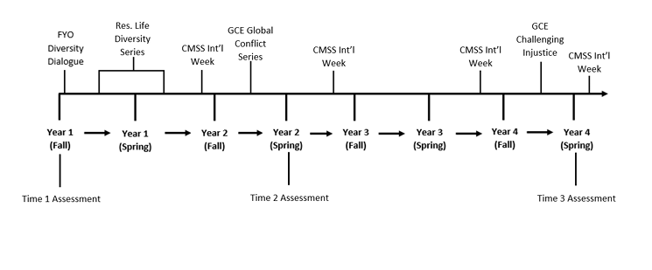

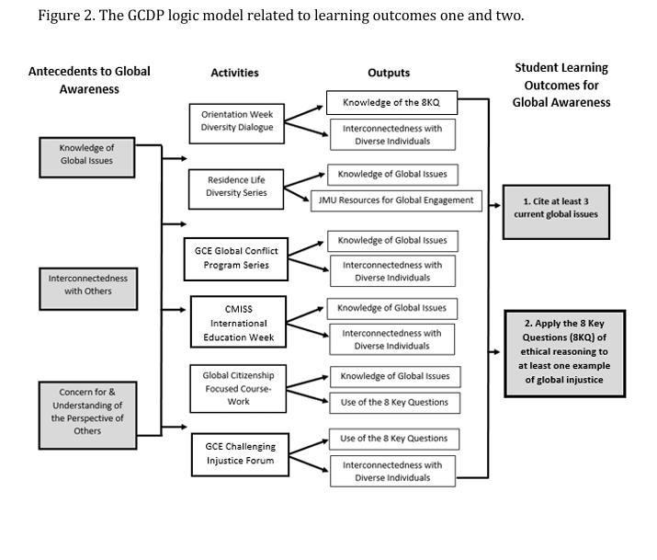

Appendix A: Previous Assessment Results
Outcome One: Cite at least 3 examples of current global issues
Results from the Time 1 assessment showed that first-year students at JMU are moderately aware of global issues, as slightly over half of students (51%) are able to cite at least 3 current global issues (see Figure A1). After completing year 1 and year 2 programming, 88% of students are able to cite at least 3 current global issues, meeting our department’s goal of 85% of students meeting outcome one. However, results of the Time 3 assessment showed a less than desirable percentage of graduating seniors (74%) are meeting outcome one. (see Figure A2).
Figure A1. List at least 3 current global issues and the location(s) effected by each issue.
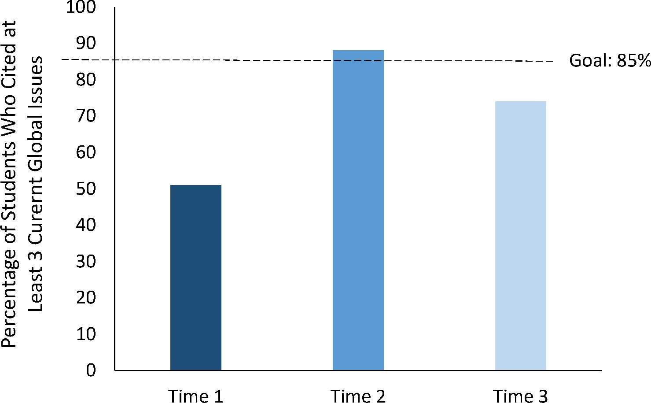

Figure A2. Breakdown of responses to the outcome one free response item by assessment time point.
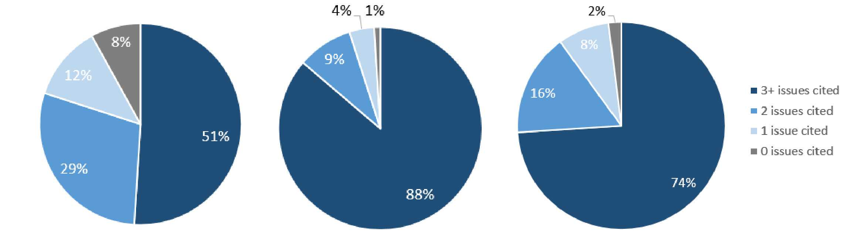
Time 1 Time 2 Time 3
Outcome Two: Apply the 8 Key Questions (8KQ) of ethical reasoning to at least one example of global injustice
Results from the Time 1 assessment showed that 42% of first-year students at JMU were able to adequately apply the 8KQ ethical reasoning framework to an example of global injustice (see Figure A3). After completing year 1 and year 2 programming, 44% of students were able to critique an example of global injustice using the 8KQ framework, showing no improvement from Time 1. Results from the Time 3 assessment show that although more students achieved a 4 or higher on the global injustice essay than at Time 1 or 2 (60%), these graduating seniors still did not reach the 85% benchmark required to meet outcome two.
Figure A3. Percentage of Students who obtained a rubric score of 4 or higher on the global injustice essay for outcome two.
