Student Affairs Learning Improvement Application
Please complete the application below to apply for the learning improvement initiative with Student Affairs Support Services (SASS) within the Center for Assessment and Research Studies (CARS). This initiative is a partnership between SASS and the Division of Student Affairs to focus on the improvement of student learning and development.
At Madison, we value improvement of learning and development, which can be accomplished by wellthought-out programming and assessment. In turn, a complete and coherent application is a first step to making such initiatives successful. Applications are due May 15th.
There are two options for when programs may begin the project: Summer or Fall. In the application, you will be asked to indicate whether you plan to begin the project in the Summer or Fall. Please select a starting date that best aligns with your office schedule. Selected programs will be notified by May 31st.
__X__ Summer
Please select one starting date:
Fall Semester
Although several application questions will ask you to describe previous assessment results and previous improvement efforts, programs will not be selected based on the number of years they have conducted assessment or demonstrated improvement. Rather, programs will be selected based on readiness and commitment to a long-term improvement process. Up to 2 programs will be selected per year based on their readiness and commitment.
Should any questions arise while completing this application, you may contact SASS (SASS@jmu.edu).
Once completed, submit your application to the co-chairs (Sarah Sunde, sundesa@jmu.edu; Kathleen Campbell, campbekl@jmu.edu) of the Student Affairs Assessment Advisory Council for review.
- Program Overview
In this section, please provide general information about your program. Responses are meant to be short, as you will have the opportunity to provide more detail in the sections below.
- Name of applicant’s office:
Office of Student Conduct
- Name of program of interest:
PRIME for Life Alcohol Education Program
- Purpose of the program (1 paragraph max):
The goal of the program is to reduce the risk of alcohol-related health and impairment problems for at-risk students by providing accurate, unbiased information on personal health risks in a non-judgmental environment.
- Number of students who complete the program:
100-140 students per year
- Number of staff members who facilitate the program:
staff member and 2 graduate students
- Point person/primary overseer of the program:
Andrea Pope, Student Conduct Coordinator
- Current Assessment of Student Learning Outcomes
The goal of this section is to ensure your office is well acquainted with the assessment process. We find that offices that have carefully thought about programming and assessment are in a better position to make improvements. In the space below, please provide a brief summary of the program of interest. In your summary, please include 1) your student learning and development outcomes; 2) a general/broad description of the programming in which students are provided the opportunity to learn or develop; and 3) the procedures used to assess whether the desired outcomes are actually being met. Careful consideration of these questions is crucial to the success of a learning improvement project. Please address 1, 2, and 3 within 1 to 2 pages maximum:
Overview of Program
PRIME For Life is a motivational intervention for students sanctioned for alcohol violations. Many alcohol programs are a collection of facts and activities; however, PRIME For Life’s content and delivery target specific changes in attitudes, beliefs, and behaviors. In addition, PRIME For Life addresses readiness for change. PRIME For Life facilitators provide information that helps participants assess their personal risk (of experiencing negative consequences associated with alcohol consumption) without engendering resistance. Self-assessment of risk helps participants self-evaluate their need for change and make choices about reducing risk. More specifically, the intervention consists of two 2.5 hour sessions, facilitated by a staff member or graduate student, that 1) teaches students to assess their personal risk levels for developing alcoholism, 2) provides specific drinking guidelines for each risk level, 3) encourages students to examine their commitment to avoid negative consequences due to alcohol and uphold personal values.
Student Learning Outcomes
As a result of completing PRIME for Life, students will:
- Identify at least 3 factors that contribute to alcoholism
- Be able to articulate their personal risk level for developing alcoholism
- Be able to determine appropriate drinking guidelines given risk level for developing alcoholism
- Demonstrate increased knowledge of strategies for sustainable drinking behavior modification (i.e., reducing quantity and/or frequency of consumption)
- Report the intention to drink more responsibly than indicated at pretest (i.e., fewer drinks consumed per week and/or lower reported BAC on peak drinking days)
- Report fewer drinks consumed per week and lower BAC on peak drinking days than noted at pretest
- Report fewer negative consequences experienced as a result of alcohol consumption than at pretest
Assessment
Students complete a pretest prior to the intervention, a posttest immediately after the intervention, and a second posttest four weeks after the intervention. The pretest and immediate posttest are administered in person using a pencil and paper test. The four-week posttest is administered online via Qualtrics (the program is sanctioned, so response rate is 100%). The surveys use multiple-choice and open-ended questions to assess alcohol knowledge and attitudes, drinking behaviors, and negative consequences experienced due to drinking. Each objective is assessed yearly and results are shared in a year-end report with the division.
- Focus of Partnership with SASS
You may want to improve learning/development related to all outcomes. However, for this partnership, you will need to select 1 or 2 learning/development outcomes on which to focus. These outcomes should be sufficiently important to warrant the ample resources that will be devoted to improving all related programming and assessment activities.
The most crucial information you will provide in this section concerns the program theory that guides your program. In other words, how was your programming intentionally designed to achieve the student learning and development outcomes you’ve decided to focus on for this partnership? Programs that have not given this considerable thought will find it difficult to engage in a learning improvement initiative.
- Student learning/development outcome(s) selected for improvement initiative (1 or 2):
5. As a result of attending PRIME for Life, students will report the intention to drink more responsibly than indicated at pretest (i.e., fewer drinks consumed per week and/or lower BAC on peak drinking days than at pretest).
- Description of why these outcomes were selected for the learning improvement initiative. Why are these outcomes important to your department? (1-2 paragraphs):
Nearly 50% of cases heard by the Office of Student Conduct involve alcohol in some way (underage drinking, DUIs, alcohol-related violence, etc.). Given the connection between alcohol and these negative consequences, addressing dangerous or excessive drinking is a priority for our office. The PRIME for Life program works by changing attitudes and beliefs. According to the Theory of Reasoned Action, these attitudes and beliefs influence students’ intentions to change, which are a strong predictor of actual behavior. Given this hypothesized causal model, our team decided, during an all-staff meeting (11/7/17), that it would be most feasible to focus on impacting student intentions via their attitude, as opposed to trying to impact students’ actual actions.
- Description of why these outcomes are important to JMU (1 paragraph):
According to a national survey, almost 60% of college students ages 18-22 drank alcohol in the past month, and almost 2 out of 3 of them engaged in binge drinking during that same time frame (Substance Abuse and Mental Health Services Administration, 2014). Clearly, alcohol is present in college communities at large. In fact,
- Each year, nearly 2,000 college students between the ages of 18 & 24 die from alcohol-related unintentional injuries, including motor-vehicle crashes (Hingson, Zha, & Weitzman, 2009).
- Each year, approximately 97,000 students between 18 & 24 are sexually assaulted by another student who has been drinking (Hingson, Heeren, Winter, & Wechsler, 2005).
- About 1 in 4 college students report academic consequences from drinking, including missing class, falling behind in class, doing poorly on exams or papers, and receiving lower grades overall (Wechsler et al., 1998).
Given the connection between alcohol use and negative consequences, addressing excessive drinking must be a priority for our university. One of the first steps to changing behavior is changing students’ attitudes and intentions related to drinking (i.e., Theory of Reasoned Action), hence our goal to change attitudes via PRIME for Life programming.
- Description of the specific programming (curriculum, pedagogy, intervention, etc.) used to provide students with an opportunity to meet the selected outcome(s) only. An objective- to-curriculum map should be included as part of this description (may attach as appendix):
The primary goal of PRIME for Life is to reduce the quantity and frequency at which at- risk students consume alcohol. Based on the Lifestyle Risk Reduction Model, the Transtheoretical Model, and persuasion theory, PRIME for Life emphasizes changing participants' perceptions of the risks of drug and alcohol use and related attitudes and beliefs. Risk perception is altered through the carefully timed presentation of both logical reasoning and emotional experience. Instructors use empathy and collaboration (methods consistent with motivational interviewing) to increase participants' motivation to change behavior to protect what they value most in life. Together, these strategies affect student’s intention to change their behavior. Participants are then assisted in developing a detailed plan for successfully following through with the intended behavior change. A more detailed outline of the curriculum is presented in Appendix A.
- Describe how this programming is expected to result in the desired student learning/development outcome(s). In other words, please explain the logic behind why certain program features were chosen to achieve the selected outcomes. This is often referred to as program theory or logic. If you are unfamiliar with these terms, please watch this short introductory video before constructing your response (2 pages max). If you need support using program logic to develop curriculum/programming, please visit JMU’s Center for Faculty Innovation:
Given the importance of reducing high-risk drinking behavior, it was imperative that we find and implement a program with strong evidence supporting its potential effectiveness. We needed to identify a program that 1) was grounded in theory and 2) had empirical support. We did not want to reinvent the wheel or implement a program with no clear idea about how or why it should work.

There are several models that provide a framework for understanding how to impact attitudes and behaviors. Similarly, there is literature on how to persuade individuals to adopt beliefs and attitudes that may contradict their existing views. Developing a program without consulting this literature would significantly decrease the likelihood of program effectiveness. Additionally, these theories of behavioral change have been used to develop alcohol programs at dozens of institutions. Many of these programs were assessed—information that should be evaluated before designing or selecting an intervention. Thus, before developing PRIME for Life, we investigated if certain program features were (in)effective when used in similar contexts.

Below, PRIME for Life’s theoretical foundations are briefly described. Additionally, empirical support for the program is summarized. Most importantly, a logic model is provided in Appendix B to further illustrate how the program is expected to work by depicting the program’s features and providing theoretical and/or empirical justification for their inclusion. We could not have built this program without integrating theories.

Theoretical Support for PRIME for Life
The Lifestyle Risk Reduction Model (see Appendix C)
The PRIME for Life program was designed using the Lifestyle Risk Reduction Model as its primary theoretical framework. This model describes how health problems like alcoholism develop and it identifies important conditions for reducing the number of negative consequences associated with high-risk activities. More specifically, the Lifestyle Risk Reduction Model emphasizes that a person’s total risk (for developing alcoholism and/or experiencing severe negative consequences related to drinking) is a function of their biological risk level and their drinking behavior (quantity and frequency of consumption). The Lifestyle Risk Reduction Model also highlights five conditions that must be present to reduce individuals’ risk of experiencing negative consequences related to consumption of alcohol. These conditions are:
- People must believe: “It (an alcohol or drug-related problem) could happen to me, and it is my quantity/frequency choices that will determine whether I experience a problem or not.”
- People must learn how to estimate their level of biological risk, and what quantity/frequency choices are high risk and low risk to them. People can say: “I know what to do to prevent problems.”
- Social factors that support age-appropriate low-risk choices need strengthening, and social factors supporting high-risk choices need weakening. People can say: “The people around me support me in making age-appropriate low-risk choices.”
- Psychological factors supporting age-appropriate low-risk choices need strengthening, and psychological factors supporting high-risk choices need weakening. People can say: “I value what low-risk choices will help me achieve, and I want to make age-appropriate low-risk choices.”
- People learn the necessary skills to make and maintain age-appropriate low-risk choices. They can say: “I know how to make age-appropriate low-risk choices.”

The Transtheoretical Model
PRIME for Life incorporates aspects of the Transtheoretical Model, which explains how change occurs and describes processes needed for behavior modification. PRIME for Life adopts the ideology that to move from precontemplation (not ready for or considering change in behavior) to action (reduction in quantity/frequency of consumption), students must be assisted in 1) recognizing they are making unhealthy decisions, 2) understanding the negative consequences associated with negative behavior, 3) appreciating benefits associated with changing negative behavior, and 4) acquiring knowledge, skills, and support needed to change behavior. These 4 necessary skills overlap and expand on the 5 conditions of the Lifestyle Risk Reduction Model.

Motivational Interviewing
PRIME for Life draws heavily from literature on motivational interviewing. Motivational Interviewing (MI) is a goal-oriented, client-centered counseling style for eliciting behavior change by helping clients explore and resolve ambivalence. MI recognizes and accepts that clients who need to make changes approach counseling at different levels of readiness to change their behavior. For example, some clients may have thought about making a behavior change, but may not yet have taken steps to make that change themselves. Alternatively, other clients may be actively trying to change their behavior and may have been doing so unsuccessfully for years.
Motivational interviewing is non-judgmental, non-confrontational and non-adversarial. The approach attempts to increase participant’s awareness of potential problems caused, consequences experienced, and risks faced as a result of the behavior in question. Alternatively, or in addition, facilitators help participants envision a better future, and become increasingly motivated to achieve it. Either way, the strategy seeks to help participants think differently about their behavior and ultimately to consider what might be gained through change. Motivational interviewing focuses on the present and entails working with a participant to access motivation to change a particular behavior that is not consistent with a participant’s personal value or goal. Warmth, empathy, and acceptance are necessary when motivational interviewing.
For a facilitator to succeed at motivational interviewing, they should first establish four basic interaction skills: ability to ask open-ended questions, ability to provide affirmations, capacity for reflective listening, and ability to periodically provide summary statements to students. In the PRIME for Life program, these skills are adapted slightly to work at a group level. To develop these skills, facilitators complete intensive training before leading PRIME for Life.
Empirical Support for PRIME for Life
PRIME for Life programming was created by integrating the above theories that proposed to influence behavior. PRIME for Life has been successfully employed at a number of institutions including University of Virginia, University of Richmond, and University of Kentucky. Researchers and practitioners have implemented two types of evaluations of PRIME for Life: changes in thinking (e.g., motivations, risk perceptions) that occur during the course of participation in PRIME for Life, as well as intentions for use after the program; behavior for a period of time after completing PRIME for Life. Some evaluations have focused on recidivism following PRIME for Life participation, and a few have looked at subsequent substance use. Findings have typically supported PRIME for Life’s effectiveness. For example, PRIME for Life demonstrates consistent improvements in attitudes, risk perception, and drinking and drug use intentions. There is also evidence of alterations in drinking and drug use in some studies. For a more detailed overview of the literature on the effectiveness of the program, please see the following technical report: Rosengren, D. B., Crisafulli, M. A., Nason, M., & Beadnell, B. (2013). A review of the empirical support for PRIME For Life. (Technical Report 4.1). Lexington, KY: Prevention Research Institute.
Additionally, assessment reports are available from universities that implemented PRIME for Life over last 2 decades: https://www.primeforlife.org/Research/Evaluations/Campus_Evaluations
- Summarize results of previous assessment related to the selected outcomes (1 page max):
In previous assessment at this university, nearly 30% of students indicated that as a result of completing the program, they did not intend to change the quantity or frequency they drank. Additionally, only 60% of students agreed that the program changed their thinking about how much or how often they should drink. For more detail pertaining to Objective 5, see Appendix D.
- Action Plan
In this section, you will be asked to consider why the student learning/development outcomes you selected are not being met and propose possible strategies for addressing these obstacles.
- For each selected outcome, provide an explanation/hypothesis about why current programming is not supporting student learning/development to the degree you desire (1 page max):
This issue was discussed during meetings where all program facilitators and the lead program coordinator were present. We reached the following consensus:

We believe the Lifestyle Risk Reduction and Transtheoretical Models are sound. We believe the issue is that we’re struggling to move certain students from “precontemplation” to “contemplation”. More specifically, we believe the “It Would Never Happen to Me” video and discussion may not be enough to change students’ attitudes regarding the dangers and personal ramifications of excessive drinking. Facilitators consistently note that students are often unengaged during programming, possibly because it is the first substantive activity on the first day when students are most disgruntled about being mandated to attend. We believe this lack of engagement during this activity decreases the effectiveness of subsequent activities, because students do not see the information about risk levels and drinking guidelines as relevant to them.
- Prior to this new partnership with SASS, have you tried to improve student learning/development related to these outcomes? If so, please describe the improvement initiatives. Have those initiatives been successful? (1 page max):
While this is the fourth year the program has been implemented, assessment results have only been available for the past two years. This is the first year we’ve attempted to delve deeper into the results in order to improve the effectiveness of the program.
- Based on your answers to the questions above, what changes to a) your programming and b) your assessment processes do you believe are necessary to demonstrate improvements in student learning/development?
Assessment Modifications
- With regard to assessment, we currently do not have a pre- post-measure of behavioral intentions—intentions are measured immediately after the program and four weeks post only. To make stronger inferences about the effectiveness of the program, we would like to reconsider our data collection design. Would it be necessary to evaluate intentions to drink before the program? Or compare students’ intentions to drink after the program to their reported drinking levels prior to the program? Either way, it may be necessary to revise Objective 5 to make it more specific with regard to what would constitute “meeting” the objective. We would like to think about better measures of intentions to drink as well.
- We are interested in creating an implementation fidelity checklist—a tool used to collect data about how well the program is delivered, how engaged students are, etc. Essentially, implementation fidelity gets at how closely the delivered program aligns with the intended program. This information may help us better understand which aspects of our program are effective/ineffective, and if objectives aren’t being met, what can be done to improve.
Programmatic Changes
The following suggestions for program changes have been made by staff members based on 1) our hypotheses about why the program is ineffective in changing intentions for a large number of students, 2) the theories underlying the program, and/or 3) evidencebased practices used by similar programs. At this point, we have the following ideas to work through over the summer if selected for the learning improvement initiative:
- The “introduction” of the program should be lengthened. The icebreaker should be used more intentionally to reduce resistance, encourage engagement, and build rapport between facilitators and participants. This activity should require students to speak, allowing students and facilitators to meaningfully connect and create a non- judgmental atmosphere.
- Instead of a single 30-minute activity (video, discussion), the entire first day should be devoted to ensuring students meet the first condition of the Lifestyle Risk Reduction Model (i.e., acknowledge that an alcohol or drug-related problem could happen to them, and it is their quantity/frequency choices that determine whether they will experience a problem). While all of the conditions of the risk reduction model are important, if students don’t view their behavior as problematic, nothing else matters. Making this change would likely require lengthening the entire program (possibly adding an additional day).
- It may also be that watching a video about students who have experienced problems due to alcohol isn’t compelling enough (i.e., intervention is too weak). If so, it may be sufficient to simply replace the video activity with another activity of equal length. For example, having a panel of JMU students who have experienced (but overcome) negative experiences due to alcohol may be more persuasive. Or, it could be better to have these students facilitate conversations in small groups to encourage greater participation from program attendees.
- Provide a detailed timeline that articulates your plan to improve student learning/development to the degree you desire. This timeline should include 1) whether you plan to begin this work in Summer or Fall, 2) plans to initially assess the program, 3) plans to make programmatic changes, and 4) plans to re-assess the program:
Broadly speaking, we envision our work as consisting of two phases: planning and implementation (see Appendices E for more detail). We plan to begin working on the learning improvement initiative during Summer 2018.
Planning Phase
During the Planning Phase, we would first like to clarify Objective 5—focusing on the question, what would it look like to meet or exceed expectations with regard to this objective? Next, we would like to simultaneously work on revising the PRIME for Life curriculum while also making any recommended changes to our data collection design and/or assessment instruments. Once this is completed, we will be able to articulate our full learning improvement plan and move forward to implementation.
Implementation Phase
The first PRIME for Life workshop of the fall semester will be given in October. Our goal is to finish program and assessment revisions, train facilitators, and secure all necessary materials to implement and assess the program by this time. December and January will then be dedicated to exploring the data, drawing inferences about program effectiveness, sharing results, and identifying additional opportunities for program improvement.
One of the most important resources needed to evidence student learning improvement is time. As such, each program will commit 10 hours per week to the initiative. This amount of time is necessary to think critically about the program, collect evidence regarding student learning and development, and engage in evidence-based, intentional program redesign. By committing this time up front, programs will be able to distribute other responsibilities accordingly.
- Weekly Time Commitment (10 hours/week)
Please select a Lead Coordinator who will serve as the primary contact and chief overseer of the initiative. This person may choose to commit all ten hours each week, or assemble a team to share the workload. Note: Graduate assistants may lend support where needed, but most decisions/discussions will require extensive familiarity with the program over several years, an understanding of the program theory/logic behind the program, knowledge of departmental resources, and a level of authority beyond what most graduate students possess. As such, graduate assistants may not serve as lead coordinators and should contribute less than 1/3 of the total hours spent on the initiative each week.
- Support from Direct Supervisor (1 hour/week)
Regular contributions from upper-level administrators are crucial to the long-term success of a learning improvement initiative and, in turn, the future of the program. Direct Supervisor, please sign below to indicate a commitment of 1 hour per week to the learning improvement project detailed in this application. This time may be spent in whatever manner is most helpful to the program.
Lead Coordinator:
Other Team Members (names only; no signatures required):
- Commitment to partnership

(Name) |  | (Signature) |  | (Date)

Direct Supervisor (1 hour commitment each week):
(Name) |  | (Signature) |  | (Date)

Director:
(Name) |  | (Signature) |  | (Date)

Appendix A: PRIME for Life Curriculum & Objective Map
As a result of completing PRIME for Life, students will:
- Identify at least 3 factors that contribute to alcoholism
- Be able to articulate their personal risk level for developing alcoholism
- Be able to determine appropriate drinking guidelines given a person’s risk level for developing alcoholism
- Demonstrate increased knowledge of strategies for sustainable drinking behavior modification (i.e., reducing quantity and/or frequency of consumption)
- Report the intention to drink more responsibly than at pretest (i.e., fewer drinks consumed per week and/or lower BAC on peak drinking days)
- Report fewer drinks consumed per week and lower BAC on peak drinking days than at pretest
- Report fewer negative consequences experienced as a result of alcohol consumption than at pretest
Activities | Obj. 1 | Obj. 2 | Obj. 3 | Obj. 4 | Obj. 5 | Obj. 6 | Obj. 7
Introduction & Icebreaker
“It Could Never Happen to Me” Video & Small- Group Discussion | X |  |  |  | X | X | X
Risk Factors PPT and Activity | X | X | X |  | X | X | X
Levels of Risk PPT and Activity |  |  | X |  | X | X | X
Self-Assessment  Survey &  Discussion |  | X |  |  | X | X | X
Risk Reduction Plan Activity |  |  |  | X |  | X | X
Post-Assessment | -- | -- | -- | -- | -- | -- | --

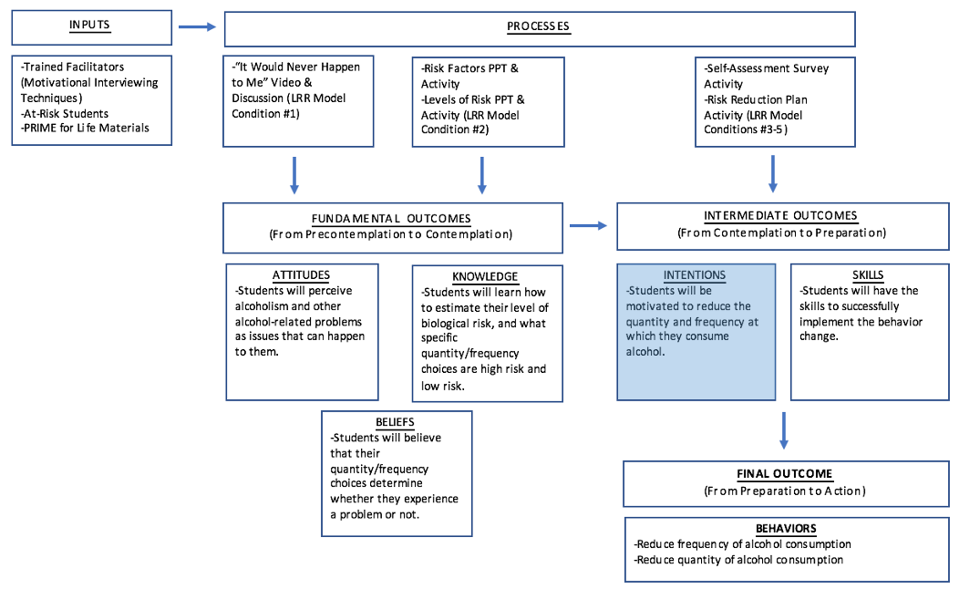
Appendix B: PRIME for Life Logic Model

Student Affairs Assessment Advisory Council ∙ DIVISION OF STUDENT AFFAIRS ∙ Student Affairs Assessment Support Services
Updated 9.26.17
Note. The focus of this learning improvement initiative is on impacting students’ intentions. Given the placement of this outcome in the logic model (shaded box), it’s clear that all three of the fundamental outcomes (i.e., attitudes, knowledge, beliefs) must be met to successfully increase motivation to reduce the quantity and frequency at which alcohol is consumed. As such, changes to the current programming that address one or all of these fundamental outcomes may successfully impact intentions.
Appendix C: The Lifestyle Risk Reduction Model
Overview
As opposed to many other risk reduction strategies, the Lifestyle Risk Reduction Model focuses on the reduction of problems as the ultimate outcome measure, instead of the reduction or prevention of use. While the Lifestyle Risk Reduction Model also concerns itself with reducing use; it posits that another, more critical objective is to reduce a certain kind of use—high-risk use.
Programs that focus on reduction of use generally seek to reduce the number of people using at all, and the frequency with which people use. By contrast, the Lifestyle Risk Reduction Model makes individual behavior change the focal point. The goal is to impact the choices of as many individuals as possible by using a collection of strategies specifically designed to accomplish individual behavior change.
The Five Principles
The Lifestyle Risk Reduction Model suggests that alcohol and drug-related health and impairment problems are lifestyle-related. Lifestyle-related health problems, such as alcoholism, heart disease, and many forms of cancer, can be understood in terms of five principles:
- The first principle states that each person has an inborn level of biological risk (or vulnerability) for developing the health problem. While everyone has some level of biological risk, different people have different levels of biological risk. For example, while anyone could develop heart disease, people with a family history of heart disease have increased biological risk for the disease. Similarly, while both children of parents with alcoholism and children of parents without alcoholism can develop alcoholism, children of parents with alcoholism have 4X increased risk, even if raised separately from the biological parent (Goodwin, ’84). Another way of saying this is that everyone has a trigger level for alcoholism (and other lifestyle-related health problems). Some people have a lower trigger level than others. Persons with a lower trigger level are at increased risk and will generally develop the disease sooner than someone with a standard trigger level.
- The second principle states that lifestyle choices also present risk. Research has linked specific quantity (how much)/frequency (how often) choices to lifestyle-related health problems, like heart disease and alcoholism. How much and how often people exercise aerobically, what makes up their diet, and whether or not they smoke, all influence their risk for heart disease. How much and how often people drink influences their risk for alcoholism, cirrhosis, and other alcohol-related problems.
- The third principle is that the level of biological risk determines how much and how often is high risk. As explained in the first principle, people who are at increased risk biologically will generally develop the disease sooner than people not at increased risk. It will take fewer high-risk quantity/frequency choices to trigger the disease. Therefore, how much and how often is high risk for each person depends on their biological make-up. Heart disease is similar. People with a high biological risk (low trigger level) for heart disease often develop higher levels of cholesterol than others, even when consuming less fat in their diet than others. Therefore, their guidelines for a low-risk diet would need to be different from people who have a lower level of biological risk for heart disease. Their guidelines need to be adjusted (from the standard guidelines given) in order to account for this increased risk. The same applies to alcoholism. People who have increased biological risk (low trigger level) for developing alcoholism also need different guidelines. This is true even though they may have a high tolerance to alcohol, and thus may be less impaired.
- The fourth principle states that the only thing necessary to produce the health problem is for the level of high-risk choices to equal or surpass the level of biological risk. The health problem will then occur regardless of how smart, strong, moral, or emotionally healthy the person is. This is not saying that quantity of drinking diagnoses alcoholism. It is saying that quantity/frequency of drinking, along with inborn biological risk, triggers the alcoholism.
- The fifth principle is that social and psychological factors play an important role in the development of lifestyle-related health problems, by influencing the quantity/frequency choices. However, they do not directly cause the problem. For example, in heart disease, Type A personality and social norms around diet and exercise will influence the rate of heart disease. But norms or personality do not cause heart disease. In the same way, certain personality traits or social norms around drinking will influence the rate of alcoholism, but personality and norms do not cause alcoholism.
The Biology + Quantity/Frequency Formula
The following formula integrates these five principles. It is the basic formula for all lifestyle-related health problems including the most common type of heart disease and many other of today’s health problems. Note that biological factors and quantity/frequency choices make up total risk. They interact with one another so that, depending on the choices made, the health problem either does occur, or does not occur. The quantity/frequency choices needed to trigger the health problem depend on the level of inborn biological risk. Psychological and social factors have arrows pointing to quantity/frequency choices because they influence drinking and drug choices. Examples of psychological influences include values, attitudes, levels of stress, and personality traits such as being particularly impulsive or rebellious, or gregarious. The availability of drugs and alcoholic beverages, and having friends who enjoy heavy drinking, are examples of social influences. It is important to remember that psychological and social factors influence choices, which interact with biological factors to determine whether or not a problem will occur.
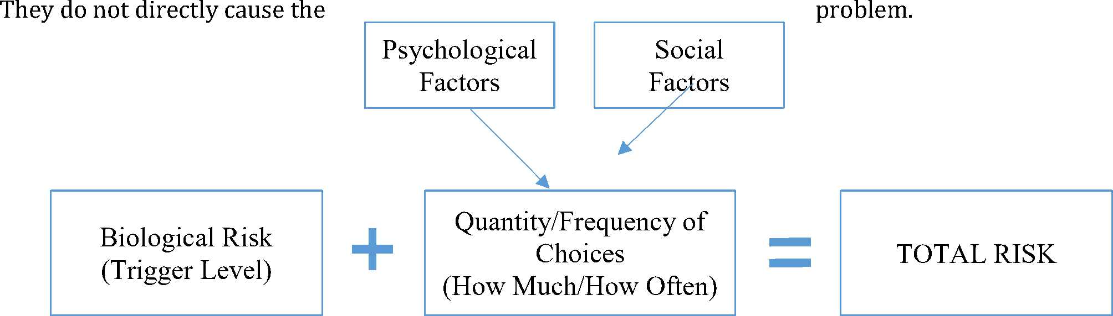

To summarize, the Risk Reduction Model says that alcohol and drug problems result from an interaction of the quantity/frequency choices people make and their levels of biological risk. Psychological and social factors influence the choices people make. Alcohol and drug problems can happen to anyone if they make enough high-risk choices.
While the Risk Reduction Model was first developed to address health problems, it applies equally well to alcohol impairment problems, such as drunk driving. The formula is modified for impairment problems so that trigger level, or biological vulnerability, is replaced by a tolerance level, and situations that create risk are added to the equation.
The Five Conditions for Effective Risk Reduction
To reduce the risk associated with drinking, the Lifestyle Risk Reduction Model states that individuals must learn how to estimate their biological risk for alcoholism and what specific quantity/frequency choices (including abstinence) carry a low risk for problems. Young people need this information coupled with age- appropriate expectations. Without this information, many people will unknowingly make high-risk choices, increasing their risk for health and impairment problems.
While having relevant information about biological risk and low-risk choices has successfully led to prevention of heart disease, relevant information is often not enough for the prevention of alcohol and drug problems. In American society today, many young people and most adults perceive personal risk for heart disease to occur at some point in life. Perceptions of risk for alcohol and drug problems are different because people often hold one or more of the common views (discussed earlier) about what causes alcohol or drug problems. If people do not believe that problems could happen to them, they are not likely to take their alcohol and drug choices seriously—-even if they do know how to estimate biological risk, and what choices are low risk or high risk.
In addition, sometimes people do not have the psychological or social support they need for making low- risk choices. Sometimes people do not know how to make them, even if they know what those choices are. To address these issues, the Lifestyle Risk Reduction Model identifies five conditions prevention efforts should strive to establish. These can be thought of as conditions in people’s lives that increase the likelihood they will not experience alcohol- or drug-related problems. They are as follows:
- Condition One - People must come to believe: “It (an alcohol or drug-related problem) could happen to me, and it is my quantity/frequency choices that will determine whether I experience a problem or not.”
This condition must be established for prevention to be effective. People will not care how much or how often they drink, or use drugs, if they do not feel personal vulnerability—if they do not believe it is possible for problems to happen to them. They must come to truly believe that anyone—not just certain kinds of people can develop problems. They must also understand that quantity/frequency choices have everything to do with causing alcohol and drug problems; that choices matter. This is true in many other areas besides alcohol and drug problems. If people do not believe that AIDS could happen to them, they will not use preventive measures. If they do not believe that skin cancer is likely to happen, they are not likely to limit exposure to the sun. This condition is even relevant to non-health issues such as personal finances. People who do not believe that financial problems could possibly happen to them are not likely to take money management seriously. A variety of critical attitudes must be addressed to effectively accomplish this condition with target audiences. Students often leave alcohol education experiences fortified in their beliefs that they are not “that kind of person,” and therefore do not need to worry about their drinking choices. The first task of prevention education must be to replace the belief, “It happens because of the kind of person you are” with the belief, “It could happen to anyone, including me, and how much and how often I drink matters.”
- Condition Two – People must learn how to estimate their level of biological risk, and learn what specific quantity/frequency choices are high risk and low risk. People can say: “I know what to do to prevent problems.”
The terms “risk reduction,” “low risk” and “high risk,” refer to research-based guidelines on specific quantities and frequencies of drinking. Low-risk choices (which include abstinence) are those choices not associated (statistically) with any known problem outcome. High-risk choices are linked to a variety of health and impairment problems. Just as people must know what quantity/frequency choices about diet and exercise will reduce risk for heart problems, they need to know what specific quantity/frequency choices decrease (or increase) risk for alcohol and drug- related problems.
Past prevention efforts tell us specificity is important. In our field, most efforts to quantify have been vague and counter-productive. To help people understand how much is too much, people have been told things like, “You know you’ve had too much when you have a problem.” That is like saying, “You’ll know you’ve had too much cholesterol when you’ve had a heart attack!” This is certainly not the kind of prevention advice people have gotten for heart disease. They’ve benefited from some very specific guidance, such as exactly how long and how often people should exercise aerobically, or how little saturated fat to eat per day. Without this guidance, people may believe larger amounts of cholesterol, and less exercise, to be low risk than is actually the case. People have also heard that they should drink moderately, or responsibly, if they choose to drink. But how much is moderate? How much is responsible? To many, it is any amount that is less than their friends are drinking. On today’s college campuses, two six packs of beer may seem moderate. Again, guidance needs to be specific and research- based.
- Condition Three - Social factors that support age-appropriate low-risk choices need to be strengthened, and social factors supporting high-risk choices need to be weakened. People can say: “The people around me support me in making age-appropriate low-risk choices.” We could quickly think of dozens of ways our society supports people in making low-risk heart choices. Labeling fat content on foods, making fat-free products available, and encouraging regular exercise are examples. The same thing can, and has already begun, to be done to support low-risk alcohol, tobacco, and other drug choices. Alcohol- free social events, no-smoking policies, and employer drug policies are examples. As shown, many customs, values, policies, and messages influence people’s choices. If there is not adequate social support for low-risk choices, then the prevention professional must help individuals, groups, and communities find ways to build that support. Simply put, people must feel support for making low-risk choices, or they are not likely to make them.
- Condition Four - Psychological factors supporting age-appropriate low-risk choices need to be strengthened, and psychological factors supporting high-risk choices need to be weakened. People can say: “I value what low-risk choices will help me achieve, and I want to make age-appropriate low-risk choices.”
How do psychological factors influence choices? We often think of a person with low self-esteem taking drugs to feel more a part of a group, or to “loosen up” and have fun. No doubt, such people exist; plenty of prevention strategies attempt to build self-esteem. But it is also true that people with high self-esteem may drink in high-risk quantities and frequencies, and thus develop alcoholism, all the while believing that someone with good self-esteem can’t have an alcohol or drug problem. Thus, their beliefs also influence them to make high-risk choices. Someone who is rebellious may drink in ways that flaunt authority. Someone with an anti-social personality may use a socially unacceptable drug like heroin, partly because it feels good, and partly because it is socially unacceptable. Psychological factors are critical to target since they can be such powerful influences on quantity/frequency choices. The prevention professional must ask if people have adequate psychological support for making age-appropriate low-risk choices. And if they do not, how can this condition be improved?
- Condition Five - People learn the necessary skills to make and maintain age-appropriate low-risk choices. They can say: “I know how to make age-appropriate low-risk choices.” People not only need motivation and support for making low-risk choices; they must actually know how to make low-risk choices. For instance, parents can help teach their kids how to turn down a drink without losing a friend. Knowing how to live sober, how to socialize, relax, or engage in recreation without alcohol or drugs are also necessary skills. Prevention efforts should be aimed at giving people skills they need to make age-appropriate low-risk choices.
Summary
The Five Conditions are those conditions under which change is likely to happen. People will be most likely to adopt the desired prevention behaviors (age appropriate low-risk choices) when they believe problems could happen to them and that their choices matter (Condition One); when they know, from research, what is low risk for them (Condition Two); when they have social support for making low-risk choices (Condition Three); when psychological factors are present to overcome attitudes leading to high-risk choices (Condition Four); and when they have skills needed to consistently make low-risk choices (Condition Five).
Which conditions the prevention professional seeks to establish first will depend on how much support or opposition there is to Conditions Three, Four and Five. When there is little support for Conditions Three, Four and Five, establishing them would be the first priority. People without hope, or with very little sense of self-worth, for example, probably will not be motivated to learn how to estimate biological risk or the range of low-risk choices. On the other hand, establishing Conditions One and Two is the first priority when there is fairly strong support for Conditions Three, Four and Five.
Conditions One and Two are the core of the Lifestyle Risk Reduction Model and are unique to it. The Lifestyle Risk Reduction Model is the only prevention model that identifies the cause of problems as being biological factors interacting with quantity/frequency choices with psychological and social factors influencing these choices. Conditions Three, Four and Five are not unique to the Lifestyle Risk Reduction Model, in concept (although their expression with specific wording, such as the link to “low-risk choices” is unique). Some Models, in fact, would explain the cause of problems very similarly to Conditions Three, Four and Five. For example, the Developmental Model would say problems are caused by psychological factors (Condition Four). The Peer Resistance Model would say they are caused by the lack of skills for resisting peer pressure to drink or use drugs (Condition Five). The Risk and Resiliency Model would say they are caused by the interplay of psychological and social factors (Conditions Three and Four). Conditions Three, Four and Five are an integral part of the Lifestyle Risk Reduction Model, though, when they are established in support of Conditions One and Two.

Appendix D: PRIME for Life Results (Related to Intentions to Change Drinking Behavior)
At the four-week posttest, students generally reported that their drinking before the class was not low risk. A significant percentage (21.2% at immediate post-test, 24.1% at four-week posttest) believed their drinking was low risk, but only if they used their definition of low risk, not the low-risk guidelines discussed in the course. These self-reported assessments remained somewhat stable at the four-week posttest, with slightly more students reporting at the four-week posttest that their drinking before the class was not low risk (see Figure 12).
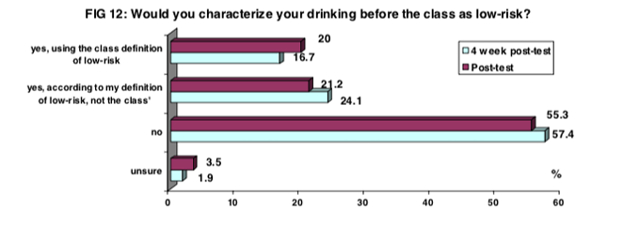

At the four-week posttest, a majority of students (59.3%) agreed or strongly agreed that taking the class changed their thinking about how often and how much they should drink. At the immediate posttest, only 48.2% agreed or strongly agreed. However, students were also more likely to disagree or strongly disagree that the class changed their thinking (22.2% at four-week posttest vs. 8.2% at immediate posttest). See Figure 13.
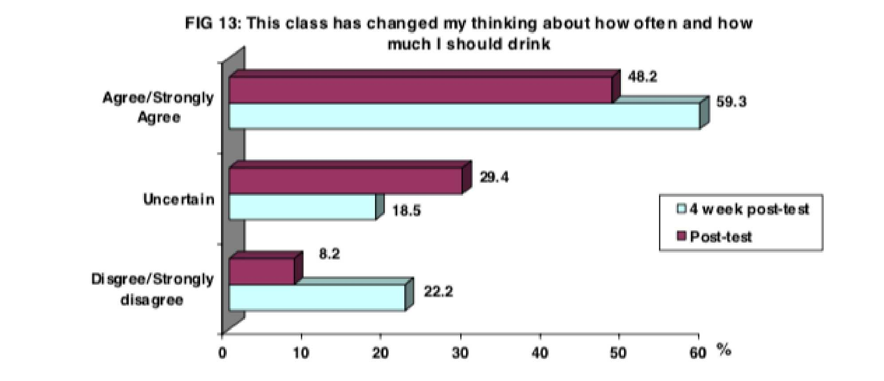
Students were asked about their intentions to change their drinking behavior. A majority of students decided to reduce their drinking levels both at the immediate posttest (72.6%) and at the four-week posttest (72.7%). At the four-week posttest, a greater percentage of students reported a desire to follow their low-risk guidelines (29.1% vs. 26.2%). See Figure 14.
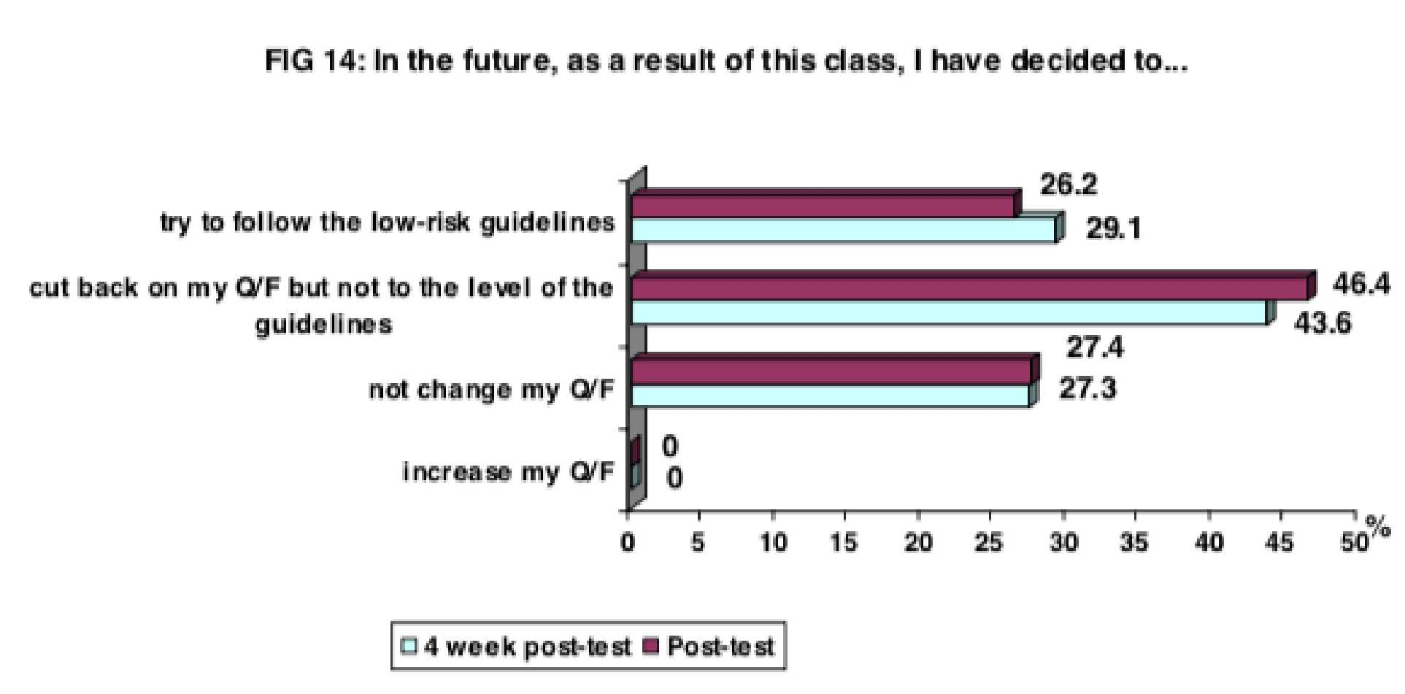
Not only did students report an intention to reduce their drinking levels (or to continue drinking within their low-risk guidelines), but their responses at the four-week posttest indicate that most students followed through with those intentions (see Figure 15). Most students (78%) either followed their low-risk guidelines or cut back on their quantity and frequency of alcohol use since the class. Only 2% report increasing their drinking le
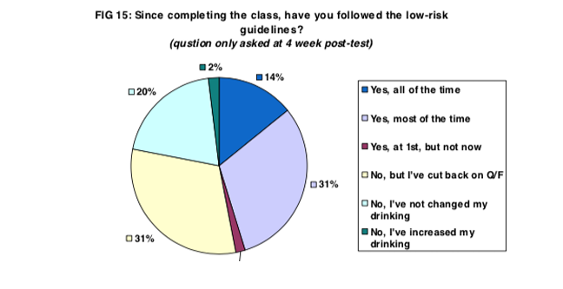
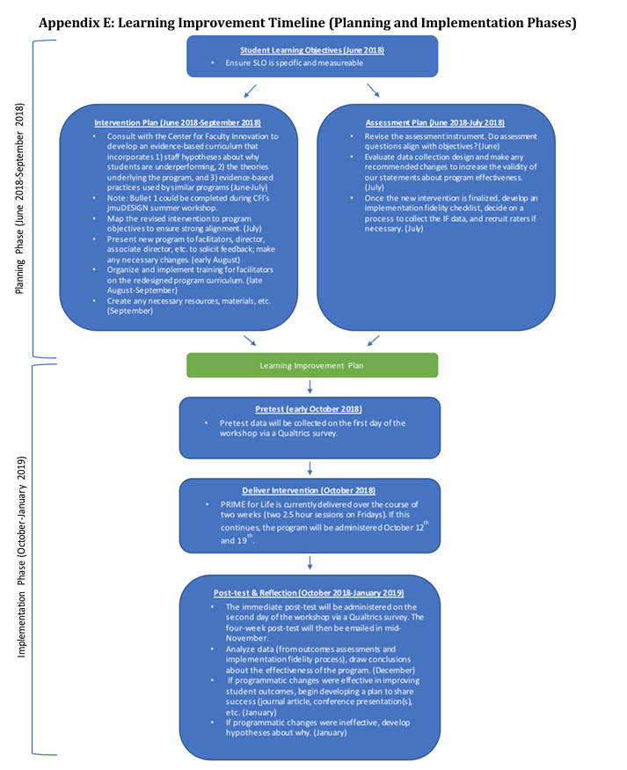

Appendix F: References
Center for Behavioral Health Statistics and Quality. (2015a). 2014 National Survey on Drug Use and Health: Table 6.88B—Alcohol Use in the Past Month among Persons Aged 18 to 22, by College Enrollment Status and Demographic Characteristics: Percentages, 2013 and 2014. Substance Abuse and Mental Health Services Administration, Rockville, MD.
Center for Behavioral Health Statistics and Quality. (2015b). 2014 National Survey on Drug Use and Health: Table 6.89B—Binge Alcohol Use in the Past Month among Persons Aged 18 to 22, by College Enrollment Status and Demographic Characteristics: Percentages, 2013 and 2014. Substance Abuse and Mental Health Services Administration, Rockville, MD.
Hingson, R., Heeren, T., Winter, M., & Wechsler, H. (2005). Magnitude of alcohol-related mortality and morbidity among US college students ages 18–24: Changes from 1998 to 2001. Annu. Rev. Public Health, 26, 259-279.
Hingson, R. W., Zha, W., & Weitzman, E. R. (2009). Magnitude of and trends in alcohol-related mortality and morbidity among US college students ages 18-24, 1998-2005. Journal of Studies on Alcohol and Drugs, Supplement, (16), 12-20.
Motivational interviewing. (n.d.). Retrieved December 31, 2017, from https://en.wikipedia.org/wiki/Motivational_interviewing
Pratt, K. (n.d.). How to Change Behavior: A Theoretical Overview [Web blog post]. Retrieved December 31, 2017, from https://healthypsych.com/how-to-change-behavior-a- theoretical-overview/
Theory of Reasoned Action. (n.d.). Retrieved December 31, 2017, from
http://www.cios.org/encyclopedia/persuasion/Gtheory_1reasoned.htm
Understanding the Lifestyle Risk Reduction Model. (n.d.). Retrieved December 31, 2017, from http://thepdi.com/LRRmodel.pdf
Wechsler, H., Dowdall, G. W., Maenner, G., Gledhill-Hoyt, J., & Lee, H. (1998). Changes in binge drinking and related problems among American college students between 1993 and 1997 Results of the Harvard School of Public Health College Alcohol Study. Journal of American college health, 47(2), 57-68.

