


Student Affairs Learning Improvement Application
Please complete the application below to apply for the learning improvement initiative with Student Affairs Support Services (SASS) within the Center for Assessment and Research Studies (CARS). This initiative is a partnership between SASS and the Division of Student Affairs to focus on the improvement of student learning and development.
At Madison, we value improvement of learning and development, which can be accomplished by wellthought-out programming and assessment. In turn, a complete and coherent application is a first step to making such initiatives successful. Applications are due May 15th.
There are two options for when programs may begin the project: Summer or Fall. In the application, you will be asked to indicate whether you plan to begin the project in the Summer or Fall. Please select a starting date that best aligns with your office schedule. Selected programs will be notified by May 31st.
Please select one starting date: ___ Summer _X_Fall Semester
Although several application questions will ask you to describe previous assessment results and previous improvement efforts, programs will not be selected based on the number of years they have conducted assessment or demonstrated improvement. Rather, programs will be selected based on readiness and commitment to a long-term improvement process. Up to 2 programs will be selected per year based on their readiness and commitment.
Should any questions arise while completing this application, you may contact SASS (SASS@jmu.edu). Once completed, submit your application to the co-chairs (Sarah Sunde, sundesa@jmu.edu; Kathleen Campbell, campbekl@jmu.edu) of the Student Affairs Assessment Advisory Council for review.
Student Affairs Assessment Advisory Council · DIVISION OF STUDENT AFFAIRS · Student Affairs Assessment Support Services
Updated 9.26.17
- Program Overview
Please provide general information about your program. Responses are meant to be short, as you will have the opportunity to provide more detail in the sections below.
- Name of applicant’s office:
Community Service-Learning (CS-L)
- Name of program of interest:
Community-Engaged Federal Work-Study (CFWS)
- Purpose of the program (1 paragraph max):
The purpose of the community-engaged federal work-study program is to match eligible students with community-identified priorities in a mutually beneficial partnership between students and local community partners. Meaningful student service will enhance the capacity of community partners while supporting student learning. By participating in pre-service orientation, ongoing reflection sessions, and service work, students should complete this experience with the knowledge of how to ethically and thoughtfully serve.
- Number of students who complete the program:
~40 students per semester
- Number of staff members who facilitate the program:
2 Full Time Staff Members, 2 Graduate Assistants (CSPA and Assessment GAs)
- Point person/primary overseer of the program:
Briana Craig, Community Engagement Assessment Lead
Current Assessment of Student Learning Outcomes
II.
In the space below, please provide a brief summary of the program of interest. In your summary, please include 1) your student learning and development outcomes; 2) a general/broad description of the programming in which students are provided the opportunity to learn or develop; and 3) the procedures used to assess whether the desired outcomes are being met. Careful consideration of these questions is crucial to the success of a learning improvement project. Please address 1, 2, and 3 within 1 to 2 pages.
The Office of Community Service-Learning strives to cultivate “positive social change through mutually beneficial service partnerships, critical reflection, and the development of engaged citizens through our values of humility, intentionality, equity, accountability, service, relationships, and learning.” Therefore, the ultimate distal outcome of all programs in the office is that students become active citizens, or in other words, become individuals who are empowered to cultivate positive social change by supporting community partners in achieving specific goals.
To develop active citizens, all CS-L programs should support one of the three goals in our 3x3 model (Figure 1): (1) Social justice and inclusion, (2) Civic Learning, and (3) Self-authorship. Each of these general goals can be specified further into three levels: (1) Intrapersonal (related to the self/individual), (2) Interpersonal (related to relationships with others), and (3) Systemic (related to the dynamics of larger communities, their values, and their policies).
- .) Current Learning Outcomes of Community-Based Federal Work-Study (CFWS):
To achieve the overall distal outcome of developing active citizens, CS-L has specified the following (intermediate) learning outcomes for CFWS. Below you will see each learning outcome under one of the three general goals for the office and the level of focus is noted in parentheses.

Social Justice and Inclusion
Goal: Students will be able to integrate “knowledge of social justice, inclusion, oppression, privilege and power into one’s practice” with advocacy for “issues of social justice, oppression, privilege, and power that impact people based on local, national, and global interconnections”(ACPA & NASPA, 2015, p. 30).
Learning Outcomes: As a function of CFWS, 80% of involved students will be able to…
- Describe two or more dimensions of their social identity” (Self)
- Analyze a social, political, or environmental issue in the local community (Systemic)
- Increase in awareness of the connection between the university and local community (Systemic)
Civic Learning
Goal: Students will have the knowledge to be active and responsible participants in a representative democracy dedicated to the common good.
Learning Outcomes: As a function of CFWS, 80% of involved students will be able to…
- Describe how the local government works (Systemic)
- Identify at least one political representative for the area (Self)
- Identify a political issue at the local, state, national, or international level related to one’s service (Systemic)
Self-Authorship
Goal: Students will develop self-authorship, which is a “shift from uncritical acceptance of external authority to critical analysis of authority in order to establish one’s own internal authority” (Hodge, Magolda, & Haynes, 2009)
Learning Outcomes: As a function of CFWS, 80% of involved students will be able to…
- Explain how their values influence their actions (Self)
- Appraise situations through empathetic perspective taking (Interpersonal)
- Increase in their sense of belonging in the community (Self) The focus of this application.
Connection of Goals to Active Citizenship:
One definition of an Active Citizen is an individual who prioritizes the community in their values and behaviors and see the world through the lens of social issues that matter to them and their communities (Source). We believe that the Social Justice and Inclusion Goal supports the development into an active citizen because individuals need to learn about social issues to take action on issues that matter to them. The Social Justice and Inclusion goal intends to incorporate knowledge and inspire advocacy, which we believe are essential parts of the definition of active citizens. The Civic Learning Goal connects to active citizenship because civic engagement is a behavior that allows individuals to become involved in social issues. This supports active citizenship because involvement with social issues is also a key aspect of active citizenship. The Personal Growth Goal helps students establish an internal authority, which may assist them in determining what social issues truly matter to them (Hodge et al., 2009). Establishing which social issues matter is an essential aspect of active citizenship, because active citizenship is defined by an individual’s ability to see the world through the lens of those social issues.
- .) Description of Programming:
Students in CFWS are matched with a variety of community-based organizations in the Harrisonburg and Rockingham area. Students interview for positions and are ultimately paired with a community partner that is accessible, aligned with their interests, and a good match for accomplishing stated goals (List of community partners may be found here). Students are expected to commit an entire academic year, but on occasion may only contribute for a semester due to competing commitments. Students may re-enroll in CFWS for subsequent years depending on community priorities and previous student performance.
The CS-L office recognizes that participation in strong, direct service alone does not develop students into active citizens, as the service must be accompanied by training, education, critical reflection, and other elements that contribute to the “learning” piece of service learning (Jacoby, 2014). The Alternative Break Program (ABP) uses the Active Citizen Continuum (ACC) located in Figure 2 to design intentional service trips and model an individual’s progress as they engage with their surrounding community. Although not traditionally used for the CFWS program, we believe the ACC can be applied to CFWS to explain the impact of service work on a student’s progression into an active citizen. It begins with the lowest level of community engagement: membership. When someone is simply a member of a community, they are not involved and likely not aware of the strengths and challenges that exist within the community and may rely on uninformed assumptions. Once a member interacts with the community to a small degree at the individual, interpersonal, and systemic level, they may take the next step to be a volunteer. Volunteers participate in service but do not understand their motivation, have not developed an awareness of how to interact respectfully with community members, and are not informed about the complexity of community issues. In some instances, volunteers, although well-intentioned, may do more harm than good. Once a volunteer understands more about root causes of strengths and problems in the community, then they can develop into a conscientious citizen. For a conscientious citizen to develop into an active citizen, they must take ethical and intentional action, and integrate the community into their values and priorities.
To help move students from “members” to “active citizens”, the CFWS program includes intentionally constructed critical reflection meetings for students to make meaning from service experiences. First, before beginning service, students attend a pre-service orientation session. The pre-orientation meetings act as an introduction to the “What” in Figure 2 by first exposing students to the strengths, challenges, and community-identified priorities in the community that they may be addressing. To facilitate meaningmaking, CS-L faculty facilitate two types of meetings: monthly group reflection sessions and several one- on-one meetings at the beginning of CFWS, end of CFWS, and as-needed. These meetings provide opportunities for students to describe their experience and then to examine their descriptions to shed light on their role in the community, their relationship with staff and clients at their community partner, their motivation, and how their experience connects to their courses. By incorporating these reflection opportunities, we provide opportunities for students to ask, “So what?” questions about their “What” reflections. This engenders more cognitive complexity and builds the understanding necessary to move from volunteer to conscientious citizen. The purpose of the one-on-one meetings is to support students in integrating the reflections from the large group sessions with the freedom to explore in more depth the challenges, successes, and unanswered questions they have been unearthed in the reflection sessions and at their community partner. The pre-service orientation, reflection sessions, and one-on-ones should support the aforementioned learning objectives, by incorporating intentional reflection, and guided workshops. Relevant to this project, the meetings are structured such that the SOB objective maps to specific activities within meetings.
- .) Current Assessment Procedures:
Currently, there is no assessment of SLOs for CFWS. CFWS students complete an end of semester evaluation, which asks each individual questions about their overall experience, their community partner, their satisfaction with monthly meetings, and their recommendations for future workshops. The goal of this evaluation is directed towards gaining feedback about the program, rather than measuring SLOs.
You may want to improve learning/development related to all outcomes. However, for this partnership, you will need to select 1 or 2 learning/development outcomes on which to focus. The most crucial information you will provide in this section concerns the program theory that guides your program. In other words, how was your programming intentionally designed to achieve the student learning and development outcomes you’ve decided to focus on for this partnership? Programs that have not given this considerable thought will find it difficult to engage in a learning improvement initiative.
Focus of Partnership with SASS
III
- Student learning/development outcome(s) selected for the improvement initiative (1 or 2):
As a function of Community-based Federal Work Study, 80% of involved students will increase in their sense of belonging in the community.
- Description of why these outcomes were selected for the learning improvement initiative. Why are these outcomes important to your department? (1-2 paragraphs):
According to the ideas presented in the ACC, increasing sense of belonging (SOB) in the community will help achieve the distal outcome of increasing community engagement by developing active citizens. By participating in CFWS, a student will already be at the volunteer stage of the ACC, because by nature of the program they will be completing well-intentioned service work. However, by increasing a student’s sense of belonging in the community, the program could bring community problems more into the forefront of students’ values and priorities. If active citizenship is defined by shift in values to shared community values, and an increase in sense of belonging is marked by individuals adopting shared values (McMillan & Chavis, 1986), then we believe that if this program successfully increase SOB, then students will develop along the ACC towards active citizenship (Schur, 2003).
Additionally, this SOB outcome supports the personal growth aspect of the 3x3 goal model, especially on the interpersonal relationship domain. When a student feels a greater sense of belonging with their community, not only does it positively influence their personal growth, but it fosters connections with other individuals in the community (Department of Education, 2000; McMillan & Chavis, 1986) Part of the mission of CFWS is achieved through mutually beneficial service partnerships, suggesting that students should feel positively connected, benefited by, and valued by individuals at their placement site, and vice versa (Jacoby, 2014; Additional Online Resource).
- Description of why these outcomes are important to JMU (1 paragraph):
JMU’s vision is to “be the engaged university: engaged with ideas and the world.” To effectively engage with the world requires the knowledge, skills, and abilities necessary to engage with the community. In doing so, the university hopes to inspire engaged learning, civic engagement, and community engagement in the student body. CFWS outcomes are important to JMU, because they support the third facet of that vision, community engagement. On the JMU website, community engagement is defined as “fostering mutually beneficial and reciprocal partnerships, ranging from local to global, that connect learning to practice, address critical societal problems and improve quality of life.” We believe that through increasing a student’s connection and belonging to the community, we can promote mutually-beneficial local partnerships.
- Description of the specific programming (curriculum, pedagogy, intervention, etc.) used to provide students with an opportunity to meet the selected outcome(s) only. An objective-to-curriculum map should be included as part of this description (may be attached as an appendix):
Sense of Belonging in the Community:
Before discussing how the program provides an opportunity to meet the selected intermediate outcome of sense of belonging in the community, it is important to have a clear definition of sense of belonging in the community. This way, we can avoid vagueness in connecting program elements to our learning outcome. For our learning outcome, we will use a definition of sense of community put forward by McMillan and Chavis (1986), which involves 4 dimensions:
- Membership - The feeling of being a part of the community.
- Influence - A sense of mattering and making a difference in the community.
- Integration and Fulfillment of Needs – The community meets the needs of the individual.
- Emotional Connection – A commitment to the shared experiences, places, and people that make up the community.
This definition will act as a guide for how each program component will be connected to a student’s overall sense of belonging in the community. To achieve our chosen objective of increased SOB, each of the four dimensions of SOB are represented in the logic model (Appendix). Although this definition is older, McMillan and Chavis’ definition is still resounded in recent literature on local communities (Hooper et al, 2018), and has also been applied to college communities (Strayhorn, 2018) and the workplace (Garrett, Spreitzer, & Bacevice, 2017).

Description of Program Components:

Site Placement
Although we recognize that students may have different experiences with their community partner, we believe the commonalities in our program will support our student learning objectives. The program components that contribute to student development should be experienced by every student, no matter their placement site. All students will be committing up to 10 hours a week of direct service with a community partner (i.e., Site Placement in Appendix). In McMillan and Chavis’ (1986) article, an individual feels as though they have influence when they simultaneously feel as though they can influence their community, but also respect the influence that the community has on them. This balance of influence is believed to be a feature of the service work, because CFWS promotes mutually beneficial partnerships, where the students and the community partners are both the beneficiary and the focus (Jacoby, 2014).
Additionally, site placement will help build emotional connection. A study conducted by the Department of Education in 2000 polled Federal Work-Study students employed in communitybased service positions. They found that 88% of students reported they would take a similar job in the future, 62% reported their position supported their academic or career goals, 68% reported the experience positively influenced their academic performance, and 81% reported their experience would influence them to continue service activities in the future. These results suggested an overall positive experience with others and the surrounding community, which we believe supports emotional connection. According to McMillan and Chavis (1986), “the more positive the experience and relationships, the greater the bond [emotional connection]” (p 13).

Pre-Service Orientation
Many of the pre-service orientation activities are logistical in nature. Students learn how to report their hours, and what to expect during their service work. However, pre-service orientation activities also intentionally build to establish relationships between students and the CS-L faculty. Students should realize that CS-L faculty and graduate assistants are here to help and support their growth. In keeping with CS-L’s values of intentionality and relationships, students will engage in “pre-flection” where they will be prompted to consider their hopes, fears, and goals for their service experience. This will set the expectation for reflection and meaningmaking. These more meaningful prompts and conversations will enhance the emotional connection students will feel with CS-L staff, their peers, and support them in discussing with their community partner their rationale for serving (Ash & Clayton, 2009).
Although not done in previous years, the pre-service orientation would also be a good opportunity to inform students of the learning objectives of CFWS, so students feel excited, inspired, or motivated by the idea that they will grow through CFWS. We believe informing students of learning objectives is important for engagement in learning and focusing students on their development (Dean et al., 2012). We additionally believe this is the opportunity to introduce the concept of community membership to the students. Membership is supported, because orientation will be structured such that students can learn that they have a place in the JMU and Harrisonburg community. A programmatic change to incorporate a buddy system will be implemented, such that each CFWS student is paired with another student in another placement site. The buddy system encourages camaraderie and provides an opportunity for peers to recognize each other’s accomplishments, feel more comfortable at group reflections, and express opinions freely. All of these aspects of the buddy system not only build membership (McMillan & Chavis, 1986), but also sense of belonging in general (Huppert, 2017).
Group Reflections
The purpose of the group meetings is two-fold. Firstly, the group meetings provide an opportunity for students to engage in critical reflection with their peers. Critical reflection is an evidence based-process that “generates, depends, and documents learning” and has been used in the applied learning (e.g., service learning, internship, study abroad) context to aid the achievement of learning outcomes (Ash & Clayton, 2009).
Secondly, group meetings serve as an opportunity for education. During this time, CS-L faculty or invited guests facilitate informative sessions on a variety of topics, including social issue education, history of the Harrisonburg community, and career and academic planning. We expect both the critical reflection and information sessions will contribute to developing SOB. Although not all information sessions will align with student SOB, we do expect that some, such as the history of the Harrisonburg community, will increase students’ SOB. By learning about places, history, and shared experiences, group meetings should support emotional connection (Smith & Sobel, 2014).
Research suggests that students involved in service due to the influence of a group (e.g., sorority, club, internship) have greater SOB than students who seek out service individually. This finding suggests that students feel more emotional connection through service because of the organization that coordinates service opportunities (Soria, Troisi, & Stebleton, 2003). Therefore, the group aspect of these group meetings alone can help students build their SOB. Through hearing about other student’s experience in the community, students may feel more familiar with the Harrisonburg community, and thus feel more belonging to the community. Although not a measured outcome, students may also feel more belonging to the university by interacting with other like-minded JMU students.

One-on-one Meetings
The one-on-one meetings provide each CFWS student an opportunity to practice critical reflection at the individual level, which will continue to foster student development (Ash & Clayton, 2009). The critical reflection present in both group and one-on-one meetings will loosely follow the “What? So What? Now What?” Model based on the Kolb Experiential Learning Cycle. Additionally, these meetings serve to cement the student’s relationships with CS-L faculty members, helping them feel more supported, and belonging in the program. This should relate back to the Integration and Fulfillment of Needs element of the sense of community definition, as this is the best time for students to come forward about their needs, and have those needs addressed. Problems may arise with workplace communication, transportation issues, or other aspects of the job, and hinder a student’s comfort with the community, or negatively impact their experience and development. The one-on-one meetings are intended to help mitigate these problems, and as a result, help to achieve the integration and fulfillment of individual needs aspect of our definition of community belonging. According to McMillan and Chavis (1986), an individual’s sense of community can only increase proportionality to the degree by which “communities successfully facilitate person-environment fit (meeting of needs) among members.” In the article, these needs include rewards such as reinforcement, status of membership, success of the community, and the competence of others in the community. Through the one-on-one meetings, we hope to meet two of these needs by reinforcing what the students are doing (e.g., praising good work) and foster their success in the placement (e.g., helping problem solve when things are not going well).
- Describe how this programming is expected to result in the desired student learning/development outcome(s). In other words, please explain the logic behind why certain program features were chosen to achieve the selected outcomes. This is often referred to as program theory or logic. If you are unfamiliar with these terms, please watch this short introductory video before constructing your response (1 page max). If you need support using program logic to develop curriculum/programming, please visit JMU’s Center for Faculty Innovation (CFI):
A Logic Model can be found in the Appendix.
- Summarize the results of previous assessment related to the selected outcomes (1 page max): There has been no assessment related to the selected outcome, only a loosely structured evaluation at the end of each semester.
The most relevant evaluation questions for the SOB objective are displayed in the tables below.
Table 1.
Fall 2018 Data for Question 24
# | Question | Strongly Disagree |  | Disagree |  | Agree | Strongly agree |  | Total Number
1 | Through the FWS experience, I built a strong relationship with my community organization. | 0.00% | 0 | 0.00% | 0 | 7.14% | 1 | 92.86% 13 | 14
2 | Through the FWS experience, I connected more with the community. | 0.00% | 0 | 0.00% | 0 | 28.57% | 4 | 71.43% 10 | 14
5 | This experience has better prepared me to be an engaged member of the community after graduation. | 0.00% | 0 | 0.00% | 0 | 46.15% | 6 | 53.85% 7 | 13

Table 2.
Spring 2019 Data for Question 24
# Question |  | Strongly Disagree | Disagree Agree | Total  Strongly agree  Number
 | 1 Through the FWS experience, I
 | built a strong relationship with my community organization. | 0.00% 0 | 2.86% 1 34.29% | 12 62.86% 22 35
 | 2 Through the FWS experience, I
 | connected more with the community. | 0.00% 0 | 8.33% 3 30.56% | 11 61.11% 22 36
 | 5 This experience has better prepared me to be an engaged | 0.00% 0 | 5.56% 2 38.89% | 14 55.56% 20 36
member of the community after graduation.
Note. The Spring 2019 survey was split into an anonymous and non-anonymous section, and this question was included in the anonymous section. The Fall 2018 survey included the same questions without anonymity.
IV. Action Plan
In this section, you will be asked to consider why the student learning/development outcomes you selected are not being met and propose possible strategies for addressing these obstacles.
- For each selected outcome, provide an explanation/hypothesis about why current programming is not supporting student learning/development to the degree you desire (1 page max):
The office has not been assessing this program with respect to SOB in the community. Therefore, it is difficult to determine whether the current programming supports student development of SOB; there is simply no evidence.
The only programmatic data collected is an evaluative, self-report survey taken at the end of each semester, so we can only examine data from one point in time. With this current structure of assessment, it is impossible to determine whether the program helped students, because we do not know how students related to their community before participating in CFWS.
Additionally, there were inconsistencies with the measurement tool, so data cannot be connected longitudinally. This data issue occurred because the survey was conducted anonymously during some semesters, and non-anonymously during other semesters. Additionally, if data are collected anonymously as was done in 2019, there will be no way to link pre-test and post-test scores if both are collected.
Moreover, the SOB outcome may be influenced by community partner. Due to the nature of the program, each student is assigned to a specific community partner. There are a variety of social/community issues addressed, work environments, and student responsibilities at each partner. Students serving with certain partners may have more or less opportunity to learn and develop to the degree we desire. Without a solid assessment strategy, it is difficult to say whether this differential effect occurs, and to what extent, but this should be examined.
- Prior to this new partnership with SASS, have you tried to improve student learning/development related to these outcomes? If so, please describe the improvement initiatives. Have those initiatives been successful? (1 page max):
The CFWS programs tries to incorporate feedback from the end-of-semester evaluations. This feedback most often results in changes to the monthly group meetings, since those are within CS-L’s control. In extreme cases, the feedback received could potentially influence whether we continue working with certain community partners.
However, these evaluation-based adjustments are independent of the learning goals. After a change in leadership, the office has only recently redone the student learning goals and outcomes to the ones listed above, so there has not been a lot of opportunity for improving them, as we do not yet know how well they are being achieved in the first place.
- Based on your answers to the questions above, what changes to a) your programming and b) your assessment processes do you believe are necessary to demonstrate improvements in student learning/development?
- Programming Changes
Because each student will have a different experience from their partner, the group meetings provide the biggest opportunity to reach all students in a similar way. Although each CFWS program component contributes to our student learning outcomes, special attention will be given to this common component. The group meetings should be designed and implemented intentionally, such that each activity supports student development. This way, if there is poor implementation fidelity at the partner, or other issues outside our control, each individual should still have exposure to activities, which aid progress into active citizenship.
- Assessment Changes
To adequately determine whether CFWS supports the intended outcomes, there are three major changes we would like to make to the assessment process:
- Pre/Post Design. Our assessment process needs to shift from evaluative, to an assessment model which reflects the “Weigh Pig, Feed Pig, Weigh Pig” Model. Through the use of a pre and post-test we hope to better capture the development of the students.
The ”Weigh Pig, Feed Pig, Weigh Pig” Model: http://www.learningoutcomesassessment.org/documents/Occasional_Paper_23.pdf
- Valid Measures. We want to measure sense of belonging with a relevant and well-researched measure with good psychometric properties, not a scale with unknown psychometric properties. In doing so, we can help ensure that we are properly capturing the outcome.
- Consistency. We want to assess students the same way every semester, so that we can longitudinally examine students who stay in the program for many semesters and examine how changes to the program effect student growth each semester.
d. Provide a detailed timeline that articulates your plan to improve student learning/development to the degree you desire. This timeline should include 1) whether you plan to begin this work in Summer or Fall, 2) plans to initially assess the program, 3) plans to make programmatic changes, and 4) plans to re-assess the program:

Assessment Plan:
This work will begin in the upcoming fall:
- The assessment will include three timepoints to accommodate students who stay for multiple semesters, as well as students who start later in the academic year.
- The first timepoint will be in the beginning of the fall semester at the Pre-Service Orientation (Time 1), and include all students participating in CFWS in the fall.
- The second timepoint will be at the end of the fall semester (Time 2), this will serve as a postprogram assessment for students doing CFWS in the fall, and well as a pre-program assessment for new students beginning in the spring.
- After Time 2, the CS-L staff will critically examine the results of the fall students for program effectiveness and consider how to adjust the program in the following semester.
- In the spring semester, the CFWS program will undergo the agreed upon adjustments.
- All students will complete an assessment at the end of the spring semester (Time 3), this will serve as a post-program assessment for students who began in the spring, and also as point of longitudinal comparison for students in the Fall (see Table 3 and Figure 4)
Table 3
Timeline of Assessment
Tentative Dates | Plan of Action
August | - Start of Fall Semester (Beginning of Learning  Improvement Initiative)  - CFWS Pre-Service Orientation  o Administer Pre-Assessment at beginning of  Orientation Session (Time 1)
September | - 10hrs/week of Service  - Monthly Reflection Meeting  - One-on-one Meetings
October | - 10hrs/week of Service  - Monthly Reflection Meeting
November | - 10hrs/week of Service  - Monthly Reflection Meeting
December | - 10hrs/week of Service  - One-on-one Meetings  - Monthly Reflection Meeting  o Administer Assessment at the end of the final group meeting of the semester (Time 2).  - End of Fall Semester  - Evaluate this semester’s assessment results.
January | - Based on the Assessment Results, this is the time to decide on programmatic changes to be made.  - Start of Spring Semester  - Monthly Reflection Meeting
February | - 10hrs/week of Service  - Monthly Reflection Meeting  - One-on-one Meetings
March | - 10hrs/week of Service  - Monthly Reflection Meeting
April | - 10hrs/week of Service  - Monthly Reflection Meeting
May | - 10hrs/week of Service  - One-on-one Meetings  - Monthly Reflection Meeting  o Administer Assessment at the end of the final group meeting of the semester (Time 3).  - End of Spring Semester
 | • Evaluate this semester’s assessment results.
Note. All three time periods for assessment will include the same battery of assessments.

Figure 4.
Assessment Timeline fo r each Type of Student
Note. Xs represent a period of assessment for a student, dotted lines represent a period of intervention.
Commitment to Partnership
V.
One of the most important resources needed to evidence student learning improvement is time. As such, each program will commit 10 hours per week to the initiative. This amount of time is necessary to think critically about the program, collect evidence regarding student learning and development, and engage in evidence-based, intentional program redesign. By committing this time up front, programs will be able to distribute other responsibilities accordingly.
- Weekly Time Commitment (10 hours/week)
Please select a Lead Coordinator who will serve as the primary contact and chief overseer of the initiative. This person may choose to commit all ten hours each week, or assemble a team to share the workload. Note: Graduate assistants may lend support where needed, but most decisions/discussions will require extensive familiarity with the program over several years, an understanding of the program theory/logic behind the program, knowledge of departmental resources, and a level of authority beyond what most graduate students possess. As such, graduate assistants may not serve as lead coordinators and should contribute less than 1/3 of the total hours spent on the initiative each week.
- Support from Direct Supervisor (1 hour/week)
Regular contributions from upper-level administrators are crucial to the long-term success of a learning improvement initiative and, in turn, the future of the program. Direct Supervisor, please sign below to indicate a commitment of 1 hour per week to the learning improvement project detailed in this application. This time may be spent in whatever manner is most helpful to the program.
Lead Coordinator:
(Name)
(Signature)
(Date)

Other Team Members (names only; no signatures required):
Direct Supervisor (1 hour commitment each week):
(Name)
(Signature)
(Date)
Director:
(Name)
(Signature)
(Date)
References
ACPA & NASPA. (2015). Professional competency areas for student affairs educators. Washington, DC: Authors.
Ash, S. L., & Clayton, P. H. (2009). Generating, deepening, and documenting learning: The power of critical reflection in applied learning. Journal of Applied Learning in Higher Education.
Dean, C.B., Hubbell, E.R., Pitler, H., and Stone B.J. (2012) Classroom Instruction That Works http://www.ascd.org/publications/books/111001/chapters/Setting-Objectives-and-Providing- Feedback.aspx
Garrett, L. E., Spreitzer, G. M., & Bacevice, P. A. (2017). Co-constructing a Sense of Community at Work: The Emergence of Community in Coworking Spaces. Organization Studies, 38(6), 821–842.
Hodge, D. C., Baxter Magolda, M. B., & Haynes, C. A. (2009). Engaged learning: Enabling self-authorship and effective practice. Liberal Education, 95(4), 16-23.
Hooper, P., Foster, S., Knuiman, M., & Giles-Corti, B. (2018). Testing the Impact of a Planning Policy Based on New Urbanist Planning Principles on Residents’ Sense of Community and Mental Health in Perth, Western Australia. Environment and Behavior.
Huppert, M (2017, October 25) Employees share what gives them a sense of belonging at work. Retrieved from https://business.linkedin.com/talent-solutions/blog/company-culture/2017/employees-share- what-gives-them-a-sense-of-belonging-at-work
Jacoby, B. (2014). Introduction to Service-Learning. Service-Learning Essentials: Questions, Answers, and Lessons Learned.
McMillan, D. W., & Chavis, D. M. (1986). Sense of community: A definition and theory. Journal of Community Psychology, 14(1), 6-23.
Schur, L. (2003). Employment and the creation of an active citizenry. British Journal of Industrial Relations, 41(4), 751-771.
Smith, G. A., & Sobel, D. (2014). Place-and community-based education in schools. Routledge.
Soria, K., Troisi, J., & Stebleton, M. (2003). Reaching out, connecting within: Community service participation and sense of belonging among college students. Higher Education in Review 9: 65–85.
Strayhorn, T. L. (2018). College students' sense of belonging: A key to educational success for all students. Routledge.
The National Study of the Operation of the Federal Work-Study Program:Summary Findings from the Student and Institutional Surveys 2000 https://www2.ed.gov/offices/OUS/PES/finaid/FWS_summary_dec_2000.pdf
Figure 1. CS-L 3x3 model for Student Learning Goals
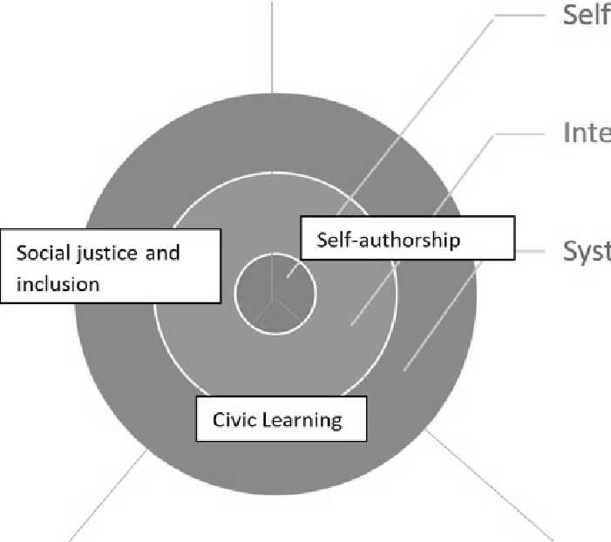

Note. CS-L has organized its vision for student learning as an integration of these main goals (Social Justice, Self-Authorship, and Civic Learning). To add specificity to otherwise broad goals, each examined at the self, interpersonal, and systemic levels. This allows the goals to have a natural path of development as students may find that they need to develop at the individual (self) level before reaching goals at the interpersonal level, and then the systemic level.
Figure 2. The Active Citizen Continuum
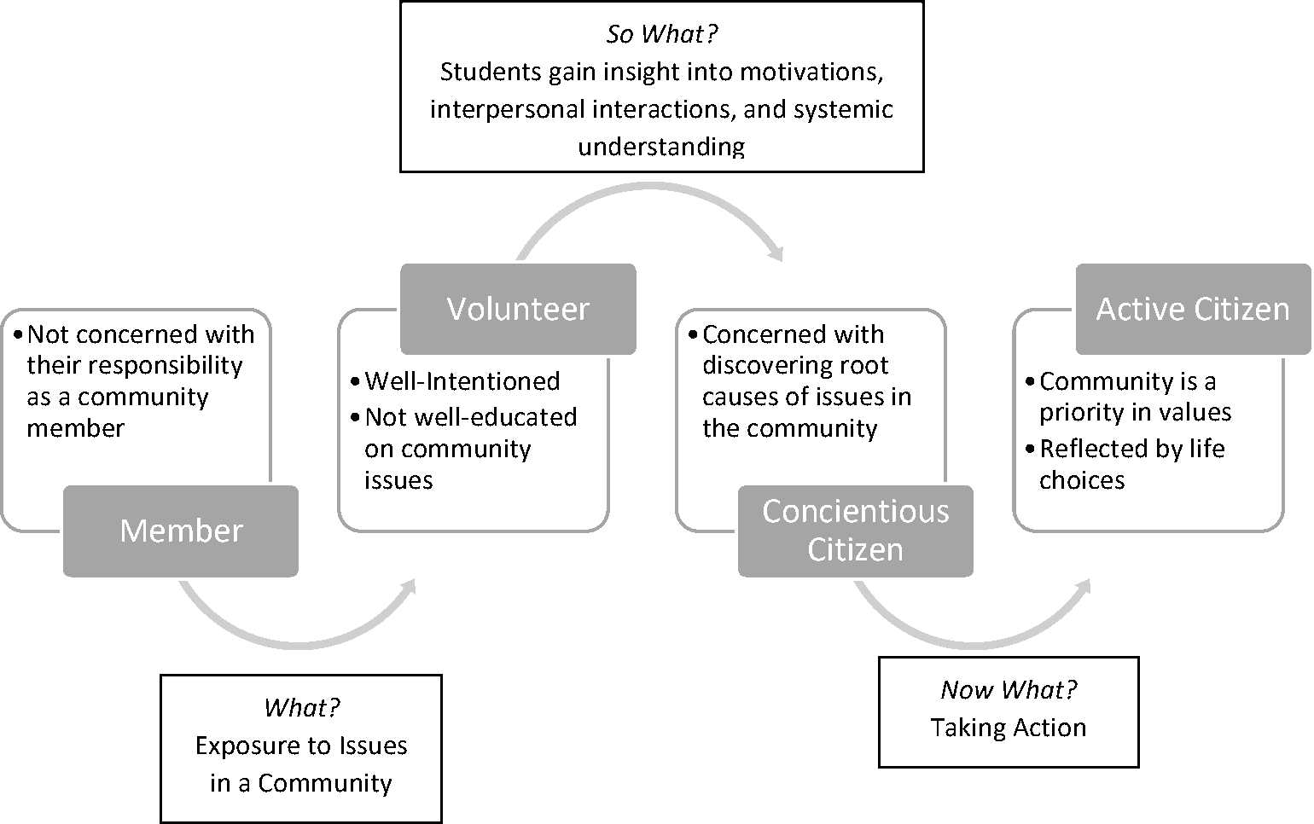
Note. This figure is based on the continuum developed by Break Away (found here).
Appendix:
Logic Model of Intermediate and Distal Outcomes
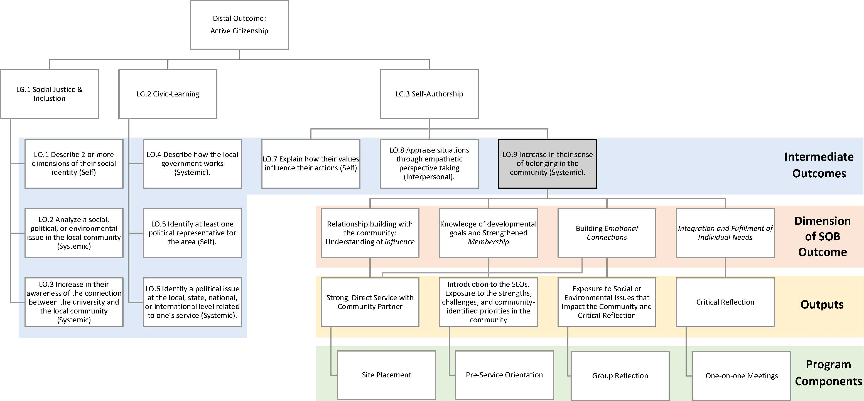

Note. Program components refer to the actual activities and curriculum implemented in CFWS for the intermediate outcome (or Learning Objective – LO) of Sense of Belonging. The components that should influence that outcome, based on research and theory are, site placement, pre-service orientation, group reflection and individual reflection. These program components produce certain outputs, which influence the intermediate outcome (i.e., SOB . The dimensions of SOB, Influence, Membership, Emotional Connection, and Fulfillment of needs were based on the work of McMillan and Chavis (1986 who proposed that these were dimensions of the larger construct of sense of community (SOB . Each LO is connected to a Learning Goal (LG , which all connect to the distal outcome of creating active citizenship.

