


Student Affairs Learning Improvement Application
Please complete the application below to apply for the learning improvement initiative with Student Affairs Support Services (SASS) within the Center for Assessment and Research Studies (CARS). This initiative is a partnership between SASS and the Division of Student Affairs to focus on the improvement of student learning and development.
At Madison, we value improvement of learning and development, which can be accomplished by wellthought-out programming and assessment. In turn, a complete and coherent application is a first step to making such initiatives successful. Applications are due May 15th.
There are two options for when programs may begin the project: Summer or Fall. In the application, you will be asked to indicate whether you plan to begin the project in the Summer or Fall. Please select a starting date that best aligns with your office schedule. Selected programs will be notified by May 31st.
Please select one starting date: Summer
__X _ Fall Semester
Although several application questions will ask you to describe previous assessment results and previous improvement efforts, programs will not be selected based on the number of years they have conducted assessment or demonstrated improvement. Rather, programs will be selected based on readiness and commitment to a long-term improvement process. Up to 2 programs will be selected per year based on their readiness and commitment.
Should any questions arise while completing this application, you may contact SASS (SASS@jmu.edu). Once completed, submit your application to the co-chairs (Sarah Sunde, sundesa@jmu.edu; Kathleen Campbell, campbekl@jmu.edu) of the Student Affairs Assessment Advisory Council for review.
Student Affairs Assessment Advisory Council · DIVISION OF STUDENT AFFAIRS · Student Affairs Assessment Support Services
Updated 9.26.17

Program Overview
I.
In this section, please provide general information about your program. Responses are meant to be short, as you will have the opportunity to provide more detail in the sections below.
- Name of applicant’s office:
Office of Political Engagement
- Name of program of interest:
Political and Civic Engagement Program (PACEP)
- Purpose of the program (1 paragraph max):
In general, the aim of our program is to increase students’ political participation. More specifically, we hope to increase students’ behaviors intended to influence governmental decisions and public policy (e.g., voting, protesting, discussing issues, voicing of opinions related to issues, contacting governmental officials/agencies, campaigning).
- Number of students who complete the program: ~4500 students
- Number of staff members who facilitate the program:
5 staff members
- Point person/primary overseer of the program: Aaron Myers, Civic Engagement Coordinator

II. Current Assessment of Student Learning Outcomes
The goal of this section is to ensure your office is well acquainted with the assessment process. We find that offices that have carefully thought about programming and assessment are in a better position to make improvements. In the space below, please provide a brief summary of the program of interest. In your summary, please include 1) your student learning and development outcomes; 2) a general/broad description of the programming in which students are provided the opportunity to learn or develop; and 3) the procedures used to assess whether the desired outcomes are actually being met. Careful consideration of these questions is crucial to the success of a learning improvement project.
Please address 1, 2, and 3 within 1 to 2 pages maximum:
Student Learning & Development Outcomes
After completion of two semesters of the Political and Civic Engagement Program (PACEP): Cognitive
- 85% of students will be able to articulate the necessity of being an informed and socially- responsible citizen.
- 85% of students will be able to explain potential advantages and disadvantages of public protest. Affective
- Students, on average, will report a 25% increase in the value they attribute to political discussion than prior to experiencing programming.
- Students, on average, will report a 25% increase in the value they attribute to boycotting and protesting than prior to experiencing programming.
Behavioral
- 85% of students will report having participated in a political discussion, whether face-to-face or online, in the previous week.
- 90% of students will be registered to vote in the next local, state, or federal election.
- Students, on average, will report a 25% increase in their intentions to vote in the next local, state, or federal election than prior to experiencing programming.
- Students, on average, will report a 25% increase in their intentions to contact relevant governmental officials/agencies than prior to experiencing programming.
General Description of Programming
At JMU, civic engagement is believed to be an individual’s moral and public responsibility as a citizen of the community, state, and/or nation. The Political and Civic Engagement Program (PACEP) is a civic engagement intervention that aims to go beyond merely providing a means for voter registration and educating potential voters but aims to encourage those student behaviors that will lead to a lifetime of being a civically engaged citizen. To develop these behaviors, we aim to provide students with the foundational knowledge needed to facilitate informed, civically-minded decision making. Additionally, we aim to develop positive attitudes and beliefs in students regarding civic engagement.
To facilitate students achieving the student learning outcomes, the Political and Civic Engagement Program will use a multifaceted approach to assure students are exposed to programming during various points and in various contexts of their college experience. Students will be first exposed to relevant programming during first-year orientation where they will watch a video scenario involving a political discussion and participate in a small-group, facilitated discussion. Additionally, PACEP will maintain a “Democracy Wall” where students will be free to respond to weekly civically- and politically-pertinent questions/topics relevant to the university, community, state, and nation. Monthly debates will be held between students from the Student Government Association and city, county, and state politicians. Students will debate current issues relevant to the university, community, state, and nation. Finally, faculty and staff will be encouraged and supported in the development and implementation of curricular and co-curricular activities that support PACEP’s student learning and development outcomes.
Current Assessment
Given the proposed programming has not been implemented, we have not collected data as of yet. We aim to collect baseline data prior to implementing PACEP programming. We hope to implement a longitudinal data collection design where data are collected during first-year orientation from a population of first- year students prior to being exposed to PACEP and then again at the end of the students’ first academic year. Given JMU’s commitment to civic engagement, we hope to collect data again during Spring Assessment Day from a representative sample of a cohort of students after they have completed 45-70 credit hours.
- Focus of Partnership with SASS
You may want to improve learning/development related to all outcomes. However, for this partnership, you will need to select 1 or 2 learning/development outcomes on which to focus. These outcomes should be sufficiently important to warrant the ample resources that will be devoted to improving all related programming and assessment activities.
The most crucial information you will provide in this section concerns the program theory that guides your program. In other words, how was your programming intentionally designed to achieve the student learning and development outcomes you’ve decided to focus on for this partnership? Programs that have not given this considerable thought will find it difficult to engage in a learning improvement initiative.
- Student learning/development outcome(s) selected for the improvement initiative (1 or 2):
After completion of two semesters of the Political and Civic Engagement Program (PACEP):
- Students, on average, will report a 25% increase in the value they attribute to political discussion than prior to experiencing programming.
- 85% of students will report having participated in a political discussion, whether face-to- face or online.
- Description of why these outcomes were selected for the learning improvement initiative. Why are these outcomes important to your department? (1-2 paragraphs):
According to a recent survey, only 47.1 and 52.0% of JMU students voted in the 2012 and 2016 presidential elections, respectively (Institute for Democracy & Higher Education, 2017). The national average voting rate for college students among US universities was 46.9 and 50.4% in 2012 and 2016, respectively, with considerable variability in average voting rates across universities (13.1-81.4%). Although JMU may be slightly above average with respect to voting rates aggregated across first-year through senior students, JMU underclassmen (i.e., first-year and sophomore) fall short of the national average voting rate at 46.0%. Aligning with JMU’s vision to be the national model for the engaged university, it is imperative that we begin targeting JMU students from day one to develop civically- and politically-engaged citizens.
Given theoretical underpinnings and previous research, our staff feels that focusing on student learning and development objectives three (value of political discussions) and five (participation in political discussions) is both feasible for the next year and may have immediate and long- lasting impacts on student civic engagement. A popular theoretical framework of political engagement posits that political mass media influences voter behavior via interpersonal political discussions. Said another way, political mass media tends to stimulate interpersonal political discussions which, in turn, positively influence voter behavior. This pattern of relations has been supported empirically (Jung, Kim, & Zúñiga, 2011). Although we, as an office, may not be able to manipulate political mass media, we may be able to stimulate interpersonal political discussions among students by other means. Thus, the relevant aspects of the theory are the relation between interpersonal political discussions and voting behavior. Accordingly, PACEP aims to expose JMU students on their first day of school, and continuously throughout their undergraduate education, to programming aimed at influencing behaviors conducive to civic engagement (e.g., interpersonal political discussions).
- Description of why these outcomes are important to JMU (1 paragraph):
Recent attention has focused on how universities prepare college students to be civically- engaged citizens. This focus is largely due to the decline of civic and political participation among college students (considerable decline in voting rates and interest or willingness to engage in discussing political issues). This problem is worse with respect to college students’ participation in local, midterm, and off-year elections, specifically. Moreover, engagement in civic clubs and organizations geared toward social change is markedly down in recent years. According to a recent survey, only 45.3 and 48.3% of college students ages 18-24 voted in the 2012 and 2016 presidential elections, respectively (Thomas, Bergom, Connors, Gautam, Gismondi, & Roshko, 2017). The number of college students voting in the 2016 presidential election did increase slightly. The proportion of voting college students to the general population, however, remained roughly the same as in previous presidential elections, implying the increased number of college students voting may be simply due to there being more students in college. Further, relatively older voters are disproportionately more likely to vote than college students. Given the importance of civic and political engagement among citizens in a democratic society, it is imperative that higher-education institutions do their part in preparing college students to be civically-engaged citizens. And given JMU’s endeavor to be the national model for the engaged university, it is imperative that we begin supporting JMU students’ development of their civic and political engagement.
- Description of the specific programming (curriculum, pedagogy, intervention, etc.) used to provide students with an opportunity to meet the selected outcome(s) only. An objective-to-curriculum map should be included as part of this description (may be attached as an appendix):
One of the major objectives of PACEP is to increase voting-related behaviors (e.g., interpersonal political discussions) among college students. Grounded in theoretical frameworks including the theory of reasoned action applied to voting behavior (Fishbein, Ajzen, & Hinkle, 1980) and the related cognitive mediation model (Jung, Kim, & Zúñiga, 2011), PACEP aims to increase voting behavior by fostering positive attitudes toward political discussions (outcome 3) and by facilitating respectful and productive interpersonal political discussions among students (outcome 5). Program components relevant to the selected outcomes follow (see below for an objective-to-program map):
- During first-year orientation, students will watch a video scenario involving a divisive political discussion between two individuals with opposing political views. The students will then be asked to reflect on the potential advantages of civil political discussions and how they may have handled the discussion differently. Students will then break into small groups to engage in discussions facilitated by trained student facilitators.
- To facilitate engagement in a non-confrontational political dialogue, we will maintain a “Democracy Wall” where students will voluntarily (and anonymously) provide respectful written responses to civically- and politically-relevant topics that are changed weekly.
- Building on fostering favorable attitudes and non-confrontational political dialogue, we will host monthly debates. Debate participants may include students from the Student Government Association, city, county, and state politicians. Students will debate current issues relevant to the university, community, state, and nation.
- Faculty and staff will be encouraged to develop programs and incorporate curricular and co-curricular activities aimed at fostering favorable attitudes toward civically- and politically-relevant discussions, as well as incorporate civically- and politically-relevant discussions into their programs. Faculty and staff will be supported through our office and the Center for Faculty Innovation to develop these programs.
Table 1
Student Learning and Development Outcome to Program Map for Selected Outcomes
Outcome | Program Component
Outcome | 1. Video Scenario | 2. Democracy Wall | 3. Student Debates | 4. Curricular & Co-curricular
Value of Political Discussion | X | ? | ? | ?

Engage in Political
Discussions
- Describe how this programming is expected to result in the desired student learning/development outcome(s). In other words, please explain the logic behind why certain program features were chosen to achieve the selected outcomes. This is often referred to as program theory or logic. If you are unfamiliar with these terms, please watch this short introductory video before constructing your response (1 page max). If you need support using program logic to develop curriculum/programming, please visit JMU’s Center for Faculty Innovation (CFI):
Although the widespread importance that higher-education institutions place on civic engagement is relatively new, many fields (e.g., communications, sociology) have devoted considerable attention to civic and political engagement. Given the importance that JMU places on civic engagement and the resources necessary to implement PACEP, we feel it is imperative that we base our programming on solid theoretical foundations to have the highest likelihood of achieving our student learning and development outcomes. We next discuss theoretical frameworks and relevant literature supporting these theoretical frameworks.
One theoretical framework that has received immense attention and most importantly, empirical support, is the theory of reasoned action (Ajzen, 1991). This theory may help explain why we expect to see the desired learning and development with respect to outcomes three (i.e., value of political discussions) and five (engaging in political discussions). Fundamentally, the theory of reasoned action suggests that attitudes and norms affect behavioral intentions which in turn affect behavior. Generalized to voting behavior, Fishbein, Ajzen, and Hinkle (1980) posit that to change voting behavior, it is necessary to first influence individuals’ attitudes toward politics. That is, attitudes toward politics influence voting intentions which, in turn, influence voting behavior. Communications researchers have adapted the theory of reasoned action (termed the cognitive mediation model), positing that political mass media affects attitudes toward politics which affect voting-related behaviors (e.g., engaging in political discussions [outcome 5]; Eveland, 2004; McLeod, Kosicki, & McLeod, 2002). See Figure 1 for an illustration of this series of hypothesized causal relations. Recall, however, that we are not currently interested in the effects of political mass media because we cannot manipulate its impact on voting behavior.
Nonetheless, other political communication (e.g., written political messages, verbal debates) may influence attitudes toward politics and, ultimately, participation in political discussions. Correspondingly, our objective is to impact students attitudes (outcome 3—increased value of political discussion) and voting-related behaviors (outcome 5—political discussions), which in turn may influence future voting.
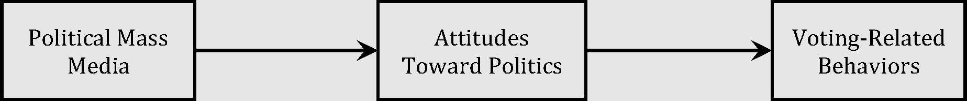
Figure 1. Illustration of the relation between political mass media, attitudes toward politics, and voting-related behaviors.

The above link between attitudes towards politics and voting-related behaviors, such as engagement in political discussions (outcome 5), underscores the significance of outcome three (i.e., value of political discussions). A framework developed by Jung, Kim, and Zúñiga (2011) help us further understand the influence of attitudes toward politics and political discussions on voting. Their framework posits that political mass media influences voting behavior via a) online political discussion (e.g., voting-related behavior) and b) face-to-face political discussion (e.g., voting-related behavior) and political knowledge (see Figure 2 in Appendix C for an illustration of this framework).
Altogether, the results from these studies imply that to positively impact voting, we must direct programming toward encouraging participation in voting-related behaviors (e.g., political discussions) and to positively impact these voting-related behaviors, we must direct programming toward developing positive attitudes toward politics. By manipulating multiple predictors (i.e., attitudes toward politics and political discussions), we will maximize the likelihood of influencing voting behavior. In sum, we suspect that norms, behaviors, and attitudes of students on college campuses will influence students’ decisions to be civically and politically engaged citizens. See Figure 2 in Appendix D for an illustration of this hypothesized causal framework put together in a single logic model.
- Summarize the results of previous assessment related to the selected outcomes (1 page max): Not applicable

Action Plan
IV.
In this section, you will be asked to consider why the student learning/development outcomes you selected are not being met and propose possible strategies for addressing these obstacles.
- For each selected outcome, provide an explanation/hypothesis about why current programming is not supporting student learning/development to the degree you desire (1 page max):
Because PACEP is a new program that has not yet been implemented, we are not able to directly hypothesize why programing is not supporting student learning and development. Thus, to demonstrate our readiness and commitment to both this program and the assessment process, we now reflect on potential weaknesses and/or ideas that we believe may lead to demonstrable student learning and development.
Programming Ideas
Recall, outcome three is related to fostering favorable attitudes toward political discussion. Given the previously discussed theoretical framework that posits that political attitudes influence voting behavioral intentions which influence voting, fostering favorable attitudes toward political discussion is a principal component of PACEP programming. As such, it is imperative that we devote substantial and effective programming to outcome three. Currently, the only programming designed to directly influence students’ attitudes is the video scenario and facilitated discussion during first-year orientation (and potentially faculty and staff developed curricular and co-curricular activities). Nevertheless, we expect that merely observing positive, non-confrontational, and non-divisive messages posted on the Democracy Wall and debates will promote favorable attitudes toward political discussion. However, our staff anticipates that we may need to develop further programming targeting these attitudes. Our hopes are that this programming takes place in general education classes and co-curricular activities. Thus, we may need to consider methods of promoting and encouraging staff and faculty to incorporate relevant programming into their classes and activities.
Assessment Process Ideas
As a campus-wide initiative, it is imperative that we are able to assess student learning and development outcomes among the population of students or a sample representative of the population. Given the magnitude and resource demand of PACEP, as well as to support the inferences desired by the office and JMU, we believe it is imperative that we assess these outcomes at multiple time points (i.e., longitudinally). Moreover, to facilitate efficiency in the assessment process, we may consider assessing student learning and development outcomes in phases corresponding with the hypothesized causal ordering of the variables. For example, given the causal structure—political attitudes 🡪 voting behavioral intentions 🡪 voting behavior—it may be prudent (for efficiency reasons) to measure attitudes (outcome 3) during a first phase and voting-related behaviors (outcome 5) during a second phase. However, as mentioned earlier, collecting data for both outcomes at multiple time points may better support desired inferences.
- Prior to this new partnership with SASS, have you tried to improve student learning/development related to these outcomes? If so, please describe the improvement initiatives. Have those initiatives been successful? (1 page max): Not applicable
- Based on your answers to the questions above, what changes to a) your programming and b) your assessment processes do you believe are necessary to demonstrate improvements in student learning/development?
Not applicable
- Provide a detailed timeline that articulates your plan to improve student learning/development to the degree you desire. This timeline should include 1) whether you plan to begin this work in Summer or Fall, 2) plans to initially assess the program, 3) plans to make programmatic changes, and 4) plans to re-assess the program:
PACEP staff have devoted considerable time to researching and designing the most appropriate programming that we believe will have the greatest influence on fostering positive attitudes toward and supporting political discussions. See Appendix E for an illustration of the timeline proposed.
Instrument Development
At the beginning of the fall 2018 semester we anticipate devoting three to four months to designing/selecting/creating instruments to measure a) attitudes toward political discussion and b) interpersonal political discussions. Given political discussion can be face-to-face or via various social media platforms, we anticipate that considerable time will need to be devoted to thinking through the most appropriate ways to measure this behavior.
Data Collection Design
At the beginning of the spring 2019 semester we anticipate devoting three to four months to laying out the data collection design. Given the temporal ordering of the variables (i.e., political attitudes 🡪 voting behavioral intentions 🡪 voting behavior), we hope to design a data collection system, with the help of SASS, that aligns with this hypothesized causal relation (showing the impact of PACEP). Accordingly, this portion of the process may take additional time to properly develop.
Baseline Data Collection
We anticipate beginning the data collection process during first-year orientation during summer 2019. PACEP programming will not be implemented until a full cycle of baseline data for one cohort has been collected (i.e., data collected at first-year orientation, end of first year, and Spring Assessment Day 2020); thus, PACEP programming will begin fall 2021.
Re-assessing the Program
Recall that we anticipate one year of planning and nearly two years of collecting baseline data for one cohort before implementing PACEP programming. Moreover, we do not expect meaningful student development with respect to the selected student learning and development outcomes until students have been exposed to at least two years of programming. During baseline data collection (i.e., summer 2019-spring 2020) we anticipate focusing our attention on helping other faculty and staff develop curricular and co-curricular activities targeted at outcomes three and five. Accordingly, we will not complete data collection for a cohort who has experienced PACEP programming until spring 2022. Thus, any programmatic changes will not be considered until we have the results from s pring 2022 Assessment Day.

V. Commitment to Partnership
One of the most important resources needed to evidence student learning improvement is time. As such, each program will commit 10 hours per week to the initiative. This amount of time is necessary to think critically about the program, collect evidence regarding student learning and development, and engage in evidence-based, intentional program redesign. By committing this time up front, programs will be able to distribute other responsibilities accordingly.
- Weekly Time Commitment (10 hours/week)
Please select a Lead Coordinator who will serve as the primary contact and chief overseer of the initiative. This person may choose to commit all ten hours each week, or assemble a team to share the workload. Note: Graduate assistants may lend support where needed, but most decisions/discussions will require extensive familiarity with the program over several years, an understanding of the program theory/logic behind the program, knowledge of departmental resources, and a level of authority beyond what most graduate students possess. As such, graduate assistants may not serve as lead coordinators and should contribute less than 1/3 of the total hours spent on the initiative each week.
- Support from Direct Supervisor (1 hour/week)
Regular contributions from upper-level administrators are crucial to the long-term success of a learning improvement initiative and, in turn, the future of the program. Direct Supervisor, please sign below to indicate a commitment of 1 hour per week to the learning improvement project detailed in this application. This time may be spent in whatever manner is most helpful to the program.
Lead Coordinator:
(Name)
(Signature)
(Date)
Other Team Members (names only; no signatures required):
Direct Supervisor (1-hour commitment each week):
(Name)
Director:
(Signature) (Date)
(Name)
(Signature)
(Date)
Appendix A
Table 1
Student Learning and Development Outcome to Program Map for Selected Outcomes
Outcome | Program Component  Curricular & Co  Video Scenario Democracy Wall Student Debates  curricular
Value of Political Discussion  Engage in Political  Discussions | X ? ? ?  X X X

Appendix B
Figure 1. Illustration of the relation between political mass media, attitudes toward politics, and voting-related behaviors (Section III, Part e). This model is based on the theory of reasoned action adapted to voting behavior by Fishbein, Ajzen, and Hinkle (1980). Notice the influence of political communications (mass media) on voting-related behaviors (i.e., outcome 5) via attitudes toward politics (i.e., outcome 3).

Appendix C
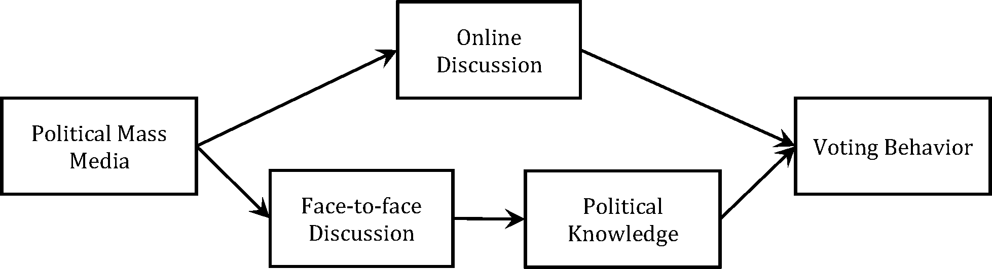
Figure 2. Illustration of the relation between political mass media, political discussion (online and face-to-face), political knowledge, and voting behavior (Section III, Part e). This model is based on the cognitive mediation model theory by Eveland (2004) and empirically supported by Jung, Kim, and Zúñiga (2011). Notice this model does not account for the influence attitudes toward politics (i.e., outcome 3) has on political discussions (i.e., outcome 5), but illustrates the influence of political discussions on voting behavior.
Appendix D
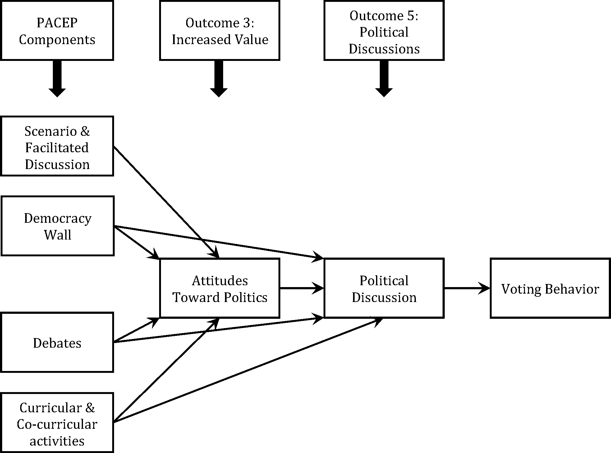
Figure 3. Logic model illustrating hypothesized influence of Political and Civic Engagement Program (PACEP) interventions on student learning and development outcomes three (attitudes toward politics) and five (political discussions) and their influence on voting behavior (Section III, Part e).

Appendix E
2018 Fall | Baseline Data Collection and Development of Program 2019 2020 2020  Spring Summer Fall Spring Summer Fall Spring
Select/design instruments | ^{Design B}eg^{i}n basel^{i}ne 1 year of End baseline data  data data collection _{baseline data} collection
^{collection} ⁽Or^{i}en^{t}a^{ti}on⁾ (Assessment Day)

Assist faculty and staff
with curricular and co-
curricular activities
Data Collection for Cohort Experiencing PACEP Programming
2020  Summer Fall | 2021 2022  Spring Summer Fall Spring Summer Fall
Begin data collection for intervention group (Orientation) | 1 year of data End data collection for  collection for intervention group  intervention group (Assessment Day)
Implementation of
PACEP Programming

Figure 4. Timeline of plan to improve student learning and development (Section IV, Part d).
References
Ajzen, I. (1991). The theory of planned behavior. Organizational Behavior and Human Decision Processes, 50, 179-211. DOI: 10.1016/0749-5978(91)90020-T
Eveland, W. P., Jr. (2004). The effect of political discussion in producing informed citizens: The roles of information, motivation, and elaboration. Political Communication, 21, 177-193.
Fishbein, M., Ajzen, I., & Hinkle, R. (1980), Predicting and understanding voting in American elections: Effects of external variables. In I. Ajzen & M. Fishbein (Eds.), Understanding Attitudes and Predicting Social Behavior (pp. 173-195). Englewood Cliffs, NJ: Prentice-Hall.
Institute for Democracy & Higher Education: National Study of Learning, Voting and Engagement (2017). 2012 & 2016 NSLVE Campus Report: Student Voting Rates for James Madison University. Medford, MA. Retrieved from https://www.jmu.edu/civic/reports/JMU-Voter- Turnout.pdf
Jung, N., Kim, Y., & de Zúñiga, H. G. (2011). The mediating role of knowledge and efficacy in the effects of communication on political participation. Mass Communication and Society, 14, 407-430. DOI: 10.1080/15205436.2010.496135
McLeod, D. M., Kosicki, G. M., & McLeod, J. M. (2002). Resurveying the boundaries of political communication effects. In J. Bryant & D. Zillmann (Eds.), Media effects: Advances in theory and research (2nd ed., pp. 215-267). Mahwah, NJ: Lawrence Erlbaum Associates.
Thomas, N., Bergom, I., Casellas Connors, I., Gautam, P., Gismondi, A., & Roshko, A. (2017).
Democracy counts: A report on U.S. college and university student voting. Institute for Democracy & Higher Education, Tufts University’s Jonathan M. Tisch College of Civic Life.
Retrieved from https://idhe.tufts.edu/sites/default/files/NSLVE%20Report%202012- 2016-092117%5B3%5D.pdf

