


SCHEV COMPETENCY REPORT

Student Learning Assessment:
Critical Thinking
James Madison University
REPORTING PERIOD  2021–2026 | COMPETENCY AREA  Critical Thinking
REPORT SUBMITTED  2026 | STUDENT COHORT  ~5,000 annually

Center for Assessment and Research Studies (CARS)
James Madison University · Harrisonburg, VA

What does JMU expect students to learn or to do? What courses, experiences, or activities allow students to develop their knowledge and/or abilities in these areas?
Critical Thinking is central to a JMU liberal arts and sciences education because it is essential for students’ academic success and for life beyond college. It involves subjecting one's own and others' ideas, arguments, assumptions, and evidence to careful, logical scrutiny in order to make informed judgements, draw sound conclusions, and solve problems. These skills are developed across the JMU curriculum, including in General Education classes as well as in major and minor programs of study.

Course Offerings
As a foundation, JMU requires every student to complete a Critical Thinking course in the General Education program during their first year. Current first-year course offerings span six academic disciplines:
Discipline | Course Experience
Business | BUS160: Business Decision Making in a Modern Society
Education | EDUC102: Critical Questions in Education
History | HIST150: Critical Issues in Recent Global History
Integrated Science and Technology | ISAT160: Problem Solving Approaches in Science and Technology
Philosophy | PHIL120: Critical Thinking  PHIL150: Ethical Reasoning
Media Art and Design | SMAD150: Mediated Communication: Issues and Skills
The breadth of these courses illustrates how essential Critical Thinking is to the many disciplinary areas of expertise and knowledge.

Student Learning Outcomes
Unique to JMU, all of these courses were developed by JMU faculty to meet a set of common learning outcomes:
After completing one of the JMU first-year courses in Critical Thinking, students will be able to:
- Identify the basic components of arguments, including premises, supporting evidence, assumptions, conclusions, and implications.
- Evaluate claims and sources for clarity, credibility, reliability, accuracy, and relevance.
- Evaluate arguments for soundness, strength, and completeness.
- Demonstrate an intellectual disposition to be fair-minded in considering evidence, arguments, and alternative points of view.

How do faculty and staff know whether—and how well—students have learned?

Data Collection
During the 2021–2026 assessment cycle, JMU evaluated critical thinking dispositions at scale for graduating seniors (approximately 5,000 annually) who were required to complete a battery of assessments prior to graduation.

Assessment Instrument
The critical thinking assessment utilized several validated instruments to measure students’ dispositions and beliefs related to critical thinking and learning. Specifically, the assessment incorporated the Critical Thinking Disposition Scale (Sosu, 2013), selected subscales from the Comprehensive Intellectual Humility Scale (Krumrei-Mancuso & Rouse, 2015), and the Self-Theory of Intelligence Scale (De Castella & Byrne, 2015). These instruments assess key dimensions such as critical openness, reflective skepticism, intellectual humility, and students’ beliefs about the malleability of intelligence. All items were rated on a seven-point Likert scale ranging from Strongly Disagree (1) to Strongly Agree (7).

Critical Thinking Disposition Scale
The Critical Thinking Disposition Scale (CTDS; Sosu, 2013) is an 11-item measurement instrument developed to assess two core dispositional dimensions of critical thinking: Critical Openness (CO) and Reflective Skepticism (RS). The CO subscale comprises seven items and evaluates the extent to which individuals are receptive to new ideas, thoughtfully assess them, and are willing to revise their views when presented with compelling evidence. The RS subscale contains four items and measures the inclination to reflect on past experiences and critically examine the quality and trustworthiness of available evidence.

Comprehensive Intellectual Humility Scale
The assessment committee selected and adopted two of the subscales from the Comprehensive Intellectual Humility Scale (CIHS; Krumrei-Mancuso & Rouse, 2015): Openness to Revising One’s Viewpoint (RV) and Intellectual Overconfidence (IO). The RV subscale includes five items that assess a person’s willingness to reconsider and revise their beliefs in light of new evidence or persuasive reasoning. The IO subscale consists of six items that measure the tendency to overestimate the accuracy of one’s beliefs and to resist acknowledging personal fallibility.

Self-Theory of Intelligence Scale
The revised Self-Theory of Intelligence Scale (STIS), developed by De Castella and Byrne (2015), is an 8-item instrument designed to assess students’ beliefs about the malleability of their own intelligence. The scale includes two subscales: Entity Self-Theory (ES) and Incremental Self-Theory (IS). The ES subscale consists of four items that reflect the belief that one’s own intelligence is fixed and largely unchangeable, regardless of effort. In contrast, the IS subscale includes four items that capture the belief that intellectual ability can be developed over time through persistence, learning, and effort.

Are the institution’s expectations in these areas being met?
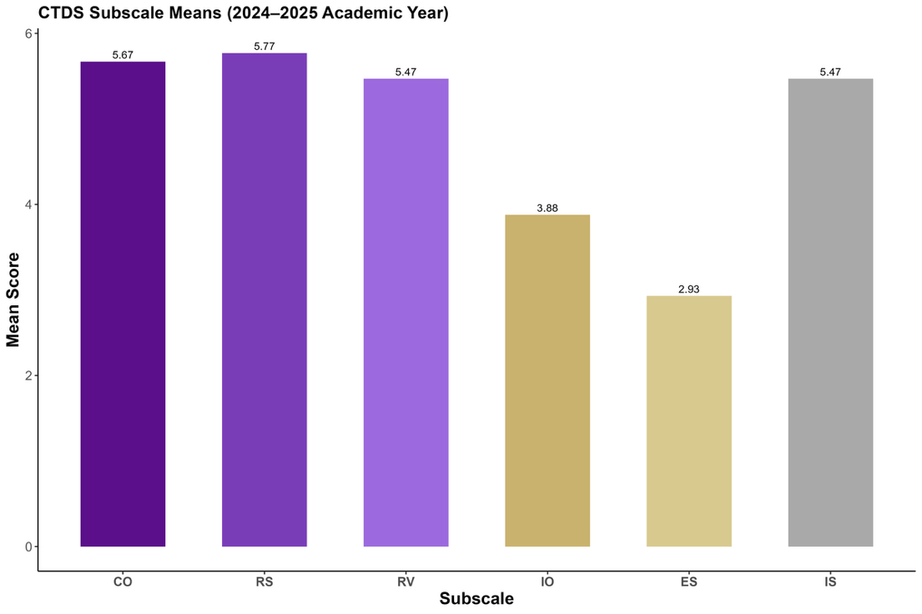
Overall, the findings suggest that students are demonstrating dispositions aligned with JMU’s expectations for critical thinking. Students consistently demonstrate strong habits of open-mindedness, thoughtful evaluation of information, and a belief in learning and improvement. More specifically, the following summarizes each area’s findings, including the mean score for students’ senior year assessment (AY 2024-2025).

- Critical Openness (CO) remains relatively strong (5.67). Students continue to value critical thinking and new perspectives, with only a small decline over time that does not undermine this strength.
- Reflective Skepticism (RS) is consistently high (5.77). Students regularly report that they question claims and think reflectively, showing stability across several years.
- Openness to Revising One’s Viewpoint (RV) continues to be strong (5.47). Students generally agree that they should revisit their views when presented with new information, and this attitude remains steady.
- Intellectual Overconfidence (IO) is mostly balanced, albeit not extreme (3.88). Students do not strongly see themselves as intellectually overconfident, suggesting a healthy mix of confidence and humility.
- Entity Self-Theory (ES) is low (2.93). Most students disagree with the idea that intelligence is unchangeable, and this belief does not increase over time.
- Incremental Self-Theory (IS), akin to growth mindset, is strong and enduring (5.47). Students consistently believe that intelligence can be developed through effort and learning, aligning well with the institution’s educational mission and values.

Generally, students show continuing strengths in critical thinking, openness, reflection, and learning mindset. While there are minimal shifts over time, these do not indicate meaningful decline. Taken together, the findings suggest that the institution is successfully cultivating the intellectual habits it values, and those habits are holding steady across cohorts.

How does/will the institution use this information to improve students’ educational experience and enhance future achievement?
JMU expects students who complete a critical thinking course to demonstrate the ability to analyze arguments, evaluate the quality and credibility of evidence and sources, and engage thoughtfully with multiple perspectives. These learning outcomes are central to the university’s General Education Program and serve as key indicators of students’ readiness to think independently and responsibly. Assessing these skills allows the university to understand how well students are meeting these expectations and how effectively the curriculum supports their development. In an increasingly complex world, these assessed outcomes reflect JMU’s commitment to preparing students for informed decision-making, active citizenship, and lifelong learning.
Assessment results show that many JMU seniors demonstrate strong critical thinking dispositions. Rather than emphasizing change over time, current reporting focuses on students’ senior-year intellectual habits and the extent to which students reflect readiness to use critical thinking effectively across academic, civic, and professional contexts. Moving forward, JMU is shifting its focus from teaching basic critical thinking skills to helping students apply said skills across different courses and disciplines. This approach aligns with the university’s redesigned General Education Program, which emphasizes integrated learning, shared themes such as critical thinking and information literacy, and meaningful connections between coursework and students’ personal, civic, and professional lives. For instance, first-year students encounter courses that introduce and strengthen critical thinking, while upper-level students apply these skills via hands-on, integrative, and capstone projects.
Overall, this approach reflects JMU’s commitment to ensuring that students do not simply learn how to think critically during college, but to leave with the ability to apply those skills throughout their lives beyond graduation. Strong critical thinking skills help graduates navigate complex information, solve real-world problems, and make thoughtful decisions in their careers and communities. By intentionally embedding these skills across the curriculum, the university positions higher education as a powerful catalyst for lifelong learning and good citizenship. In doing so, JMU prepares graduates to contribute meaningfully to the workforce and to society as informed, engaged, and adaptable thinkers.

