**James Madison University**

Outcomes of the General Education Communication Course

WHAT DO STUDENTS REPORT AS STRENGTHS OF THE COURSE?

Students mentioned these gains in open-ended responses on end-of-course evaluations:

Confidence in public speaking was the most commonly-

reported outcome

Reduced anxiety about speaking Skills in conducting research

Enhanced knowledge of how to support a point of view Experience in cooperation and group work

*"The*

*communication skills we*

*learned in this*

*pplicable*

*th ld."*

*class are*

*a to*

*e real wor*



T H E C O U R S E S

The courses that are part of the General Education Program

are SCOM 121 Fundamental Human Communication: Presentations,

SCOM 122 Fundamental Human Communication: Individual Presentations, and SCOM 123 Fundamental Human Communication: Group Presentations.

In these classes, students study human communication as a process. They gain an overview of the principles and practices of interpersonal and public communication, with an emphasis on examining the role of self-concept, perception, and culture, as well as verbal and nonverbal dimensions in the communication process. Students study the concepts of power and the management of conflict.

In all versions of the course, students apply critical listening skills, use information literacy to research topics, and organize information to shape and deliver informative and persuasive speeches, either individually or in groups.

These courses are the main delivery of the foundational skills of Information Literacy for the university through a series of online modules, quizzes and course activities that cement learning about Information Literacy.

WHAT'S NEXT

While we are successful at providing students with crucial communication knowledge and skills, we need to be doing more to address the growing ethical issues related to seeking information and creating messages, particularly in a landscape where Artificial Intelligence tools (AI, ChatGPT, etc.) are proliferating.

# WHAT WE EXPECT STUDENTS TO LEARN

By the time students complete one of the human communication courses (known as SCOM 121, SCOM 122 or SCOM 123) in the General Education Program, we expect that students will be able to:

 Explain the fundamental processes that significantly influence communication.  Construct messages consistent with communication purposes, audiences,

contexts, and ethics.

 Listen to messages in manners appropriate for communication purposes, audiences, contexts, and ethics.

 Utilize digital literacy skills expected of ethical communicators.

# HOW DO WE KNOW WHETHER, AND HOW WELL, STUDENTS HAVE LEARNED?

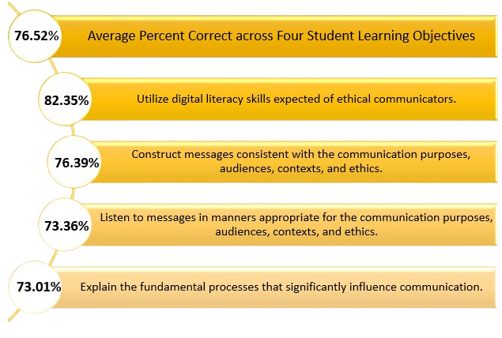

*\*Percentages represent the averages across all questions related to each learning outcome*

Students are assessed on these learning outcomes based on their performance on an end of course cumulative 100-item exam. 50% of the questions require students to apply the concepts to scenarios. The exam is administered to every student enrolled in all sections of the SCOM general education course (5,000 in 2022-2023) after 15 weeks of instruction; crafting and delivering of two research-based presentations; and completion of a series of online modules and quizzes related to digital literacy. Each year, the SCOM Basic Course Committee reviews the test results and addresses any objectives not performing well (under 70%), by updating the questions and recommending curricular changes that are communicated to all faculty teaching the course.

FACULTY PERCEPTIONS OF STUDENT IMPROVEMENT

Faculty report an average of 5-15% improvement on both speech development and speech delivery skills from the first to the second speech in the course.

They share that students improve in research skills, assessment of source credibility, outlining, source citation, and making ideas coherent for an audience.

*"I learned how*

*to work with a*

*group in an*

*Setting, which*

*Academic*

*is vital to*

*coursework in*

*harder*

*college."*

In terms of improvement in delivery they note that student confidence is evidenced by more eye contact, conversational tone, enthusiasm and energy in delivery, and in their focus on incorporating strategies to appeal to an audience.