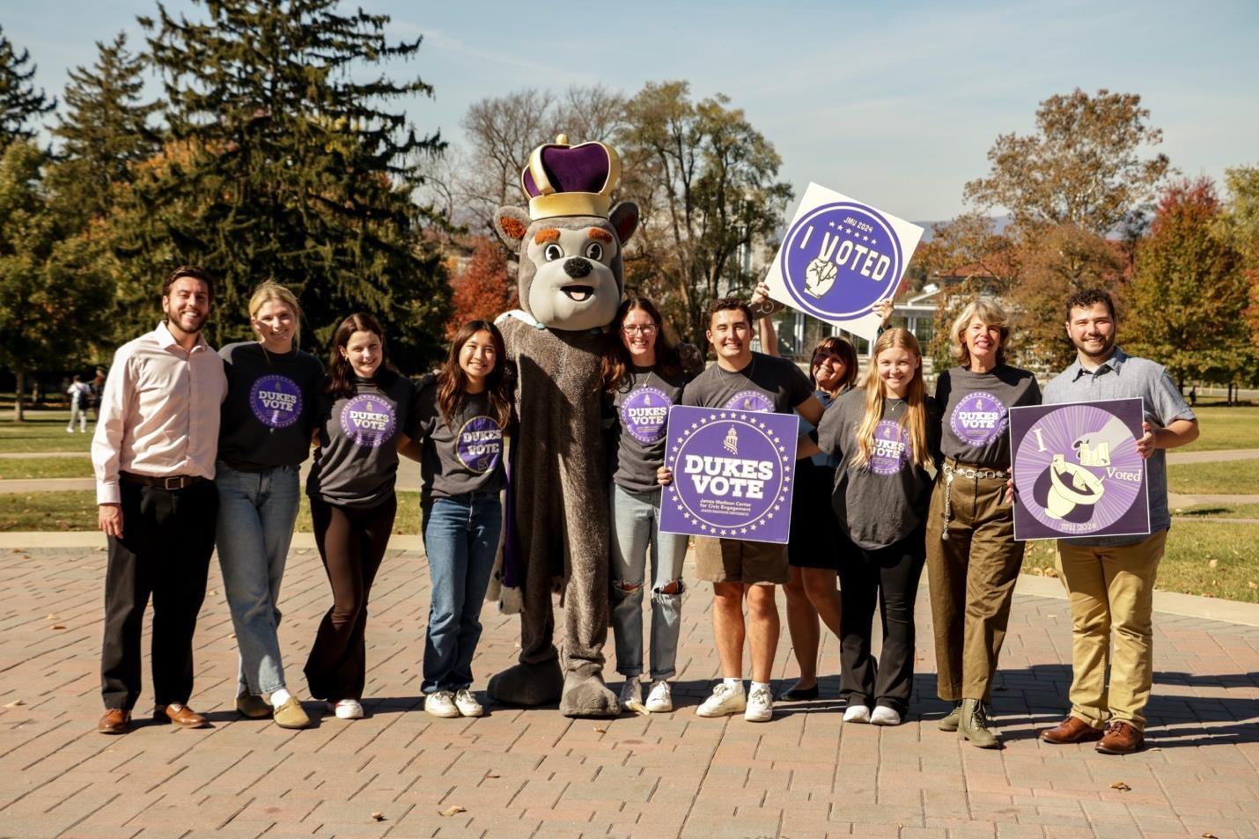



Civic Engagement at James Madison University

SCHEV Report Summer 2025



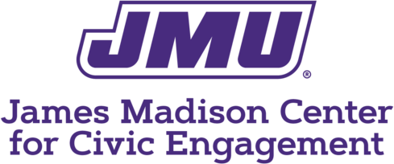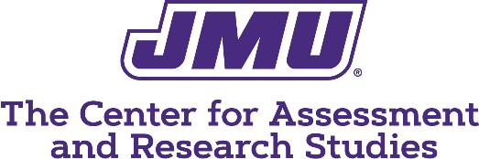

Questions about this report can be directed to [civic@jmu.edu](mailto:civic@jmu.edu) or [assessment@jmu.edu.](mailto:assessment@jmu.edu)

CIVIC ENGAGEMENT AT JMU

Civic engagement is integral to the mission of James Madison University: “We are a community

committed to preparing students to be educated and enlightened citizens who lead productive and

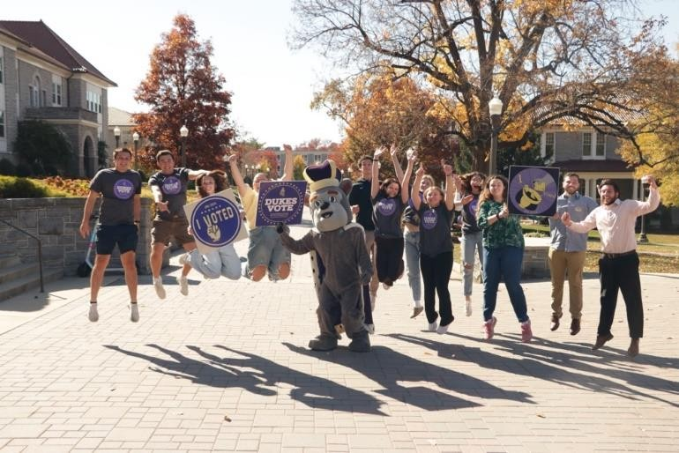meaningful lives.” This report highlights two key civic engagement programs at JMU: Dukes Vote and the Better Conversations Together program. Details about the programs and their assessments are available in a supplemental report.

DUKES VOTE

As a student-led program, [Dukes Vote](https://www.jmu.edu/civic/vote/index.shtml) provides non-partisan student voter education through voter registration support for in-state and out-of-state students, hosting town hall meetings and candidate debates, compiling voter information guides, and innovative and engaging social media programming answering students' questions about candidates, ballot initiatives, and the voting process.

The ultimate goal of Dukes Vote is to get

students to participate in elections. Results from the National Study of Voting, Learning, and Engagement (NSLVE) indicate impressive voter turnout in presidential elections, with JMU student voter turnout being 75% in 2020, up 23% from 2016. Results have not yet been provided for the 2024 election. Voting rates in midterm elections are known to be lower than in presidential elections and JMU is no exception, with voter turnout being 21% in the 2022 midterm, which is lower by 10% relative to other institutions. The 57% registration rate in the 2022 midterm, however, was encouraging and 8% higher than 2018. Together these results suggest Dukes Vote should continue and increase efforts in all election years, including midterms.

Dukes Vote programming is also intended to promote discussions about elections. A survey administered to a random sample of 303 sophomores and juniors indicated a significantly higher percentage of students who experienced Dukes Vote discussed the 2023 election online or in person. For example, of those who had a Dukes Vote classroom visit, 72% discussed the election with others, compared to only 51% who did *not* have a classroom visit. The findings are encouraging and suggest Dukes Vote positively affects students’ engagement with elections.

BETTER CONVERSATIONS TOGETHER

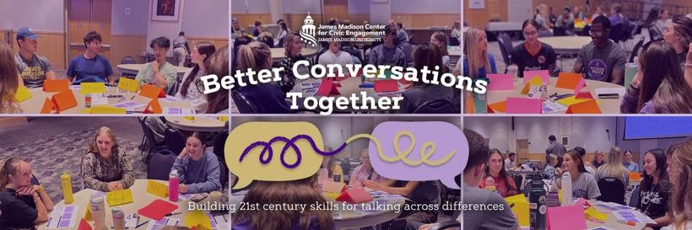

In response to Governor Youngkin’s request, all incoming JMU students participate in [Better](https://www.jmu.edu/civic/programs/bct-overview.shtml) [Conversations Together,](https://www.jmu.edu/civic/programs/bct-overview.shtml) a two-part program aimed at developing 21st century skills for talking about difficult, complex, and sometimes polarizing issues. The 2024–2025 academic year served as a pilot for full implementation and assessment of Better Conversations Together. In Part I, students complete online modules before arriving on campus, exploring how people form beliefs, process information, and engage across differences. Part II involves small-group deliberative forums on complex issues, like AI in the workplace or election integrity, using nonpartisan materials.

The goals of the program can be categorized into four broad areas:

1. **Empathy and Respect**: Students will demonstrate increased empathy and respect for individuals with differing political and social views, reducing affective polarization.
2. **Intellectual Openness**: Students will show greater intellectual humility by seeking out diverse perspectives, acknowledging the limits of their own knowledge, and understanding the reasoning behind opposing views.
3. **Dialogue Skills and Confidence, Including Listening**: Students will feel more confident and capable of engaging in respectful, productive conversations about difficult or complex issues.
4. **Understanding and Perspective-Taking**: Students will develop a deeper understanding of social issues, including their complexity, the need for compromise, and the value of fair and open dialogue.

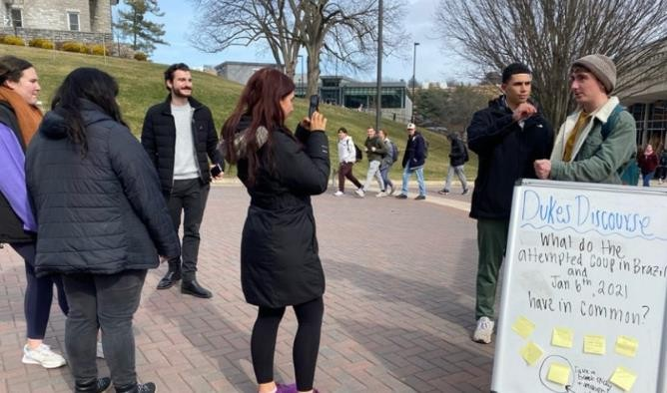Preliminary results from the program are promising. A comparison of pre- and post-program assessments after the first phase showed a decrease in affective polarization. Following the second phase, students reported increased openness to differing views and a better understanding of complex issues. Notably, 89% agreed their deliberative forum group fairly considered differing ideas, 83% felt more willing to engage in tough discussions, and 78% said their views evolved through dialogue. An incredibly encouraging finding is that forum participants reported that their group found common ground on at least one issue, with 80% in support of

acting together on the areas of agreement found in their group.

This was the initial year of delivering the Better Conversations Together program and many lessons were learned. Most notably, there is a need to improve how the program requirement is communicated to students, as full participation in both the program and its assessment was not achieved.

MOVING FORWARD

The results of both programs indicate positive progress is being made in creating "educated and enlightened citizens" who can talk across lines of difference, hear the views of candidates and their peers that might diverge from theirs, reasonably consider and fairly consider alternate ideas, and vote. Despite implementation and assessment challenges of the Better Conversations Program, we are excited to be moving the needle in a positive direction on key indicators of democratic learning. As more students participate next year, we hope to see additional movement in scores across all indicators. We also see the impact of the campuswide Dukes Vote program as important to creating a campus culture where students can see themselves as deliberative voters rather than passive consumers of political information. We are eager to enhance Dukes Vote touchpoints like classroom visits, town hall/candidate forums, and other educational opportunities where the [Democracy Fellow](https://www.jmu.edu/civic/people/democracy-fellows.shtml) student leaders can provide a positive model for being an engaged citizen.

The Madison Center is currently using civic engagement assessment data to make program improvements for the next academic year. We have already adjusted the Better Conversations assessment process in hopes of improving participation. We are also continuing to find ways to more deeply embed Dukes Vote and Better Conversations Together into classrooms as appropriate, including stipending faculty voting champions who will talk about registering to vote. Our [Faculty Fellows in Collaborative Dialogue](https://www.jmu.edu/civic/people/faculty-fellows.shtml) - faculty who use discussion-based tools and facilitation methods to engage students in difficult discipline-specific topics - are also encouraged to design their courses with these principles in mind. We hope to build on the successes of this year and see greater improvement.