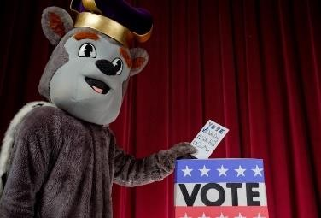
Political Engagement Project Survey Results at JMU: Assessment Day Administration Differences Across FA17, FA19, SP18, and SP19
As part of a collection of assessments used to inform the civic engagement initiative at JMU, the Political Engagement Project Survey (PEPS) was administered to a random sample of 1,278 students on four different Assessment Days - to incoming freshmen during Fall 2017 and 2019 and to students with 45-70 credit hours during Spring 2018 and 2019. We analyzed data to get the civic engagement “pulse” of the JMU student body and also to consider whether political competencies differed across the four
groups. Contrary to the expected results that groups would differ by class level and time, the only consistent trend observed was the freshman in FA17 scoring more favorably than all or most other groups. In the six ANOVAs found to be significant, scores for FA17 were more favorable than the freshmen in FA19 and the two spring administrations did not statistically differ from one another.

