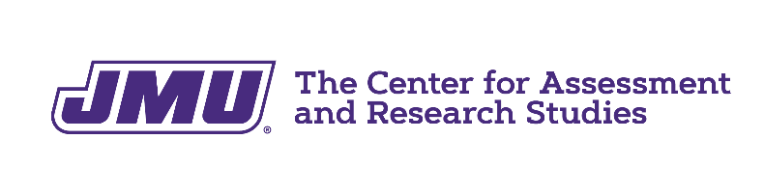

Orientation to Assessment Progress Template (APT) Feedback For Department Heads

For assistance, please contact PASS at programassessment@jmu.edu

- Copy and paste password from e-mail into login page.
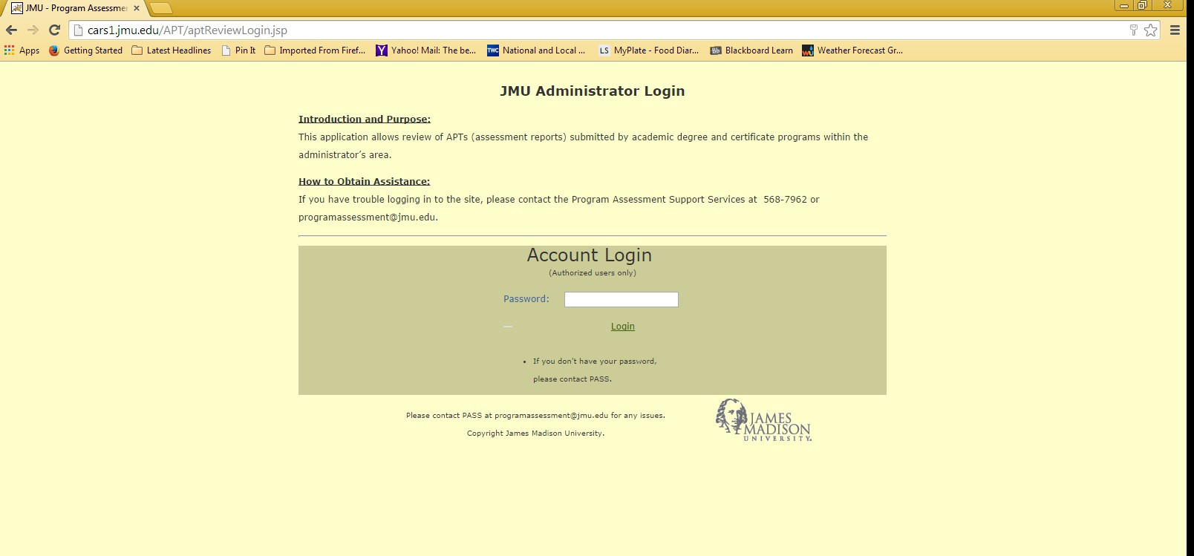

- Now at your department head REVIEW Page – Note, NO action is needed from you at this point. You have access to the feedback reports for each program within your department.

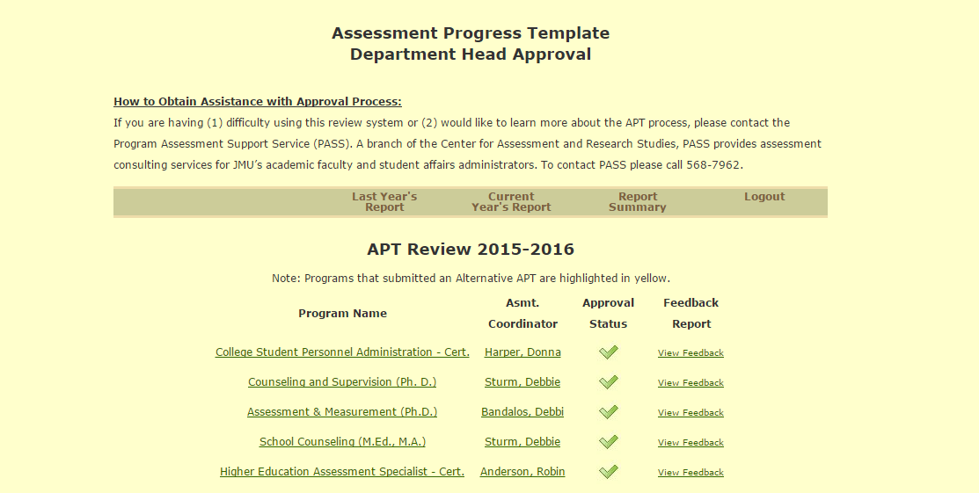
Clicking on “Report Summary” provides a unique dept. head view that summarizes feedback for all of your programs.

You can review the assessment feedback report for each program in your department. See next page of this orientation document for more information about “View Report.”

- You are now at the APT Feedback Page for one of your programs.

Scroll over “About This Report” to access supporting documents.
Click on “APT List” to return to the other APTs

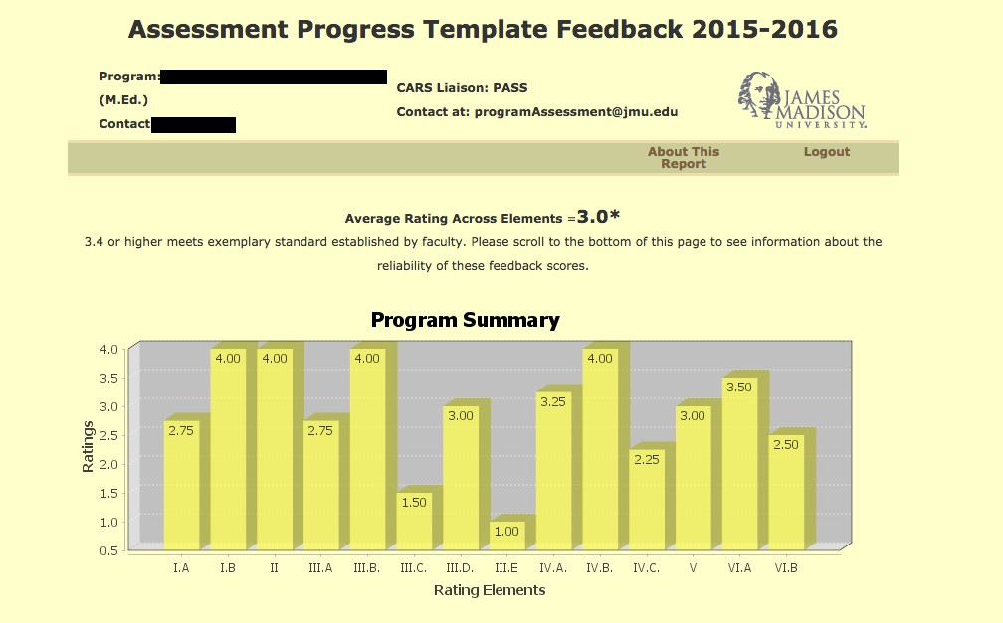
A

Scroll down to read comments

