

Orientation to Assessment Progress Template (APT) Feedback For Assessment Coordinators

For assistance, please contact PASS at programassessment@jmu.edu

- Copy and paste username and password from e-mail into login page.
JMU - Program Assessment Report L... '

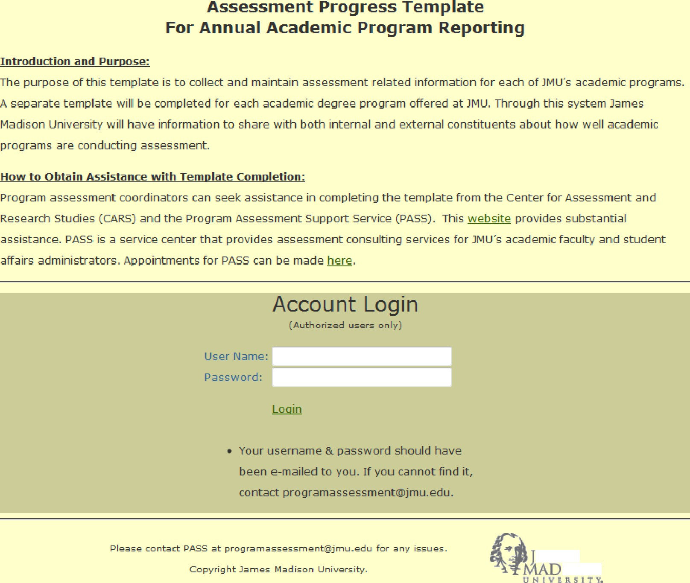
- ' Do you want Firefox to remember the password for "psysciMA" on jmu.edu? Rab Nigver for This Site Not No x
.AM L S

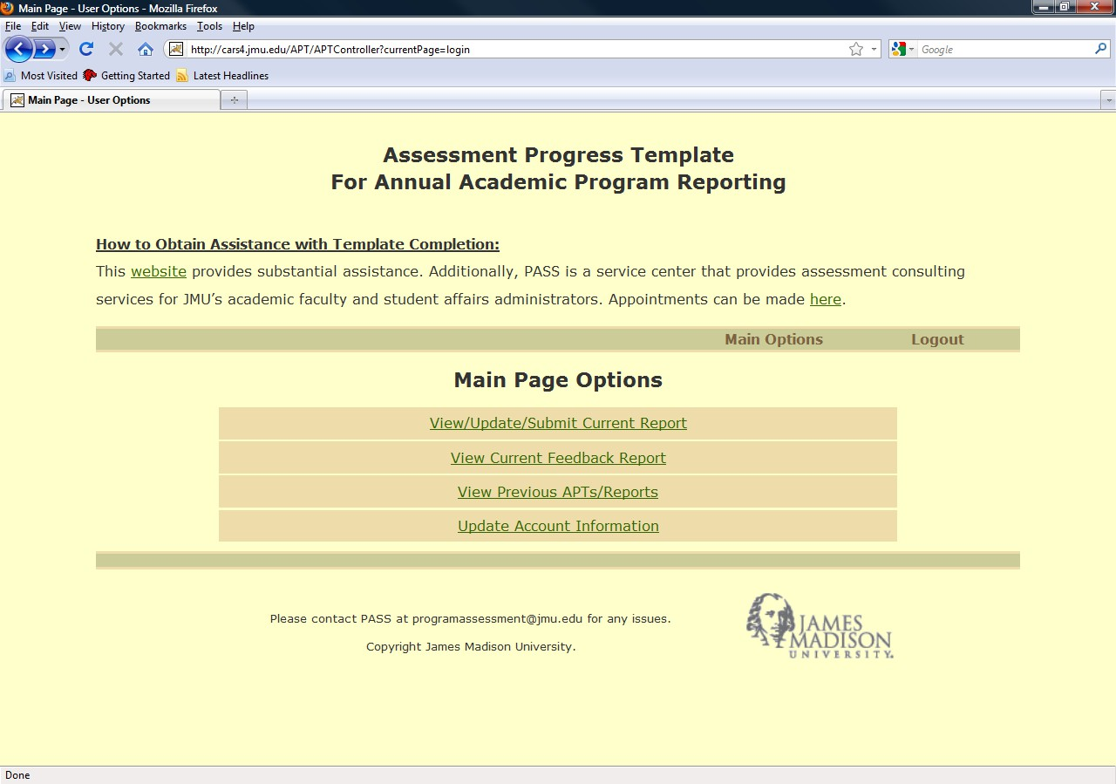
- Select the 2nd Option from the Main Page Options.

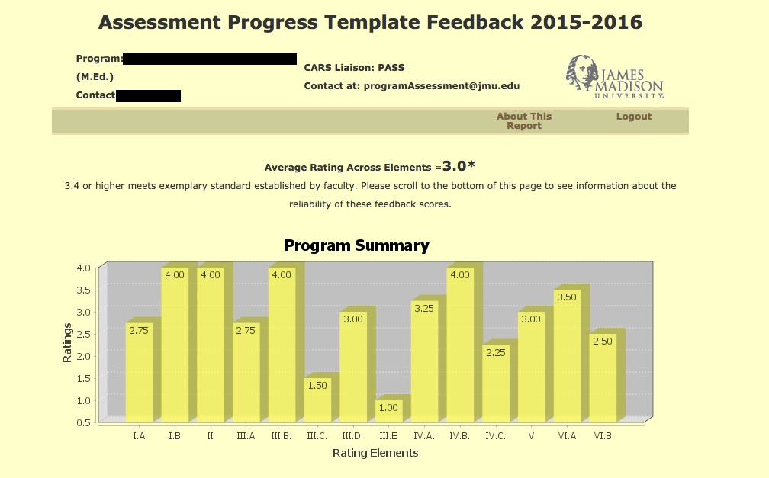
- You are now at the main APT Feedback Page.
Scroll over “About This Report” to access
supporting documents.
Scroll down to
read comments

