macOS Wireless Printing Instructions

For the Studio Center Color printer – Dell 7130cdn

The following instructions assume that you are using Mac OS X 10.6 (Snow Leopard) or newer.
Download and install the driver found HERE

During Install Dell Printer setup-
Press Continue

In the confirmation window, press Continue
The driver installation is complete.

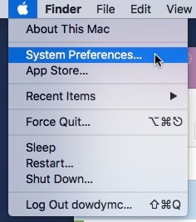
Open System Preferences from the Apple menu.

Select Print & Fax from System Preferences
Click the plus icon to add a printer
Select IP from the toolbar
Fill in the form as follows, then click Add.
- Address: labprint.jmu.edu
- Protocol: Line Printer Daemon - LPD
- Queue: StudioCenter-100_C1
- Name: Studio Center 100 Color Printer
- Location: Studio Center 100
- Use: Dell 7130cdn, 1.1.0
On the next tab under “Paper Trays:” select One Extra Tray

The printer is now ready to use

