Hongnhung Dang
danghb@dukes.jmu.edu
9 March 2018

Floating Wishes – Water Lanterns and Kinetic Art

Grade level: 8th grade

Time: 4 class sessions (75 min each)

Lesson Overview: In this lesson, we will be exploring Michio Ihara’s kinetic art. We will consider the definition of “kinetic art,” and identify what makes Ihara’s kinetic art seemingly “move.” We will then learn about water lanterns, their origins, how they “move” (kinetic art), why they are constructed, and why they are made to float. After filling out writing prompts that will help us identify a wish we might have for the future, we will construct our own water lanterns that visually reflect said wish.

Challenge: Students will be challenged to ponder the following questions: How can something that is still seemingly “move”? How can a moving thing be a work of art? What can make something “move” or give the illusion of “moving”? How can light and nature act upon kinetic art in order for the art to have an “effect”? With their answers, the students will be challenged to construct a form that “moves” harnessing nature.

Visual Culture:
Most students might be familiar with the pasttime of folding paper boats and letting them sail on a body of water. Some students might have also floated toy boats or rubber ducks in a body of water (most likely the bathtub or at a swimming pool). In the same way, a paper lantern is an object that is floated on top of a watery surface.

Some students may be familiar with the movie Tangled, or at the very least, a segment of a film where the two main characters light up lanterns and lift them into the sky, creating an awe-inspiring show of light that is controlled by forces of nature. While we are not creating those sorts of lanterns, the idea of the forces of nature having an effect upon art and objects is still present.

Virginia Standards of Learning:

Physical Science SOLS:
PS.6 The student will investigate and understand forms of energy and how energy is transferred and transformed. Key concepts include a) potential and kinetic energy; and b) mechanical, chemical, electrical, thermal, radiant, and nuclear energy.

Visual Art SOLS
8.6 The student will communicate ideas, experiences, and narratives through the creation of original works of art, using selected media.
8.11 The student will create three-dimensional works of art by combining a variety of techniques and processes.
8.21 The student will describe and justify personal responses to visual qualities in works of art.

Lesson Objectives:

Students will:

- Define what kinetic art is
- Observe how kinetic art harvests the forces of nature
- Identify how the forces of nature act upon kinetic art to make it “work”
- Write about a wish they might have for the future
- Construct a water lantern that illustrates a wish that they might have for the future

Vocabulary Words for Visual Analysis:

- Kinetic Art: a form of art that typically incorporates motion in order to create an effect, whether that be through mechanical or natural means. The effect that is created by the motion is generally a key component of the art.
- Effect: a direct result of an action—an appearance resulting from a force acting upon an element.
- Water Lanterns: illuminated lanterns that float on the surface of water. Water lanterns have historically been made in East, Southeast, and South Asian countries for festival and traditional purposes. Typically, these lanterns are cubic in appearance, but some are also flower, bowl or sphere-like (depending on the region). They have an opening in the top to allow for a candle to be placed inside. These lanterns sometimes will have illustrations or cutouts on the outside.
- Wish: “a desire or hope for something to happen.” (From the Oxford dictionary)

Historical/Cultural/Artist Information:

Michio Ihara is a world-renowned kinetic sculptor from Japan. His works have been on display in many countries, including the United States. Using metal, he constructs pieces that depend upon light, shadow, and wind to evoke sensual effects. His works have been described as “meditative.”

Water lanterns are, as mentioned above, lanterns that are designed to float on water for festival and traditional purposes. Cultures where water lanterns can be found in usage include Japan, Korea, China, Vietnam, India, and Thailand, among others. These lanterns are especially made and floated for festivities that venerate the dead, honor the gods, welcome happiness, or ward off bad luck. Some water lanterns are decorated with drawings and written wishes or letters to loved ones. Water lanterns (and water lantern festivals) are celebrated all around the world today.

Image description:
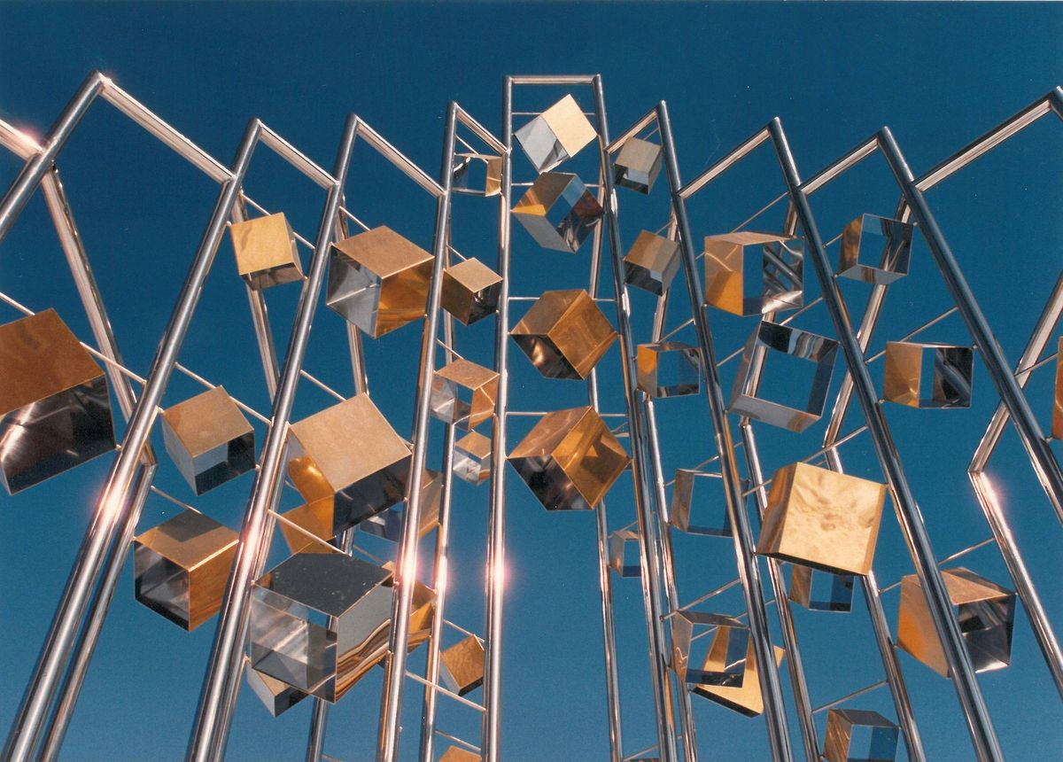

Pawtucket Prism, retrieved from (http://act.mit.edu/cavs/item/cavsdf_ihara_m_Sact-office16102911580)
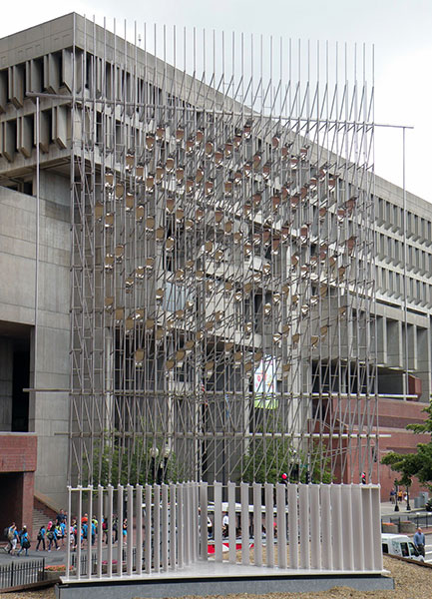

Wind Wind Wind, retrieved from (http://www.michioihara.com/sculpture/details/2012_WindWindWind_Boston_MA.html)

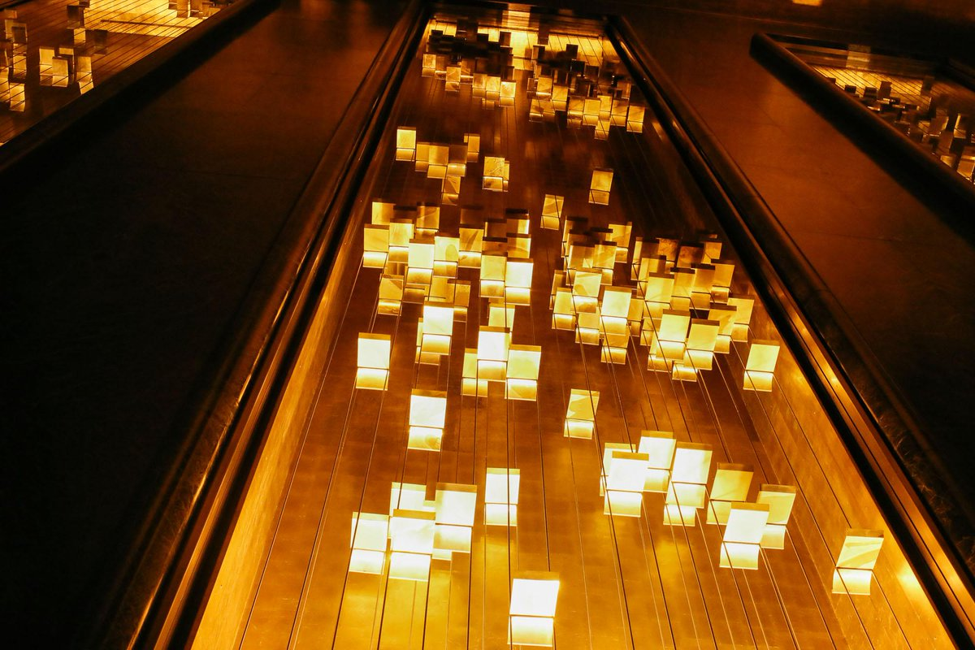
Light and Movement from the Rockefeller Center, retrieved from (https://twitter.com/rockcenternyc/status/1016653790408314881)

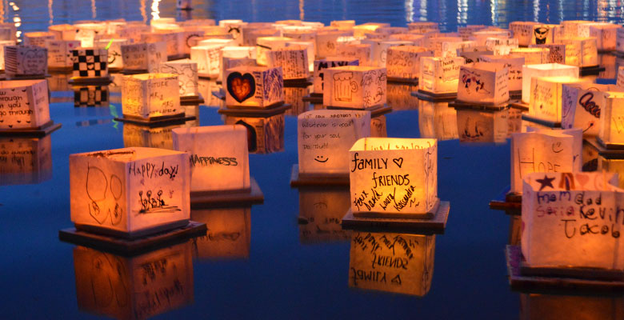

Water lanterns from the Water Lantern Festival, retrieved from (https://www.waterlanternfestival.com/losangeles.php

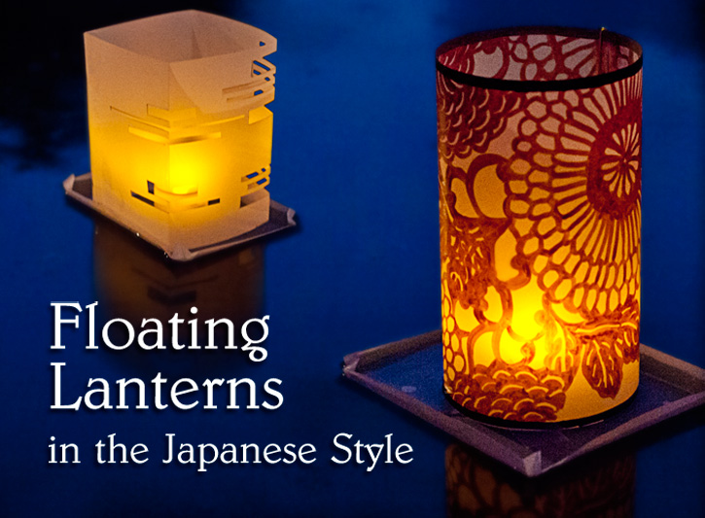
Water lanterns in cube and cylinder style, retrieved from (https://www.dickblick.com/ProjectIdeas/Floating-Lanterns/)

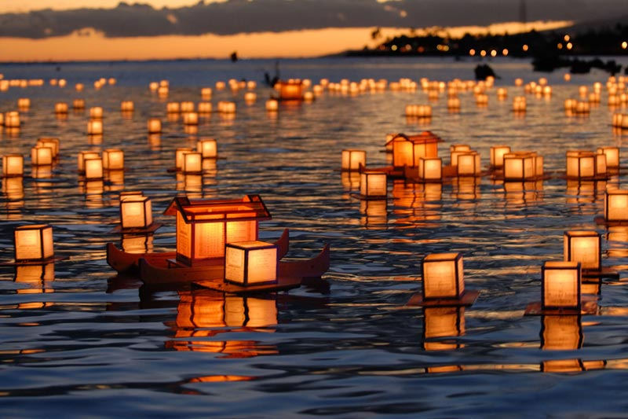
Water lanterns (cube and boat variety), retrieved from (https://www.exportersindia.com/twinkling-lanterns/floating-water-lanterns-bangalore-india-685399.htm)

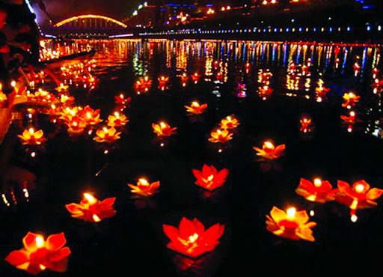

Lotus shaped water lanterns on the Ghost Festival, retrieved from (http://www.chinatravelpage.com/chinas-ghost-festival-zhong-yuan-jie)

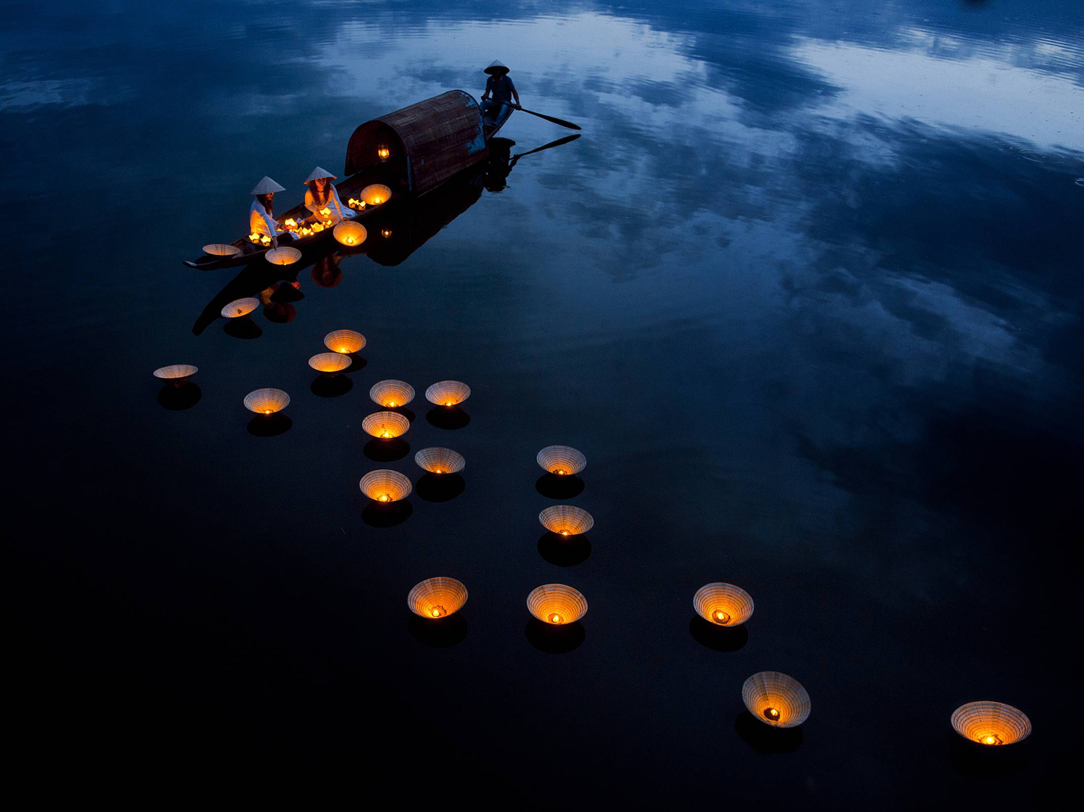

Hat (non la) shaped water lanterns from Vietnam, retrieved from (https://www.reddit.com/r/MostBeautiful/comments/5r8q15/lighting_dream_lanterns_on_the_perfume_river_in/)

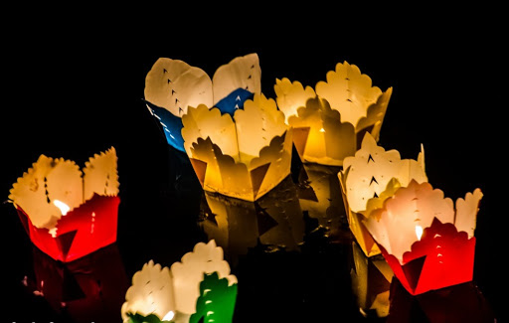

Oyster pail shaped water lanterns from Vietnam, retrieved from (http://hoianfoodtour.com/top-7-fun-hoi-an-activities-for-new-year-eve/)

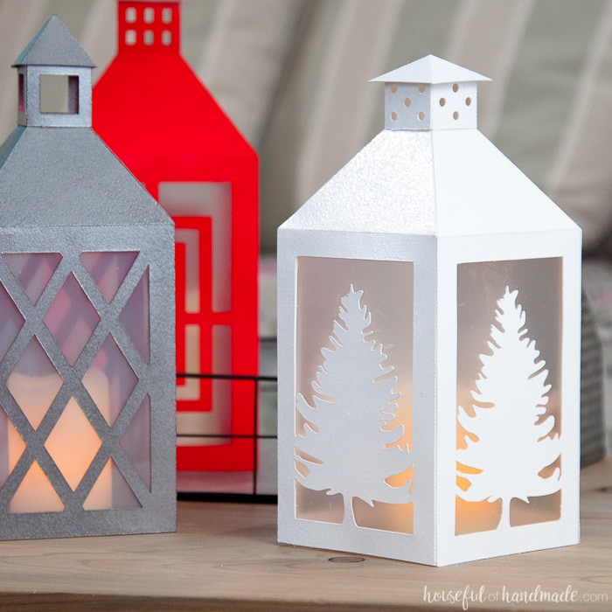
Tree cutout lantern, retrieved from (https://housefulofhandmade.com/diy-paper-lanterns-decor/)

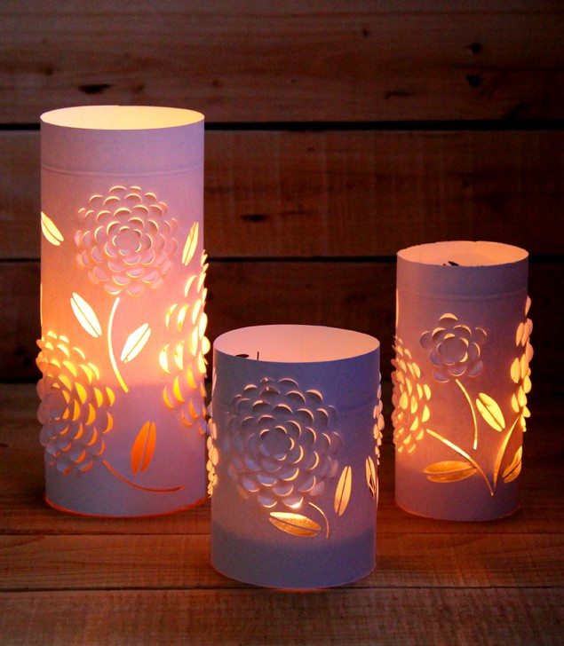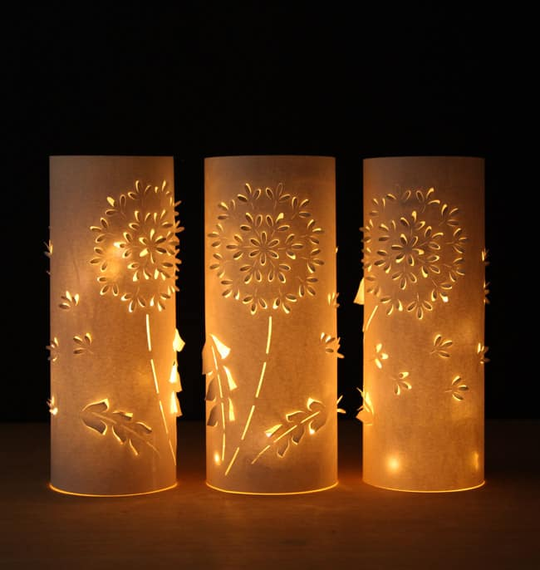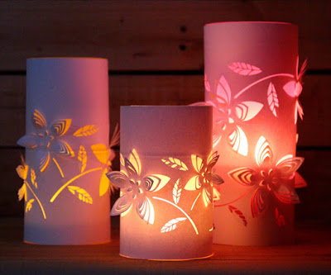
Flower cutout lanterns, retrieved from (https://www.apieceofrainbow.com/diy-dimensional-paper-lantern/)

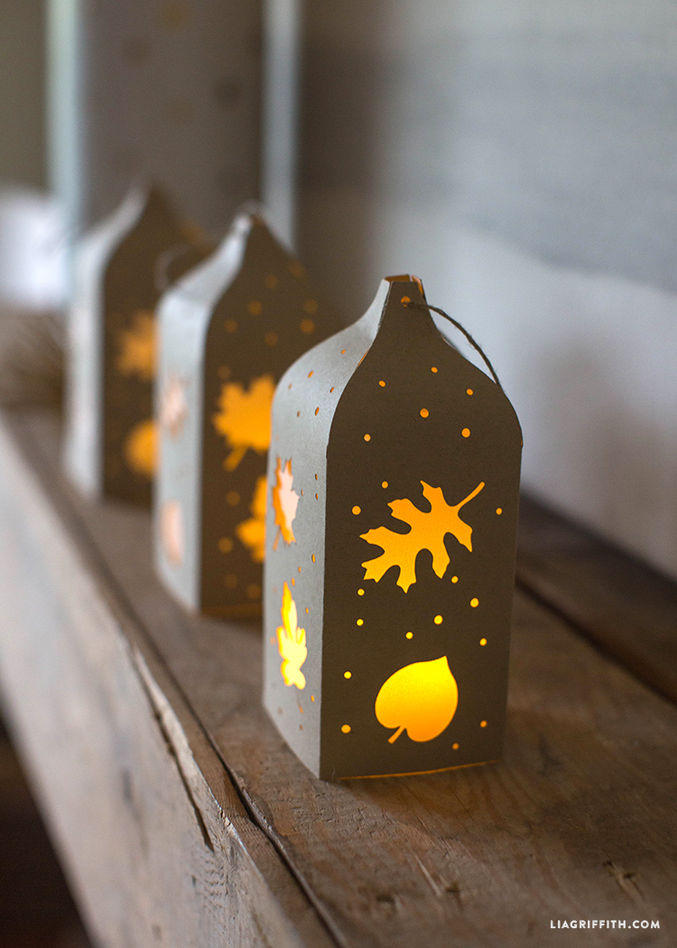

Leaves cutout lantern, retrieved from (https://liagriffith.com/fall-paper-cut-lantern/)

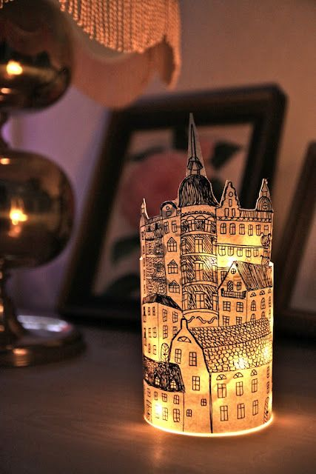
Circular town lantern, retrieved from (https://www.boredart.com/2015/11/the-simple-but-sensational-art-of-making-and-decorating-with-paper-lanterns.html)

Guiding questions to ask:

- In the images and videos (linked in Procedures) that show Wind Wind Wind, what do you notice?
  - How are the metal cubes moving in Pawtucket Prism? What’s causing this change in appearance?
  - How are the metal plates in Wind Wind Wind moving? What’s causing this change in appearance?
  - Identify what is acting upon these pieces to cause these effects.
  - What effects does nature have on these pieces? Describe what you notice and see.
  - How do these effects make you feel about the work? Are the pieces more interesting to look at because of the motions and effects from the motions?
  - From the videos, what else can you sense? Is there anything about the sound of the pieces that makes the pieces more interesting (especially Wind Wind Wind?)
  - How is the piece Light and Movement similar to the water lantern festivals in appearance?
    - Note some similar qualities!
- What are some interesting things about all of the water lanterns I showed you that you can point out?
  - What forms do you notice, first of all? (Cube, rectangular prism, cylinder, cone…)
    - Why do you suppose some of these forms were chosen?
  - What materials do you think these lanterns are made of? Do these materials seem light and buoyant (that means, can the materials float)?
  - What modifications, additions, or alterations to the surface of these lanterns do you notice?
    - (Point out cuts, patterned rims, drawings, paintings, words…)
    - How can these modifications be functional? Decorative? Or both?
    - Do you think these modifications have any sort of meaning?
- What makes water lanterns similar to Michio Ihara’s works?
  - They depend upon forces of nature to move and to have an effect
  - They look different, depending upon how you look at them
  - They’re three-dimensional

Lesson Procedure:

DAY 1
(2 min) Allow students to settle down: collect any sketchbook assignments, if need be.
(10 min) Begin the presentation
- BEGINNING OF PRESENTATION: Introduction to Michio Ihara’s work. Show his works, as well as the video linked below demonstrating how one of his pieces (Wind Wind Wind) works.
  - Links:
Wind Wind Wind: https://www.youtube.com/watch?v=UH4-1nsOus0
- MIDDLE OF PRESENTATION: Define kinetic art.
  - Point out how Ihara’s art always has some sort of force working on it
  - Ask students for responses what sort of forces acted upon Ihara’s sculptures
    - If they are stuck, maybe point out what they might’ve heard in the video – the sound of wind? Additionally, point to the name of the work (Wind Wind Wind) – what the students should understand is that the wind is affecting the work.
  - Clarify that kinetic art is art that has some sort of external force that works upon it to show an effect.
- END OF PRESENTATION: Go over water lanterns, their origins, and appearances around the world.
  - Say to the students that you will be introducing another type of kinetic art to them that is created around the world
  - Show students water lanterns from around the world.
Show a short clip of a water lantern festival (link: https://www.youtube.com/watch?v=VLaJA7xAFtg)
  - Talk to the students about what could be moving these lanterns and giving them an effect
    - Allow for 1-3 responses
    - Wind, water
    - The light of the candle has an effect on the lantern’s appearance, making it look as if it is flickering
      - What sort of effect would this flickering have on an image, do you think?
  - Explain that water lanterns are used around the world as prayers, either for good luck, or ancestors, or wishes.
    - “Most importantly, these lanterns were used to hold wishes.”
      - Some of these lanterns carry wishes for ancestors to live a good life in heaven, or wishes for good luck for the next year.
      - “What is a wish?”
(3 min) Talk briefly about the assignment in the PowerPoint.
- Have prototypes demonstrating the three base shapes that you will allow them to use at first (on the table for them to refer to) as well as a finished piece demonstrating an example. Explain to students that:
- First, they will have an assignment to work on until the end of this class - > beginning of next class that involves coming up with an illustration that illustrates their wish for the future. (Writing prompts for their brainstorming process will be on the worksheet).
- Next, after they make sketches of those illustrations, they will choose a base shape that they think would work best with their illustration. Here in this part of the PowerPoint, show lanterns that have illustrations on them to get the students started.
- With that base shape, students will also come up with any sort of paper cuts that they might want to make to make to the lantern. Here in this part of the PowerPoint, show lanterns that have interesting cut-outs to get the students started.
- Pass out the worksheet by table.
(50 min) Brainstorming / work time.
- Let the class work alone for ten-fifteen minutes.
- Once those ten minutes are up, start walking around the class and seeing how the students are doing with the worksheet / writing prompts.
  - Ask the students what sort of wish they are thinking of so far, and what they might draw to represent that wish.
  - If they are stuck on a wish, ask questions such as:
    - “What do you imagine for yourself in one year? Five years?”
    - “Is there anything big you might want to do later?”
    - “Is there anything you want to work on for yourself?”
    - “Is there anything that you want the world to change?”
  - If they are stuck on what to use to represent a wish, ask questions like:
    - “So what sort of object do you associate with that wish?”
    - “You said your wish was this—how about (x object)?”
    - “What object does this wish remind you of?”
- At 25 minutes, tell students that they should have a good idea of what their wish might be and that they all should have finished the writing prompts. The rest of the time for work should be focused on drawing (5) quick thumbnails and then a final rough sketch approximately the same size as the lantern showing what sort of illustration as well as any sort of paper cuts they might want to make.
- Then at around 40 minutes, tell students they have 10 more minutes to work.
(4 min) Small discussion / share time.
- Ask three students to come up and share their wish.
- After the students have shared their wish, talk about expectations for next class (refer to day 2)
  - “We will be starting our final illustrations next class, so if you have not finished your thumbnails then you may bring home the assignment to work.”
  - “I’ll also be demoing how to use an Xacto knife to cut the translucent paper we’ll be using for the final illustration, how they will be safely distributed, and how they will be safely collected at the end of class.”
(4 min) Clean up
- Students put away all supplies (pencils,markers, etc) at this time.

DAY 2
(2 min) Allow students to settle down.
(5 min) Demonstration on using an Xacto knife and cutting mat to cut designs on the translucent paper
- Have sample illustration at the ready
- Have students come up to a demonstration table to watch the way that you cut.
- General instructions
  - Always cut on a cutting mat so that you don’t scratch the table.
  - Make sure your blade is not worn out.
  - Cut slowly, and lightly (Don’t press too hard)
    - If need be cut over the line twice
  - Make sure you have drawn your design lightly before you start cutting
  - Try to cut away and to the side of you. Make sure your hand is not in the way of the knife!
  - Hold the paper you are cutting firmly with your free hand.
  - Also, when you’re demonstrating make sure that the design you are cutting out is a) big enough so that the students can see what you are doing b) visible in general, so try not to block the way with your hand or arm.
- Set Xacto knives and cutting mats for students to check out at your desk.
(60 min) Work time
- At this point the students should be laying down and starting to color their illustration.
  - An adaptation to note – because vellum is translucent, what students can do first is take their final rough sketch and put it underneath the vellum. They can then lightly trace over their final rough sketch on the vellum with a pencil, and once that’s laid down, they can refine their illustration.
    - Perhaps this property of vellum can also be demonstrated during the Xacto knife demonstration! (Show students how to trace a design, and then cut that design out.)
- Around 20 minutes or so, go around the room and check where students are. Assist if need be.
- By the end of this work time students should at least have their design down and have at least gotten to halfway done cutting and/or illustrating.
(5 min) Clean up
- Students will put away all coloring supplies (markers and colored pencils), pencils, erasers, etc that they have used.
- They will throw away any paper scraps.
- They will also wipe down their tables.
- If a student has used an Xacto knife they will cap their knives and bring it back to the front of the table, along with the cutting mat that they hav used.

DAY 3
(2 min) Allow students to settle down.
(5 min) Demonstration on how to put together a lantern.
- Start with a cylinder (as this is the easiest one to put together). Roll a piece of vellum around, and then dab a glue stick on the end of the vellum (up to ½’’), sealing it shut and making a cylinder form.
- Then, demonstrate how to fold down a cube / rectangular prism shape.
  - Instructions: first fold ½” from one edge of the paper.
  - Then, take the other edge and fold it all the way to the crease made by the ½” folded edge.
  - Next, take that same edge and fold it to the crease made by the first fold. Do not unfold.
  - Last, fold over the new edge one more time to the crease made by the 1/2” folded edge. Unfold.
  - Now the paper should be able to be folded into a prism or cube shape. Take a glue stick, dab it onto the ½’ folded edge, and close up the shape.
- Last, demonstrate how to stick the lantern down to the balsa wood base.
  - First, put the lantern form on the base to see where hot glue should be dabbed.
  - Mark four corners lightly on the balsa wood base with pencil. (Use corners of the square created by the prism as a reference.)
  - Take the glue gun and dab hot glue on these four corners. Press the corners of the prism down onto the hot glue.
  - Safety precautions to mention:
    - Keep hot glue gun pointed outwards.
    - Never have your finger on the trigger unless you are squeezing out glue
    - Never touch the tip with your fingers or your body
    - Make sure to prop the glue gun on a rack or on its metal stand and not sideways when you are done using it.
  - Hot glue guns will always be at the front (students can’t use them alone). You can watch the students as they use them.

(65 min) Work time
- The rest of the time is for work.
- At this point all students should have had cut designs in their illustrations, if they have any.
  - Tell students that if they have not done so today is their last day to cut designs (as they will not be out on day 4.)
- Once again, go around the room and check on students’ progress. Help them if need be (especially with attaching lanterns to the base).
- If a student is done with their work early, they can decorate their balsa wood base with markers.
- If a student is not done by the time work time is over, they will have 30 minutes to finish up next class.
(5 min) Clean up
- Teacher: unplug hot glue guns
- Students: clean up supplies and put back in bins, bring Xacto knives and mats back to the front, and put unfinished work to the side of the classroom. Throw away any excess trash.
- Wipe down tables.

DAY 4
(2 min) Allow students to settle down.
(30 min) Work time + finishing touches
- This time is for students to finish up anything if they need to.
- Go around the room and check if students need help with anything.
- If students finish early, they can use this time to fill out the final response sheet, which is placed up front at the demonstration table.
- Pass out battery powered candle lights to the students and tell students to put the candles in when it’s time for discussion.
(10 min) Discussion about projects
- Ask students to turn on their candles and put them inside their lanterns. Turn the lights off.
- Up front, you should have prepared a tub or plastic bin full of water. This bin is for students who volunteer to come up and float their lanterns.
- Ask for volunteers (4-5) to come up and float their lanterns. As each student comes up, before they can place their lantern in the water, ask them to describe their wish, and their illustration. (Make sure whoever comes up hasn’t volunteered before!)
- After all volunteers have gone, ask students the following questions (also found in Questioning Strategies)
  - If we had gone to a river and floated all of our lamps, what sort of force of nature do you think would have acted upon it, giving it movement and thus making our lanterns kinetic art? Remember what we talked about during our first class! (as a review question)
    - Here maybe incorporate some movement, using a hand fan?
  - If we used real candles, how do you think our lanterns might’ve looked?
  - If we had kept the lights on, do you think our lanterns would have looked as beautiful or good? Why not?
    - One response each
(5 min) Clean up
- Teacher: put away any hot glue guns if there are any out.
- Students: put back supplies into bins, throw away any excess trash, leave art projects on the side for grading (make sure their names are on the base somewhere), turn in worksheets if they have finished.

For the rest of class – Students can finish filling out their final response sheet (if they have not done so already), work on sketchbooks, or free draw for the rest of class. They are also welcome to come up and float their lanterns on the water up front.

Evaluation:

Name:_________________________
Period: ________
Date: _____________
Floating Wishes- Rubric

Did the student... | 4 -Advanced | 3 - Proficient | 2 -Emerging | 1 - Incomplete
Illustrate a wish for the future using any or all of the media given, and does the illustration demonstrate thoughtfulness and neatness? | The student’s illustration conveys the wish clearly through the composition.  The elements used in the illustration are arranged thoughtfully. | The student’s illustration is complete and utilizes any of the the media given (or all) in a sufficent manner. Illustration could use a little more touch-ups, but for the most part it is presentable. | The student made an illustration, but the illlustration could have used more thought or effort into neatness and composition. | The student failed to complete the illustration or the illustration demonstrates a lack of thought or neatness.
Construct a water lantern with neatness and invention? | The student’s lantern is constructed well, with no structural errors or little structural errors that are not distracting. | The student constructed the lantern, and there are minor structural errors that are somewhat distracting, yet does not take away from the overall piece. | The student constructed the lantern, but the lantern has some structural errors that are distracting. | The student failed to complete the project or the student’ final lantern demonstrates a lack of neatness in construction.
Justify, through writing, their illustration and design choices? | The student put a great deal of thought into the writing prompt, and the writing easily connects back to and justifies the design choices. | The student completed the writing prompt, and the writing sufficiently justifies the design choices. | The student completed the writing prompt, but the response is somewhat incomplete and does not fully justify the design choices. | The student failed to complete the writing prompt AND/OR the student’s writing does not make sense or is unrelated to the project.

For a total of 12 points - ___/12

Materials and Preparation:

- Heavy-weight vellum (8.5’’x 11’’ or 9’’ x 12’’) (or if it can be afforded, Yupo paper) for the final lantern
- Hot glue for attaching the lantern to the base
- Glue sticks for gluing the lantern together
- Painter’s tape
- Dowels
- Balsa wood board (cut into 6 x 6 squares, enough for the entire class) for the base of the final lantern; can replace with any sort of buoyant wood
- Pencils
- Erasers
- Rulers for folding
- Sharpies and fine black pens for outlining
- Colored pencils and markers for coloring in the illustration
- Xacto knives for making cuts in paper
- Cutting mats for making cuts
- Tea lights (battery powered) for the lanterns

Preparation

BEFORE DAY 1
- Print out worksheets
- Set out materials: colored pencils, liner pens, markers, pencils, erasers for students
- Make prototypes: cube, rectangular prism, cylinder
BEFORE DAY 2
- Set out materials: colored pencils, liner pens, markers, pencils, erasers, glue sticks for students
- Set out vellum for students
- Set up Xacto knife demonstration.
- Set Xacto knives out at the teacher’s desk for students to ask for them
- Set cutting mats out at the teacher’s desk
BEFORE DAY 3
- Prepare balsa wood bases for students.
- Set out materials: colored pencils, liner pens, markers, pencils, erasers, glue sticks for students
- Have hot glue guns out.
- Set Xacto knives out at the teacher’s desk for students to ask for them
- Set cutting mats out at the teacher’s desk
BEFORE DAY 4
- Set out remaining balsa wood bases.
- Set out materials: colored pencils, liner pens, markers, pencils, erasers, glue sticks for students
- Fill large container (a long storage bin?) with water.
- Have hot glue guns out.
- Prepare battery lit candles for students.

Resources:

Floating Lanterns in the Japanese Style . (n.d.). Retrieved from https://www.dickblick.com/ProjectIdeas/Floating-Lanterns/

Michio Ohara. (n.d.). Retrieved from http://www.michioihara.com/index.html

5 Ways to Nurture Gifted Art Students. (2017, November 15). Retrieved from https://blog.schoolspecialty.com/5-ways-nurture-gifted-art-students/

Special Populations: Accelerated Learning/GT

Students in accelerated learning/GT often finish early and/or seek more to do, so the following accommodations or changes for this specific project could be made:

- Instead of asking students to identify a wish they have for the future, they could instead be given a “research” project that seeks out a problem in the world that they find troubling. Their wish could be based upon improving this problem that they have identified, and then they will be tasked with coming up with an illustration for this wish.
- Students could also be allowed to experiment with different types of paper. For instance, they could layer colored paper, or use colored paper instead of white paper
  - They could also add found 3D elements such as paper flowers, rhinestones, etc – so as long as the material is light. If this option is added, students will be tasked with identifying and incorporating light objects that can be supported by the balsa board.
- Beyond cube and cylinder forms, students could also try to experiment with other forms such as cones, flowers, etc.
- Extra time – if students (not just accelerated students) want extra time to work on their projects, they can come in during lunch or after school.

Extra Materials:
- PowerPoint showing additional examples of lanterns with paper cuts in them
- Prototypes of base lanterns that students can use to build their lantern off of
- Demo lantern that you have made before class
- Extra Xacto blades
- Scissors
- Plastic bin and/or inflatable kid’s pool for demonstrating buoyancy.
- Fan for generating “wind”
- Visual worksheets demonstrating how to fold lanterns and how to attach them to wood.

Questioning Strategies

- If we had gone to a river and floated all of our lamps, what sort of force of nature do you think would have acted upon it, giving it movement?
- If we had kept the lights on, do you think our lanterns would have looked as beautiful or good?
- Why have something beautiful to represent a wish?
- Why do you think other cultures wanted to have wishes “move?”
- What effect does cutting out designs have on the piece (how does it look?) How does it make you feel?
- What are some interesting things about all of the water lanterns I showed you that you can point out?
  - What forms do you notice, first of all? (Cube, rectangular prism, cylinder, cone…)
    - Why do you suppose some of these forms were chosen?
  - What materials do you think these lanterns are made of? Do these materials seem light and buoyant (that means, can the materials float)?
  - What modifications, additions, or alterations to the surface of these lanterns do you notice?
    - (Point out cuts, patterned rims, drawings, paintings, words…)
    - How can these modifications be functional? Decorative? Or both?
    - Do you think these modifications have any sort of meaning?
- What makes water lanterns similar to Michio Ihara’s works?
  - They depend upon forces of nature to move and to have an effect
  - They look different, depending upon how you look at them
  - They’re three-dimensional

