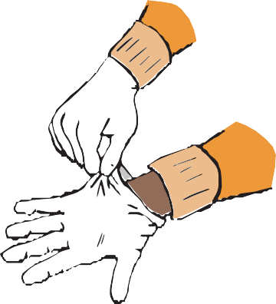

**1**

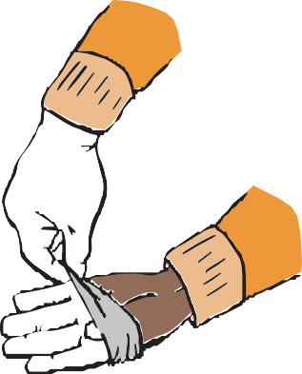

**2**

With both hands gloved, grasp the outside

of one glove at the top of your wrist, being careful not to touch your bare skin.

Peel off this first glove, peeling away from your body and from wrist to fingertips, turning the glove inside out.

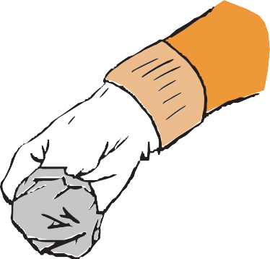

**3**

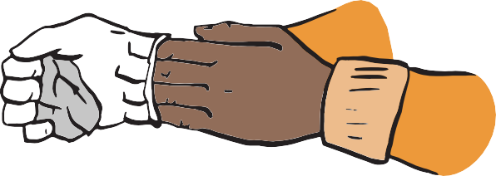

**4**

Hold the glove you just removed in your gloved hand.

With your ungloved hand, peel off the second glove by inserting your fingers inside the glove at the top of your wrist.

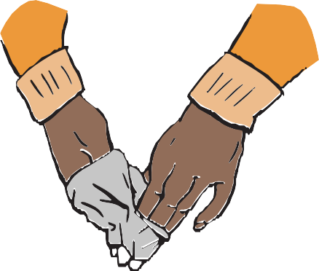

**5**

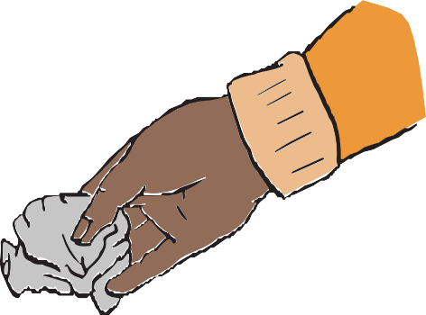

**6**

Turn the second glove inside out while tilting it away from your body, leaving the first glove inside the second.

Dispose of the gloves safely. Do not reuse the gloves.

**How to Remove Gloves**

To protect yourself, use the following steps to take off gloves

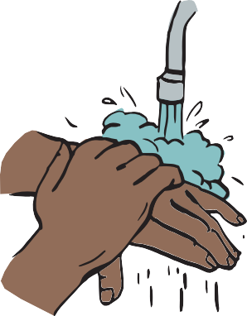

**7**

Clean your hands immediately after removing gloves and before touching any objects or surfaces.