THE COMMONWEALTH OF VIRGINIA
THE VISITORS OF JAMES MADISON UNIVERSITY

Ad Hoc Governance Committee
Thursday, November 18, 2021
Meeting Room 3
1:00 p.m.

Agenda

- Review Board By-Law Revisions

- Review the Self-Evaluation Process

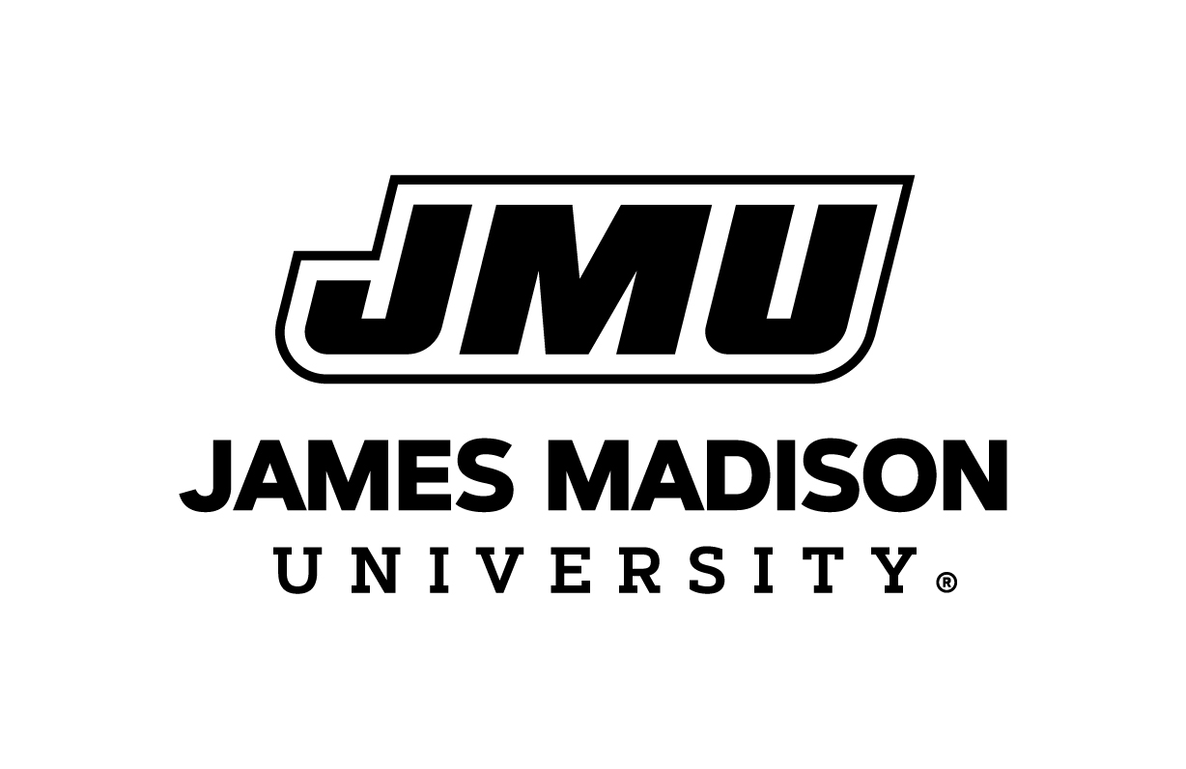
Board of Visitor
November 18, 2021

