University Writing Center
2012-2013 Annual Report

Version 1.0

June 2013
Presented by:
Emiline Buhler, GA
Jared Featherstone, Coordinator

Laura Schubert

Paige Normand

UWC Annual Report
The University Writing Center empowers students, faculty, and staff to develop writing skills and confidence by providing one-to-one consultations, resources, and programming that support and enhance writing across campus.

New Programs

Library Fellows
This year second year that the UWC has partnered with University Libraries. Librarian Reba Leiding was the Faculty Fellow from the libraries to have a year-long residency in the writing center. The program was very successful in that it enriched professional development for both UWC and library staff, giving us opportunities to think about the overlap and differences between research and writing problems. In May 2013, the two former UWC fellows gave a presentation to library staff about their experience. The libraries are interested in continuing this partnership.

Disciplinary Writing Panel
The UWC hosted its second annual disciplinary writing panel, an event that featured three faculty members from ISAT who discussed disciplinary writing conventions in subjects like intelligence analysis and biotechnology. The panel drew high attendance from current and aspiring tutors, and CIT filmed the event so that future students can learn from the discussion. Instead of asking each faculty member to present on writing conventions and assignments in their discipline, as we did last year, we created a conversation among panelists by posing questions for them to respond to. We also reserved time for questions from students in the audience. The result was a more discussion-based, cohesive forum than last year’s panel.

Athletic Performance Center

This year, the UWC opened its third satellite location in the Athletic Performance Center. After the successful placement of a Writing Fellow in a writing course consisting mostly of athletes, the APC was interested in having tutoring in their study hall location. The APC funded tutoring two days a week in the evenings during the fall and spring semesters. The UWC conducted over 61 sessions in this new satellite location.

Ongoing Programs

Writing Fellows
This year, the writing fellows program supported 32 writers in two sections of GWRTC 103. A decision was made to apply funds from the UWC’s endowment to develop and expand the program next year into new departments.

Presentations and Workshops
For the 2010-2011 year, the Writing Center gave 22 presentations to 388 attendees; for the 2011-2012 year, the Writing Center gave 78 presentations to 2,546 attendees; for the 2012-2013 the Writing Center gave 98 presentations to approximately 2,687 attendees. Over half of these presentations are 45-minute workshops, course-specific presentations.

This year we have worked with professors to develop course-specific content for classes in Music, Health Science, Chemistry, Nursing, Graduate Psychology, College of Business, and Sport and Recreation Management. Some of these collaborations included conversations about assignment design, feedback, and contextualizing how they and their students can best make use of the Learning Centers. We also maintained last year’s collaboration with SMAD, the College of Business, and the WRTC Gen Ed faculty.

The Presentation Series also maintains campus outreach through their work with specific groups and orientations. This year we presented for The Physician’s Assistants Graduate Student Orientation, the Resident Assistants’ Orientation, Madison Jump, the Resources Panel for the Foundations of Hospitality, Sport and Recreation Management, Resident Assistants’ academic hall programs, and a presentation for the visiting students of Hiroshima University.
This year, the Writing Center tutors collaborated with Paige Normand to develop a new “Introduction to the Writing Center” (ft. French Toast) that promises to be a more memorable and engaging “intro” presentation. Several tutors – Emiline Buhler, Drew Watt, and Lindsay Ragole – worked with Paige and the Communication Center to feel comfortable giving either introductory presentations or our 45-minute workshop presentations. Emiline Buhler, Camille Corum, and Paige collaborated to develop a new “writing process” presentation: “What Law and Order has taught me about the Writing Process,” which Paige will promote to faculty during the 2013-2014 school year.

Faculty and student response to these presentations has been enthusiastic. The next step will be two-fold: encouraging stronger tutor involvement and developing a strategy for articulating and assessing outcomes for the Presentation Series.

Website and Online resources
Marketing and Outreach Interns updated the UWC website, adding some resources created by the tutors. They also created alumni pages, which should launch sometime in Fall 2013.

Newsletter
This was the third year of production for UWC Monthly, the Center’s in-house newsletter. We continue to send out color hardcopies to approximately 100 administrators and faculty members, and we archive digital PDFs on our website. Peer tutors have always taken primary roles in the production of the newsletter, but this year even more responsibility was transferred to them. This year Faculty Fellow Kevin Jefferson oversaw the production and editorial process of the newsletter.

Peer Tutor Development
The professional development curriculum changed again this year, with the intent of providing more structure to the meetings and creating more accountability. The curriculum’s mission was to help UWC and FYI tutors stay abreast of current scholarship, practices, and trends in the discipline; to provide collegial support; to help tutors develop and improve their craft; and to inspire tutors to contribute to the discipline of writing centers. Like last year, tutors met in small groups to discuss tutoring topics, to debrief challenging sessions, and to engage in group learning activities. However, we paired a faculty facilitator with each group this year so that tutors could consult regularly with an expert. Each faculty member met with their group weekly, communicated with peer tutors via email, suggested articles and topics for discussion, and helped to lead meetings. The faculty members helped the groups maintain consistency and accountability, in terms of attendance, shared responsibility, and group effort. Since several groups had inconsistent attendance last year and did not complete their projects, we thought more faculty leadership would increase accountability and productivity. In addition, faculty facilitators communicated important UWC announcements and reminders to enhance communication throughout the UWC.
Although increased faculty involvement created more work for the facilitators, groups benefitted greatly. As demonstrated by regular attendance across all groups (with only a few exceptions) and completed projects that further the center’s mission, the curriculum proved successful. Tutors reported that regular access to an expert consultant brought deeper disciplinary knowledge, which enriched their conversations and individual learning. They said the groups were more useful than last year, when sometimes it felt like “the blind leading the blind.” Conversations with peer tutors also suggest that groups are most successful when they contain a balance of new and experienced tutors.

This year’s program also revealed the importance of a small group size (i.e., fewer than seven members). Two groups in particular were much larger than the others, due to tutors’ scheduling conflicts. These groups’ faculty facilitators reported that the size was overwhelming and interfered with group synergy. For example, both of these groups had to divide into subgroups in order to complete their projects. It was evident that groups that were able to collaborate on the same project had greater intimacy and a stronger whole-group relationship. This finding suggests that the UWC should identify one common hour when all groups can meet, in order to ensure a manageable group size.

Conferences
The UWC continued to involve peer tutors in professional conferences this year in bringing three peer tutors, three graduate students, one faculty fellows, and one core faculty to the Mid Atlantic Writing Centers Association conference in Pennsylvania. The graduate students gave a presentation entitled, “Novice and Experienced Tutoring Strategies.” Paige Normand, along with two peer tutors, gave a presentation entitled, “Avenues for New Media Consultations” at the 20th Anniversary Symposium for the Undergraduate Writing Center, University of Texas at Austin.

Jared Featherstone and Laura Schubert also gave presentations at the International Writing Centers Association conferences in San Diego and Las Vegas. UWC Faculty Fellow Kevin Jefferson was part of the Las Vegas presentation.

Maymester tutoring and resource creation
Again, we offered tutoring during the Maymester. This year, Paige Normand sent out messages to professors offering in-class presentations. We conducted over 20 sessions for undergraduates, graduates, and faculty. Though there is still considerable room for growth, this is double the number of consultations we did last Maymester. The tutors were able to create more resources for the Link Library, but the major project was assessment. Our GA and an undergraduate tutor with a psychology background were able to code our session data to find important trends in our consultations. Their findings will inform the tutoring writing course and professional development in the UWC.

Assessment

Usage and Impact

The University Writing Center held 3878 appointments during the 2012-2013 academic year. We served 1879 unique clients; 779 of which were returning users. Over the last two years, we have introduced (and increased appointments at) several satellite locations. The Athletic Performance Center (APC) opened this fall. The breakdown of writing consultations by location is as follows:

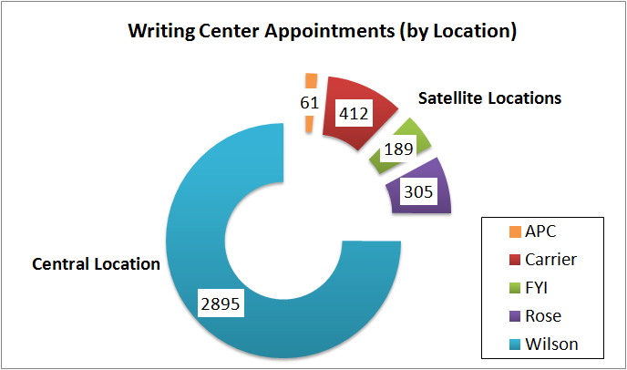
Session Surveys

Following a tutorial, students are emailed a post-session survey. We have observed that this is the best means to elicit a feedback from UWC clients. This year, we’ve collected a total of 535 post-session surveys. The most valuable results from this illustrate that we are fulfilling one of our mission-statement objectives, “...to empower students, faculty, and staff to develop writing skills and confidence by providing one-on-one consultations, resources and programming that support and enhance writing across campus.”
The post-session surveys indicated:

-95% of respondents felt more prepared to write or revise their paper following their consultation.

-91% of respondents learned something about writing that could be applied to future tasks.

-75% of respondents rated their confidence as a 6 or 7 (on a 1 to 7 rating scale).
This is particularly noteworthy because our client intake forms show only 10% of students indicate a confidence rating of 5 or above prior to a tutorial.
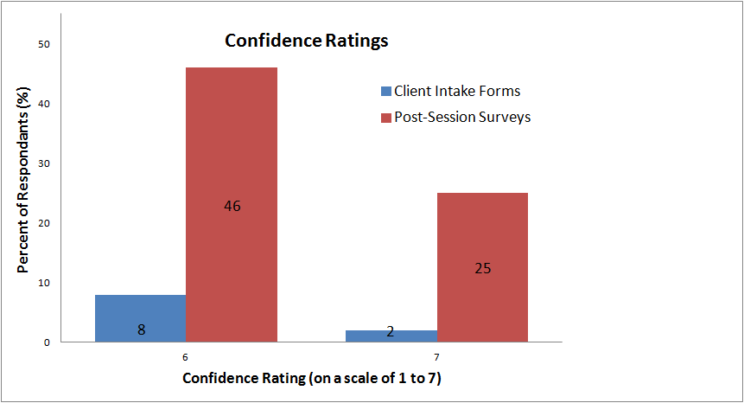

These post-session surveys are checked regularly and incorporated into weekly emails and professional development meetings. Accordingly, client feedback is immediately addressed in our writing center practice.

The results also show that professor recommendation continues to be our number one reason that students visit the center. Knowing this, we have will continue connecting with campus faculty. We are currently doing this by hosting annual disciplinary-specific writers’ panels. We are also are connecting with faculty by developing writing center resources. This year, our tutors have identified specific courses (such COB 300, GHIST, GLIT, and GHUM) and interviewed faculty of those departments to develop student and tutor materials.

WC Online

This year, we became more familiarized with WC Online, and have experimented with various applications such as word queries, data exports, and system statistics.

System statistics:

This application tells us detailed scheduling data, including appointment length, location, staff, date, and time. We anticipate (and already have begun) using this information to inform scheduling decisions. This year, we conducted a pilot study of the ECL remote location; we found that the science-focused sessions have doubled over the last year. Using a Chi-squared analysis, we determined the number of science-focused sessions was significantly higher at ECL than at our central location (Wilson Hall). Next fall, we will strategically schedule tutors with science and social science backgrounds at that location. We plan to continue to examine session demographics to identify the semester’s “high-capacity weeks” (like midterms) so we can add additional staff hours to meet that demand.

Word Queries:

WC online has the capacity to isolate certain search terms from our consultations. For example, we can select session reports that address “COB 300”. We have used these word queries to identify techniques and strategies used in certain sessions. These items have contributed to the development of course- specific and discipline-specific resources this year.

Data Export:

This year we have exported data from WC online to store all the information from several years in one place. We have exported these mass data sets into other (more sophisticated) statistical programs, such as SPSS and NVivo. This step is critical for moving into mixed-methods studies about demonstrated learning, tutoring strategies, and affective learning.

SPSS

Complete Data Set:

As previously mentioned, we were able to successfully compile data from our Client Intake Forms and our Session Report Sheets. SPSS now contains several years of data (beginning with spring 2010). This allows us to see how our practice has evolved over time. To analyze this data, we will be using a combination of Excel, SPSS, and NVivo. This data will provide quantitative validation to the qualitative phenomenon that has been observed in previous writing center pedagogy.

Demographic Data (2012-2013)

SPSS, when paired with WC Online, provides us with very sophisticated demographic information. For this academic year, we streamlined our data to get a breakdown of clientele majors and their colleges. The diverse set of majors illustrates that we are reaching students across campus. One interesting finding was that we are serving a large number of science and business students. Below is representation of our results from fall 2012:

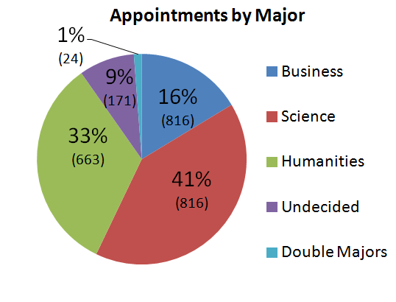

We have completed a similar breakdown to identify common courses and their instructors. This way, we are able to connect with instructors who are (or are not) sending students to us. This is important knowledge to have access to, because our marketing assessment indicates “professor recommendation” is our number one referral to the writing center.

Marketing Assessment:

Along with our demographic breakdowns from both WC Online and SPSS, we administered a marketing survey via email to students on campus. On a whole, we found that the survey results generally reflected results from the client intake form. However, the survey feedback additionally indicated that we should consider generating more resources for students that are a part of the online JMU community.

Out of 121 respondents, 91% of the respondents were aware about face-to-face consultations, but only 6 % knew about UWC’s online tutoring service. While the low awareness level regarding online tutoring services maybe because of UWC’s conditional online tutoring policy, UWC may need to consider publicizing this service more if it plans to expand online tutoring services in the future.

Observation Sheets:

Last year, UWC rewrote the observation form used to evaluate peer-tutoring sessions. In previous years, this form has been used by the Coordinator and other UWC supervisors to observe faculty, graduate, and undergraduate tutors. This year, in addition to the semester observations, a study was completed to identify differences between novice and experienced tutors. The major trends identified during this study included differences in: agenda setting, consultation values, use of external resources, and take-away (transferrable) skills.

Method

This study was a qualitative, cross-case analysis. Eight sessions, four novice and four experienced, were video recorded and analyzed. Tutors who were in their first semester of tutoring were categorized as “novice tutors” and tutors who had tutored for more than two semesters were categorized as “experienced tutors”. The recordings were observed by the three researchers and evaluated on the basis of the following categories: transferable skills, student-centered/tutor-centered sessions, higher-order/lower-order concerns, and miscellaneous.

Transferable skills were defined as writing skills that students could take away from the session. Student centered and tutor-centered sessions were determined on the basis of the level of involvement in the session – student-centered if the student was involved and played a significant role in determining the direction of the session; tutor -entered if the tutor was more involved and controlled the session direction. Higher-order concerns were defined as concerns relating to organization, structure, idea formulation, rhetorical awareness, thesis generation and overall coherence. Lower-order concerns were defined as sentence-level concerns such as grammar, word choice, and punctuation.

Findings
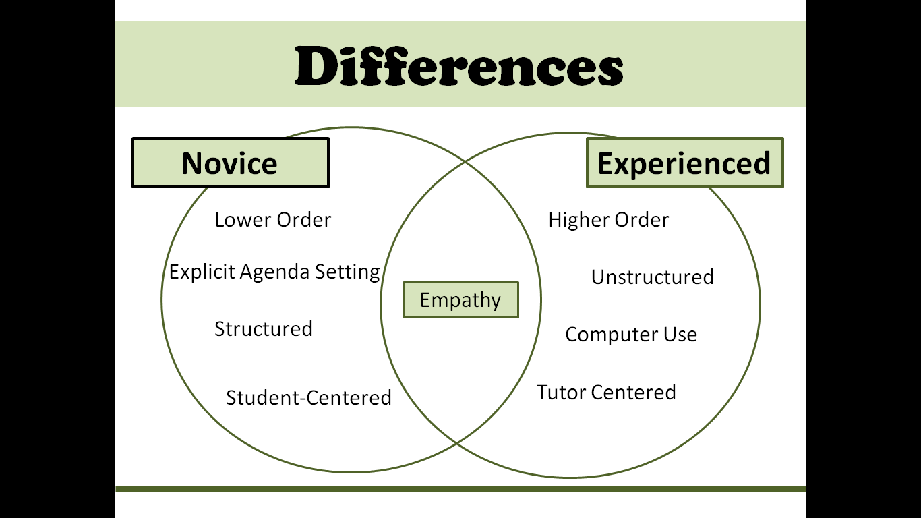

As illustrated in the diagram shown above, there were several differences between novice and experienced tutors.

Implications

The findings of this study indicate that sessions of novice tutors were more effectively managed, structured, and productive than those of experienced tutors. This illustrates that the tutoring writing class has been effective in training and producing capable tutors. It also shows that over time, tutors tend to develop their own strategies: more implicit agenda-setting strategies, more directive tutoring methods and higher use of external resources. These findings validate the importance of our professional development groups (where our staff can communicate strategies amongst each other).

It also highlights the importance of peer-observations. As UWC tutors continue to observe and provide feedback on a regular basis, experienced tutors and novice tutors can learn from each other.

This study was presented by three graduate students at the spring 2013 Mid-Atlantic Writing Center Association Conference (MAWCA); the video-clips and presentation will be adapted for use as a pedagogical tool for the tutoring writing class.

It is noteworthy that the keynote speaker at MAWCA discussed using quantitative evidence to validate qualitative observations. Our response to this is detailed in our section on NVivo.

NVivo

Like SPSS, NVivo will provide empirical evidence for writing center pedagogy. Currently, we have three years worth placed into NVivo. NVivo is a qualitative coding software that makes words (for example: higher-order: thesis, organization, etc) into a designated number (i.e.: “7”). The numeric designations allow us to go back and run more sophisticated statistical tests (such as a Chi-Squared Test in excel).

Last year, UWC staff met with CFI to establish coding system for NVivo. This Maymester, we have worked to establish an organizational system for the coding. So far, we have developed several queries that can be run on various session demographics.

The system we settled on is as follows:

Queries:
Higher Order Concerns, Mid-Range Concerns, and Lower-Order Concerns
Tutoring Methods or Techniques
Affective Change
Categories:
Tutor Stratum
-Faculty, Graduate, or Peer-Tutor
Language
Standing
Location
Course-Specific
-GWRTC 103, General Education, etc
Sample Question: Are faculty tutors more likely to report higher-order learning demonstrated in sessions than non-faculty tutors?

Tutor Strata: | Session Reports with Higher-Order Concerns | % Frequency
Faculty Tutors | 447 of 797 | 56.08%
Non-Faculty Tutors | 933 of 2718 | 34.33%

We can run a Chi-Square Analysis on this data:

 | Higher-Order | No Higher-Order | Totals
Faculty | 447 | 350 | 797
Non-Faculty | 933 | 1785 | 2718
 | 1380 | 2135 | 3515

122.354 = x²
p < .000

The low “p-value” indicates that:

Yes, faculty tutors are significantly more likely to report higher-order demonstrations of learning in sessions than non-faculty tutors. This however, is not an indication of whether more higher-order learning is actually occurring; an alternative explanation may be that faculty tutors are better at articulating and describing learning than peer-tutors.

Future Directions

Now that this data has been more categorized, we are plan frame our analysis around Writing Center Objectives and General Education Objectives (primarily cluster 1 and cluster 2). If we can critically examine word frequencies as they appear in session reports and client intake forms, we can illustrate how often we meet these objectives in these at the UWC.

Alumni Assessment

This year, one of our graduate tutors established an Alumni Database to follow job placements of our tutors. We were interested in discovering what skills tutors leave the center with and how these skills are used in the professional sphere. It will be useful to our current (and prospective) tutors to understand how the UWC can help them outside of the writing center world. Accordingly, we emailed a Qualtrics Survey to obtain this information. Currently, the database is comprised of 68 students and is expected to grow as our current staff graduates over the next few years.

Returning Student Motivation

This study looked at frequent UWC users to examine whether repeat users are improving their writing process with frequent use, or if they are developing a dependence on our services.

Methods

Returning students who visited UWC more than ten times during the fall 2012 and spring 2013 semesters were identified and contacted. Five students (one native speaker and four ELL students) agreed to participate in the 30-minute interviews, held at UWC.

Specifically, the interviews aimed to evaluate:
- The motivation of these students to visit the writing center multiple times
- Whether these students developed transferable skills
- Whether these students have specific tutor preferences
- Whether these students have any specific suggestions for the center.

Findings

All five students acknowledged that repeated visits to the UWC were helpful for improving and refining their writing process. Some of the specific transferrable skills identified by the students were: analytical skills, read aloud revision strategies, free-writing, outlining, citation and bibliography techniques, organization techniques, brainstorming skills, summarizing skills, skill to identify grammatical mistakes, and ability to compose effective introductory and concluding paragraphs.

Implications for UWC

The findings suggest that UWC has made a positive impact on returning students in terms of their writing process and skills. All five students acknowledged that they have benefited from their UWC visits and developed specific transferrable skills. Therefore, judging from the qualitative responses of these five returning students, it seems that UWC is achieving its mission of helping students become better writers.

Approval

Learning Centers Director: |  | Date: |  | / |  | /
UWC Coordinator: |  | Date: |  | / |  | /

