Evidence-Informed Programming
Semester-Long Reading Group (JMU, Spring 2021)
Learning Outcomes:
After engaging with the readings and reading questions, participants will be able to:
- List factors that contribute to student learning and retention of knowledge
- Identity effective teaching strategies or interventions for optimal learning
- Infuse the scientific concepts of learning into programming and/or curriculum
- Identify resources (e.g., databases, repositories, books) housing effective strategies and interventions to promote learning and development
Date | Readings | Reading Discussion Questions
January  12 | The New Science of Wise Psychological Interventions (Walton, 2014) | 1. What are Wise Interventions? What is an example of a wise intervention that the readings provide that aligns with your outcomes and how? (The supplemental reading and database will help you answer this)  Supporting Document/Website: https://www.wiseinterventions.org/ Wise Interventions: Supplemental Reading (Walton & Wilson, 2017)  2. How do Wise Interventions “work”? How does this align with intermediate and distal outcomes in program theory? Supporting Document: The Essential Role of Program Theory (Pope, Finney, & Bare, 2019)  3. Describe the principles of Wise Interventions.  4. What are the three basic motivations that underlie meaning-making and what are techniques to change meaning-making? Describe them.
 | Wise Interventions: Psychological Remedies for Social and Personal Problems (Walton & Wilson, 2018)
January  19 | Social-Psychological Interventions in Education (Yeager & Walton, 2011) | 1. Choose a social-psychological intervention from the reading (see Table 1) and use the information to construct a basic logic model.  2. How are these social-psychological interventions “stealthy”?  3. Though these educational innovations work in the contexts they were applied to, we need to know how to make these educational innovations work reliably in different contexts.  a. What is “scaling” and what should be scaled?  b. What are the barriers to scaling this?  c. What kind of strategies & expertise are needed to scale social-psychological interventions effectively?
January  26 | A Question of Belonging: Race, Social Fit, and Achievement (Walton & Cohen, 2007) | 1. (A Question of Belonging: Race, Social Fit, and Achievement (Walton & Cohen, 2007) In the first experiment, both minority and majority students found it difficult to generate eight friends in a field of study. However, only the minority students responded with a reduction in their sense of social fit. What factors contributed to this decremented sense of fit and what claims were supported/not supported?  2. Describe the transition from Experiment 1 and Experiment 2 in "A Question of Belonging: Race, Social Fit, and Achievement" (Walton & Cohen, 2007).  3. Why is it important to have opportunities to learn in addition to the intervention? Why does this intervention's outcome remain effective after the brief intervention has been concluded?
 | A Brief Social-Belonging Intervention (Walton & Cohen, 2011)
February  9 | Applying the Science of Learning (Halpern & Hakel, 2003) | 1. While programs/curriculum/procedures may have worked in the past, they don't always stand the test of time. If this is the case, why do you think many educators stick with the old ways? What are the pros and cons of sticking with what you know?  2. Why do you think the first and only goal is to teach for long-term retention and transfer? Give a short summary of at least 3 of the basic principles outlined in this article. How can you apply these principles to your program?
February  16 | How Learning Works (Ambrose et al., 2010)  --Forward,  --Introduction  --Chapter 1 | 1. What is learning and its components? What provides the principles of learning the strength that leads to retention and transfer?  2. What are some effects of various kinds of prior knowledge and what implications does it have for teaching? Does your program expect prior knowledge from students? What implications do they pose for your program?
February  23 | How Learning Works (Ambrose et al., 2010)  --Chapter 2 | 1. Rich and meaningful knowledge structures are preferable to support learning and performance. How do these structures vary depending on context? What does "form fits function" mean and how does it apply to your program?  2. Briefly describe panels A, B, C, and D on page 50. How can we enhance student/novice organizational structures to match expert organizational structures?
March  2 | How Learning Works (Ambrose et al., 2010)  --Chapter 3 | 1. "Goals provide the context in which values and expectancies derive meaning and influence motivation" (Ambrose et al., pg. 70). Describe the important concepts in the previous statement and think about how those descriptions relate back to the statement.  2. Restate Figure 3.2. in your own words - have you experienced these different types of motivations in students?
March  9 | How Learning Works (Ambrose et al., 2010)  --Chapter 4 | 1. In what area do you want your students to attain mastery?  a. What key set of skills is required for these students? (i.e., for advising – area could be "academic success" with key skills including time management, study strategies, etc.; for career center – area could be "career preparation" with key skills in resume building, professional standards, etc.)  b. How can students practice integrating these skills and knowing when to apply them?  2. On average, where do you think your students are in Figure 4.2: Stages in the Development of Mastery (pg. 97)? Consider the strategies the reading provided and pick one or two that you feel may be applicable to your program.
March  23 | How Learning Works (Ambrose et al., 2010)  --Chapters 5 | 1. Identify and explain the key features of effective practice and effective feedback. How do they work together to facilitate the retention and transfer of knowledge?  2. Do you find that you have already implemented some strategies that the research suggests? How do you implement these strategies? Are there any that you feel could be integrated into your programs?
April  6 | How Learning Works (Ambrose et al., 2010)  --Chapters 6 | 1. Summarize the stages of intellectual and social identity development in the models mentioned in this chapter. On average, what stages do you see your students at? What strategies that promote student development do you think would be useful in these stages?  2. Briefly describe the four basic areas of climate outlined in this chapter. Considering the strategies suggested by Ambrose et al. (2010), what can you or your students do to foster a “good” course climate?
April  27 | How Learning Works (Ambrose et al., 2010)  --Chapter 7  --Conclusion chapter | Provide a summary of the concept(s) in this chapter you feel resonated with you and how this relates to the concepts discussed over this semester.
May  4 | Debrief Session about the reading group | - What worked?  - What would you change?  - What are you next steps regarding EIP?

Information to Supplement Reading Questions for Jan. 19th
Logic models represent the relation between planned program components and intended outcomes. Particularly, logic models depict how (i.e. through what causal mechanisms) program components lead to specific outcomes. In a way logic models are representations of program theory that underly a program, thus the arrows in the example below should be evidence-based. Below is an example of a basic logic model based on Pope, Finney, and Bare (2019):
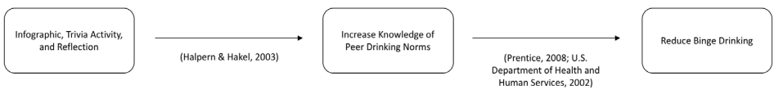
Pope, A., Finney, S.J., & Bare, A. (2019). The essential role of program theory: Fostering theory-driven practice and high-quality outcomes assessment in student affairs. Research & Practice in Assessment, 14, 5–17.
Below is an example using Walton and Cohen (2007, 2011; p. 272) from the article:
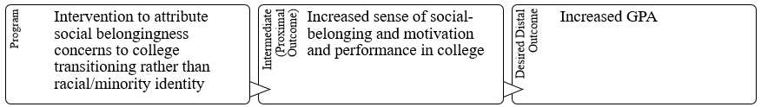
- Choose a social-psychological intervention from the reading (Table 1) and use the information to fill in a basic logic model:

