Jessica Pence
Brown3jh@dukes.jmu.edu
Art Education 400:
March 23, 2020

Lesson Theme: Michio Ihara Sculpture
Grade level: 6th grade
Time: 4 class periods at 90 minutes each

Lesson Overview:
Students will learn of our featured sculptural artist Michio Ihara during this lesson. They will create their own sculptural artworks using cardboard boxes, strips of cardboard, tape, glue, and paint. During our field trip students will evaluate and compare famous sculptural artworks that are around our community. If weather isn’t permitting the trip, we will engage in a virtual field trip of the spaces. Students will focus on the variety of materials used between each sculpture and the relationship the materials have with one another and the intention of each sculpture. The field trip will end at JMU with our featured artist. Students will be asked to look closely at the scale, positive/negative space, organic/geometric shapes, and balance.

Challenge:
Students will be challenged to think critically about how they are constructing their sculpture, problem solve with the materials they are given, and overcome any limitations the materials would produce. Students’ will be asked to think of these questions as they make their sculptures: How have all the cubes, and other geometric shapes been arranged to create positive and negative space? How is your sculpture impacting the space you would put it on display? Can you defend in the critique why you would display it in the chosen location?

Visual Culture Component:
Students will be asked if they have ever seen sculptures outside of buildings around their town, or places they have traveled. They will be asked if the sculptures improve the space or if the sculpture takes away from the space and becomes distracting. We will take a few mini field trips around Harrisonburg to see art sculptures. As we take the trips students will be asked to consider the scale of the sculptures and other terms discussed in the previous lesson. Students will be asked to pick a space of their choosing of where they will “display” their sculpture. Since they will not actually be on display students can imagine any place they want for this project, it can be a location they have been to, or want to go to.

Virginia Standards of Learning:
- Visual Art Standards of Learning 6.8
  - The student will use modeling, assembling, or carving to create three-dimensional works of art.
- Visual Art Standards of Learning 6.9
  - The student will identify the components of an artist’s style, including materials, design, technique, subject matter, and purpose.
- Visual Art Standards of Learning 6.11
  - The student will describe ways artists contribute to society through their work.
- Visual Art Standards of Learning 6.13
  - The student will explain the relationship between art-making processes and finished products.

Non-Art Standards of Learning

Lesson Objectives: Students will be able to:
- Build a free-standing geometric 3D sculpture after learning of Michio Ihara
- Understand the sculptural vocabulary terms and show understanding of vocabulary terms by applying it to their sculpture
- Show planning process with preliminary sketches for sculpture, brainstorming of locations they would display their art, and research on the given location to defend why they would display it there.
- Be able to answer questions about the lesson as the teacher walks around to give help
- Understand geometric shapes and how they can be used to build on one another

Vocabulary Words for Visual Analysis:
- Plane – a flat and level surface that can stretch out in any direction.
- Edge – where two things meet.
- Weight – the visual or physical heaviness of an object or a composition.
- Volume – refers to the space within a form. Thus, in architecture, volume refers to the space within a building.
- Mass – refers to the effect and degree of bulk, density, and weight of matter in space.
- Balance/visual and physical – an equal arrangement of specific elements within a composition deliberately organized by the artist
- Positive space – the area(s) of a work of art that are filled with meaningful intentions.
- Negative space – the empty space or seemingly unimportant background space.
- Scale – the size of the artwork.
- Geometric – a shape or form derived from or suggestive of mathematics.
- Organic – a shape or form relating to those found in the natural world.
- Movement – path the viewer's eye takes through the work of art.

Historical/Cultural/Artist Information:
Michio Ihara is a Japanese kinetic sculptor. His works have been on display at the Rockefeller Center in New York and other international venues. He also has work on display at James Madison University.

Image Descriptions:
Michio Ihara images to have students see how the sculptures interact with the landscape. This will make the students think critically about their own work and where they would display it if they could.
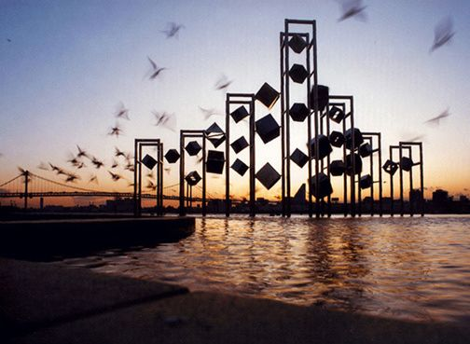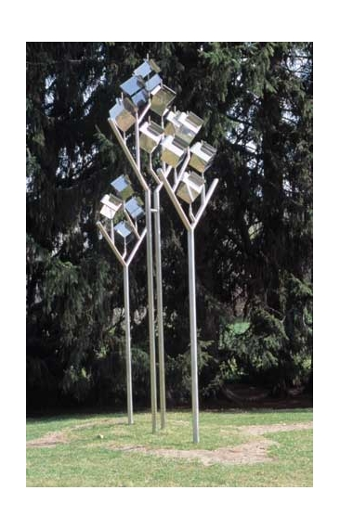

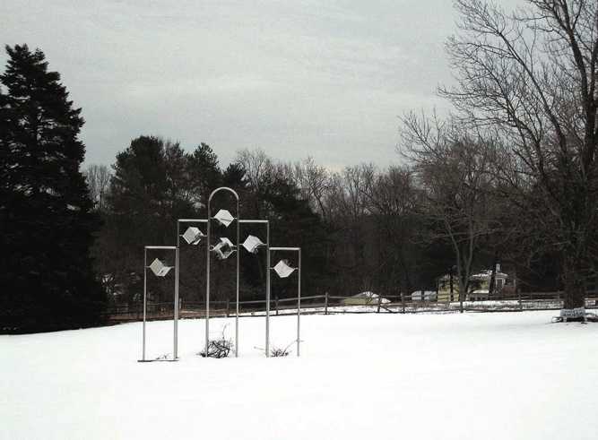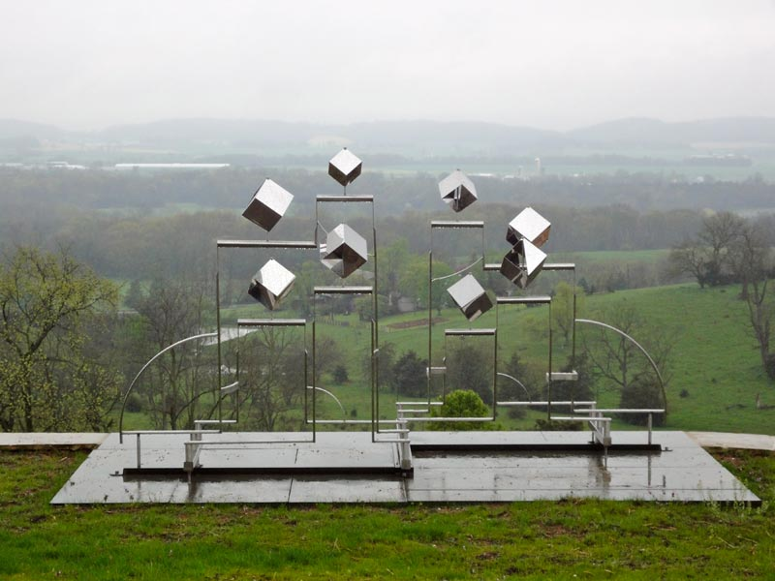

How has he used positive and negative space? What Geometric shapes does he use? Are the forms all geometric or are some organic? How has he built off of each shape and how does this show movement?

Images to show what can be done with the cardboard and use of positive and negative space
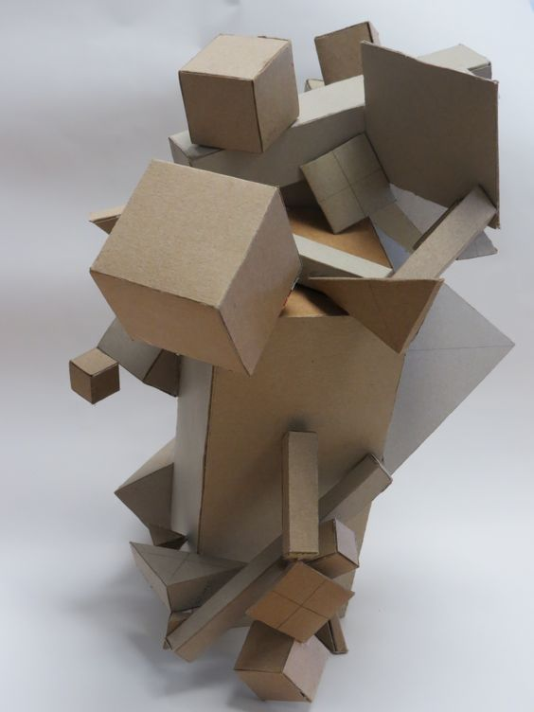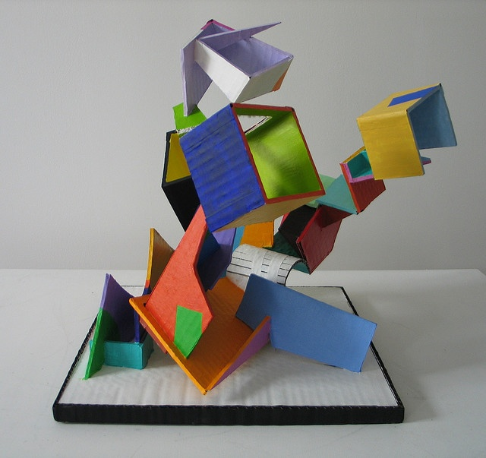
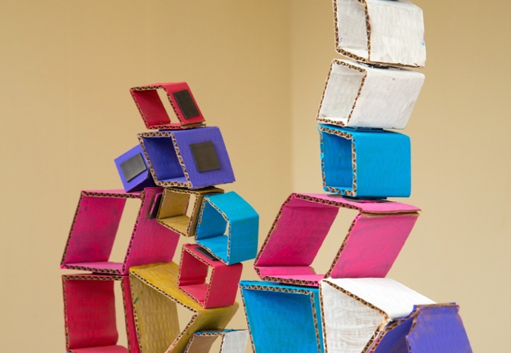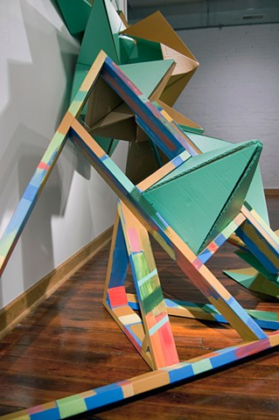

Lesson Procedure:
Day 1: Introduction to the project, research and brainstorming
- Instructor will have everything set up and laid out in stations for students to pick up their own materials, prior to students’ arrival.
- Sketch books for planning and research
- Pencils
- (2 minutes) Students come in. Give brief directions on what to grab before sitting at their seats. (Sketchbooks, and pencils)
- (5 minutes) Introduce project to students.
- (20 minutes) PowerPoint on Michio Ihara and his work. During presentation ask students’ if they have ever thought about how sculptural art can interact with the location and space it inhabits. Engage in discussions about any sculptures they have seen around their community, or maybe on vacations with friends and family. Engage in discussions about why they think Michio Ihara has chosen those locations for featured sculptures.
- (15 minutes) Second PowerPoint with sculptural vocabulary and examples of the terms using work by Michio Ihara. Once PowerPoint is over pass out the vocab worksheet for students to use as they plan their projects.
- (5 minutes) Give directions for the remainder of class. Half the remaining time will be for research on locations for where they would display their art. The other half will be the design time for their projects.
- (18 minutes) Have students engage in a free write and note taking activity during research time in their sketchbooks. I will walk around for one on one time with students and have them explain their chosen locations to me, and why they are leaning towards this location. We will discuss how the elements will play a role in their materials and will they stand up to the locations of their choosing.
- (20 minutes) Students will use this time to begin to sketch out their ideas for what they want the sculpture to look like. I will walk around the room and discuss with students if they think their ideas can be done with our limited material choices. I will participate in discussions with students. The brainstorming process will be solidified when they go to construct their project. We will talk about if they will need to come up with a new blueprint design for the project if the first design fails.
- (5 minutes) Clean up and review. Students will be dismissed by table to put sketchbooks away on their shelves and be seated again for quick review of what students have learned today, I will ask questions related to the PowerPoint. An exit slip with matching vocab will be given for students to fill out before leaving. I will collect it and evaluate their answers to find out what I’ll need to go over next class.
Day 2: Field trip!
(2 minutes) Take attendance in classroom.
(5 minutes) Load students onto the bus.
(30 minutes) Allotted time for round trip driving.
(15 minutes) Look at 3 sculptures at EMU to show diversity in sculptures and how they are displayed in each location.
(5 minutes) Take attendance and load students back onto the bus.
(20 minutes) Look at Michio Ihara sculpture at JMU. Participate in discussions about our featured artist and the sculpture outside of Duke Hall
(5 minutes) Take attendance and load students back onto the bus.
(8 minutes) Have students come back to the classroom, pack up and get ready for their next class. Send home the sketchbook assignment for homework. Have students review and reflect on the day and make any changes to their location or drawing.

Day 3: Workday and in progress one-on-one advice
- Instructor will have everything set up and laid out in stations for students to pick up their own materials, prior to students’ arrival.
- Exacto knives
- Cutting board
- Scissors
- Masking tape
- Nontoxic glue sticks/liquid Elmer’s Glue
- Cardboard
- Paint, paint brushes, and water cups
- Sketch books for planning and research
- Pencils
- Pick of the week worksheet
- (8 minutes) Greet students as they come in and have them grab a “Pick of the week” and begin working on that. The pick of the week is a worksheet that asks students to recall the featured artist, analyze one of their works of art, and write a few sentences about the work using their fundaments of design. It will be turned in at the end of class today.
- (2 minutes) Give brief directions on the location of materials around the room.
- (5 minutes) Go over safety procedures and how to use equipment. Hold a mini demonstration for Exacto knives and how theses will be distributed and accounted for at the end of class.
- (5 minutes) Introduce the artmaking part of the project to students. Students will make a cardboard sculpture in the style of Michio Ihara. They must be at least 1 foot by 2 foot but can be bigger if they choose to work in a larger scale.
- (60 minutes) Work time. Students will be able to freely begin working on their projects based on of their sketches. Students may begin however they choose only using the provided materials. I will work around as they begin to construct their projects and go over logistics, will their original design work? If not, how can we tweak it so it can work? Will their design work in their location? Have students explain their pieces to me as I walk around.
- (10 minutes) Students will begin their clean up procedures and be seated to finish their pick of the week to turn in as they exit the class.

Day 4: Finishing up projects and critique
(3 minutes) I will give directions on time allotted for finishing touches and critique.
(5 minutes) Students will get started right away, get materials and projects out and get to work.
(30 minutes) Students will be finishing up their projects. Those that are finished will work in their sketchbooks. This activity would be an extension of the lesson. The students sketch their sculpture and draw it into its intended setting using a photographer’s rule of thirds for the sculpture’s placement in the imaginary (or literal) scene location.
(45 minutes) Critique should be very detailed and productive discussion between students and the teacher. During this time each student will take a few minutes to present their work and explain where they would display it and why. I will ask students what they had difficulty within their art making, what they like and what they would add/change if more time was given. Students will be encouraged to speak about classmates work to give helpful criticism.
(7 minute) Clean up and self-review of project.

Evaluation:
Students will be graded with a rubric. They will participate in a self-review of their own work. Students will participate in an art critique at the end of the project.

- NAME: | grade: | PROJECT:

Showed skill with media | Excellent 5  Build a free-standing geometric 3D sculpture after learning of Michio Ihara | Good 4  Build an almost free-standing (needs minimal support) geometric 3D sculpture after learning of Michio Ihara | Average 3  Build an almost free-standing (needs a lot of support) geometric 3D sculpture after learning of Michio Ihara | Needs Improvement 2  Sculpture does not stand and isn’t 3D | Failed 1  Chose to do nothing
Was organized / creative | 5  Shows good planning process with preliminary sketches for sculpture, brainstorming of materials they would use in their art, and research on Michio Ihara work and how and where it is displayed. | 4  Shows most of the planning process with preliminary sketches for sculpture, brainstorming of materials they would use in their art, and research on Michio Ihara s work and how and where it is displayed. | 3  Shows some of the planning process with preliminary sketches for sculpture, brainstorming of materials they would use in their art, and little research on Michio Ihara work and how and where it is displayed | 2  Missing one of the two planning or research part of project | 1  Chose to do nothing
Understands Specific design principle or element | 5  Uses all learned vocab in critique applied the knowledge in the sculpture. Can answer all my questions on the project | 4  Used most of the learned vocab in critique applied the knowledge in the sculpture. Can answer most of the questions | 3  Used limited learned vocab in critique applied the knowledge in the sculpture. Limited answers for my questions | 2  Didn’t use the learned vocab in critique or apply the knowledge in the sculpture  Can’t answer any of the questions | 1  Chose to do nothing

Total: 15 Points | Your score: | Point Average: | Grade:

Materials and Preparation:
- Exacto knives
- Cutting board
- Scissors
- Masking tape
- Nontoxic glue sticks/liquid Elmer’s Glue
- Cardboard
- Paint, paint brushes, and water cups
- Sketch books for planning and research
- Pencils
- Pick of the week worksheet
Safety and material instructions:
Glue training
- We open the liquid glue by twisting the orange cap
- We do not open twist the white cap
- Glue does not go in mouths
- Glue only goes on your own projects not your neighbors
- Glue does not go on any of our artist friends
Scissor training
- When carrying scissors hold them with the blades closed, gripping the blade end in the hand, forming a fist around the blades, and leaving the handles exposed. The scissors should be held close to one's side when walking
- Never run with scissors
- Never use them on anyone else’s projects
Exacto knife training
- Knife blades are sharp, always cut on a cutting board or matt
- Always cut away from body keeping fingers away from blade at all times
- They must be returned to the knife block at the end of class with blade intact before anyone can be dismissed
- If you drop a knife do not try to catch it. Let it fall
- When carrying to seat they must have the lid on them, and blade pointed down at side when walking. Never run with the knife

Resources:
(n.d.). Retrieved from https://www.google.com/shopping?hl=en&source=og&tab=if1
(n.d.). Retrieved from https://www.google.com/calendar?tab=ic1
(n.d.). Retrieved from https://www.google.com/shopping?hl=en&source=og&tab=if1
(n.d.). Retrieved from https://www.youtube.com/?gl=US&tab=i11
(n.d.). Retrieved from
http://michioihara.com/sculpture/details/1991_Harumi_Municipal_Pier_Park.html

Special populations: Gifted and talented
- Design your lessons with Bloom's Taxonomy in mind
- Assign independent projects
- Ask intellectually stimulating questions
- Expose the student to new ideas and areas
- Use short-term goals and rewards

Extra Materials:
- Sculptural PowerPoint, with examples and new sculptural vocabulary
- Viewing sculptures around Harrisonburg, visiting both EMU and JMU
- PowerPoint for virtual field trip if weather isn’t permitting travel
- PowerPoint of Michio Ihara to reinforce learning of this specific artist
- Individual grading rubric for self-review to turn in with projects
- Pick of the week worksheet with featured artist Michio Ihara

Sculptural Vocabulary Worksheet
Plane – a flat and level surface that can stretch out in any direction.
Edge – where two things meet.
Weight – the visual or physical heaviness of an object or a composition.
Volume – refers to the space within a form. Thus, in architecture, volume refers to the space within a building.
Mass – refers to the effect and degree of bulk, density, and weight of matter in space.
Balance/visual and physical – an equal arrangement of specific elements within a composition deliberately organized by the artist
Positive space – the area(s) of a work of art that are filled with meaningful intentions.
Negative space – the empty space or seemingly unimportant background space.
Scale – the size of the artwork.
Geometric – a shape or form derived from or suggestive of mathematics.
Organic – a shape or form relating to those found in the natural world.
Movement – path the viewer's eye takes through the work of art.

