Youth Assent Form (Ages 13-17)
IRB Protocol #
I am from James Madison University and I am doing a study to see how students (like you) will rate three different types of hot dogs.

I am asking you to participate because you are a student who likes hotdogs. You will be asked to try three different types of hotdogs.

You then will rate them on a scale of one to ten (one means really bad and ten means really good). The information you give us will allow us to help your cafeteria to provide the best-rated hotdog for all students.
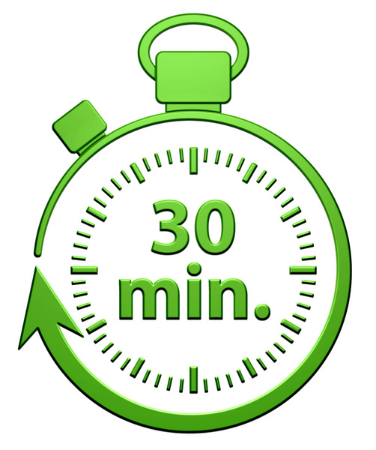

This should take about 30 minutes to complete.
I would also like to video record your reactions to eating each hotdog.
You do not have to participate if you don’t want to. You can also stop participating at any time. If you are allergic to hotdogs, you should not participate to make sure you don’t get sick. If you do participate, please know that eating too many hotdogs can make you sick as well.
Your results are confidential. That means that I will not tell anyone which answers you gave.

Talk to your parents about our study. If you would like to join us, please check the “yes” box and have your parents sign below. If you do not want to (and that is okay), please check the “no” box.
I want to participate in this study.
I do not want to participate in this study.
___________________________________ (Printed name of child) ____________ (Date)
___________________________________ (Signature of Investigator) ___________ (Date

It is okay to be video recorded.
I do not want to be video recorded.

