2022-2023 APT for the Religion program, Department of Philosophy and Religion
Assessment Coordinator: Frances Flannery
Report prepared by Frances Flannery in consultation with all full-time faculty: Robert Brown, Alan Levinovitz, Christina Kilby, Alan Kirk, Sushil Mittal, Cyril Uy II, and Emily Gravett, with David Kirkpatrick.

TABLE OF CONTENTS
- INTRODUCTION: Background to the 2022-2023 APT...............................................3
- LEARNING OBJECTIVES for the 2022-2023 Religion Assessment
Table One: Program Learning Objectives …………...................................................11
III. MAPPING OF COURSE AND LEARNING EXPERIENCES
Table Two: Program Learning Objectives mapped onto Courses and
Learning Activities………………………………………………………………………………………………12

IV. METHODOLOGY AND MEASURES OF PROGRESS...................................................13
V. METHODOLOGY OF DATA COLLECTION ................................................................15
VI. DESIRED RESULTS ................................................................................................16
VII. RESULTS AND ANALYSIS 2022-2023 .....................................................................17
A. REL 101
B. REL 200
C. Senior Capstone
- QUANTITATIVE PROGRAM EVALUATION SURVEY
- QUALITATIVE PROGRAM EVALUATION SURVEY
VIII. USE OF RESULTS (PLAN for 2023-2024)....................................................................32
IX. DISSEMINATION OF RESULTS...................................................................................35
Appendix A1: 2018-2019 New Religion Program Objectives and Course Experiences.........36
Appendix A2: 2015-2016 Religion Program Objectives and Course Experiences.................39
Appendix A3: 2013-2014 Religion Program Objectives and Course Experiences.................41
Appendix B1: 2018-2019 Rubrics for Papers in REL 200....................................................43
Appendix B2: 2018-2019 Rubrics for Capstone Presentations..........................................44
Appendix B3: 2016-2017 Draft Capstone Presentation Rubrics (developed by faculty)…..45
Appendix B4: 2016-2017 Draft Capstone Presentation Rubrics (adapted from AACU)......47

Appendix B5: 2014-15 Draft Capstone Presentation Rubrics (developed by faculty).........52

I. INTRODUCTION to the 2022-2023 APT

For almost a decade, the Religion Program has been particularly dedicated to Assessment, working to implement an increasingly refined and beneficial assessment cycle that informs curricular updates, pedagogy, and program design. This accomplishment has been made possible by the dedication of the entire Religion Program Faculty and by means of relatively consistent Assessment leadership since 2015-2016 by an Assessment Coordinator and Interim Assessment Coordinator for Spring 2022. Extra support through CARS, including the APT Assessment Rater Training workshop in 2016, have also helped refined our APT process, which has earned the rating of Exemplary since 2015:

Program Year Reporting format Rating numerical Coordinator
2015-2016 APT Exemplary Flannery
2016-2017 Alternative APT Exemplary 3.5 Flannery
2017-2018 Alternative APT Flannery
2018-2019 APT Exemplary 3.7 Flannery
2019-2020 Alternative APT Exemplary 3.7 Flannery
2020-2021 APT Exemplary 3.4 Flannery
2021-2022 Alternative APT Exemplary 3.4 Flannery and Kilby

It is important to note that assessment for the 2019-2020, 2020-2021, and 2021-2022 years were significantly impacted by the pandemic. Many of us taught remotely, all meetings were conducted by zoom with significant zoom fatigue on the part of students and faculty alike. Many students conveyed significant negative impacts from the pandemic, necessitating additional faculty attention to and support for academic, social, and health accommodations, as well as increasing referrals for medical needs, particularly psychological needs. Even as the pandemic waned in 2022-2023 and was officially declared at the federal level as concluding in May 2023, significant numbers of students continued to fall ill and to feel negative impacts, with Academic Affairs stressing that faculty should endeavor to provide the best possible accommodations for students missing class, including those struggling with mental health issues. Faculty have also worked hard to address student learning gaps, particularly for incoming Freshmen.

During the pandemic, the program’s faculty deliberated carefully and agreed that assessment of an aberrant year during the pandemic was less useful to the program’s trajectory and growth than assessment than in a regular year. We agreed to reduce any additional stress on faculty, who were already stretched in unusual ways, pausing various elements of assessment year to year. We did agree to maintain the multiple-choice assessment exam for REL 101 which has been in place since 2015, as a useful longitudinal instrument to measure our students’ progress and learning effectiveness.
In 2022-23 we were able to fully implement all areas of assessment again for the first time since the pandemic. In addition to the REL 101 instrument, this included two raters for papers in REL 200: Exploring Religion (Flannery and Levinovitz), two raters for presentations in the Senior Capstone REL 450: Religion and Medicine in the Fall of 2022 (Levinovitz and Uy) –, and two raters for the Senior Capstone REL 460: Topics in Ancient Jewish and Christian Literature The Bible, Religions, and Climate Change in Spring of 2023 (Flannery and Kilby). As Associate AUH, Dr. Christina Kilby also conducted a senior exit interview (qualitative) and survey assessment (quantitative) on Assessment day, with the Assessment Coordinator including the report in the APT.
In February 2023, the full-time faculty of the Religion program also participated in a half-day Assessment Workshop. Facilitated by Flannery, the purpose of the workshop was to infuse the learning objectives, which in the main we created in 2015-2016, with the perspectives and expertise of a number of new faculty who have since joined the program. Drawing on the pedagogical model of backwards course design, we temporarily set aside our Learning Objectives for the Program to envision the ideal program each of us would like to see. The workshop resulted in a great deal of energy and fresh approaches that will constitute the main focus of assessment for 2023-2024, in which we ambitiously aim to redesign our Program Learning Objectives, reconsider the structure of our curriculum, and reconsider the track system that was once useful for students, but which has proven at times to be a possible hindrance to some students in completing their major in a timely fashion and which has also become cumbersome under a new Registrar system for tracking progress.

Historical Background to the 2022-2023 report:
Some highlights of program and assessment changes made in response to the APT Feedback reports since 2012 include the following:
2012-2013

- Faculty in the Religion program engaged in vigorous discussion for well over a year on curricular redesign in light of APT feedback reports from Fall 2009-Spring 2012.
- Religion Faculty devised a new curricular ‘Track’ structure, fully implemented as of 2012-13 and still in operation. This organizes courses into four tracks (Eastern Religions; Western Religions; Biblical Studies & Theology; Religion & Society), with requirements that ensure that majors achieve breadth across the four areas and depth in one area of their choosing.
2013-2014

- The APT utilized a hybrid assessment method consisting of: 1. A trial quantitative method (a multiple choice exam on five global religions, taken at the end of REL 101 by entry level students). 2. A quantitative and qualitative program evaluation survey by graduating seniors in the major. 3. An hour-long exit interview of graduating seniors in the major.
- Religion Faculty redefined our Program Objectives, which may be found in Appendix A3: 2013-2014 Program Objectives.
- Religion Faculty developed a new core course required of all majors - REL 200: Exploring Religion (Theories and Methods), which fulfilled Objective 7. This involved the whole Religion faculty, who agreed upon a fixed set of theories and methods to be covered in the course, with faculty members taking turns teaching it.
- Religion Program now has three common core courses for all majors:
    - REL 101: World Religions,
    - REL 200: Exploring Religion (Theories and Methods),
    - A Senior Capstone, variously numbered between REL 400-495, with varying topics but a common seminar style format with original research project and presentation.
2014-2015

- Religion faculty developed new assessment rubrics and methods for the 2014-15 APT.
- We temporarily eliminated the multiple-choice exam in REL 101, tabling it on the grounds that we could not identify those students who would become majors.
- Religion faculty developed rubrics for faculty raters to assess presentations in our capstones and in REL 200: Exploring Religion, on the grounds that these courses consist of a greater proportion of majors than REL 101 (which was assessed the year before).
- In REL 200, two raters evaluated presentations. In REL 450: Religious Dialogue Capstone, two raters evaluated junior-senior level presentations at the end of the course.
- The hybrid-method assessment then consisted of four parts: 1. Student presentations in the capstone course (numbered variously between 400-495 and designated a capstone), 2. Student presentations in REL 200 Exploring Religion. 3. a quantitative and qualitative program evaluation survey by graduating seniors in the major and 4. an hour-long exit interview of graduating seniors in the major. The faculty generated rubrics from 2014-2015 may be found in Appendix B5: 2014-2015 Rubrics.
2015-2016

- Religion faculty again revised our program objectives, which may be found in Appendix A2: 2015-2016 Program Objectives.
- Religion faculty created new rubrics with identifiable measures for evaluating progress on our program objectives. This need was met by implementing slightly revised versions of the AACU-VALUE (Valid Assessment of Learning in Undergraduate Education) rubrics, developed by the Association of American Colleges and Universities (AACU). From these VALUE rubrics, we chose to use the following rubrics and mapped these onto our stated Program Objectives, as follows:
  - Intercultural Knowledge and Competence (Objectives 1, 2, 3),
  - Critical Thinking (Objectives 3, 4, 5),
  - Information Literacy (Objective 6),
  - Inquiry and Analysis (Objectives 5, 7),
  - Oral Communication (Objective 8),
  - Written Communication (Objective 9), and
  - Integrative Learning (Objectives 3, 4).

We slightly revised the AACU-VALUE rubrics so that they would better fit the course expectations in REL 200 and the Capstone courses (numbered between REL 400-495).
- The 2015-16 Religion Program APT earned an exemplary rating.

2016-2017 (Alternative APT)

- The faculty continued to tweak the Religion Program Learning Objectives and to rethink course design in REL 101, REL 200, and the capstones in order to meet these objectives (i.e. mapping of course and learning experiences). We continued to think about this in terms of scaffolding of abilities; to quote from our 2016-2017 APT: “With the implementation of REL 200 as a required course for all majors, we have been able to integrate a multi-dimensional approach to the academic study of religion that builds from a foundational socio-historical overview of religion (REL101), to a focused investigation of theoretical approaches to the field (REL 200), and finally to the in-depth application of knowledge in topic-specific seminars (REL 400-495).”
- We added a ten-item multiple choice assessment test at the end of REL 101.
- We redesigned the Rubrics used in the capstone presentations, using two trial versions adapted from the AACU-VALUE assessment rubrics, in an attempt to make these more context appropriate, given the interdisciplinary nature of the academic study of religion. See Appendix B3: Fall 2016 Trial presentation assessment rubrics for REL 460: Fall 2016 (Gospel of John) and Appendix B4: 2016-2017 Trial presentation assessment rubric for REL 460: Spring 2017 (The Bible, Politics, and Environmentalism)
- Feedback for the assessment suggested increased attention to two areas: III.E. Systematic method for evaluating progress on objectives – Additional validity evidence (2.25); and VI.B. Documents the use of results for improvement of assessment process (2.75). Faculty decided that the most opportunity for improvement that relate to III.E and VI.B. were 1) inter rater reliability and 2) rubric development. Hence, we mainly turned our attention to these areas to decide how to improve and to better assess whether there was value added to our program through other changes we had previously made.

2017-2018 (Alternative APT )

After earning an exemplary rating two years in a row, our program was offered the alternative APT. We used this time to think more broadly about our approach to assessment and to address the areas noted for improvement in our 2016-17 APT Feedback Report.
- We reviewed the learning objectives. We renamed “Intercultural Knowledge” as “Contextualized Cultural Knowledge,” since not all of us were engaged in comparative religions. We reviewed and tweaked how the objectives are mapped onto our courses. We also renamed “Interpreting Religious Texts” as “Interpreting Texts,” since we also ask students to read analyses of religious texts with skill.
- We made significant revisions to the cumbersome rubrics. As a group, the entire religion faculty streamlined each objective to one assessed rubric item, with four benchmark sets of skills rated for each. We also crafted language that was discipline appropriate and more user friendly, truly making these rubrics our own.
- We revisited the multiple-choice instrument for REL 101 and retooled several questions, which prompted fruitful discussions about the different emphases that instructors include in their iterations of the course. This led to informative discussions about varying kinds of content, goals, and approaches in REL 101.
- A four-person subcommittee (Flannery, Gravett, Mittal, Kilby) refined the process further, noting courses in which it was impractical to implement assessment of a particular objective and streamlining the presentation rubric into a distilled one-page version for use during class.
2018-2019
The program significantly prioritized assessment, discussed in nearly all program meetings and spurring the following curricular developments.

- Three to four pilot faculty began to administer the multiple-choice instrument at the beginning and end of the REL 101 course, which entailed preparing an online assessment test administered through canvas for the end of term Fall 2019 and beginning of term 2020. However, the pandemic interrupted assessment for the end of term 2020.
- We revisited and tweaked program learning objectives, including the phrase “original research” in number 3 to assess the crafting of arguments or original research projects. We began discussion of objective four about “religious texts” in relation to REL the Capstones and agreed to continue the discussion. We also discussed the draft of an objective related to empathy and agreed on the kind of empathy we sought to hone, namely, cognitive empathy (rather than affective or emotional empathy), and dispositional empathy (which informs one’s worldview and interactions with others, rather than situational empathy, which arises due to a particular event). Faculty developed a new DRAFT objective related to these goals, as well as a new DRAFT self assessment question for the REL 101 Assessment Test and senior exit interview: Proposed new REL 101 assessment question and Senior exit interview question: Consider the following statement: “I feel equipped to interact with others whose perspectives on religion are different from mine.” How true is this statement for you now?
- We identified attention to disability studies and pedagogy as an existing emergent strength of the program as a result of senior assessment and Gravett’s new course offering and reconsidered the learning objectives in light of disability needs.
- We also reviewed the presentation assessment rubrics for REL 200 and concluded that the marking sheet we use for assessment is adequate as long as we have an accompanying explanation sheet that serves as a guide. A draft was created that may be tweaked by Faculty in 2019-2020, and we decided that the Capstone Assessment Rubric Criteria Chart should be handed out to students in the Capstone before they create their presentations.
- For the first time, we posted the 2017-2018 Alternative APT on the public website and on the Department canvas page for faculty, and plan to continue this practice for each subsequent year.
- We set a goal to distribute revised program objectives to all students in all Religion courses in 2019-2020.
- We collectively revised the description of REL 200 for the 2019-2020 catalog and continued to engage in ongoing deep discussion of the goals and curriculum for REL 200, restricting the course to include seven approaches operative in the interdisciplinary study of religion, including the following:
  - Textual (various kinds of text criticism – could be combined with other approaches)
  - Ritual (e.g. Geertz / Turner / Bourdieu / Rappaport)
  - Experiential or psychological (e.g. Eliade / Otto / James / Freud)
  - Sociological or anthropological (e.g. Durkheim / Evans Pritchard
  - Postcolonial (e.g. Said / Asad / Spivak / Bhabha/ Chakrabarty)
  - Feminist (e.g. Butler / Adler / Christ / Plaskow / Daly / Ruether / Trible)
  - Economic (e.g. Marx / Weber)
  - Optional: Professor’s Choice (e.g. material studies, science and religion, mysticism, environmental history, other)

2019-2020 (Alternative APT)
The pandemic impacted our ability to conduct a thorough program assessment. However, we retained the assessment instrument in REL 101 (at the end of Fall 2019 and the beginning of 2020), and we conducted senior exit interviews and evaluation surveys. We did not publicize learning goals to all students despite our plans to do so, however we made progress on the following:
- We tweaked the language of the REL 101 instrument for clarity.
- We reworked learning objective 7 so that it would apply to all Senior Capstones, to read: “Interpret texts by integrating skills in reading, critical thinking, and contextualization.”
- After extensive review of the learning objectives, faculty agreed to substantial revisions. Among the most important: we agreed to map REL 200 to objectives 2, 3, and 4 only. This was a change from previous years, which had sought to assess 2, 3, 4, 5, 6, and 7 in this course.
- After further discussing a possible ninth learning objective on empathy that would read “Develop the ability to engage effectively with perspectives on religion that differ from one’s own,” faculty decided to continue discussion at a later date. In the meantime, in light of the vast civil unrest over societal/ racial inequity and injustice, we added this question to the Senior Exit Interview: “To what extent did you develop the ability to engage effectively with perspectives on religion differ from your own?”
- We added a note to learning objective 6 (oral proficiency) to provide clearer accommodations for disabled students.
- Prompted by queries about assessment in REL 200, we substantially revised the catalog description and continued to hold vigorous and sustained discussions about the goals and structure of the course as well as REL 102.
- Beginning in 2019-2020, we posted the 2018-2019 – present APTs to the program’s public website and faculty canvas site.

2020-2021
- The data from the REL 101 quiz demonstrated that students generally begin REL 101 with poor religious literacy and leave the REL 101 course with much improved religious literacy, fulfilling Objective 1: Demonstrate contextual cultural knowledge and competence by identifying and recalling key concepts of five major global religious traditions (Hinduism, Buddhism, Judaism, Christianity, and Islam).” Prior learning gaps in Judaism saw satisfactory improvement on par with content in other religions.
- Faculty were trained on administering the instrument on canvas and took important steps towards a more complete assessment of the REL 101 exam online for both the start and end of REL 101.
- The canvas format, while resulting in greater participation and efficiencies, also meant that we could not generate data in the format collected earlier, but only as the average score of all students who took the test in a given section. Since our earlier benchmark for success was based on a percentage of students scoring above a certain threshold, this canvas data will require that the faculty agree in 2021-2022 on a new desired result.
- Every section with usable data indicated the average student score rises from an F to a C+ to B- by the end of the course.
- Although we had determined we should not include the REL 101 Honors sections due to our assumptions that these would be high performing outliers, this was not the case. One Honors section began with an average score of 26%, indicating that poor religious literacy is widespread among even JMU’s best students before they take this course.

2021-2022 (Alternative APT)
Assessment Coordinator: Frances Flannery (fall '21), Christina Kilby (spring '22).
Our program was offered the Alternative APT after attaining an exemplary APT in 2020-2021. The pandemic continued to pose obstacles to our assessment process, with significant faculty fatigue resulting in several failures to administer the REL 101 assessment quiz this year (despite multiple reminders, training materials, and offers of help from the Assessment Coordinators). Additionally, Assessment Day was cancelled this February due to several tragedies on campus, which made it more challenging to collect our senior assessment data and reduced our response rate significantly. Still, we made major strides:
- We published our Program Learning Objectives and the result’s of last year’s assessment more prominently on our departmental website
- We disseminated the Religion Program Objectives to all Religion students by including
them on every Religion syllabus in spring 2022.
- We distributed the results of last year's assessment to all Religion faculty.
- We discussed the results of last year's assessment at several Religion program meetings
as well as via email; this discussion included a review of all the suggestions on our
Assessment Progress Feedback Report from CARS.
- The outgoing Assessment Coordinator met with and trained the incoming Assessment
Coordinator (Kilby), who met with and trained our newest full-time Religion faculty member Dr. Cyril Uy in our assessment process.
- We changed the term in one of the Judaism questions on our REL 101 religious literacy
quiz from "Mishnah" to "Talmud" in order better to reflect the vocabulary commonly used in course textbooks and made strides in administering the quiz in every section at the start and end of the term.

In response to seniors expressing a greater need for career advising in our Senior Exit interview from the previous assessment, the Assessment Coordinator for Spring 2022, Kilby and the Religion faculty took several vital steps to improve our program:
- Kilby met with Emma Gibbons (once) and Libby Westley (twice) from the University Career Center to learn more about how we can better prepare our students for the career search
- Kilby created a detailed Career Prep document and led a faculty training workshop during a Religion Program meeting to instruct faculty in the capabilities of Handshake and LinkedIn for networking among Religion alums and conducting job searches.
- Based on guidance from Libby Westley, who advised that one of the most important career prep skills is being able to articulate the connection one finds between one's studies and one's career aspirations, we added a new question to the senior assessment survey that asked students to articulate in their own words how their religion degree has helped prepare them for their professional and/or civic lives. This question was also included in the Career Prep document to aid students in exploring their own answers to this question and to highlight this skill with faculty advisers earlier in their undergraduate career.
- We considered adding a new program learning objective that all students be able to “articulate the value and relevance of a religious studies degree to their professional and/or civic lives,” which remains under discussion.

II. LEARNING OBJECTIVES for the 2022-2023 Religion Assessment
Table One: Program Learning Objectives for 2022-2023
After students have taken REL 101 Religions of the World, students will be able to meet objective 1:
1. Demonstrate contextual cultural knowledge and competence by identifying and recalling key concepts of five major global religious traditions (Hinduism, Buddhism, Judaism, Christianity, and Islam).
After students have taken REL 200 Exploring Religion, students will be able to meet objectives 2, 3, and 4:
2. Identify and apply theories and/or major approaches drawn from the academic study of religion in creating academic projects of inquiry.
3. Demonstrate proficient written communication by making a sustained evidence-based argument about a topic in religious studies.
4. Apply critical thinking skills by composing sound arguments and/or by conducting analyses of historical or contemporary challenges facing one or more religious traditions.
After taking Senior Capstone, students should be able to meet objective 4 as well as objectives 5, 6, and 7:
5. Demonstrate information literacy through vetting and verifying the reliability of sources, detecting biases, and evaluating sources and/or media coverage for strengths, weaknesses, biases, and accuracy.
6. Demonstrate proficient oral communication by presenting research and/or an evidence-based argument. Note: *Alternate arrangements may be made in extenuating circumstances, in consultation with the instructor.
7. Analyze religious texts, practices, people, or ideas within their appropriate social, political or cultural contexts.

In addition to minor wording improvements, the following proposed changes were discussed in 2022-23 and remain under consideration for 2023-24:
Learning Objective 8: “Develop the ability to engage effectively/ respectfully / productively with perspectives on religion that differ from one’s own.”
Learning Objective 1 or other objectives: the addition of religious literacy in Indigenous Religions and Religions of Africa and the African Diaspora.

III. MAPPING OF COURSE AND LEARNING EXPERIENCES
Table Two: Program Learning Objectives mapped onto Course and Learning Activities
Program Learning Objectives | REL 101 World Religions, assessed or multiple-choice exam | REL 200 Exploring Religion, assessed on student paper | Senior Capstones, REL 400-495, assessed on presentation of independent or original research project
After students have taken REL 101 Religions of the World, students will be able to meet objective 1:  1. Demonstrate contextual cultural knowledge and competence by identifying and recalling key concepts of five major global religious traditions (Hinduism, Buddhism, Judaism, Christianity, and Islam). [Measured with score on REL 101 Assessment Test given at the beginning and the end of the course.] | x
After students have taken REL 200 Exploring Religion, students will be able to meet objectives 2, 3, and 4:  2. Identify and apply theories and/or major approaches drawn from the academic study of religion in creating academic projects of inquiry. [Measured with REL 200 Rubric for assessing a written paper: Methodology / Theoretical Framework; Measured with Capstone Rubric for presentation: Methodology/Theoretical Framework] |  | X | X
3. Demonstrate proficient written communication by making a sustained evidence-based argument about a topic in religious studies. [Measured with REL 200 Rubric for assessing a written paper: Written Communication] |  | X
4. Apply critical thinking skills by composing sound arguments and/or by conducting analyses of historical or contemporary challenges facing one or more religious traditions.[Measured with Capstone Rubric for presentation: Critical Thinking] |  | X | X
After taking the Capstone, students will be able to meet objectives 4, 5, 6, and 7.  5. Demonstrate information literacy through vetting and verifying the reliability of sources, detecting biases, and evaluating sources and/or media coverage for strengths, weaknesses, biases, and accuracy. [Measured with Capstone Rubric for presentation: Information Literacy] |  |  | x
6. Demonstrate proficient oral communication by presenting research and/or an evidence-based argument. [Measured with Capstone Rubric for presentation: Oral Communication]  Note: *Alternate arrangements may be made for students, in consultation with the instructor. |  |  | x
7. Analyze religious texts, practices, people, or ideas within their appropriate social, political or cultural contexts. [Measured with Capstone Rubric for presentation: dimension under development]. |  |  | X
8. Under Discussion: Develop the ability to engage effectively with perspectives on religion that differ from one’s own. [Not currently measured]

IV. METHODOLOGY AND MEASURES OF PROGRESS
Our program does not have an established sequence of courses, nor did we have any pre-requisites for course enrollment, due to the fact that many of our majors come to the program in their junior or even senior years. However, we have intentionally indicated through course numbering and through our advising of majors that REL 101 is geared to be an early level course, REL 200 a mid-level course, and REL 400-495 is intended to be an upper-level, intensive Capstone. Most Capstones also require instructor permission, ensuring that the course is taken near the conclusion of the program of study in the Religion major.
This intentional pedagogical design scaffolds student learning at appropriate levels of the undergraduate career when students take the courses in the recommended order, first exposing students to content, next guiding them in evaluating that content through critical thinking, student generated comparison of perspectives, and contextualization, and finally introducing advanced content that requires deeper inquiry and analysis through synthesis, extrapolation, and application in an original research project that exhibits cultural knowledge and sensitivity. By design, the Capstone experience also requires demonstrations of mastery of information literacy, oral and written communication - skills that students have ideally been building throughout their coursework - as well as an independent/original research contribution to the field in the form of a major project, presentation, and/or paper.
Our program assessment consists of five instruments, combining direct and indirect measures. This was the first year since the pandemic in which all five instruments were able to be administered fully. The faculty and Assessment Coordinators designed the instruments to provide feedback on student learning at the early, mid, and upper-level points of students’ undergraduate careers, as follows:
1. Multiple-Choice Quiz in REL 101: World Religions (direct measure)
The REL 101 assessment instrument consists of an exam with ten multiple-choice questions that cover five religions. This instrument assesses student learning effectiveness for Program Learning Objective 1: Basic Religious Literacy. Some faculty oversee the administration of the quiz to all students at the start and end of the term, whether remotely or in person in the classroom. The quiz does not count toward students’ grades, but is presented as our instrument for measuring learning effectiveness in the program as well as a self-evaluation tool for helping students to assess their religious literacy and progress. This instrument does not support multiple raters and there is no interrater reliability.

2. Papers in REL 200: Exploring Religion (direct measure)
Two faculty raters evaluate student papers in REL 200 Exploring Religion using rubrics we have progressively refined since we first implemented the AACU rubrics in 2016. The Rubrics used since 2018-19 are found in Appendix B1. Ideally, the raters discuss the rubrics before assessment but make their assessments independently. The papers earn a grade in the course but the assessment does not contribute toward this grade. The Rubrics assess student learning effectiveness for Program Learning Objectives 2, 3, and 4: Methodological/Theoretical Framework, Written Communication, and Critical Thinking.

3. Senior Capstone Presentations (direct measure)
Two Faculty raters evaluate presentations in real time in the Senior Capstones, using the rubric found in Appendix B1. Faculty raters are expected to review the rubrics together beforehand to standardize their interpretations of the criteria. The Rubrics assess student learning effectiveness for Program Learning Objectives 4, 5, 6, and 7: Critical Thinking, Information Literacy, Contextual Knowledge, and Oral Communication.

4. Senior Program Evaluation Survey (indirect measure)
The AAUH or AUH administers a qualitative and quantitative survey to all graduating seniors in the program on assessment day. This survey consists of 27 questions scored on assessment day from 1 (unsatisfactory) to 5 (exemplary). The questions may be found in this APT report under

5. Senior Exit Interview (indirect measure)
The AAUH or AUH also administers an agraduating seniors in the major, conducted by the Assistant AUH (indirect measure) on assessment day. The questions and results may be found under VII. RESULTS AND ANALYSIS 2020-2021: QUALITATIVE AND QUANTITATIVE PROGRAM EVALUATION SURVEY BY GRADUATING SENIORS.

V. METHODOLOGY OF DATA COLLECTION in 2022-2023
2022-2023 was the first year since the onset of the pandemic that we were able to conduct all elements of program assessment, which were administered as follows:

1. Multiple-Choice Quiz in REL 101: World Religions (direct measure)
First developed in 2014, the assessment instrument for REL 101 is a multiple-choice exam given by each faculty member who teaches the course (for 2022-2023, this included 7 full-time/tenure-track faculty, and 3 part-time adjunct faculty members). The test is a direct measure of student learning of basic content that assesses Program Learning Objective 1: Contextualized Cultural Knowledge with ten multiple choice questions covering five global religions. We have made slight wording improvements to the questions over the years, but the longitudinal data is still comparable from year to year, with only one major change in content in 2021-22 in which we changed the term “Mishnah” to “Talmud” in a question on Judaism.
Since 2018 we have progressively moved towards a goal of administering the instrument in every section of REL 101, including those taught by full and part time faculty, at both the beginning and end of each term through canvas, online through Canvas. The testing environment is an in-class remote or in-person exam testing environment, depending on the section, with a Faculty member overseeing the quiz.
To move us toward this goal, in 2019-2020 the Assessment Coordinator Flannery created a power point guide for Faculty to lower the technical bar in both posting and administering the REL 101 assessment exam through Canvas. She trained faculty in administering the instrument in program meetings and in Spring 2022 Assessment Coordinator Kilby posted the instrument in the Canvas Commons. In Fall 2020-Spring 2021, 6 out of 9 Faculty had successfully administered the quiz both at the beginning and the end of both terms.
By 2022-2023, all Faculty successfully administered the quiz at the appropriate times, but not all faculty have submitted their data for this report, which is a final area of improvement to be targeted for 2023-2024.
2. Papers in REL 200: Exploring Religion (direct measure)
Two faculty raters (Flannery and Levinovitz) evaluated student papers in REL 200 Exploring Religion (taught in Fall 2022 by Flannery), using rubrics we have progressively refined since we first implemented the AACU rubrics in 2016. The Rubrics used since 2018-19 are found in Appendix B1.

The raters discussed the rubrics before assessment but made their assessments independently. The papers earned a grade in the course but the assessment did not contribute toward this grade.

3. Senior Capstone Presentations (direct measure)
The two Faculty raters evaluate the student presentations in the capstone in real time. In 2022-23 the Senior Capstone assessment was implemented as follows:

Fall 2022: Levinovitz and Uy for REL 450: Religion and Medicine (taught by Levinovitz)

Spring 2023: Flannery and Kilby assessed seven students for REL 460: Topics in Ancient Jewish and Christian Literature – The Bible, Religions, and Climate Change (taught by Flannery)

The raters discussed the rubrics before assigning scores and worked independently. Students were given 15-20 minute slots in class and the presentations constituted a portion of their grade, but the assessment did not factor into those grades. Appendices B2-B5 chronicle the faculty’s ongoing commitment to develop useful rubrics to assess the Senior Capstone presentations. Faculty have expressed challenges in using the rubrics regarding variety of approaches and course content in each Capstone and the efficiency of system, which is to be used during real time evaluations. The rubrics are still a work in progress.
The Spring 2023 inter-rater training included a significant discussion in writing to ensure that the two raters construed the terminology in the rubrics similarly and discussed its application within the context of the course, since the course included non-confessional Theology.

4. Senior Program Evaluation Survey (indirect measure)
The senior quantitative and qualitative assessment occurred on Assessment Day in February, 2023. Only seniors whose first major in Religion were required to attend six graduating seniors in the Religion program took a quantitative test of 28 items and answered a qualitative oral exit interview conducted by Kilby, the Associate Academic Unit Head. Both instruments ask students to report their satisfaction with various elements of the Religion program. They were not graded or compensated for this feedback, but they did have to take part to be counted by the program as fulfilling their major requirements. They were asked beforehand to give their honest and constructive feedback for the betterment of the program, and the atmosphere was friendly, open, and non-judgmental. The entire process took two hours and the seniors appeared to welcome the opportunity. As this instrument does not support multiple raters, there is no interrater reliability.

5. Senior Exit Interview (indirect measure)
On Assessment Day in February 2023, Dr. Kilby, the AAUH, conducted the Senior Exit Interview for six Religion or Interdisciplinary Religion majors. The interview was conducted in person over the course of 1.5 hours.
VI. DESIRED RESULTS
Before Fall 2020, the REL 101 instrument was tabulated through Test Scoring. Since REL 101 is a General Education course mostly taken by freshmen, the vast majority of whom are non-majors, Religion faculty established the bottom threshold for program success as 80% or more of students passing the exam (scoring better than 60 points). After moving the instrument to Canvas, this metric was no longer available. Thus, we consider the threshold for program success to be that the average score at the end of the term is the equivalent of a 75% or better, and if there is clear progress of 10% improvement or better overall from the start of the term to the end.
Since REL 200 is ideally taken mid-career and consists of a mix of majors and non-majors, the religion Faculty deem the program successful if at least 80% of the students in REL 200 demonstrate an average of Benchmark level 2 performance or better (with better than a 2.0 overall across the learning domains).
The Senior Capstone consists mostly of majors and typically occurs at the end of the major’s career. Thus, our standards are the strictest here. The religion Faculty deem the program successful if at least 60% of students in the Capstone demonstrate Benchmark 3 performance or better overall across the learning domains, and at least 20% of students score mostly at the highest Benchmark 4 performance (3.5-4.0 overall across learning domains). Also, not more than 10% of the Capstone students should demonstrate performance below the minimal Benchmark 2 overall across the learning domains.
We hoped to see our Senior surveys charting continued satisfaction or better in all areas and to obtain substantive qualitative feedback from the Senior Exit Interview that can inform our curricular or other program changes to improve student learning and the student experience in the major. Especially since we recognize that student satisfaction was severely stressed during this unprecedented time of challenges during the pandemic, we hoped to see a “return to normal” in 2022-2023.
VII. RESULTS AND ANALYSIS 2022-2023
A. RESULTS AND ANALYSIS - REL 101
The REL 101 exam data has now been gathered for a long enough period to generate some meaningful comparisons across semesters; even though a few questions on the exam were slightly tweaked in from 2018-2022, the exams are closely comparable.

The data demonstrates that students generally begin REL 101 with poor religious literacy and leave the REL 101 course with much improved religious literacy, fulfilling Learning Objective 1: Demonstrate contextual cultural knowledge and competence by identifying and recalling key concepts of five major global religious traditions (Hinduism, Buddhism, Judaism, Christianity, and Islam).

 | Spring 2017 [End of term only] (635 students) | Fall 2017  [End of term only] (665 students) | Spring 2018 n/a | Fall 2018 [End of term only] (831 students) | Spring 2019 [End of term only] (543 students) | Fall 2019 [End of term only] (851 students) | Spring 2020 (beginning) (384 students):  END DATA SUSPENDED DUE TO COVID
Results: percent scoring 60%+ | 84% | 89% | -- | 91.5 | 81 | 86.13 | 46.09%
percent scoring 70%+ | 67% | 79% | -- | 81 | 81 | 72.73 | 25.52%
percent scoring 80%+ | 39.6% | 37% | -- | 64.6 | 65.4 | 56.87 | 11.72%
Mean across all sections | 70.52 | 76 | -- | 77.7 | 77.3 | 71.97 | 51.82

NOTE: The change to online administering of the exam through canvas meant that the percentages of students scoring 60%+, 70%+, and 80%+ are no available. This table records the Average Mean for All Sections of REL 101 for 2022-2023, where data was usable and/or reported:
section | Start Fall 22 | End Fall 22 | Start Fall 23 | End Fall 23
H-1 | 58 | 78 | 66 | 85
H2 | 60 | 87 | 48 | 89
H3 | 54 | 93 | no section | no section
1 | 55 | 73 | 62 | 84
2 | no data | no data | 50 | 83
3 | 54 | 81 | 62 | 77
4 | 52 | 89 | 54 | 72
5 | 63 | 78 | 58 | 78
6 | no data | no data | 58 | 73
7 | 48 | 86 | 54 | 72
8 | no data | no data | 51 | 79
9 | 60 | 84 | 53 | 83
10 | no data | no data | no data | no data
11 | 54 | 81 | 56 | 82
12 | 56 | 77 | no data | no data
13 | 55 | 79 | 53 | 83
14 | 54 | 81
15 | 57 | 74
16 | 51 | 76
17 | 57 | 81
18 | 57 | 80
STUDENT AVERAGE % SCORE | 55.6 | 81 | 55.7 | 80

Note that as of Fall 2020 assessment results determined that students in Honors sections also begin with poor literacy on par with their peers (with one section scoring 26% at the start of the term), therefore in 2022-23 these sections were included in the final tabulations. Despite missing data for some sections, for 2022-23 the overall student average scores at the start and end of both Fall and Spring terms was remarkably consistent across all sections and closely comparable to all assessment rounds since Fall 2020, when the instrument began to be administered at the beginning and end of term via Canvas.
Two results are immediately evident. First, the faculty have reached their earlier goal of administering the REL 101 assessment quiz in all sections, both at the start of the term and at the end, with full compliance in 2022-23. However, errors in reporting resulted in some missing data for certain sections. Second, the data demonstrates a clear and marked increase in student learning on Objective 1: Religious Literacy, from the beginning to term to the end of more than 20 points, and closer to 25 points
Put simply, since 2020, the student overall average on the basic Religious Literacy quiz begins at an F at the beginning of each term. By the end of the term, at the conclusion of REL 101, that average rises to a C+ to B-. For 2022-23, the final averages were in the B- range, a clear indication of the effectiveness of the course. Since our threshold for success is that the average student scores are a C (75%) or better, we are seeing program success and a clear benefit to students in General Education.

 | Fall 2020 [Start]  5 faculty | Fall 2020  [End]  5 faculty | Spring  2021  [Start]  6 faculty | Spring 2021  [End]  6 faculty | Fall 2021  [Start] | Fall 2021 [End] | Spring 2022  [Start] | Spring 2022 [End] | Fall 2022 [Start] | Fall 2022 [End] | Spring 2023 [Start] | Spring  2023  [ End]
Percent Ave. Mean (across all sections) | 55.2 | 78.8 | 54.8 | 82.8 | 52 | 76 | 54 | 79 | 55.6 | 81 | 55.7 | 80.0

- RESULTS AND ANALYSIS - REL 200 Papers
Students | Obj. 2: Theories and Methods | Obj. 2: Theories and Methods | Obj. 3: Written Comm | Obj. 3: Written Comm | Obj. 4:  Contex-tualized knowledge | Obj. 4: Contex-tualized knowledge
 | Rater 1 | Rater 2 | Rater 1 | Rater 2 | Rater 1 | Rater 2
A | 3 | 2 | 3 | 3 | 3 | 3
B | 2 | 2 | 2 | 2 | 1 | 1
C | 2 | 2 | 2 | 2 | 2 | 2
D | 3 | 3 | 3 | 3 | 3 | 3
E | 4 | 4 | 4 | 4 | 4 | 4
F | 3 | 2 | 2 | 2 | 2 | 1
G | 3 | 3 | 3 | 3 | 3 | 3
H | 4 | 3 | 4 | 4 | 4 | 3
I | 3 | 2 | 2 | 1 | 2 | 2
J | 3 | 3 | 3 | 3 | 2 | 3
K | 2 | 2 | 3 | 3 | 2 | 2
L | 2 | 2 | 3 | 2 | 3 | 3
M | 3 | 3 | 3 | 4 | 4 | 4
N | 2 | 2 | 2 | 2 | 2 | 2
O | 3 | 2 | 3 | 2 | 3 | 3
Item averages per Rater | 2.9 | 2.47 | 2.8 | 3.27 | 2.7 | 2.6
Interrater average score | 2.68 |  | 3.04 |  | 2.65

The scores for Rel 200 were not as high as desired although they did barely meet the benchmark set for success (80% of students demonstrating an average of Benchmark level 2 performance or better), with 80% of students reaching this goal. The results of students’ performance in the course were shared in program meetings and it was determined by consensus that we establish a Prerequisite for REL 200 for the first time, which was that incoming students need to have REL 101. The program had not fully anticipated that the majority of students attracted to the course on Theories and Methods of Religion would be non-majors with no experience in the academic study of Religion, which is what occurred (although Dr. Gravett had faced a similar problem a few years back, to a lesser extent). This new prerequisite will lower class size, but improve next year’s cohort and achieve our original goals for the course as a core course for majors (rather than a “feeder” course to attract new majors). The request was submitted to the C&I Committee for approval.
Particularly for a class cohort consisting of mostly non-majors, students were acceptably strong overall on theories and methods but strongest on written communication, with the greatest discrepancy between raters on the item “contextualized knowledge.” However, given the particularity of content in various iterations of REL 200 and the Senior Capstone, it is likely that when the instructor is one of the two raters that this item would show the lowest interrater reliability. The program should discuss whether this is an acceptable outcome or whether it is worth assigning the task of rating papers in REL 200 to someone other than the instructor.

C. RESULTS AND ANALYSIS - Senior Capstone
The results of the faculty raters assessments of student presentations in Senior Capstones for 2022-23 are as follows:
Fall 2022
Senior Capstone Presentation Assessment, Fall 2022 - Religion and Medicine -Rater 1 and 2
(scale 1-4, 4 indicates greater mastery)
STU-DENTS-anony-mized | Obj.2 Methods: Rater 1 | Obj. 2 Methods: Rater 2 | Obj.4  Critical Thinking: Rater 1 | Obj. 4  Critical Thinking: Rater 2 | Obj. 5 Info Literacy: Rater 1 | Obj. 5  Info Literacy: Rater 2 | Obj. 6-Oral Communication: Rater 1 | Obj. 6-Oral Communication: Rater 2 | Obj. 7- Contextual Analysis: Rater 1 | Obj. 7-Contextual Analysis: Rater 2
A | 2 | 2 | 4 | 4 | 4 | 3 | 3 | 3 | 2 | 3
B | 4 | 4 | 4 | 4 | 4 | 4 | 4 | 4 | 4 | 4
C | 2 | 2 | 4 | 2 | 2 | 2 | 3 | 3 | 2 | 3
D | 2 | 2 | 3 | 3 | 4 | 3 | 4 | 4 | 4 | 3
E | 2 | 3 | 2 | 4 | 2 | 3 | 2 | 3 | 2 | 4
F | 2 | 2 | 2 | 3 | 4 | 3 | 3 | 3 | 2 | 3
Item averages per Rater | 2.3 | 2.5 | 3.2 | 3.3 | 3.3 | 3 | 3.2 | 3.3 | 2.7 | 3.3
Interrater average | 2.4 |  | 3.25 |  | 3.15 |  | 3.25 |  | 3.0

Spring 2023
Senior Capstone Presentation Assessment, Spring 2023 - The Bible, Religions, and Climate Change -Rater 1 and 2
Scale used is 1-4, where 4 indicates greater mastery.
STU-DENTS-anony-mized | Objective 2-Methods: Rater 1. | Obj. 2-Methods: Rater 2 | Objective 4-Critical Thinking: Rater 1 | Obj. 4-Critical Thinking: Rater 2 | Objective 5-Info Literacy: Rater 1 | Obj. 5-Info Literacy: Rater 2 | Objective 6-Oral Communication: Rater 1 | Obj. 6-Oral Communication: Rater 2 | Obj. 7- Contextual Analysis: Rater 1 | Obj. 7-Contextual Analysis: Rater 2
A | 3.5 | 4 | 4 | 4 | 4 | 3 | 4 | 4 | 3 | 4
B | 4 | 3 | 4 | 4 | 4 | 3 | 4 | 3.5 | 3 | 4
C | 3 | 3 | 3 | 3 | 4 | 3 | 3 | 3 | 3 | 3.5
D | 3 | 4 | 3 | 3 | 3 | 3 | 3 | 3.5 | 4 | 4
E | 4 | 3 | 4 | 3 | 3 | 3 | 4 | 3 | 4 | 4
F | 3 | 3.5 | 3 | 3 | 4 | 3 | 3 | 3.5 | 2 | 3.5
G | 3 | 3 | 2 | 3 | 4 | 3 | 2 | 3 | 3 | 4
Item averages per Rater | 3.35 | 3.35 | 3.29 | 3.29 | 3.71 | 3 | 3.29 | 3.35 | 3.14 | 3.86
Interrater average | 3.35 |  | 3.29 |  | 3.35 |  | 3.32 |  | 3.5

For the Fall 2022 Capstone (REL 450) six students performed well (above 3.0 or at 3.0) for all Objectives assessed except for Theories and Methods. Both raters judged nearly all students (except for one) as just fair at this skill in this course, with a 2.4 overall average between the raters. The interrater reliability was high except for the raters’ scores on Objective 7: Contextualized Knowledge, indicating a need for greater training on that part of the rubric.
For the Spring 2023 Capstone (REL 460) seven student performed well (above 3.0) on all objectives measured. Interrater reliability was high for Objective 2: Theories and Methods and Objective 4: Critical Thinking, with the raters scoring students’ fulfillment of these objectives with the same overall averages. There was greater discrepancy in the raters’ scores for Objective 7: Contextualized Knowledge, indicating a need for greater training of faculty raters on that part of the rubric, as was the case for the Fall Capstone.
D. RESULTS - Senior Program Evaluation Survey (indirect measure): Quantitative
Overall, graduating Religion and Interdisciplinary Religion majors continue to find the Religion program to be effective in preparing them for future employment by building a variety of key skills and competencies and in fostering a critical and curious mind. They report it enhances meaningful cross-cultural communication and understanding, and equips them to be able to think from different social stances and diverse perspectives. They maintain that the program greatly builds their religious literacy, cultural competency, empathy, and ability to contextualize perspectives. They deeply value their faculty’s expertise, dedication, and care. Seniors are very enthusiastic about the major yet deeply dissatisfied with widespread misunderstandings and ignorance about the discipline and major outside of the department. They continue to voice strong opinions that the curriculum is headed in the right direction with increased attention to diverse local religions across the globe, the experience of a variety of minoritized populations and the relation of religion to many pressing contemporary developments and challenges. In short, they believe the program is invaluable to their liberal arts education and wish to see it grow.
E. RESULTS AND ANALYSIS - Senior Program Evaluation Survey (indirect measure): Qualitative
Dr. Christina Kilby, Associate Academic Unit Head, collected both Quantitative and Qualitative data from on Assessment Day on February 8, 2023. Six graduating seniors in religion met in person to take the quantitative and qualitative survey and to give qualitative feedback in an interview setting taking two hours. They also took a quantitative online survey via Question Pro assessing their experience in the program. This was valuable part of the assessment for 2022-23, with students exhibiting much more engagement than during the remote experience during the pandemic (in which students spent less than one minute per question and wrapped up quickly).

Overall, graduating Seniors generally reported they were satisfied or very satisfied in response to the questions asked.

REL AssessSSenior HISTORICAL RESULTS OF SURVEY  20  2009  Surv | 2009 | 2010 | 2011 | 2012 | 2013 | 2014 | 2015
Q: The Religion major . . .
1. prepared me for my future | 3.77 | 4 | 3.86 | 3.8 | 3.88 | 4.00 | 4.0
2. prepared me for grad and professional school | 4.17 | 3.9 | 4.17 | 3.71 | 3.8 | 4.25 | 3.5
3. improved skills of critical and rigorous thinking | 4.08 | 4.5 | 4.29 | 4.55 | 4.31 | 4.5 | 4.6
4. improved writing skills | 3.69 | 4.1 | 4.43 | 4 | 4 | 4 | 4.6
5. improved oral presentation skills | 3.54 | 3.9 | 4 | 4 | 3.82 | 4.0 | 4.0
6. increased knowledge of texts, figures, issues | 4.31 | 4.5 | 4.43 | 4.55 | 4.56 | 4.75 | 4.5
7. contributing citizen in democracy | 3.54 | 3.8 | 4 | 3.8 | 3.81 | 3.75 | 4.0
8. applies only to philosophy program - not scored
9. curriculum covers main areas needed (REL) | 3.69 | 4 | 3.86 | 4 | 4.15 | 4.50 | 4.3
10. adequate advising for major requirements | 3 | 3.8 | 4.29 | 3.6 | 4.18 | 4.25 | 4.0
11. adequate advising for career goals | 2.73 | 4 | 3.86 | 3.25 | 3.75 | 4.00 | 3.67
12. library has adequate resources for major | 3.77 | 3.9 | 4.14 | 3.6 | 4.06 | 4.50 | 4.3
13. adequate opportunity for majors to socialize | 3.15 | 3.5 | 3.57 | 4.36 | 3.76 | 3.75 | 4.3
Q: In the Religion major . . .
14. courses taught with high degree of competence | 4.15 | 4.2 | 4.43 | 4.45 | 4.38 | 5.00 | 4.5
15. courses intellectually demanding | 4.08 | 4.3 | 4.57 | 4.18 | 4.5 | 4.5 | 4.67
16. courses require sufficient writing | 4.15 | 4.2 | 4.57 | 4.36 | 4.44 | 4.75 | no data
17. applies only to philosophy program - not scored
18. adequate number of courses offered (REL) | 3.15 | 2.6 | 2.86 | 2.73 | 3 | 3 | 3.5
Q: The Religion faculty . . .
19. faculty academically well qualified | 4.46 | 4.3 | 4.43 | 4.64 | 4.69 | 5.00 | 4.67
20. faculty strong teachers | 3.92 | 4.6 | 4.57 | 4.55 | 4.41 | 4.75 | 4.5
21. faculty available for consultation and advising | 4.08 | 4.3 | 4.17 | 4.36 | 4.38 | 4.50 | 4.3
22. faculty demanding and have high expectations | 3.92 | 4.1 | 4.71 | 4.27 | 4.25 | 4.50 | 4.5
23. enough faculty for a quality REL program | 3.15 | 3.8 | 3.86 | 3.18 | 3.5 | 3.00 | 4.3
24. overall satisfied with my major | 3.92 | 4.2 | 4.43 | 4.55 | 4.35 | 4.75 | 4.5
25. overall satisfied with courses I took | 4.15 | 4.2 | 4.29 | 4.64 | 4.36 | 4.5 | no data
26. overall satisfied with faculty | 4 | 4.3 | 4.14 | 4.7 | 4.71 | 4.75 | 4.5
27. major helped me understand other's moral/rel values | 4.42 | 4.11 | 4.57 | 4.6 | 4.6 | 4.75 | 4.67
2009-2015 TOTALS: | 3.78 | 4.01 | 4.18 | 4.09 | 4.14 | 4.32 | 4.28

2015-2019 DATA  Q: The Religion major . . . | 2016-17 | 2017-18 | 2018-19 | 2019-20 | 2020-21 | 2021-22 | 2022-23
2. prepared me for grad and professional school | 3.5 | 4.83 | 4.3 | 4.45 | 4.5 | 4.0 | n.d.
3. improved skills of critical and rigorous thinking | 4.6 | 5.00 | 4.7 | 4.91 | 4.83 | 4.75
4. improved writing skills | 4.6 | 4.86 | 4.7 | 4.73 | 4.42 | 4.75
5. improved oral presentation skills | 4.0 | 4.29 | 4.0 | 3.82 | 4.08 | 4.5
6. increased knowledge of texts, figures, issues | 4.5 | 4.86 | 4.7 | 4.91 | 4.5 | 4.75
7. contributing citizen in democracy | 4.0 | 4.43 | 3.9 | 4.18 | 4.17 | 4.25
8. applies only to philosophy program - not scored | - | - | - | -
9. curriculum covers main areas needed (REL) | 4.3 | 4.86 | 4.6 | 4.45 | 4.58 | 4.75
10. adequate advising for major requirements | 4.0 | 4.43 | 4.5 | 4.18 | 4.5 | 4.25
11. adequate advising for career goals | 3.67 | 3.83 | 3.7 | 3.82 | 3.92 | 4.0
12. library has adequate resources for major | 4.3 | 4.00 | 4.0 | 4.27 | 4.67 | 4.0
13. adequate opportunity for majors to socialize | 4.3 | 4.00 | 4.9 | 3.82 | 4.25 | 3.0
14. courses taught with high degree of competence | 4.5 | 5.00 | 4.8 | 4.82 | 4.83 | 4.75
15. courses intellectually demanding | 4.67 | 4.86 | 4.2 | 4.91 | 4.75 | 4.75
16. courses require sufficient writing | no data | 5.00 | 4.9 | 4.55 | 4.67 | 4.75
17. applies only to philosophy program - not scored | - | - | - | - | -
18. adequate number of courses offered (REL) | 3.5 | 3.29 | 4.0 | 3.82 | 4.17 | 3.25
Q: The Religion faculty . . .
19. faculty academically well qualified | 4.67 | 5.00 | 4.9 | 4.91 | 4.92 | 5.0
20. faculty strong teachers | 4.5 | 4.86 | 4.8 | 4.82 | 4.92 | 5.0
21. faculty available for consultation and advising | 4.3 | 4.86 | 4.8 | 4.91 | 4.75 | 4.75
22. faculty demanding and have high expectations | 4.5 | 4.71 | 4.5 | 4.73 | 4.5 | 3.25
23. enough faculty for a quality REL program | 4.3 | 4.86 | 4.4 | 4.09 | 4.25 | 4.5
24. overall satisfied with my major | 4.5 | 4.57 | 4.5 | 4.45 | 4.75 | 5.0
25. overall satisfied with courses I took | no data | 4.43 | 4.7 | 4.64 | 4.58 | 5.0
26. overall satisfied with faculty | 4.5 | 4.86 | 4.9 | 4.91 | 4.83 | 5.0
27. major helped me understand other's moral/rel values | 4.67 | 4.86 | 4.8 | 4.73 | 4.92 | 5.0
28. Additional Q in 2018-19  Contributed to me becoming a more empathetic person | n/a | 4.4 | 4.55 | 4.83 | No data | 5.0
29. The Religion faculty facilitate the expression and rational discussion of diverse points of view. |  |  |  |  | 4.5 | 4.75
4.10 4.04 4.49 4.45 4.23 4.45

In 2020-2021 faculty added a new Question (listed here as Q. 29), “The Religion faculty facilitate the expression and rational discussion of diverse points of view.” This was an optional question suggested by the Interim Academic Unit Head to assess pedagogical goals discussed by the department regarding civil discourse and diversity, which both JMU as an institution and the Religion program have expressed as a priority in our strategic plans.

Unfortunately, for the 2022-23 APT there was an error in handing off the quantitative data from the faculty member who collected it on Assessment Day to the Assessment Coordinator, and due to summer travel by both this could not be resolved in time for this report. Subsequent to the submission of this APT, the Assessment Coordinator will supply the program with a supplementary addendum of the data, since tracking the graduating seniors’ quantitative evaluation scores has provided valuable longitudinal data, which is included here. It should be noted that the data from 2021-22, which was compiled by a different Assessment Coordinator, has been translated into numerical form for this report. It shows that overall the program continues to score well except for notable drops in the availability of courses and the demandingness of faculty (but it is unclear whether students thought faculty were too demanding or not demanding enough). Otherwise, the students rated faculty as nearly perfect.

F. RESULTS - QUALITATIVE PROGRAM EVALUATION SURVEY
Six students (those with a Religion or Interdisciplinary Religion major graduating in May 2023) gathered on Assessment Day, February 8, 2023 to take the quantitative and qualitative survey. Over the span of about 1.5 hours Dr. Christina Kilby conducted the in-person, qualitative interview of these Seniors. She summarized the students’ answers as follows:

- What are the most important things you learned or skills you developed through the religion major?
  - Charitable interpretation of texts that I don’t agree with
  - Looking at every point of view, and not just in class but in all of life
  - Analyzing and recognizing when my own biases get in the way of understanding
  - Understanding the capacity of religion to do good in the world, and applying religion to global questions
  - Humanities writing skills
  - Learning how to responsibly and accurately interpret scripture from the Bible
- How easy was it to get the classes that you wanted?
  - It was typically fairly easy to get the classes that I wanted within the Religion major
  - There were a few times that I had to pick one class over another due to two of them being at the same time, but I was able to take the other class during a different semester
  - Some courses were only offered once while I was at JMU, which wasn’t ideal
  - REL 363 was only offered during Maymester, so I couldn’t take it
- What are the main strengths of the religion program?
  - Transferrable skills: critical thinking and writing well
  - The faculty has to be the greatest strength of the program. They are truly dedicated to their work and their students. On multiple occasions professors went out of their way to help me. It was really a great experience.
  - Faculty are the strength––a diversity of specialized knowledge. Also, the professors know each other and collaborate.
  - Flexibility of the major––the Interdisciplinary Religion concentration leaves room to double-major which is great.
  - JMU offers more non-Christian courses at the upper level compared to other universities.
- What are the main weaknesses of the religion program?
  - The only weakness of the program is that sometimes the faculty seem stretched thin due to there being a limited number of them. Regardless of this fact, they typically went above and beyond to make sure their students felt heard and were supported.
  - REL 101 feels different than the other courses because the professors are not specialized in each religion.
  - It’s confusing to have a Philosophy and Religion major; it’s easier to explain what we do in terms of our specific concentrations and tracks, but our transcripts don’t show the tracks.
- What religion classes would you like to see offered (or offered more frequently)?
  - Queer studies and religion
  - More Africa-related courses
  - More sections of Comparative Ethics, East and West
  - More Global Religion and Global Issues courses/Track 4 courses
  - There seem to be plenty of different capstone class options, but I would like to see lower-level options of similar topics offered more often. It could be intimidating for students to see that the only class available in a certain topic is a 400-level capstone.
- How was your experience with academic advising in religion, and with your advisor?
  - Good! They fix our programs and our truly helpful.
  - Dr. Kirk was an amazing advisor. He took an interest in both my personal and academic life, and always reached out when he saw that I needed help. He was able to stand up for me and his other advisees and help to get us answers to any questions we had.
- What advice would you give to new religion majors?
  - Make a point to go to office hours and get to know the faculty. It is very special to get to be a part of such a small program at such a large university. They really care about you and want you to succeed.
  - Do your readings! You get out what you put into it. Make an effort.
  - Take advantage of internship and research opportunities!
- In your opinion, what do non-majors at JMU think about the religion program here?
  - They don’t know about us.
  - They think we are all priests-in-training.
  - It seems that they think that it is an easy major because it is not in the STEM programs. Because it is such a small major it seems that non-majors really do not know much about what happens within the religion program. After speaking with many of my non-major friends about different papers or assignments I was working on, they were always deeply interested and surprised.
  - There is a stigma that our degree is useless, but they don’t know all the cool things we can do with a Religion major. The academic study of religion needs to be emphasized and promoted more across campus, especially showcasing the top jobs that Religion majors get.
- What are your post-graduate plans? (5 out of 6)
  - Teaching middle school English and hopefully adjunct in Religion at a university on the side
  - Applying to graduate schools in school counseling
  - Applying to graduate schools in ministry to be a professor or chaplain
  - Taking the foreign service exam to enter the State Department
  - Starting my own coffee roasting business that will double as a college Christian ministry with a focus on community involvement.
- Do you have any additional comments?
  - Host more alumni events for current students so they can see the diversity of jobs available to our majors.
  - Thank you all for the work that you do at JMU, it is very important.
- Did you take an internship while at JMU? Was it for credit?
  - One internship for credit toward the Non-Profit Studies minor
  - Two internships, one for credit toward the English major
  - One course assistantship for credit
  - Two internships, neither for credit
  - One independent research course for credit
  - No internships

Several perceived program strengths emerge from this feedback. Students agreed that the faculty are highly qualified, dedicated, caring, and responsive to their needs. They were also insightful regarding the skills they had learned in the major that are transferable to a host of different employment opportunities. They were more focused on concrete post-graduation plans for their “big next step” than the previous two cohorts have been. They appreciated what one student called “non-Christian” directions of the curriculum, but they also seemed to have in mind courses about Christianity focused on non-U.S. experiences and/or marginalized populations. They expressed great appreciation for the very directions that our faculty have steered the curriculum in recent years, including Queer studies and religion, Africa and African-Diapora related courses, Comparative Ethics, East and West, and Global Religion and Global Issues courses/Track 4 courses. Students wanted to see even more of these courses.

The Seniors also highlighted some areas of the program that need attention, however, including not having enough faculty, which results in a lack of topics courses in each religion at the lower level, as well as in program offerings and additional breadth of courses. They shared the valuable insight that the General Education courses do not prepare students for the experience of the upper-level courses, which they rate highly favorably. As has been the trend since at least 2018, the primary concern that students expressed may have been that the rest of campus exhibits widespread ignorance or misperceptions about the discipline and program.

At the end of the Quantitative Survey, we also asked students to “please describe, in your own words and from your own perspective, how you believe your Religion degree will enrich your life–––whether personally, professionally, or civically.” Students’ responses included the following:

- “The best skill I learned as a Religion major was the ability to understand, critique, and present arguments in an organized and scholarly manner. I learned to practice charity when hearing challenging perspectives, and to embrace counter-arguments to my own beliefs. Beyond just gaining information, I learned to think critically and learn well. I learned to write economically and professionally and to verbalize my thoughts well, as well as engaging in healthy dialogue with people of different opinions than me.”
- “I think that having a Religion major will be very enriching in all of those aspects. I think in my personal life it has caused me to live life looking at every viewpoint I can at all times. As someone going into the education field I think that is a very important skill to have, but to also be able to teach to students, and having that modeled for me these past few years will be very beneficial in my own classroom moving forward.”
- “I think the degree has given me specialization that will be useful in the workforce as well as opened my interest to a broad range of cultures and experiences. In the line of work I intend to pursue [state department work in Africa], specific subject knowledge is vital to placement and success in the workforce, and I believe my time in the major has equipped me well for that.”
- “My Religion degree has taught me how religion touches every sphere of human life and inspired my goal of pursuing a dual MSW/MDiv program after graduating from JMU. My classes here have shown me that interfaith dialogue and collaboration can spark incredible change, and I hope to apply this knowledge through interfaith advocacy for LGBTQ+ rights. From a personal standpoint, the Religion major has encouraged me to intellectually examine my own faith and spirituality. I am pleased by the many ways that my own convictions have evolved as a result of this program.”
- “My Religion degree will certainly enrich my life in numerous ways. Though it does not necessarily directly transfer to my career path of school counseling and/or non-profit work, it has given me many valuable skills that will aid me in both of those fields. More “practical” skills include critical thinking, reading comprehension, and writing skills. Other skills that are equally as valuable in life in general include the ability to have meaningful conversations with people from many backgrounds and beliefs that are grounded in humility and seeking to understand their perspective. Another is cultural competency, which will be very helpful in either of the career fields I end up in. It has also given me tools to critically analyze my own inherent ways of thinking and biases, which will hopefully continuously allow me to recognize when those enter my thinking so that I can step outside of that and step into other points of view.”
- “In my time in the Religion program at JMU, I was exposed to several new ways to view the world and the people in it. It gave me the tools I needed to expand my world view and dive deeper into relationships with others by understanding their perspectives. Personally, the religion program taught me how to responsibly interpret scripture from the Bible that I am now able to use to add to my faith and better enrich my life.”

The profound impact of the major on students’ learning and lives is clear, as they articulate having become “enlightened citizens” engaged with learning and with the world.

VIII. USE OF RESULTS (PLAN for 2023-24)
This upcoming 2023-24 academic year will be an ambitious one for Religion program in terms of assessment. In February 2023, all faculty except for one person on education leave participated in a half-day Assessment Workshop. In the first or second Religion program meeting of Fall 2023, the Assessment Coordinator will review the results of faculty’s collective co-visioning of the program, as faculty plan to spend significant resources reconsidering and redesigning new Program Learning Objectives, the four track system meant to ensure breadth and depth for majors, and the structure of the Religion curriculum as a whole. This endeavor will occupy a significant amount of our Program Meetings and will represent the acquired expertise and insight that the Religion program has gained during at least eight years of thoughtful and vigorous attention paid to assessment. This will ensure that all new Religion faculty are co-creators of the Religion program to which they dedicate themselves, including our curriculum, learning goals, and the instruments for measuring the outcomes of student learning.
Without predetermining the results of this faculty discussion, the following important issues have arisen in recent years and merit further consideration by Religion faculty, and hopefully resolutions, in 2023-24:
- In light of tremendous faculty time spent time renaming, reimagining, designing, and teaching REL 102: Religion, Spirituality, and the Meaning of Life, we are concluding a pilot period of two years that can provide valuable feedback for assessment. Full-time and part-time faculty alike should discuss whether and how REL 102 fits into assessment.
- In the last five years, Religion faculty have also spent a great deal of time thoughtfully infusing our General Education curricula and overall program offerings with the valuable voices of racial and ethnic minorities regarding their localized expressions of religion. Faculty should continue to discuss whether and how this commitment to inclusion should be addressed in our assessment and Learning Objectives.
- As an outcome of the Senior survey and exit interviews, Religion faculty will hopefully discuss strategies for improving student academic advising about major and minor requirements and seek to plug holes in knowledge and communication, where these exist. The impending arrival of a new colleague in Religion (pending the results of a search in 2023-24) is an opportune time for this renewed reflection.
- The lack of career plans by the 2020-2021 cohort was surprising, new, and somewhat alarming, an apparent indicator of our students’ responses to the stress of an unprecedented pandemic, challenging economy, and global disruption. By 2022-23, students expressed increased certainty about their plans after graduation. However, in 2023-24 faculty may need to reflect further on how to support our recent alumni as well as the current and future senior cohorts in terms of career support.
In addition to our holistic and ambitious reconsideration of the Religion program’s curriculum and learning objectives, Religion faculty have the following smaller, measurable, attainable goals related to assessment for 2023-24:
- The Religion Assessment Coordinator will remind all faculty before the Fall term and Spring term to administer the assessment exam at both the start and end of term to ensure the continuation of 100% of faculty participating in all sections of REL 101, which is the best measure of student learning in the Program and significantly better than the participation seen in the previous five years, which was as low as 50%.
- In 2022-23, despite training, instructions, and reminders from the Coordinator, however, only 70% of Faculty submitted the full range of data requested. In 2023-24, the Religion Assessment Coordinator will reconsider and streamline the reporting of data from faculty with the goal of attaining full compliance.
- As Faculty retool the program’s Learning Objectives, we will reconsider the draft objective on empathy that has been proposed for several years.
- The Religion Assessment Coordinator will remind all faculty to include the current program learning objectives on all syllabi (which the program agreed upon previously, but which not all faculty remembered to do during covid) and will also provide an accounting of the percent of faculty who follow through on this goal.
- The Religion Assessment Coordinator will facilitate faculty discussions for devising and implementing strategies that help students become aware of the program learning objectives.
- The Religion Assessment Coordinator will facilitate faculty discussions for devising and implementing strategies that help students – both non-majors and majors - to improve their ability to articulate the value and tangible contributions of a liberal arts curriculum to their education, especially the Humanities and the discipline of the academic study of Religion. Discussions will address both General Education courses (REL 101 and REL 102) as well as upper-level courses.
- The Religion Assessment Coordinator will ensure the timely posting of the current program learning objectives as well as the 2022-23 APT on the program website.
- The Religion Assessment Coordinator will ensure that the faculty teaching REL 200 and Senior Capstones publish the rubrics for assessment at the beginning of the term. By the mid-point of Fall term, faculty raters will review the rubrics for REL 200 and the senior capstones in order to be ready for assessment at the end of each term.
- The Religion Assessment Coordinator or AAUH will onboard new and adjunct faculty in training in the assessment cycle, particularly concerning the administration and reporting of the REL 101 instrument.
- In 2020-21, some faculty members suggested that we add religious studies discipline specific questions to the REL 101 exam along the lines of, “Is this a question best addressed by the academic study of religion or by confessional/denominational theology?” The Religion Assessment Coordinator will raise this as a topic for faculty consideration in 2023-24.
Throughout the previous eight years (coinciding with the department’s APR cycle, which is undergoing external review this Fall), the Religion program has carefully designed and continually improved our assessment instruments and procedures, with vigorous participation from all Religion faculty. Assessment data have informed many aspects of our curriculum, pedagogy, advising, and supplementary programming, including but not limited to:

- Increased attention to Indigenous religions and religions of Africa and the African Diaspora in REL 101.
- Increased attention to Jewish holy days and scriptures in REL 101.
- Increased attention faculty consideration in REL 101 to including the unsavory, destructive, and/or detrimental aspects of religion, including extremism, intra-group violence, religion and nationalism, and the genocide of members of various religious groups, such as the persecution of Jews in the Shoah and historical violence against Hindus in India.
- The complete redesign of REL 102: God, Meaning, and Morality as REL 102: Religion, Spirituality, and the Meaning of Life greatly increased student enrollment in 2022-23.
- Increased attention to original research, presentations, and information literacy in the Senior Capstone as an important skill building opportunity for majors.
- Renewed dedication to the program’s emphasis on students engaging with complex texts and ideas.
- Increased attention to providing exceptional opportunities for student research and enhanced professionalism, including in campus wide, regional, and even national conferences.
- Greater opportunities by faculty raters to learn about our colleagues’ courses and to see our students’ engagement in different educational settings.

Perhaps most of all, the Senior Exit interview has enabled us to listen to our students’ needs, resulting in ongoing improvements to the student learning environment, including: more intentional cultivation of their professionalism and ability to articulate their acquired skills and perspectives gained through the discipline; curricular stress on areas of student interest – including Indigenous Religions, Religion and Africa and African-American Diaspora; the addition of numerous new courses to what is our current Global Issues track with courses such as Religion and X (Disability, Refugees, Climate Change, Medicine, Queer Identity, and more).

The wholesale reconsideration in 2023-24 of our Learning Objectives and curricular track-structure will enable all Religion faculty, including newer faculty, to co-create our program for a vibrant future.
IX. DISSEMINATION OF RESULTS
After submission to CARS, the APT will be posted on the public website of the department and on the faculty only canvas page. The Religion Assessment Coordinator will facilitate discussions of the feedback on our 2022-23 APT in Religion program meetings and Religion faculty will use this feedback to inform our 2023-24 reflections on redesigning our curriculum and learning objectives.
Appendix A1: 2018-2019 New Religion Program Objectives and Course Experiences
Program Learning Objectives | REL 101 World Religions, assessed or multiple choice exam | REL 200 Exploring Religion, assessed on student paper | Senior Capstones, REL 400-495, assessed on presentation of independent or original research project
After students have taken REL 101 Religions of the World, students will be able to meet objective 1:  - Demonstrate contexualized cultural knowledge and competence by identifying and recalling key concepts of five major global religious traditions (Hinduism, Buddhism, Judaism, Christianity, and Islam). [Measured by score on REL 101 Assessment Test given at the beginning and the end of the course to provide a baseline for measuring progress.] | x
After students have taken REL 200 Exploring Religion, students will be able to meet objectives 2, 3, and 4:  - Identify and apply theories and/or major approaches drawn from the academic study of religion in creating academic projects of inquiry.  [Measured with REL 200 Rubric for assessing a written paper: Methodology / Theoretical Framework] |  | X | X [this was added in 2018-19 as methodology and is under review]
- Demonstrate proficient written communication by making a sustained evidence-based argument about a topic in religious studies.  [Measured with REL 200 Rubric for assessing a written paper: Written Communication] |  | X
After students have taken REL 200 Exploring Religion, students will be able to meet objectives 2, 4, 5, 6, and 7 *note: objectives 2 and 4 are assessed in two courses.  - Describe and analyze the historical or contemporary expressions of one or more religions in the relevant social, political, or cultural contexts.[Measured with Capstone Rubric for assessing a presentation: Contextual Knowledge] |  | X | X
- Apply critical thinking skills by composing sound arguments and/or by conducting analyses of historical or contemporary challenges facing one or more religious traditions.  [Measured with Capstone Rubric assessing a presentation on a research project: Critical Thinking] |  |  | x
- Demonstrate information literacy through vetting and verifying the reliability of sources, detecting biases, making proper attribution and citation of sources, and evaluating sources and/or media coverage for strengths, weaknesses, biases, and accuracy.  [Correlates to Capstone Rubric: Information Literacy] |  |  | x
Demonstrate proficient oral communication by presenting research and/or an evidence based argument.  [Correlates to Capstone Rubric: Oral Communication]  Note: *Alternate arrangements may be made for the differently abled, in consultation with the instructor. |  |  | x
- Interpret texts by integrating skills in reading, critical thinking, and contextualization. [Note: This Objective is under review for appropriate implementation in 2019-2020.]

Appendix A2: 2015-2016 Religion Program Objectives and Course Experiences
Revised REL Program Objectives  2015-2016  After students have taken REL 101 Religions of the World, students will at least be able to:  - Demonstrate intercultural knowledge and competence by identifying, recalling and explaining key concepts of five major global religious traditions (Hinduism, Buddhism, Judaism, Christianity, and Islam).  - Describe and analyze the historical and contemporary expressions of these five religions in their social, political, and cultural contexts.  Throughout their course of study in the Religion program, majors will progressively deepen/reinforce their ability to:  - Critically compare and evaluate different cultural perspectives on specific issues or questions.  - Interpret religious texts by integrating skills in reading, critical thinking, and contextualization.  By the time majors in the Religion program are graduating seniors, they will have deepened/reinforced their proficiency in meeting objectives 1-4. In addition, they will also be able to:  - Apply problem solving and critical thinking skills by composing sound arguments and/or by conducting analyses of historical or contemporary challenges facing one or more religious traditions.  - Demonstrate information literacy through vetting and verifying the reliability of sources, detecting biases, making proper attribution and citation of sources, and rating sources and/or media coverage for strengths, weaknesses, biases, and accuracy.  - Integrate and apply knowledge of the key concepts of religious traditions and major theorists of religion, and analytic methodologies used in the academic study of religion (e.g. possibly including linguistics, literary criticism, historical criticism, reader response criticism, social memory theory, feminist theories, postcolonial theories, and others, as dictated by the area of study) in original academic projects.  - Demonstrate proficient oral communication by presenting and defending research and/or arguments.  - Demonstrate proficient written communication by articulating and supporting original research and/or arguments. | Integration with REL Curricular Design and Learning Experiences  2015-2016  - Required core course: REL 101 Religions of the World. Course places five major global religious traditions (Hinduism, Buddhism, Judaism, Christianity, and Islam) in historical and contemporary political and social contexts (Objectives 1, 2, 3, 4). This course is typically taken early in a major’s course of study and is taught by a variety of faculty in the Religion program.  - New required core course: REL 200 Exploring Religion (instituted 2012-13). Course is taught by rotating faculty and includes a common set of theories and methods from the academic study of Religion (Objectives 3, 4, 7).  - Track requirements that address depth: 12 credits in one of the four Tracks (Eastern Religions; Western Religions; Biblical Studies & Theology; Religion & Society) (Objectives 1, 2, 3, 4, 5, 6).  - Track requirements that address breadth: 12 additional credits from each of the other Tracks (Objectives 1, 2, 3, 4, 5, 6).  - Required core course: Capstone listed as REL 400-495. Small seminar style course focused on a theme with rotating faculty each semester. Course is writing and research intensive, incorporates oral presentation and oral defense of research thesis (Objectives 1, 2, 3, 4, 5, 6, 7, 8, 9).

Appendix A3: 2013-2014 Religion Program Objectives and Course Experiences

APPENDIX A3:  Revised REL Program Objectives  2013-2014  - Demonstrate intercultural knowledge and competence by identifying, recalling and explaining key concepts of five major global religious traditions (Hinduism, Buddhism, Judaism, Christianity, and Islam).  - Describe and analyze the historical and contemporary expressions of these five religions in their social, political, and cultural contexts.  - Compare and evaluate different cultural perspectives on specific issues or questions.  - Interpret religious texts by integrating skills in reading, critical thinking, and contextualization.  - Apply problem solving and critical thinking skills by composing sound arguments and/or by conducting analyses of historical or contemporary challenges facing one or more religious traditions.  - Demonstrate information literacy through vetting and verifying the reliability of sources, detecting biases, making proper attribution and citation of sources, and rating sources and/or media coverage for strengths, weaknesses, biases, and accuracy.  - Integrate and apply knowledge of the key concepts of religious traditions and major theorists of religion, and analytic methodologies used in the academic study of religion (e.g. possibly including linguistics, literary criticism, historical criticism, reader response criticism, social memory theory, feminist theories, postcolonial theories, and others, as dictated by the area of study) in original academic projects.  - Demonstrate proficient oral communication by presenting and defending research and/or arguments.  - Demonstrate proficient written communication by articulating and supporting original research and/or arguments. | Integration with REL Program Elements 2013-2014  - Required core course GREL 101 Religions of the World: Each religious tradition is placed in historical and contemporary political and social contexts (Objectives 1, 2, 3, 4, 5)  - Track requirements depth: 12 credits in one of the four Tracks (Eastern Religions; Western Religions; Biblical Studies & Theology; Religion & Society) (Objectives 1, 2, 3, 4, 5, 6)  - Track requirements breadth: 12 additional credits from each of the other Tracks (Objectives 1, 2, 3, 4, 5, 6)  - New REL 200 Exploring Religion (instituted 2012-13): required course in methodology of academic study of Religion (Objectives 3, 4, 7)  - Required REL 400-level seminar: writing and research intensive, incorporating oral presentation and oral defense of research thesis (Objectives 1, 2, 3, 4, 5, 6, 7, 8, 9)

Appendix B1: 2018-2019 Rubrics for Papers in REL 200
[2019] Religion Program Instruments for Measuring REL 200 objectives (#2,3,4)

- Objective #2: Theoretical framework
Rubric: AACU Inquiry and Analysis
 | Benchmark 4 | Benchmark 3 | Benchmark 2 | Benchmark 1
Design Process | All elements of the methodology or theoretical framework are skillfully developed. Appropriate methodology or theoretical frameworks may be synthesized from across disciplines or from relevant subdisciplines. | Critical elements of the methodology or theoretical framework are appropriately developed, however, more subtle elements are ignored or unaccounted for. | Critical elements of the methodology or theoretical framework are missing, incorrectly developed, or unfocused. | Inquiry design demonstrates a misunderstanding of the methodology or theoretical framework.

- Objective #3: Written communication
Rubric: AACU Information Literacy
 | Benchmark 4 | Benchmark 3 | Benchmark 2 | Benchmark 1
Use Information Effectively to Accomplish a Specific Purpose | Communicates, organizes and synthesizes information from sources to fully achieve a specific purpose, with clarity and depth | Communicates, organizes and synthesizes information from sources. Intended purpose is achieved. | Communicates and organizes information from sources. The information is not yet synthesized, so the intended purpose is not fully achieved. | Communicates information from sources. The information is fragmented and/ or used inappropriately (misquoted, taken out of context, or incorrectly paraphrased, etc.), so the intended purpose is not achieved.

- Objective #4: Contextualized Knowledge
Rubric: AACU Critical Thinking
 | Benchmark 4 | Benchmark 3 | Benchmark 2 | Benchmark 1
Influence of context and assumptions | Thoroughly (systematically and methodically) analyzes own and others' assumptions and carefully evaluates the relevance of contexts when presenting a position. | Identifies own and others' assumptions and several relevant contexts when presenting a position. | Questions some assumptions. Identifies several relevant contexts when presenting a position. May be more aware of others' assumptions than one's own (or vice versa). | Shows an emerging awareness of present assumptions (sometimes labels assertions as assumptions).  Begins to identify some contexts when presenting a position.

Appendix B2: 2018-2019 New draft Rubrics for Presentations (continued next page)
Benchmark 2 (DEVELOPING)

Benchmark 3 (GOOD; Skilled Proficiency with some areas of growth)
Benchmark 4 (EXEMPLARY/
mastery)
CONTEXTUALIZED KNOWLEDGE | CRITICAL THINKING | INFORMATION LITERACY | METHODOLOGY/THEORETICAL FRAMEWORK | ORAL COMMUNICATION
Learning Obj 4 | Learning Obj 5 | Learning Obj 6 | Learning OBJ 2 | Learning Obj 7
Student demonstrates robust contextualization in the treatment of all content (including texts), considering the appropriate historical / cultural/religious/regional/embodied contexts that shape the material and that influence the student’s interpretation of material. | Student articulates a clear & well-supported argument, with precise and logical steps. Student provides full and proper evidence to support each claim and attempts to address obstacles/contrary evidence/other positions, and a thorough investigation of the implications of assertions or conclusions. | Student uses reputable scholarly sources and has a properly documented works cited. Student distinguishes between academic and non-academic sources, understands primary vs. secondary sources, and properly cites all sources.  Student does not plagiarize. | Student skillfully incorporates methods appropriate to the course (e.g. possibly including linguistics, literary criticism, historical criticism, reader response criticism, social memory theory, feminist theories, postcolonial theories, and others, as dictated by the area of study). The student shows mastery of the method and applies it carefully. | WOW! Student gives a polished presentation, demonstrates mastery of the material, and is Student has excellent delivery and is professional and convincing. Student communicates well and any written or visual materials are complementary to the argument’s clarity.
Student demonstrates good contextualization in the treatment of all content (including texts), considering the historical / cultural/religious/regional/embodied contexts that shape the material and that influence the student’s interpretation of material. Student may not consider all relevant contexts that shape the content, may not investigate them with full depth, or may not recognize his/her/ their own interpretative context. | Student articulates a clear & well-supported argument, with basically logical steps. Student provides proper evidence to support each claim (but perhaps not to the full extent possible). Student somewhat attempts to address obstacles/contrary evidence/other positions, but may not address the implications of assertions or conclusions. | Student uses reputable scholarly sources and has a properly documented works cited. Student may use some less reliable academic or non-academic sources, understands primary vs. secondary sources , or fail to properly cites a few sources (despite showing evidence of attempting to do so).  Student does not plagiarize. | Student purposefully incorporates one or more methods and uses these well but treatment lacks some depth, contains a little inaccuracy, or does not go far enough. | Student has good delivery and good command of the material, but could be more polished and professional. Student communicates well but some written or visual materials are confusing in relation to the argument or evidence.
Student demonstrates fair contextualization in the treatment of all content (including texts), considering the main context that shapes the material and that influences the student’s interpretation of material. Student does not consider some relevant contexts that shape the content, may not investigate them with appropriate depth, and/or may not recognize his/her/ their own interpretative context in relation to the material. | Student relates a minimally clear argument that is vague, unsupported, confusing, or otherwise lacking. | Student uses some disreputable scholarly or non-academic sources, or has an improperly documented works cited. Student may fail to understand the difference between primary vs. secondary sources, or fail to properly cite all sources (despite showing evidence of attempting to do so).  Student does not plagiarize. | Student incorporates one or more methods but these are not directly addressed or methods are misunderstood or misapplied. | The student communicates the basics in this presentation, but may appear unrehearsed, rushed or unsure.
Student provides little to no context for understanding the material or for his/her/their interpretation of the material (including texts). | Student articulates a confusing argument or no clear argument. Steps are muddy, poorly delineated, or contradictory. Student does not provide evidence to support each claim. Student may not attempt to address obstacles/contrary evidence/other positions, or may ignore implications of assertions or conclusions. | Student uses disreputable scholarly or non-academic sources, has a non-standard and inappropriate works cited, or has no works cited. Student may fail to understand the difference between primary vs. secondary sources, or fail to properly cite all sources, or show no attempt to cite sources.  Student commits any plagiarism. | No clear method is evident. | Student has poor delivery in which the following is evident: failure to adhere to the time restrictions, off topic or incomplete presentation, appears unrehearsed, is not knowledgeable about the topic.

Benchmark 1 (Beginning)

Appendix B3: 2016-2017 Faculty generated trial presentation assessment rubrics for REL 460: Fall 2016 (Gospel of John)
Oral Communication Value Rubric
Organization | Organization (specific introduction and conclusion, material sequenced with transitions) clear and consistent and gives content cohesion | Organization clearly and consistently observable | Organization intermittently observable | Organization not observable
Language | Language imaginative, memorable, appropriate to audience, enhances the presentation | Language thoughtful and generally supports the presentation and appropriate to audience | Language mundane and commonplace, not always supporting the presentation and not always appropriate to audience | Language unclear, detracts from effectiveness of presentation, not appropriate to audience
Delivery | Delivery (posture, gesture, eye contact, vocal expressiveness) make presentation effective; speaker appears confident and polished | Delivery makes presentation mostly effective; speaker appears comfortable | Delivery understandable, but speaker appears tentative | Delivery poor, detracts from presentation, speaker appears uncomfortable
Supporting Material | Good range of supporting material (examples, stats, analogies, quotations from relevant authorities) compellingly supports the analysis on all points and establishes its credibility | Adequate range of supporting material appropriate and supports the analysis on most points | Occasional use of supporting material that supports the analysis on some of its points | Little use of supporting material
Central Argument(s) | Central arguments are compelling, clearly stated, well supported | Central arguments are generally clear and adequately supported | Central arguments sometimes but not always clear and adequately supported | Central arguments rarely clear and rarely supported

Cross-cultural Awareness
Knowledge | sophisticated understanding of the ancient cultural contexts of the text | basic adequate understanding of the ancient cultural contexts of the text | sporadic understanding of the ancient cultural contexts of the text | superficial understanding of the ancient cultural contexts of the text

Thesis Clarity and Research (Information Literacy)
Finding and Utilizing Appropriate Research Sources/Information | Sources/research cited are appropriate, authoritative, adequate, and relate directly to the topic/thesis; all points well researched | Sources/research mostly appropriate, authoritative, directly relatable; mostly adequate, most points well researched | Sources/research usually but not always appropriate or adequate or directly relatable; not all points well-researched | Sources/research used spottily, in appropriate; points rarely well researched or not at all
Thesis/Analysis Scope Definition | Clearly, concisely, precisely defines the thesis/line of analysis | Clear statement of thesis/line of analysis; needs improvement in precision and conciseness | Thesis/line of analysis basically understandable but needs to be made clearer, more concise, and more precise | Thesis/line of analysis not clear, understandable, or evident
Use of Research Information | Clearly synthesizes and organizes research in effective execution of thesis argumentation/analysis | Mostly gives clear synthesis and organization to research, which mostly contributes to the line of analysis | Uneven use of research information, sometimes but not always clearly organized and invoked to support analysis | Poor/limited use of research information in support of thesis/line of analysis

Critical Thinking
Explanations of topic and issues | Issue/Problem/Thesis stated clearly, fully, precisely | Issue/Problem/Thesis is for the most part stated clearly, fully, precisely | Issue/problem/thesis is stated but defective in clarity, completeness, and conciseness | Issue/problem/thesis poorly defined, unclear, incomplete, confusing
Evidence/argument | Analysis compellingly supported with sufficient evidence/reasoning | Analysis/arguments mostly supported with sufficient evidence and reasoning | Analysis/arguments not always or not clearly supported with evidence or reasoning; evidence is patchy | Analysis/arguments rarely supported with evidence; evidence is not compelling; reasoning is weak or absent
Awareness of textual/scriptural contexts | Clearly and consistently connects the text to the larger context of the work and to the biblical framework | On the whole connects the text to the larger context of the work and to the biblical framework | Occasionally connects the text to the larger context of the work and to the biblical framework | Text treated in a manner isolated from the context of the work and from the biblical framework
Awareness of various interpretative possibilities | Thoroughly surveys the range of interpretative opinions; convincingly defends one’s own interpretation | General survey of the range of interpretative opinion; selects an interpretation and offers some defense of it | Incomplete survey of the range of interpretive opinion; one’s interpretation inadequately defended | Fails to survey the range of interpretative opinion; fails to take a position or fails to defend one’s interpretation
Conclusion | Conclusions clearly and concisely stated; clearly follow from arguments and evidence | Conclusions mostly clearly and concisely stated; mostly follow from arguments and evidence | Conclusions not clearly and concisely stated; unclear how conclusions follow from the evidence and arguments | Conclusions lacking or obscure; do not follow from arguments and evidence

Appendix B4: 2016-2017 Adapted AACU-VALUE presentation assessment rubrics for REL 460: Spring 2017 (The Bible, Politics, and Environmentalism)

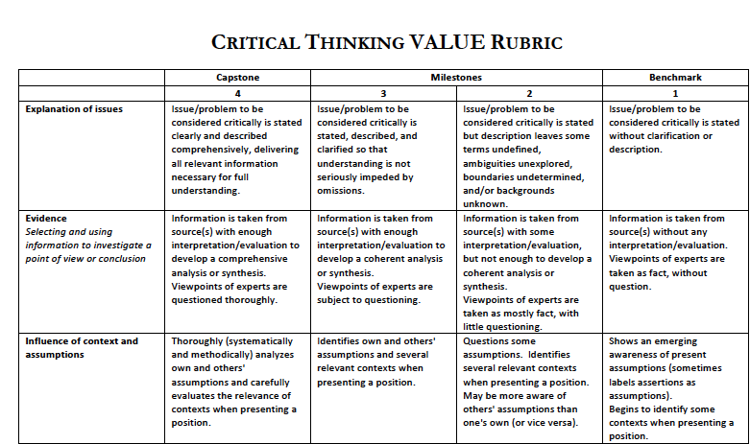
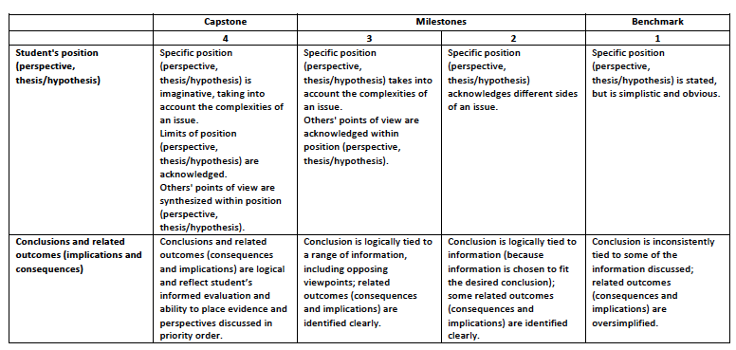

Score: __________out of 20%
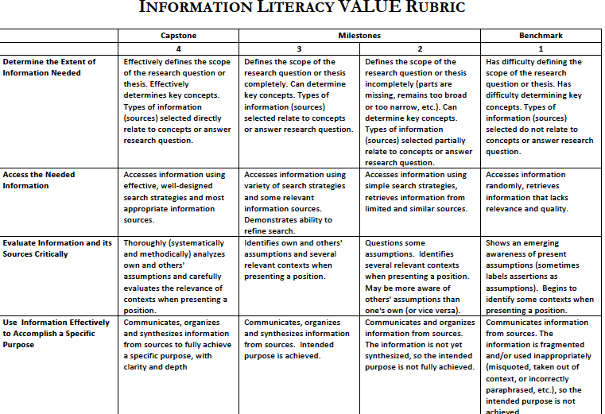
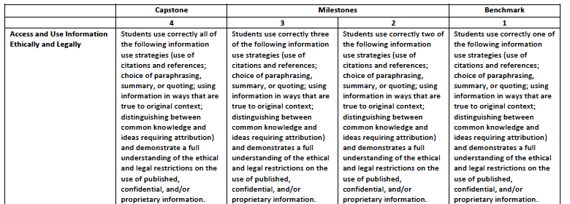

Score: __________out of 20%

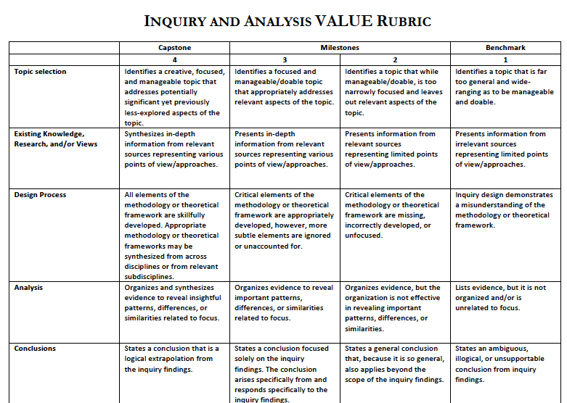

Score: __________out of 20%
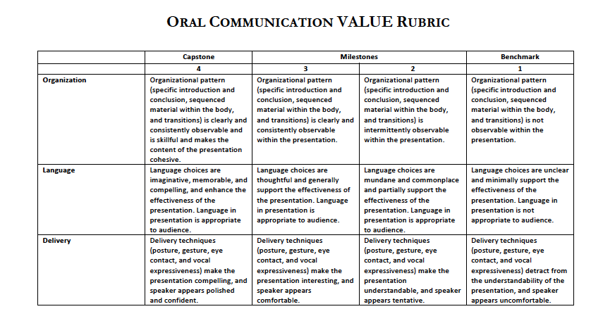

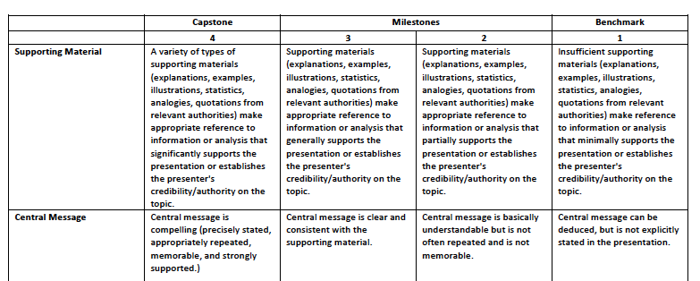

Score: __________out of 20%

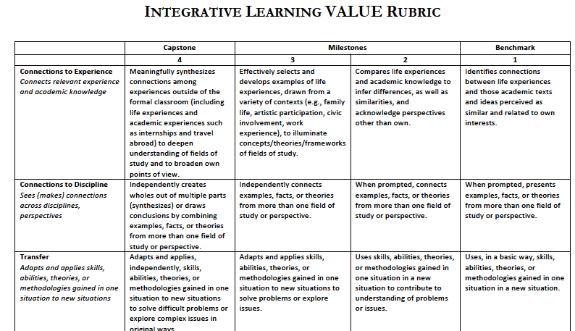
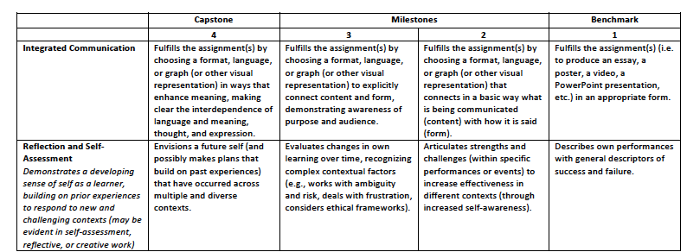
GRADING RUBRICS FOR PAPERS (REL 200 only)
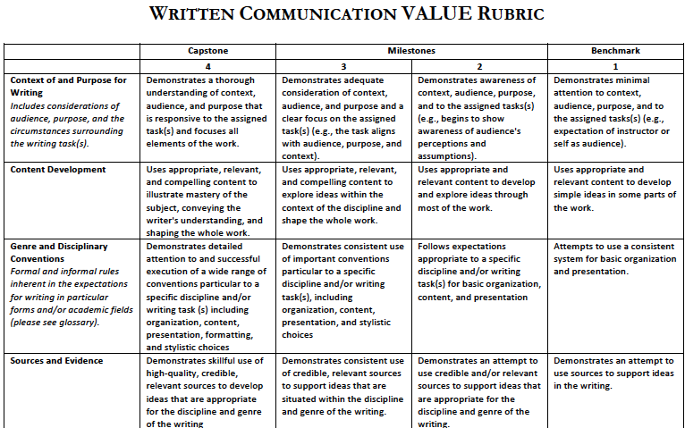

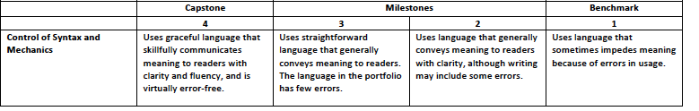

APPENDIX B5: 2014-2015 Presentation Rubrics: Each item was scored 4 = excellent, 3 = good, 2 = fine, 1=developing and in need of improvement
A. Key Concepts
1. Identifies
2. Contextualizes

B. Inquiry and Analysis
1. Integrates course material & concepts
2. Analysis of religious worldview
3. Synthesis of concepts

C. Use of academic methods
1. Comprehension of material
2. Interprets materials using methodology

D. Construction of Argument
1. Clear structure and organization
2. Able to defend argument
3. Able to critique scholarly arguments

E. Information Literacy
1. Creates accurate Works Cited page
2. Appropriate citations
3. Documents citations in oral and written presentations
4. Aware of value, accuracy, and bias of sources

F. Proficient Oral Communication
1. Well polished and rehearsed
2. Effectiveness
3. Professional, adheres to time

G. Proficient Written Communication
1. Appropriate visual aids (END OF DOCUMENT)

