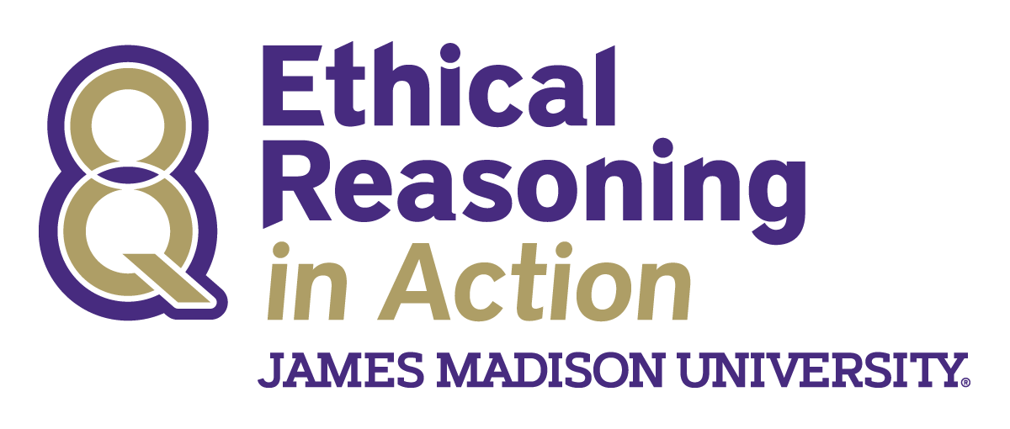

ETHICAL REASONING IN ACTION
2017-2018 ASSESSMENT REPORT
Executive Summary

Chi Au, M.A.
Jessica N. Jacovidis, Ph.D.
Allison Ames, Ph.D.
Madison Holzman, M.Ed.

Center for Assessment and Research Studies

James Madison University

Executive Summary
The 2017 – 2018 school year marked five years of Madison Collaborative: Ethical Reasoning in Action interventions. Similar to previous years, all first-year students experienced The One Book and It’s Complicated, prior to taking the ethical reasoning assessments. There were no other required interventions, though students may have experienced ethical reasoning training in coursework and/or co-curricular experiences.
A comprehensive assessment protocol is used to evaluate students’ facility with the 8KQs, as well as inform future interventions. Assessment data, aligned to each student learning objective, are collected on JMU’s Assessment Day. In the Fall, before taking any coursework at JMU, all first-year students are assessed. Students are tested a second time as second-year students in their Spring semester. The collection of data at two time points from the same students allows for longitudinal comparisons to evaluate the extent to which students’ ethical reasoning skills and abilities, as measured by the Ethical Reasoning in Action assessments, change over time. Results are highlighted below by instrument.

Survey of Ethical Reasoning (SER)
The Survey of Ethical Reasoning (SER) is a noncognitive measure designed to assess students’ attitudes toward ethical reasoning.
- Both first and second-year students ranked ethical reasoning as an important skill, with 48% of first-year and 40% of second-year students selecting ethical reasoning in their top three most important desirable skills.
- First and second-year students reported that ethical reasoning skills are important (4.53 and 4.46 out of 5 points, respectively). Additionally, first and second-year students were confident in their ability to apply the ethical reasoning process (4.12 and 4.21 out of 5 points, respectively).
- Students’ ratings of the importance of ethical reasoning decreased significantly over time(Fall 2016 to Spring 2018); however, students’ confidence scores did not change significantly over time.

Ethical Reasoning Recall Test (ERRT)
The Ethical Reasoning Recall Test (ERRT) is a short, constructed-response measure that asks students to state the 8KQs and to provide a brief explanation of each key question.
- First-year students accurately recalled about 6 and explained about 3 of the 8KQs; second-year students accurately recalled and explained about 1 of the 8KQs.
- For both first and second-year students, Fairness, Outcomes, and Responsibilities were the easiest 8KQs to recall and Fairness and Outcomes were the easiest key questions to explain.
- Empathy and Rights were the most difficult key questions for first-year students to recall and Empathy and Authority were the most difficult for first-year students to explain. Authority, Liberty, and Rights were the most difficult key questions for second-year students to recall and Liberty and Authority were the most difficult for second-year students to explain.
- Students recalled and explained significantly more of the 8KQs as first-year students than as second-year students, recalling at least four fewer key questions and explaining at least two fewer key questions as second-year student than as first-year students.

Ethical Reasoning Identification Test (ERIT)
The ERIT is a 50-item multiple choice test that asks students to consider a scenario and choose the key question most applicable to the decision or rationale presented in the scenario.
- On average, both first and second-year students scored about 68% correct.
- First-year and second-year students answered the most items correctly for Character, Fairness, and Outcomes, suggesting these key questions may be easier for students to grasp.
- First-year and second-year students answered the least items correctly for Liberty and Rights, suggesting these key questions may be harder for students to grasp.
- Students’ ERIT total scores did not change significantly from Fall 2016 to Spring 2018.

Ethical Reasoning - Writing (ER-WR) Essay
The ER-WR essay is a performance assessment instrument that asks students to respond to an essay prompt in which they are asked to describe an ethical dilemma from their own lives. The ER-WR2 and ER-WR3 essays are performance assessment instruments that provide students with a hypothetical scenario and asked them to apply the 8KQs.
- First-year students scored 1.10 points (e.g. just above marginal) on the ER-WR rubric and second-year students scored 0.97 points (e.g. marginal) on the ER-WR rubric.
- Both first and second-year students scored the highest on Element A and lowest on Elements C, D, and E.
- Students scored statistically significantly higher as first-year students (1.39 out of 4 possible points) than as second-year students (1.08 out of 4 possible points), by about 0.31 points.
- Given that both the ER-WR2 and ER-WR3 are new writing prompts, only first-year student data are available for analyses.
- The average score for the ER-WR2 (M = 1.15) is similar to the average score for the ER-WR (M = 1.10); however, the average score for the ER-WR3 (M = 0.71) is lower than the other two prompts.

Overall Summary
Generally, students’ attitudes toward ethical reasoning appear to remain stable over time. Students’ ethical reasoning skills appear to be either stable, or decreasing, over time. Ethical Reasoning in Action team could consider why student knowledge appears to be decreasing over time. For example, given that students received the It’s Complicated programming as part of their freshman orientation and students may not have had an additional exposure to the 8KQs, it seems reasonable that students would have forgotten some of what they learned. Additionally interventions could be developed to ensure that students retain the information they learned through the It’s Complicated programming.

