Criminals and Saints: Justice and Pilgrimage in Southern Italy

May 2017

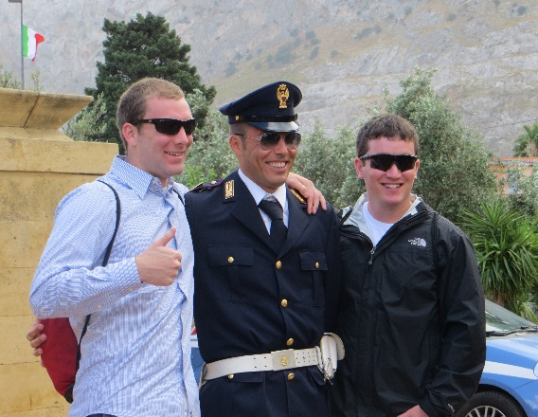
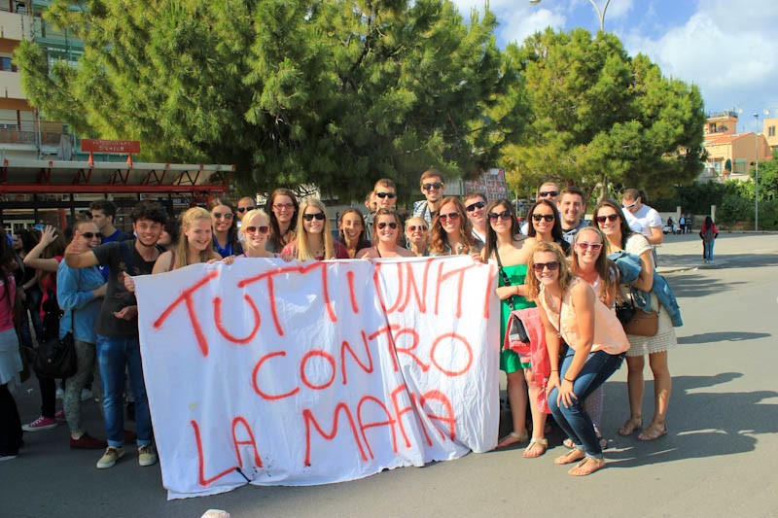
JUST 301: Organized Crime and the Anti-Mafia Movement in Italy
This course offers an overview of the Organized Crime problem in Italy, with a focus on the activites of the Anti-Mafia Movement there. While names such as Giovanni Falcone, Paolo Borsellino, and Peppino Impastato are familiar to even the youngest Italians, most Americans are unfamiliar with the inspiring actions of these heroic people and the many others who have done so much to bring about an end to one of the most insidious and brutal crime regimes in the world. In this class, students will learn about the history and current activities of the 4 organized crime groups active in Italy, and we will travel in the regions where the 3 major ones exist. In addition, we will examine the social movements which have arisen in Italy to combat the destructive actions of these criminal groups. While both Italian Organized Crime and the social movements which have emerged to combat it are unique to Italy, we will also consider the lessons which the Italian experience can teach about this growing type of criminal behavior throughout the rest of the world. In Italy, students will have the opportunity to see the sites of many significant events related to the struggle against Organized Crime, and speak with some of the major activists involved in the Anti-Mafia movements there.
