Email Signature Templates

 | Rich Email Signature (Desktop only) | Cross-Platform Signature (Mobile and Desktop)
Option 1:  The only required items are your name, position title, and “James Madison University,” which may be written in plain text or as a wordmark image. | Jane Doe  Senior Director of University Advancement | Jane Doe  Senior Director of University Advancement  James Madison University
Option 2:  This is a recommended signature. | Jane Doe  Senior Director of University Advancement  (540) 568-5555 | Jane Doe  Senior Director of University Advancement  (540) 568-5555  James Madison University  Facebook | Instagram | Twitter
Option 3:  This is a recommended signature. | Jane Doe | she/her/hers  Senior Director  (540) 568-5555  University Advancement | Jane Doe | she/her/hers  Senior Director  (540) 568-5555  University Advancement  James Madison University  Facebook | Instagram | Twitter
Option 4:  Here is an example of a JMU email signature with every option. | Jane Doe | ’00, ’07 MBA, ’14 PhD | she/her/hers  Senior Director of University Advancement  (540) 568-5555  University Advancement  Alumnae Hall  MSC 7612  91 Alumnae Drive  Harrisonburg, VA 22807 | Jane Doe | ’00, ’07 MBA, ’14 PhD | she/her/hers  Senior Director of University Advancement  (540) 568-5555  University Advancement  Alumnae Hall  MSC 7612  91 Alumnae Drive  Harrisonburg, VA 22807  James Madison University  Facebook | Instagram | Twitter
Template:  Copy and paste the following template into your Outlook Signatures pane and remove whatever fields you do not wish to include.  See the following page for detailed instructions. | [Full Name] | [degrees] | [pronouns]  [Title]  Cell: xxx.xxx.xxx | Office: xxx.xxx.xxx | Fax: xxx.xxx.xxx  [Department]  [Address] | [Full Name] | [degrees] | [pronouns]  [Title]  Cell: xxx.xxx.xxx | Office: xxx.xxx.xxx | Fax: xxx.xxx.xxx  [Department]  [Address]

How to Create an Email Signature

Start in Microsoft Word
Hyperlinking and other functions are easier in a Microsoft Word document or an Outlook email than in the Signatures window, so start by copying and pasting your preferred template into a Word doc or email body.

Edit Hyperlinks
The templates above include hyperlinks on underlined text and images, so be sure to update those for your department if needed.

Windows: | Mac:
Highlight the text that you’d like to hyperlink then right click | Highlight the text that you’ve like to hyperlink, then hold “control” button + click
Select “hyperlink”  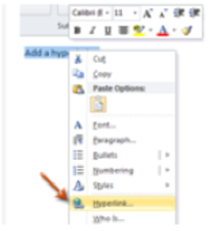 | Select “hyperlink”  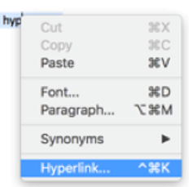
Insert the website URL that you’d like it to link to in the address bar and click “OK”  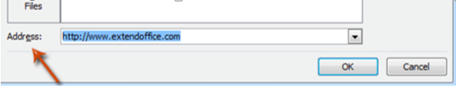 | Insert the website URL that you’d like it to link to in the address bar and click “OK”  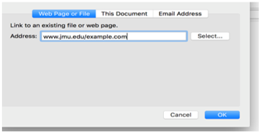

Insert Your Signature into Outlook
Copy and paste your signature into Signatures in Outlook by following these instructions.

Windows: | Mac:
Open a New Email and click on Signature in the ribbon:  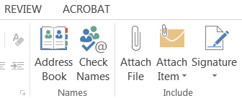 | 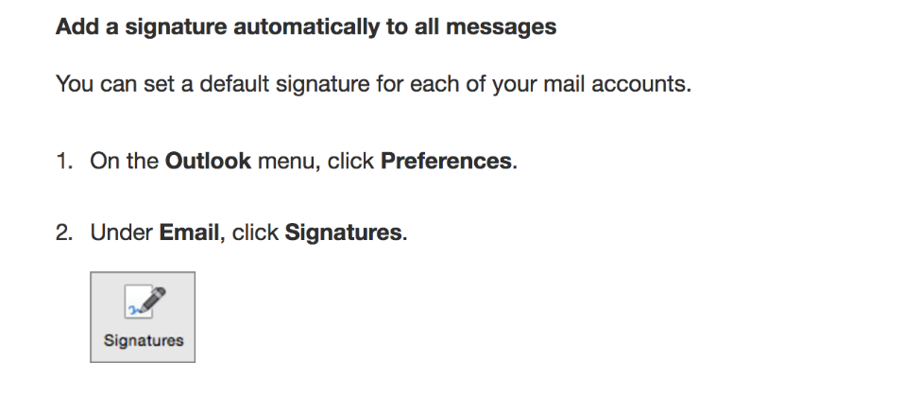
Select “Signatures…” from the dropdown, and you will have the option to delete, add, or edit your signatures.  Just paste your signatures from Word into your signature block, and you’re done! | Copy and paste your signature from Word into your signature block, and you’re done!  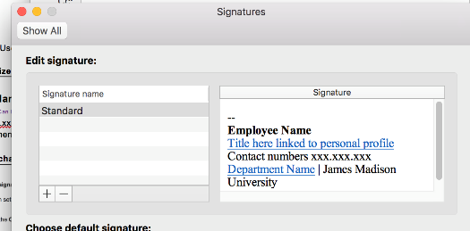

Insert Your Signature into Exchange
Your email signature will not automatically update on Microsoft Exchange when you update it on your local device. To edit your email signature on Microsoft Exchange:

Click on the gear icon to open the Settings dropdown, then select Options:
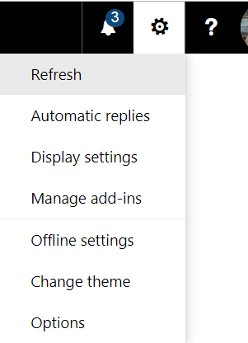

On the left side, in the Layout section at the end, select “Email signature” to open the signature pane:
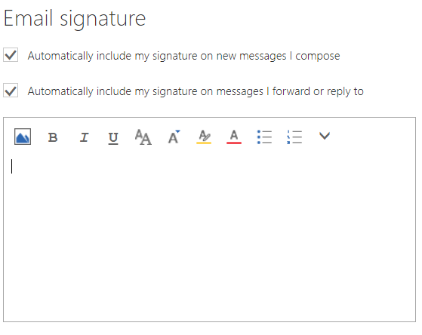
You can add images by clicking on the mountain icon in the upper left of the signature pane, but you will need to save your images as individual files first.

