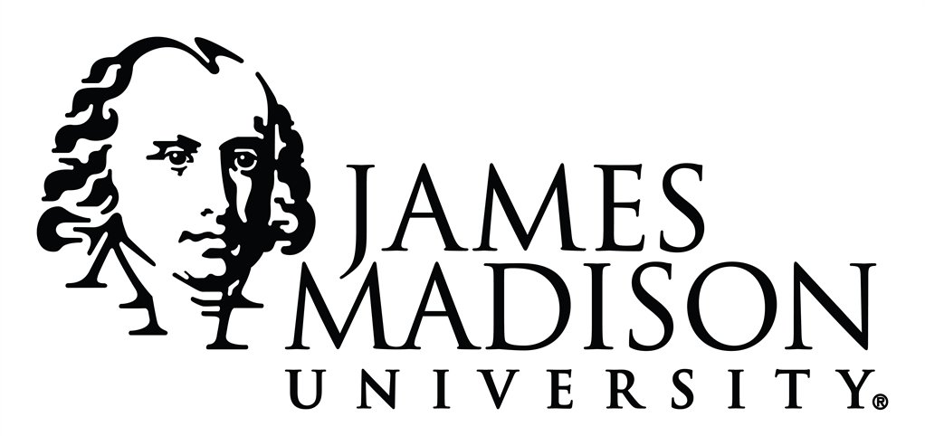

James Madison University Honor Council

Executive Board Application 2022-2023
For consideration for a position on the JMU Honor Council Executive Board each applicant must meet the minimum 2.50 GPA requirement and submit their completed application to the Honor Council Coordinator by February 11, 2020 by midnight. Each applicant must also provide a resume and an optional cover letter. This application can be submitted electronically to burnetaj@jmu.edu or the Honor Council office in Johnston 222. A full description of the positions available and their duties can be found in the Honor Code (www.jmu.edu/honor). Contact Audrey Burnett, Honor Council Coordinator at 540-568-8969 or burnetaj@jmu.edu with any questions.

Applicant Information

Name: Major:

Current Cumulative GPA: Email:

Year: Cell Phone:

Have you read the Honor Code in its entirety? Yes No

Have you ever been found responsible for a judicial violation? Yes No
If yes, please explain.

How many semesters (including the current semester have you served on the Honor Council?

Position Applying for:

President Vice-President Investigator

Would you be willing to accept any position if offered? Yes No

Please Answer the following questions:

- Which one defining quality do you feel you possess that would enable you to successfully perform a leadership role in the Honor Council?

- Have you ever held a leadership position in the past? If so, how has that experience shaped the you to be the leader that you are today?

- What initiatives or goals would you like to accomplish next year as a member of the Executive Board?

- Do you believe that students and faculty members are fully aware of the Honor Code? If not, what could be done to ensure that every member of the JMU community is aware of the Honor Code?

Disclaimer and Signature
I certify that my answers are true and complete to the best of my knowledge.
If this application leads to employment, I understand that false or misleading information in my application or interview may result in my release.

Signature: Date:

Following the submission of this application the Honor Council Coordinator will contact qualified candidates to be interviewed for the positions available. Interviews will be scheduled mid-late February. After the interviews, the candidates who are selected will be offered the position and attend a meeting with the Honor Council Advisory Board to be appointed to the position for the 2022-2023 academic year.

