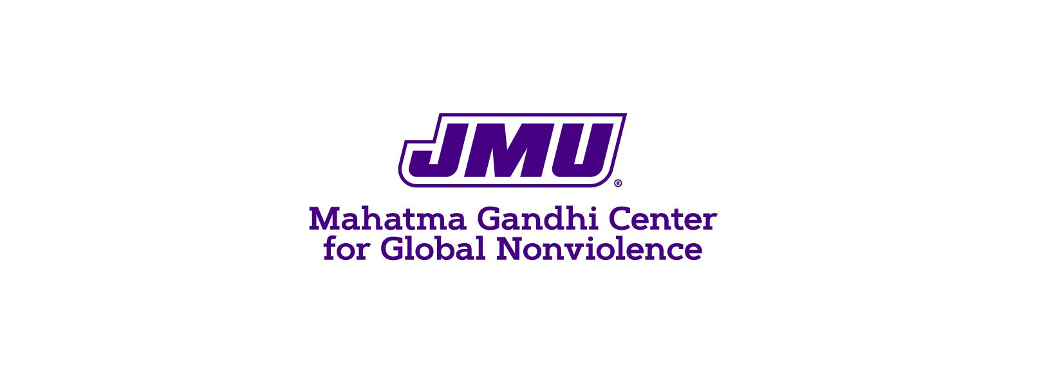

Gandhi Center Newsletter Spring 2022

We acknowledge and thank friends and partners for support through an active and highly successful semester, and to meet our mission and core values.

The Gandhi Center & Department of Justice Studies honors and celebrates the life and legacy of Dr. Terry D Beitzel, Professor of Justice Studies and Director (since 2014) of the Mahatma Gandhi Center for Global Nonviolence at JMU.

The mission of the Gandhi Center is to promote justice and nonviolence through education, scholarship, and engagement.
Core values:
- Respect (for life and its myriad forms)
- Reconciliation (for those in struggle)
- Restoration (of the social and spiritual health of diverse communities)
In this issue:
- Gandhi Center updates
- Beitzel Scholarship
- Advisory Board & Staff
- Quick hits

Gandhi Center Updates

- Beitzel Lecture Series & Symposium

The Beitzel Lecture Series brings distinguished scholars and practitioners of nonviolence to the James Madison University campus for public lectures, seminars, panel discussions and a variety of related interactions with faculty, students, and the larger community.

The inaugural Beitzel Lecture was given on March 3, 2022, by Dr. Samiullah Nuristani. Dr. Nuristani discussed key factors leading to the return of the Taliban to leadership in Afghanistan. You can watch the whole presentation here.

The Beitzel Symposium on the International Journal of Responsibility on April 7, 2022, led by Daisy Breneman and Howard Carrier, discussed the creation of the research journal and featured student research.

The fall lecture series and symposium will take place during Campaign Nonviolence, which will include two weeks of programming beginning with the International Day of Peace (September 21) to the International Day of Nonviolence (October 2 – Gandhi’s birthday).

- Justice & Nonviolence Research Lab
Dr. Corey Hickerson’s SCOM 461 class took up the Justice and Nonviolence Research lab as a public relations project this semester. Student groups presented their findings in May to the Interim Director and Academic Unit Head of the Gandhi Center. The Gandhi Center will incorporate many of the suggestions from the teams in planning for fall events and thanks the students for their research!

- International Journal of Responsibility
IJR published the fall issue on Disability and the Pandemic, co-edited by Daisy L. Breneman and Susan Ghiaciuc from JMU. The journal received editorial support this semester from the new graduate assistant.

The spring issue will be published soon featuring a special guest issue edited by Dr. Pooja Sharma on the topic “Migration, Community, and Environment During a Pandemic.”

Two issues are currently in progress for next year on the topics of “Religion and Responsibility” and “Wrongful Convictions.”

- Gandhi Center Programs and Community Engagement
The Gandhi Center offered two bystander intervention trainings this year, partnering with the Center for Multicultural Students Services (CMSS). The “Stop Police-Sponsored Violence and Anti-Black Racist Harassment was offered in February during Black History Month, and “Stop Anti-Asian/American and Xenophobic Harassment” was offered during the celebration of Asian-American and Pacific Islander (AAPI) month in April.
On campus, we supported and sponsored the AAAD conference with a speaker and helped organize the Holocaust Remembrance Day event.
We also sponsored two community programs this year: the pilot program-- Grupo de baile (Latin American and Spanish Dance Group) and World Refugee Day with Church World Services.

Dr. Terry D Beitzel Scholarship

We are excited to announce that the first Beitzel Scholarship will be awarded in the next academic year, which supports first-generation students who major in Justice Studies and have a passion for nonviolence and social justice. The endowed scholarship will be awarded in Fall 2022 thanks to the donation of expendable funds from Sylvia & Myra Beitzel.

Advisory Board and Staff

Dr. Taimi Castle, Professor of Justice Studies, began serving as Interim Director of the Gandhi Center in Spring 2021. Dr. Castle will continue her term through AY 2022-23.

The Gandhi Center also receives administrative support from Dianne Fulk, Program Support Technician.

During the AY 2021-22, the Gandhi Center employed one Graduate Assistant, Courtney Hassan, and two student interns (Evan Munsey and Audrey Billiard). Evan worked with Director Dr. Terry Beitzel previously.

We are excited that Courtney Hassan will be joining us again next year!

External Advisory Board:
Alicia Horst, Executive Director, Mid-South Immigration Advocates (Memphis, TN)
Charles Martorana, Retired Valley Region Market President, Blue Ridge Bank
Keith May, Broker/Owner, Cottonwood Commercial and Kline May Realty
Sylvia Whitney Beitzel, Community Representative
Rick Yoder, Professor Emeritus/Business, Eastern Mennonite University
Ron Yoder, International Development Advisor

Internal Advisory Board:
Dr. Smita Mathur, Associate Professor, College of Education
Dr. Abe Goldberg, Professor, Political Science (College of Arts & Letters)
Dr. Edward Brantmeier, Assistant Director of Scholarship Programs for the Center for Faculty Innovation, Professor, College of Education

Other News:

- Gandhi Center will co-sponsor Holocaust Remembrance Day event with the Center for Civic Engagement next year

- Campaign Nonviolence will take place from September 21 (International Day of Peace) to October 2 (International Day of Nonviolence and Gandhi’s birthday). Many events and announcements to come so keep an eye on our social media!

- The Beitzel Symposium will take place during the first week of Campaign Nonviolence, with guests and presentations on White Nationalism. We will also offer the Mahatma Gandhi Center National Award for Nonviolence to a very special guest who we cannot name quite yet!

- Thanks to the very generous donation from Dr. Calvin Redekop and the Redekop Family Trust, we can support future activities and programming. We are graciously indebted to his ongoing support of our efforts.

If you have questions, or would like more information, please contact Dr. Castle by email (castletl@jmu.edu) or phone (540-568-5929).

Find us on social media!
Visit our https://linktr.ee/gandhicenterjmu for updates and links to social media.

