Key Combinations for Diacritics on Windows
First, make sure you have the keyboard set to ENG INTL on the bottom right hand side of your screen. When you click on ENG US, the option should pop up to change to ENG INTL. If you don’t, skip below to enable it.

International Symbols on the Right Alt Key

The easier of the two available ways of using the international keyboard involves pressing the Alt key on the right side of the keyboard and then another key at the same time.
To add the accents to vowels, press the right Alt key at the same time as the vowel. To type á, press the right Alt key and the A at the same time. If you're capitalizing to make Á, you'll have to press three keys at the same time—A, right Alt, and shift.
The method is the same for the ñ. Press the right Alt and the n at the same time. To capitalize it, also press the shift key. To type the ü, you'll need to press right Alt and the Y key.
The inverted question mark (¿) and inverted exclamation point (¡) are done similarly. Press right Alt and the 1 key (which also is used for the exclamation point) for the inverted exclamation point. For the inverted question mark, press right Alt and the question mark key at the same time.
If the ENG INTL option does not pop up, follow these instructions for adding that keyboard option to your device.
1. Next to the keyboard symbol, click on ENG US and then, Language Preferences
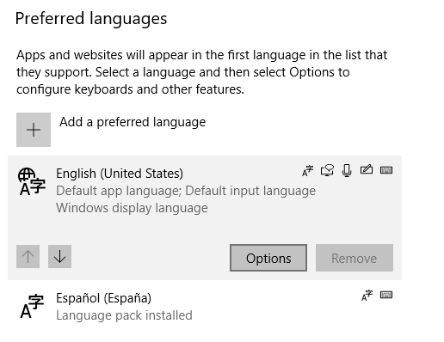
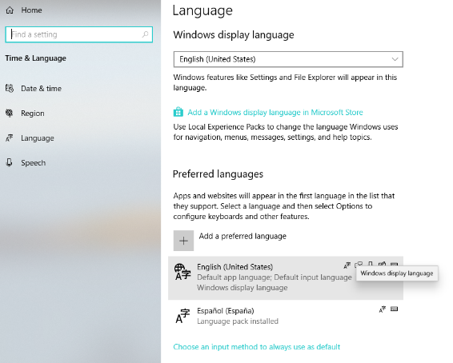
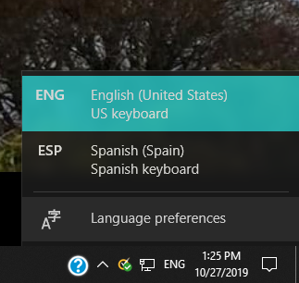
2. Click on English and choose options

3. Choose US International from
the drop down box. Click on it.
It will now appear in the list.
Close the window.
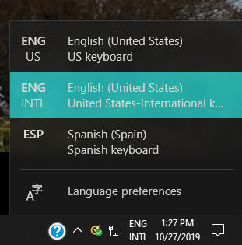
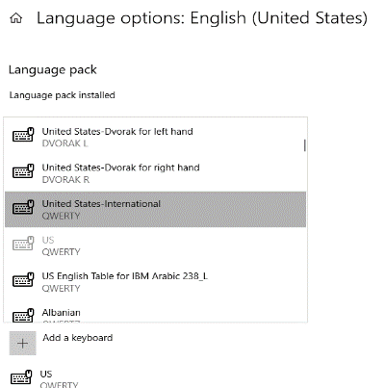
4. Now you have this keyboard option
