These instructions were created using Firefox ESR 17.0.3

You must allow pop-up windows in order to view this report

Open Firefox and from the menu bar choose Tools, then Options

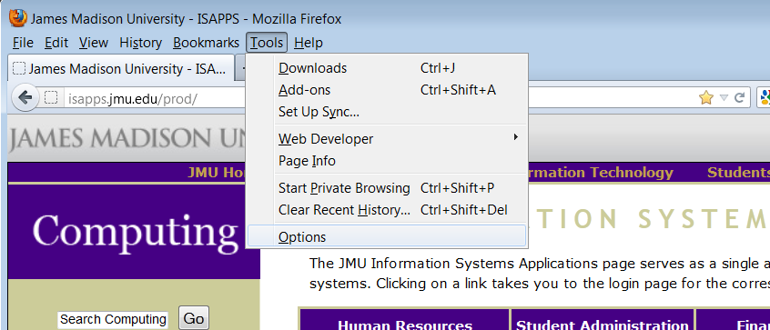

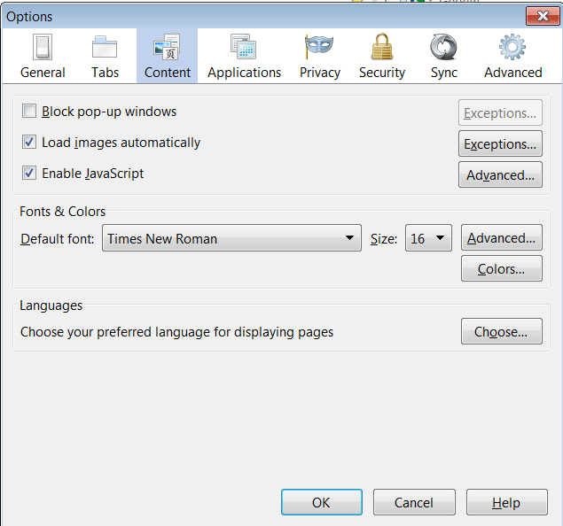

Choose the Content section.

Make sure ‘Block pop-up windows’ is NOT checked.

Click OK

You are now ready to run the nVision Report

- Log in to the Finance System and navigate to the nVision Report Request via the following path Main Menu > Reporting Tools > PS/nVision > Define Report Request

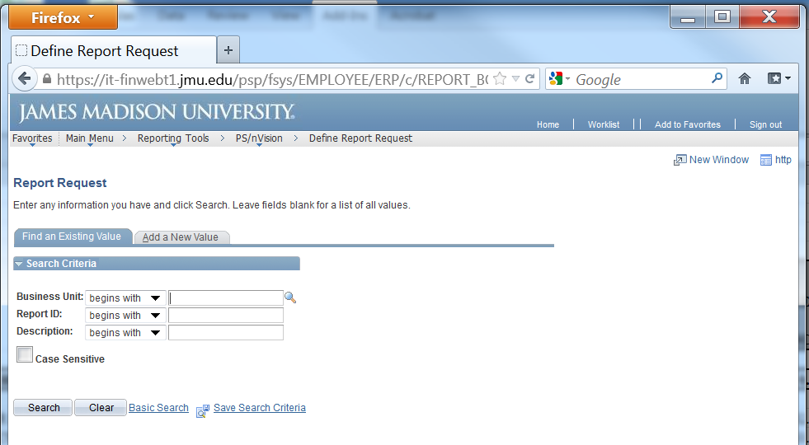

- Enter the desired department number in the Report ID box and Click Search.

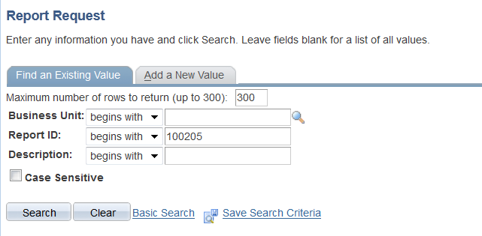
c
c

- Choose the desired report from the Search Results

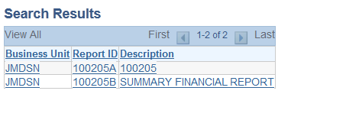

- Enter the following
  - Choose the desired ‘As Of Reporting Date’
  - ‘Tree As Of Date’ should always be set to ‘Use As Of Reporting Date’
  - ‘Overrride Tree As of Date if Specified in Layout’ should always be checked
  - ‘Type’ should be Web
  - ‘Format’ should be Microsoft Excel Files (*.xls)
Click Save & Click Run Report

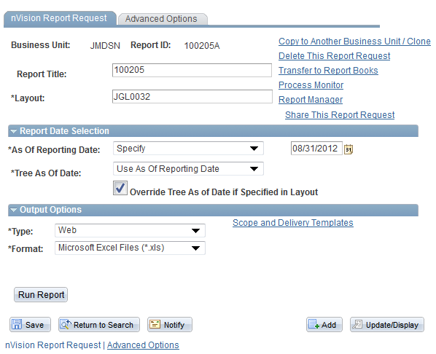

- Choose Server Name PSNT. Click OK.

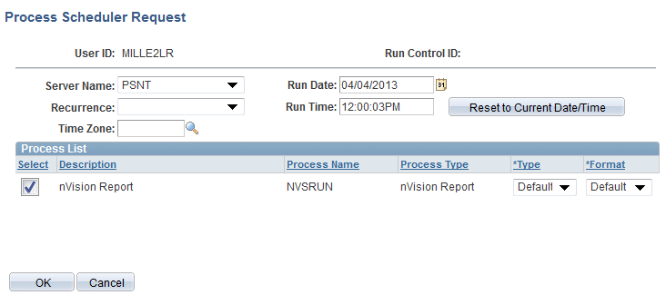

- You are returned to the Report Request page. Click the Report Manager hyperlink.

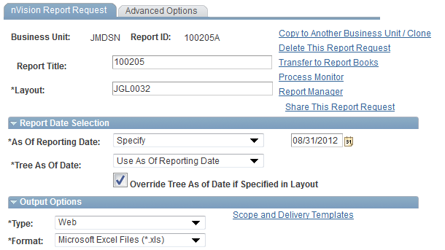

- After you click on the Administration tab, click Refresh until the Status says ‘Posted’.

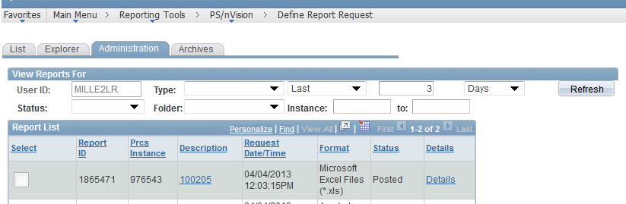

- Click on the report hyperlink (e.g. 100205) after it is available.
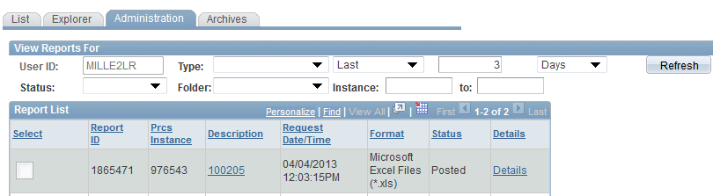

**NOTE: You must have pop-ups allowed. If you don’t, you will see a yellow message bar. Click Options and choose Allow pop-up…(you may need to click the report hyperlink again)

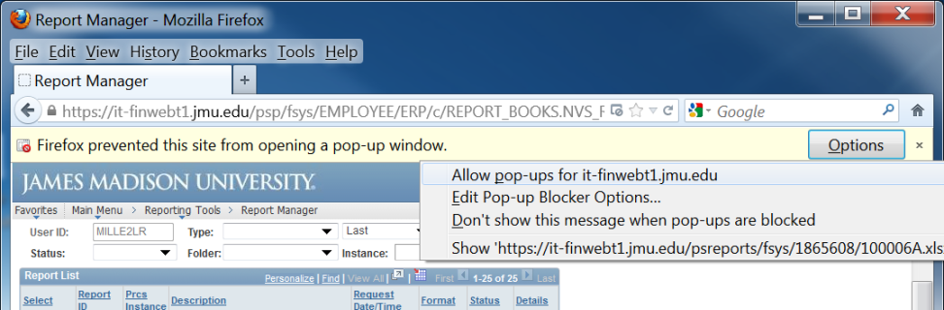

- A window should appear. Choose Open with: Microsoft Excel. If desired, you may optionally check the box to ‘Do this automatically..” Click OK

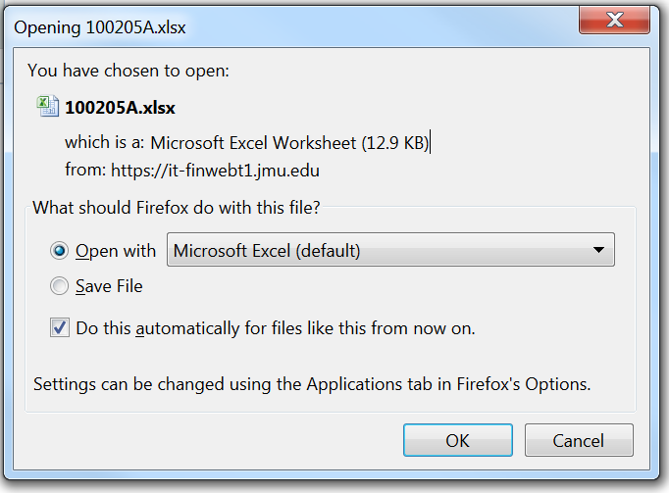

- The nVision report should open in Excel. You are now able to Save & Print the report.

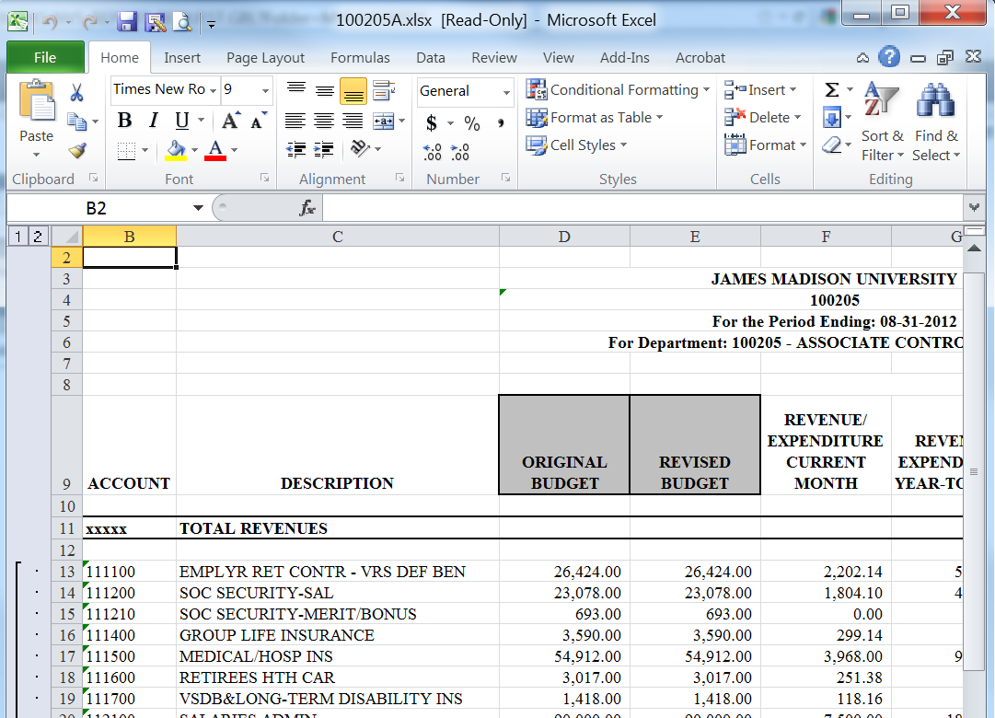

- You are still able to drill down if you have the Excel Add-In installed. Click in the desired cell and from the Add-Ins tab select nVisionDrill then Drill.

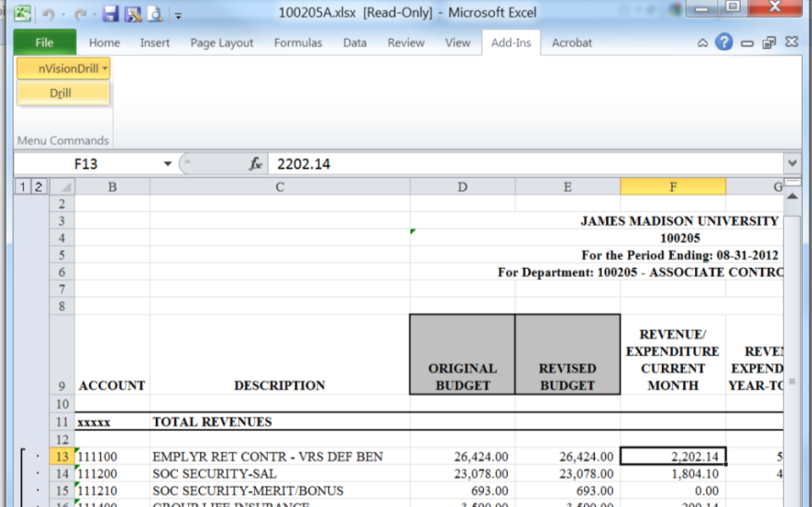

- You are transferred to the Finance system Drill Down menu. (You may be prompted to log into the Finance System with Internet Explorer first) You are now able to run the desired drilldown.

