These instructions were created using Safari version 5.1.5 (7534.55.3)

You must allow pop-up windows in order to view this report.

Open Safari and from the Safari drop down menu at the top of the screen and make sure ‘Block Pop-Up Windows’ is NOT checked.

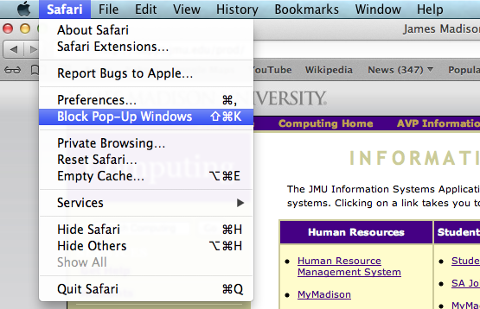

You are now ready to run the nVision Report.

- Log in to the Finance System and navigate to the nVision Report Request via the following path Main Menu > Reporting Tools > PS/nVision > Define Report Request

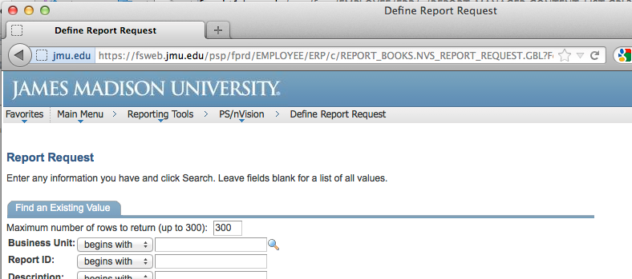

- Enter the desired department number in the Report ID box and Click Search.

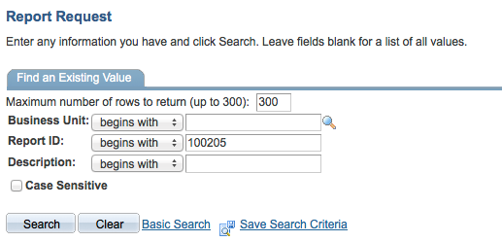

- Choose the desired report from the Search Results

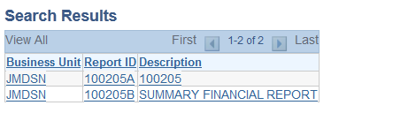

- Enter the following
  - Choose the desired ‘As Of Reporting Date’
  - ‘Tree As Of Date’ should always be set to ‘Use As Of Reporting Date’
  - ‘Overrride Tree As of Date if Specified in Layout’ should always be checked
  - ‘Type’ should be ‘Web’
  - ‘Format’ should be ‘Microsoft Excel Files (*.xls)’
Click Save & Click Run Report

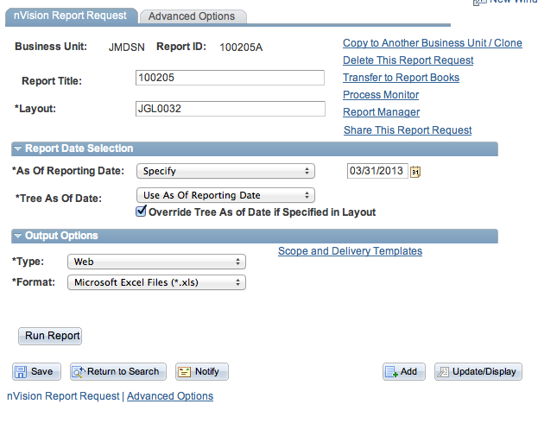

- Choose Server Name PSNT. Click OK.

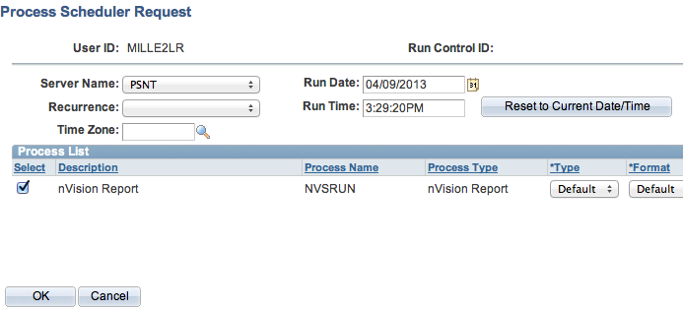

- You are returned to the Report Request page. Click the Report Manager hyperlink.

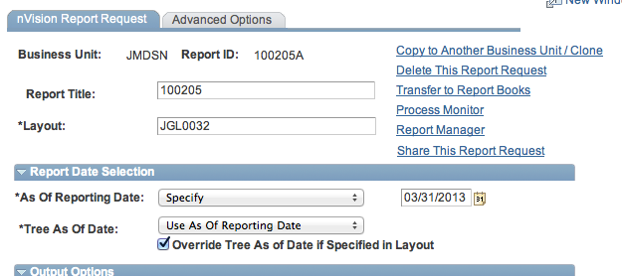

- After you click on the Administration tab, click Refresh until the Status says ‘Posted’.

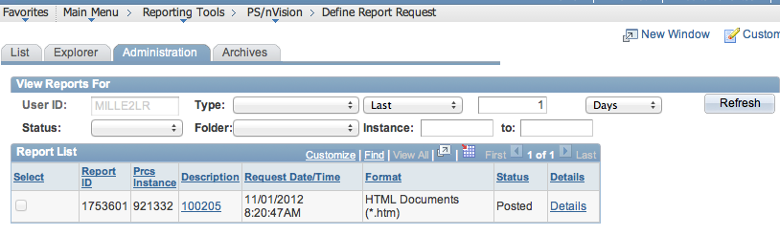

- Click on the report hyperlink (e.g. 100205) after the report is available.

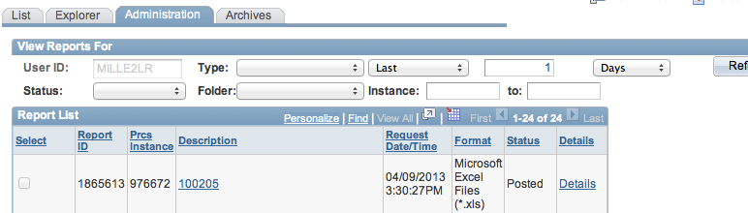

- A white Untitled Safari window will open.
NOTE: ***If you have not allowed pop-ups nothing will happen (you will not get a white screen). Make sure pop-ups are allowed and click the report again

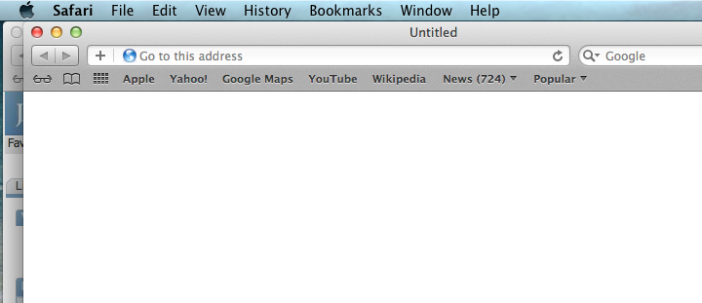

- In order to view the report you will need to find the Excel file in your Downloads. Click the Downloads icon in the upper right hand corner to display the downloaded files. Double Click the Excel file (e.g. 100205.xlsx) to open the nVision Report.

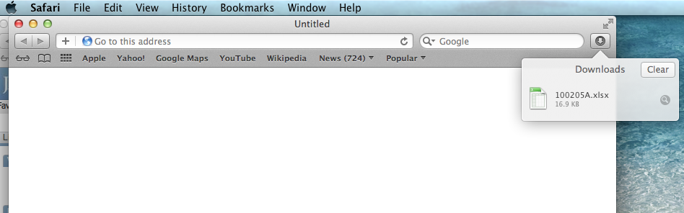

Alternately you can open the file from the Downloads folder. Click the “Downloads” folder at the bottom of the screen and Click the Excel file (e.g. 100205.xlsx) to open the nVision Report.

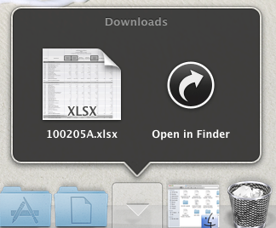
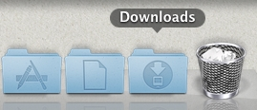

- The nVision report should open in Excel. You are now able to Save & Print the report.

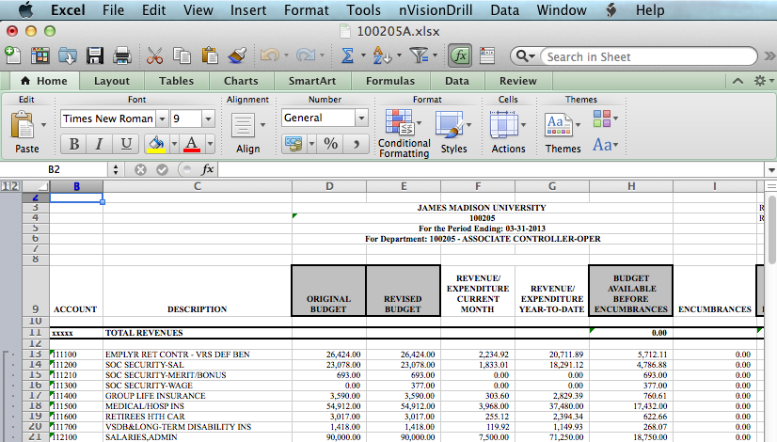

- You are still able to drill down if you have the Excel Add-In installed. Click in the desired cell and from the Excel toolbar select nVisionDrill then Drill.

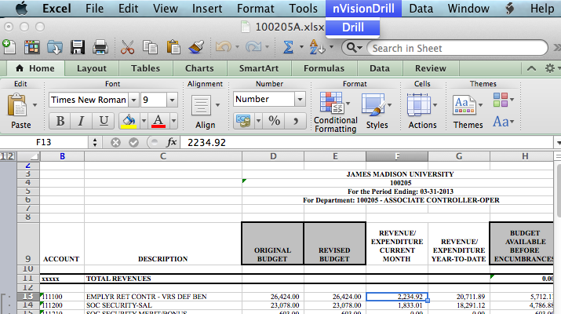

- You are transferred to the Finance system Drill Down menu. (You may be prompted to log back into the Finance System first.) You are now able to run the desired drilldown.

