These instructions were created using Chrome version 26.0.1410.63

You must allow pop-up windows in order to view this report.

Open Chrome and Click the stacked lines icon in the upper right-hand corner to ‘Customize and control Google Chrome’

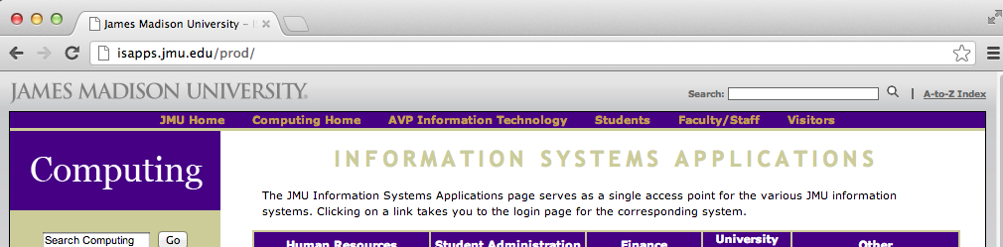

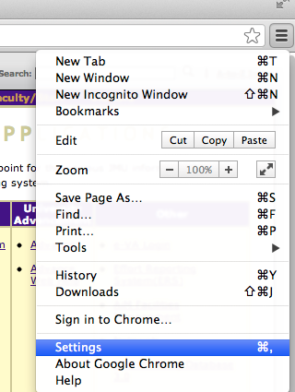

From the menu options, choose Settings

A new Settings tab will open

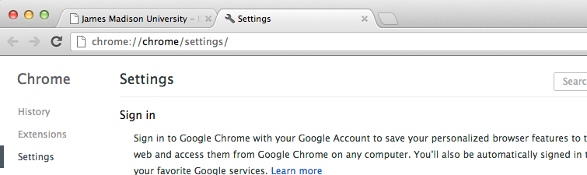
Select the Show advanced settings… hyperlink at the bottom of the screen

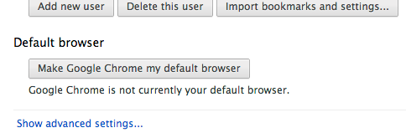

Additional options will appear. In the Privacy section, Choose Content settings…

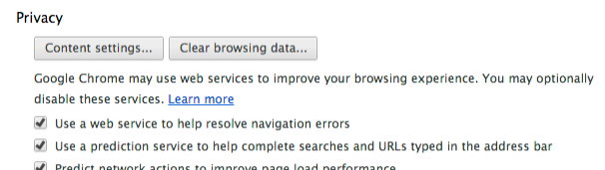

The Content settings page will appear. Scroll down to the Pop-ups section. Select Allow all sites to show pop-ups

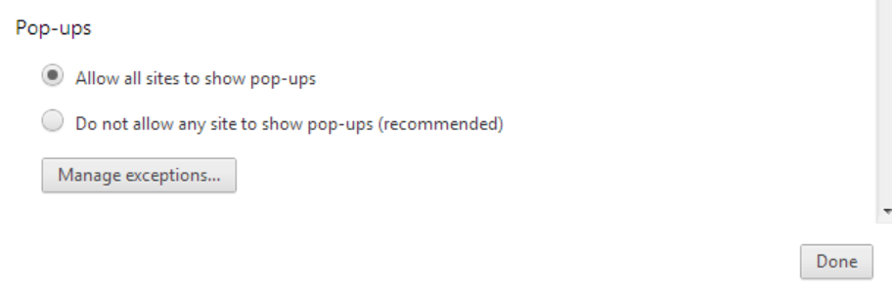

Press Done

You can now Close out the Settings tab. Your settings are automatically saved; there is no additional OK or Save button to click.

- Log in to the Finance System and navigate to the nVision Report Request via the following path Main Menu > Reporting Tools > PS/nVision > Define Report Request

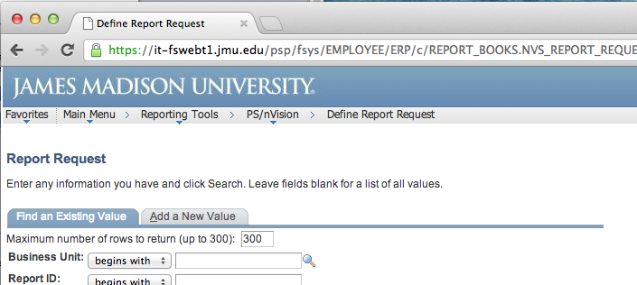

- Enter the desired department number in the Report ID box and Click Search.

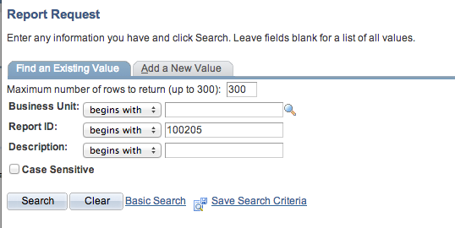

- Choose the desired report from the Search Results

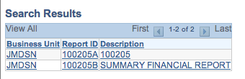
- Enter the following
  - Choose the desired ‘As Of Reporting Date’.
  - ‘Tree As Of Date’ should always be set to ‘Use As Of Reporting Date’
  - ‘Overrride Tree As of Date if Specified in Layout’ should always be checked
  - ‘Type’ should be ‘Web’
  - ‘Format’ should be ‘Microsoft Excel Files (*.xls)’
Click Save & Click Run Report

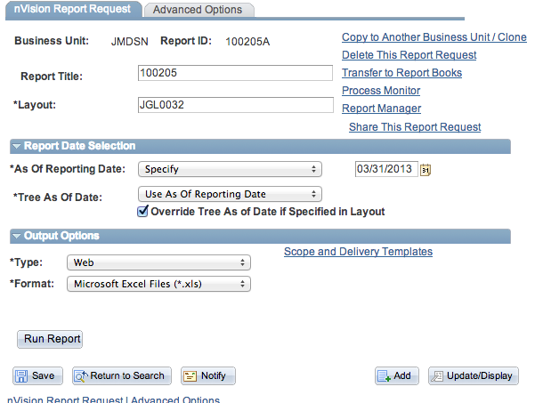

- Choose Server Name PSNT. Click OK.

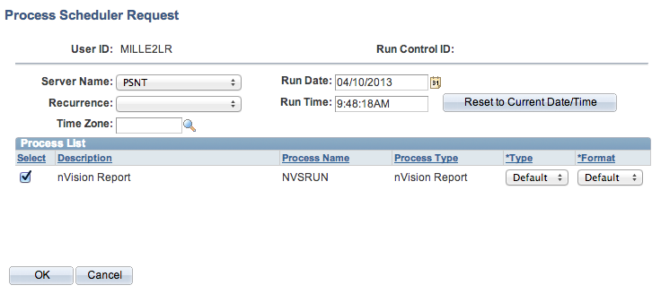

- You are returned to the Report Request page. Click the Report Manager hyperlink.

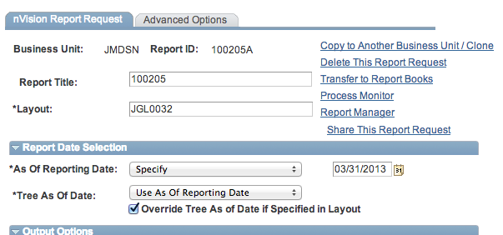
- After you click on the Administration tab, click Refresh until the Status says ‘Posted’.

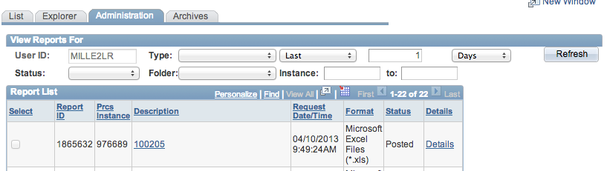

- Click on the report hyperlink (e.g. 100205) after the report is available.

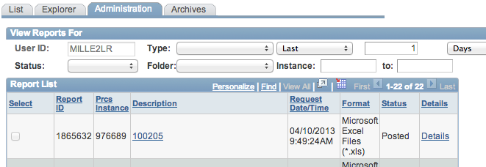
NOTE: ***If you have not allowed pop-ups a red X will appear in the address bar. Click the red X and choose Always allow popups. Click Done

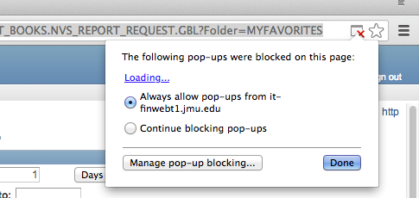

- A white ‘Untitled-Google Chrome’ window should appear. The report Excel file should be downloaded at the bottom of the window. Click on the report name to open the Excel file.

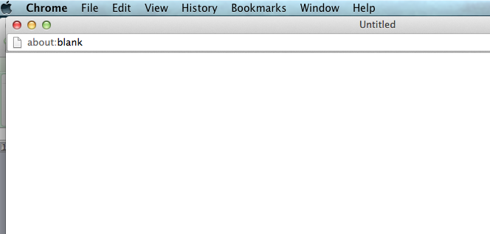

Alternately you can open the file from the Downloads folder. Click the “Downloads” folder at the bottom of the screen and Click the Excel file (e.g. 100205.xlsx) to open the nVision Report.

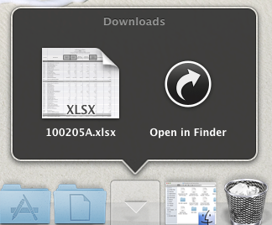
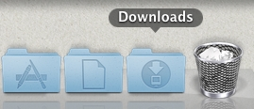

- The nVision report should open in Excel. You are now able to Save and Print the report.

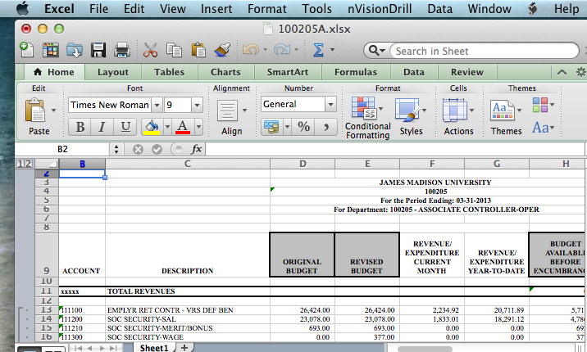

- You are still able to drill down if you have the Excel Add-In installed. Click in the desired cell and from the Excel toolbar select nVisionDrill then Drill.

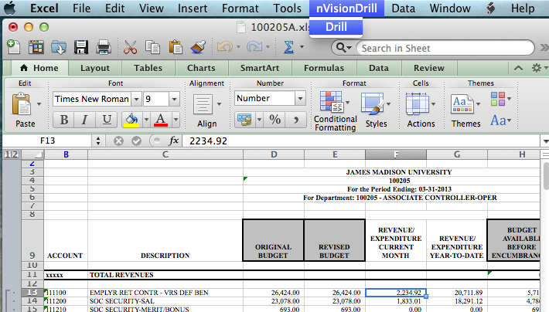

- You are transferred to the Finance system Drill Down menu. (You may be prompted to log into the Finance System with Safari first.) You are now able to run the desired drilldown.

