These instructions were created using Firefox ESR version 10.0.9

You must allow pop-up windows in order to view this report.

Open Firefox and from the menu bar choose Tools, then Options

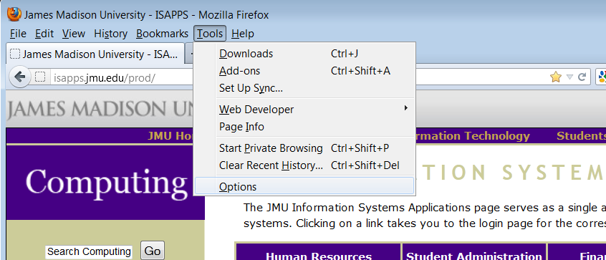

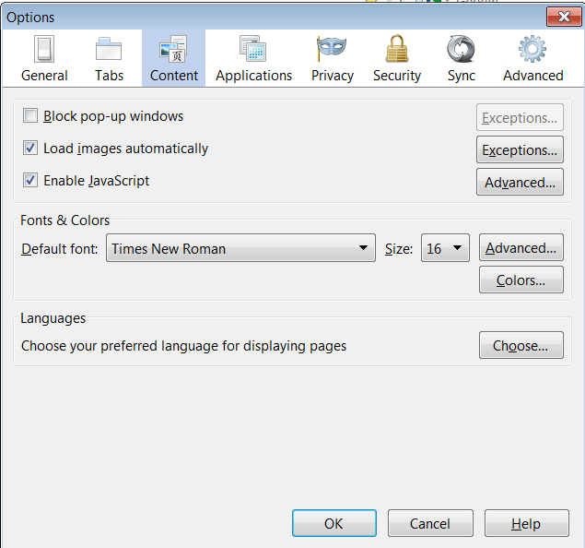

Choose the Content section.

Make sure ‘Block pop-up windows’ is NOT checked.

Click OK

You are now ready to run the Monthly Detail Report
.
- Log in to the Finance System and navigate to the Monthly Detail Report via the following path Main Menu > JMU Applications > Department > Monthly Detail Report

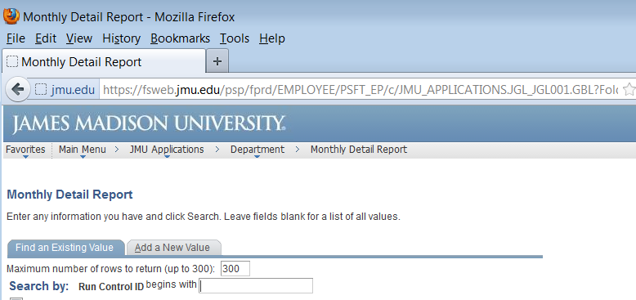

- Click Search to display your Run Control IDs

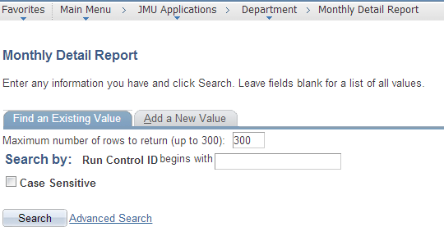

***NOTE: if this is your first time running the Monthly Detail Report you will need to select the ‘Add a New Value’ tab to create your Run Control ID which will remain in the system forever and cannot be changed. You will use this same Run Control every time to run the report. For example, you may name it Monthly_Detail (spaces are not allowed).

- Click the hyperlink for your Run Control ID (Monthly_Detail)

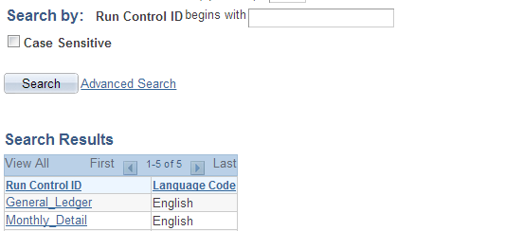

- Enter the following
  - Department Code From/To: the 6 digit Department number (If you are running the report for only one department, enter the same Dept ID in both the From and To boxes)
  - As Of Date: the last day of the month for which you want to run the report

Click Run

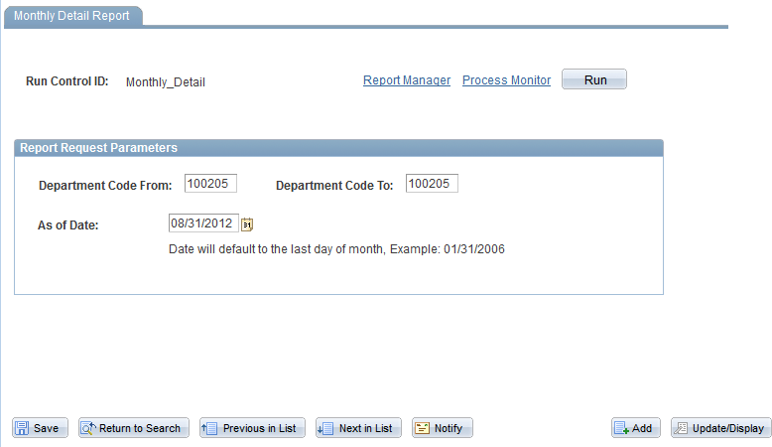

- Choose Server Name PSNT.
Type should default to Web and Format should default to PDF

Click OK

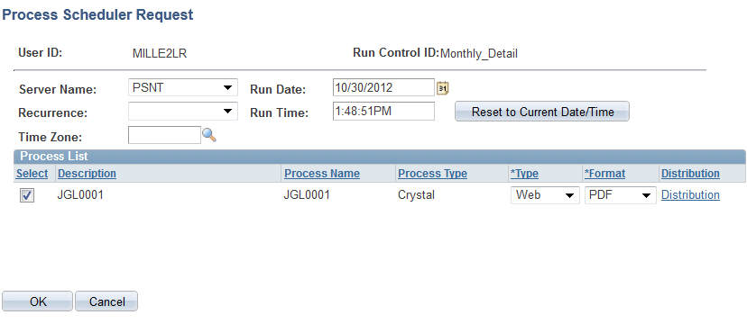

- You are returned to the Monthly Detail Report page. You will now have a Process Instance number. Click the Report Manager hyperlink.

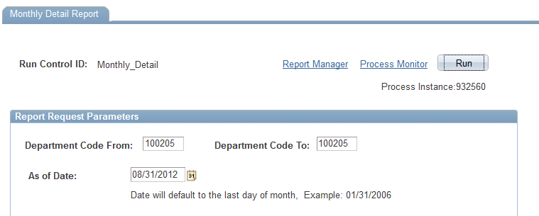

- Click the Administration tab. Click Refresh until the JGL0001 report has a Status of Posted.

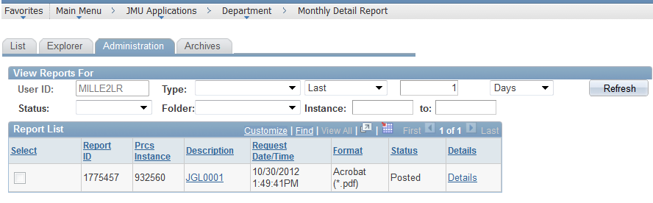

- Click on the JGL0001 hyperlink after the report is available.

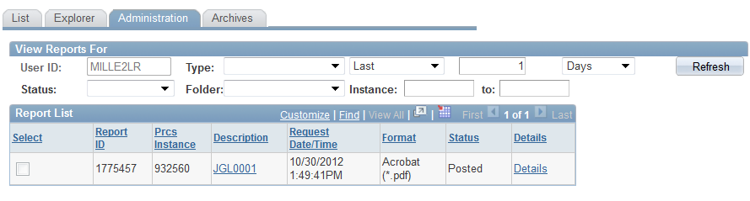

**Note: if you have not allowed Pop-ups you will receive a notification bar at the top of the window. Click Options and choose ‘Allow pop-ups…’

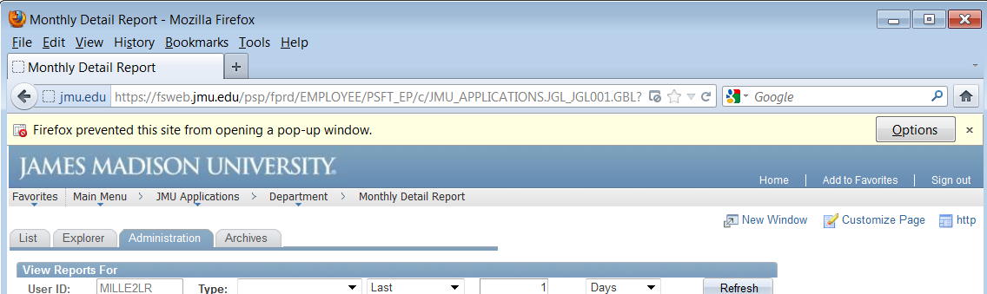
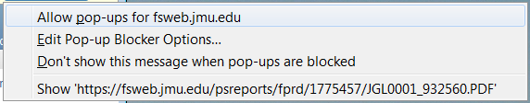
You will now have to Click the JGL001 hyperlink again

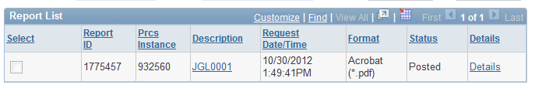

- The Monthly Detail Report should open in a new Firefox window.

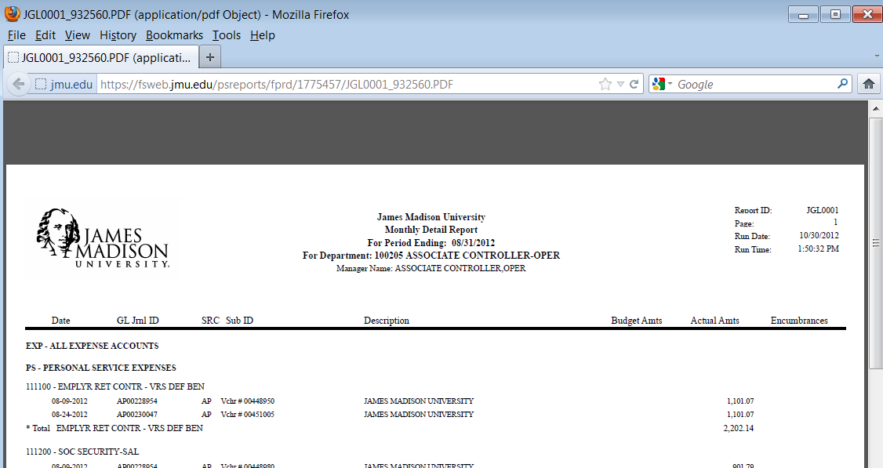

- Hover the mouse near the bottom of the page to display the Adobe toolbar. Click the Print or Save icon for the desired action.

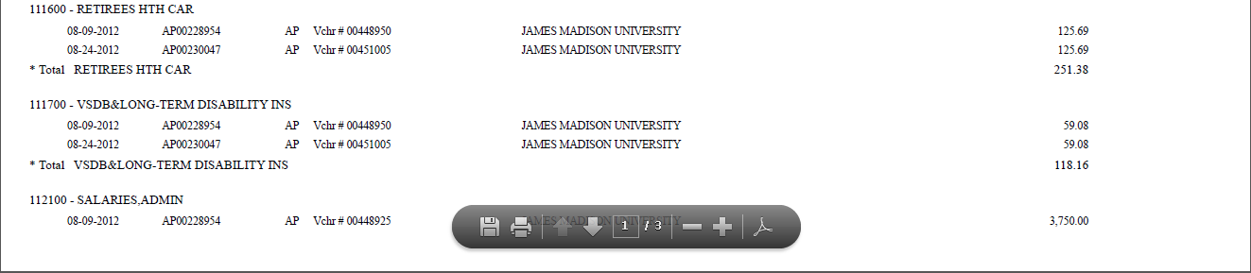

- To Save a copy of the report choose the Save in folder and enter a File name. Click Save

