These instructions were created using Chrome 22.0.1229.94 m

You must allow pop-up windows in order to view this report.

Open Chrome and Click the stacked lines icon in the upper right-hand corner to ‘Customize and control Google Chrome’

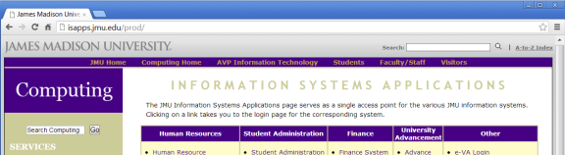

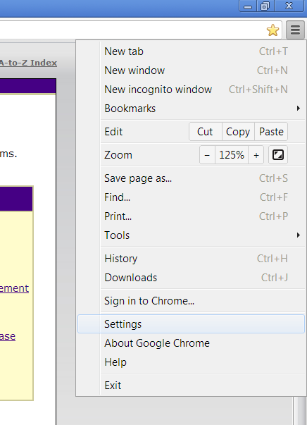

From the menu options, choose Settings

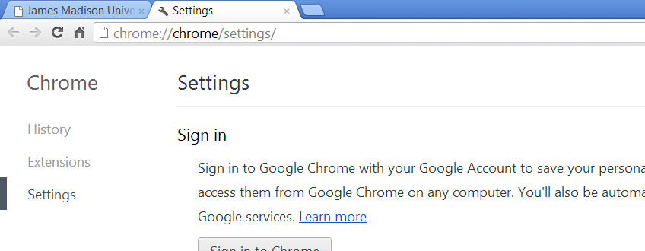

A new Settings tab will open.

Scroll down and Select the Show advanced settings… hyperlink at the bottom of the screen

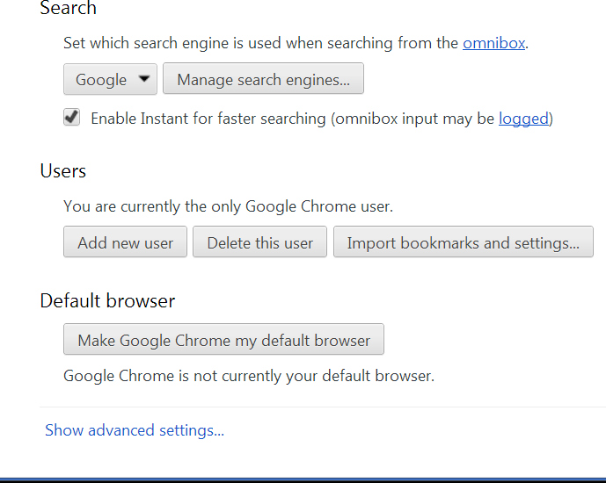

Additional options will appear

Scroll down to Privacy and Choose Content settings…

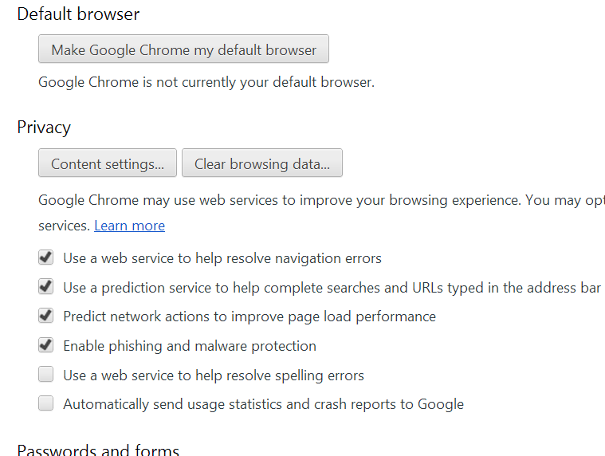

The Content settings page will appear

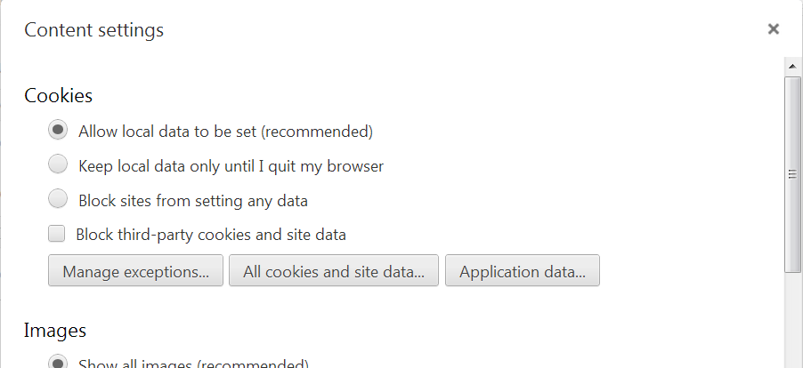

Scroll down to Pop-ups

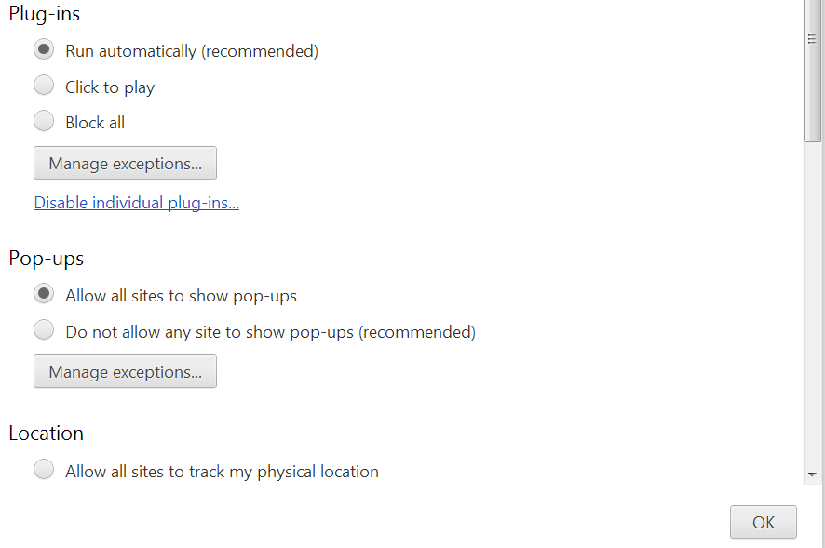

Select Allow all sites to show pop-ups

Press OK

You can now Close out the Settings tab. Your settings are automatically saved; there is no additional OK or Save button to click.

You are now ready to run the Monthly Detail Report.

- Log in to the Finance System and navigate to the Monthly Detail Report via the following path Main Menu > JMU Applications > Department > Monthly Detail Report

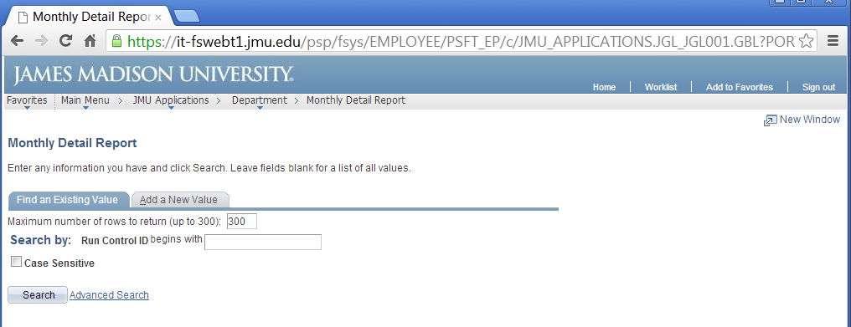

- Click Search to display your Run Control IDs

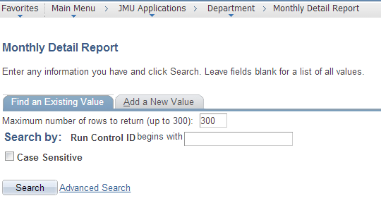

***NOTE: if this is your first time running the Monthly Detail Report you will need to select the ‘Add a New Value’ tab to create your Run Control ID which will remain in the system forever and cannot be changed. You will use this same Run Control every time to run the report. For example, you may name it Monthly_Detail (spaces are not allowed).

- Click the hyperlink for your Run Control ID (Monthly_Detail)

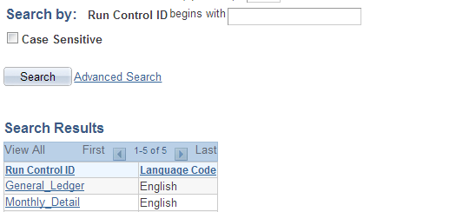

- Enter the following
  - Department Code From/To: the 6 digit Department number (If you are running the report for only one department, enter the same Dept ID in both the From and To boxes)
  - As Of Date: the last day of the month for which you want to run the report

Click Run

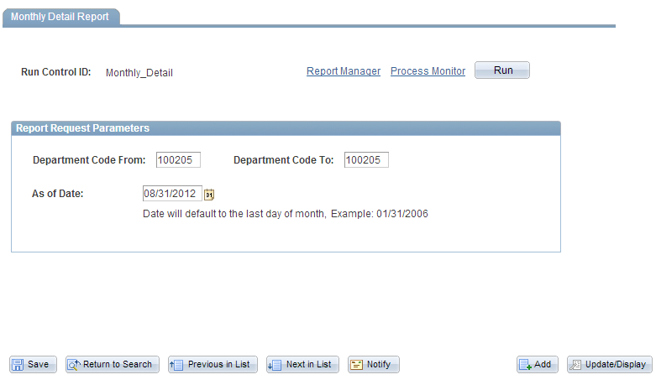

- Choose Server Name PSNT.
Type should default to Web and Format should default to PDF

Click OK.

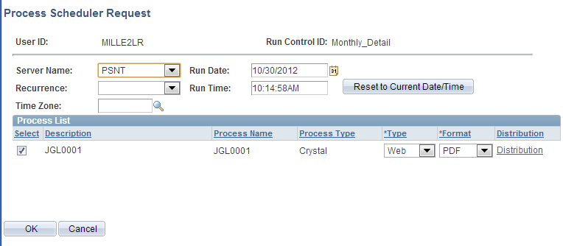

- You are returned to the Monthly Detail Report page. You will now have a Process Instance number. Click the Report Manager hyperlink.

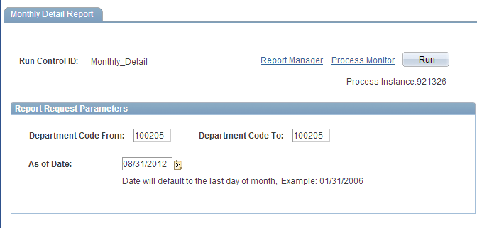

- Click the Administration tab. Click Refresh until the JGL0001 report has a Status of Posted.

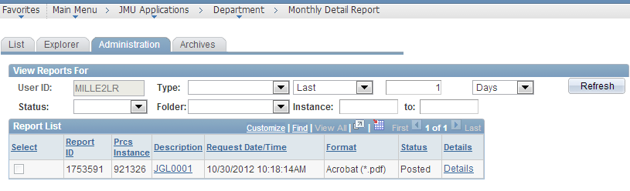

- Click on the JGL0001 hyperlink after the report is available.

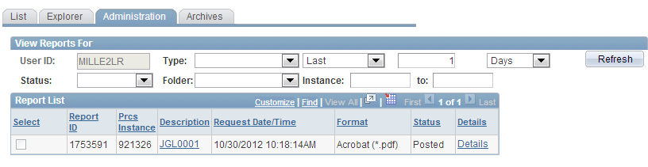

**Note: if you have not allowed Pop-ups you will receive a notification at the top right-hand side of the window. Click the small ‘window with a red X’ icon and choose ‘Always allow pop-ups…’ Click Done

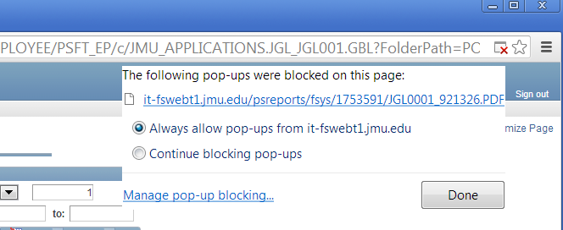

You will now have to Click the JGL001 hyperlink again

- The Monthly Detail Report should open in a new Chrome window.

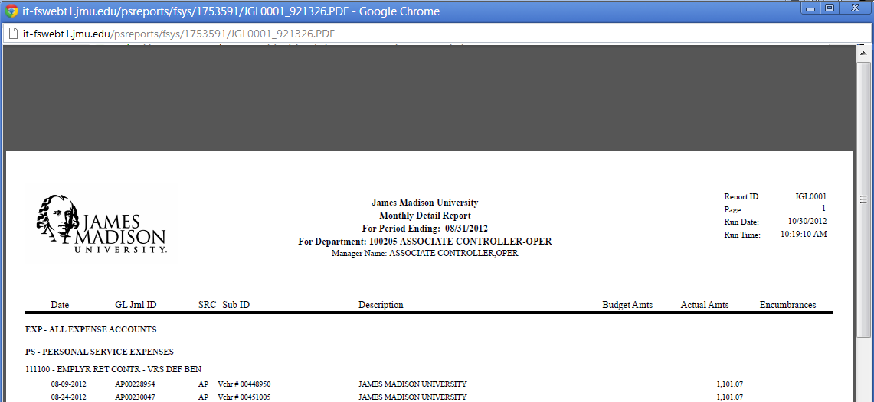

- Hover the mouse near the bottom of the page to display the Adobe toolbar. Click the Print icon to Print if desired.

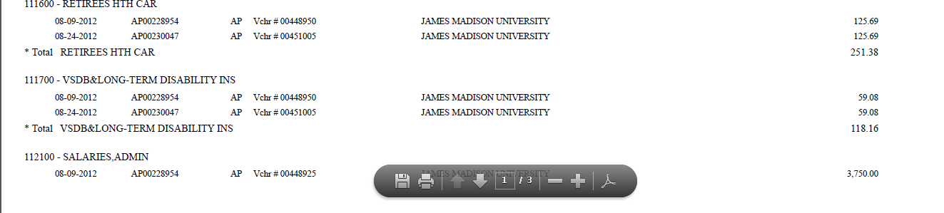

- To Save a copy of the report you will need to return to the Report Manger window.
Click the Details hyperlink.

- Right Click on the JGL001....PDF hyperlink

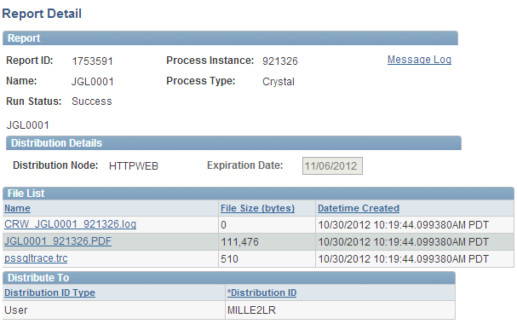

- Choose Save link as… from the menu options

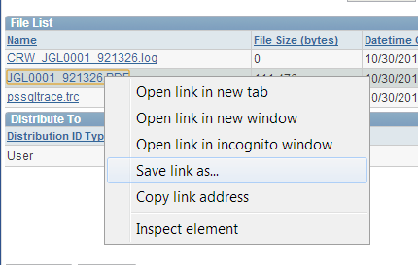

- Enter the desired File name and choose the folder in which to save the file

Click Save.

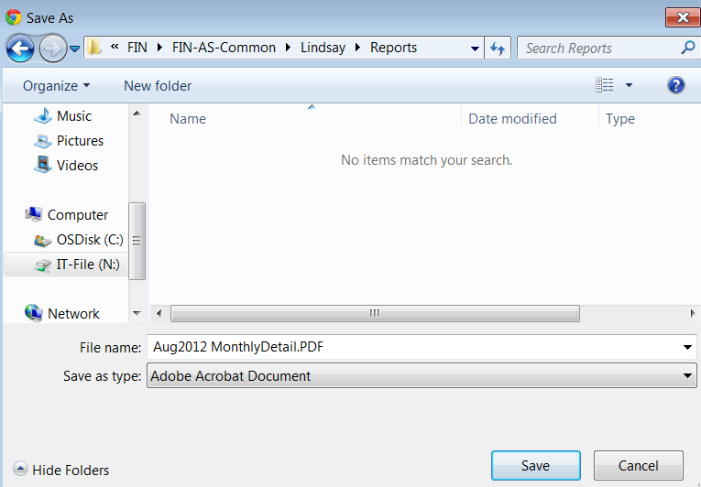

- The PDF file should appear in the Downloads bar at the bottom of the window, click the PDF file to open the report. (If the downloads bar is not visible, navigate to the folder where you saved the file and open the report.)

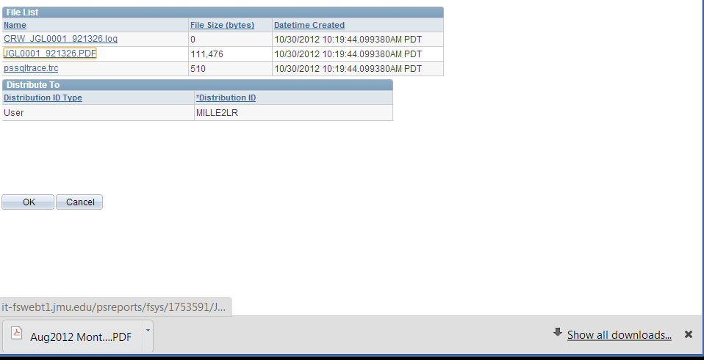

- The Monthly Detail report is now saved and you can view the report or print if desired.

