These instructions were created using Safari Version 5.1.5 (7534.55.3)

You must allow pop-up windows in order to view this report.

Open Safari and from the Safari drop down menu at the top of the screen and make sure ‘Block Pop-Up Windows’ is NOT checked.

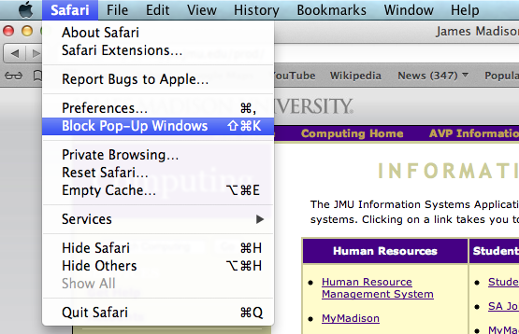

You are now ready to run the Monthly Detail Report.

- Log in to the Finance System and navigate to the Monthly Detail Report via the following path Main Menu > JMU Applications > Department > Monthly Detail Report

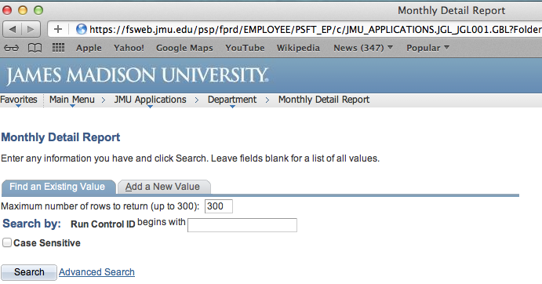
- Click Search to display your Run Control IDs

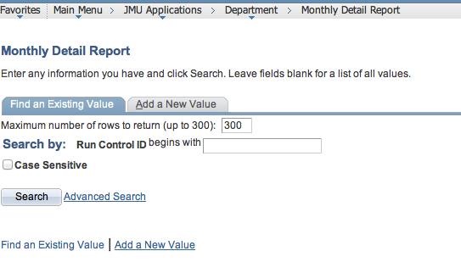

***NOTE: if this is your first time running the Monthly Detail Report you will need to select the ‘Add a New Value’ tab to create your Run Control ID which will remain in the system forever and cannot be changed. You will use this same Run Control every time to run the report. For example, you may name it Monthly_Detail (spaces are not allowed).

- Click the hyperlink for your Run Control ID (Monthly_Detail)

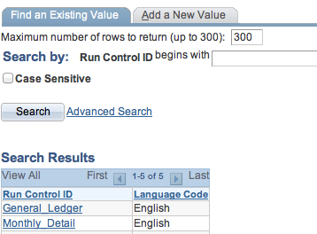

- Enter the following
  - Department Code From/To: the 6 digit Department number (If you are running the report for only one department, enter the same Dept ID in both the From and To boxes)
  - As Of Date: the last day of the month for which you want to run the report

Click Run

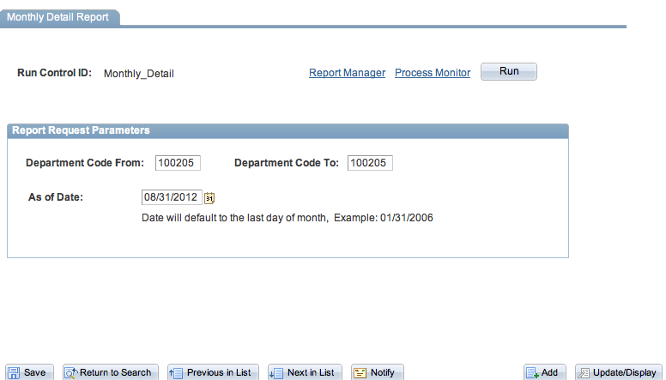

- Choose Server Name PSNT.
Type should default to Web and Format should default to PDF

Click OK.

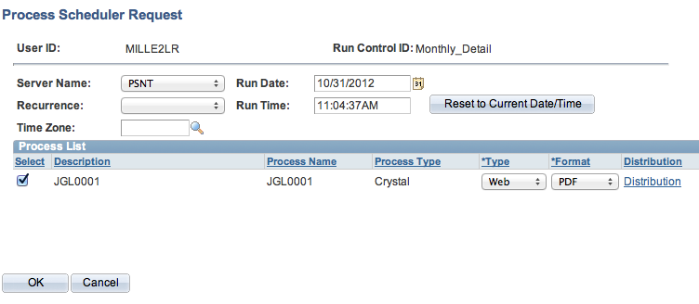
- You are returned to the Monthly Detail Report page. You will now have a Process Instance number. Click the Report Manager hyperlink.

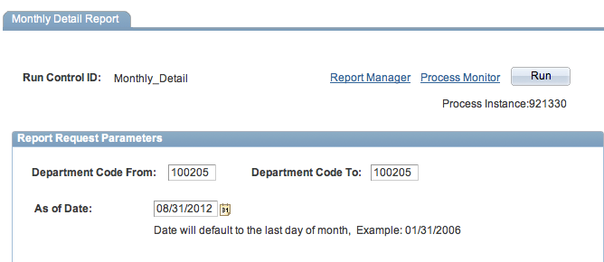

- Click the Administration tab. Click Refresh until the JGL0001 report has a Status of Posted.

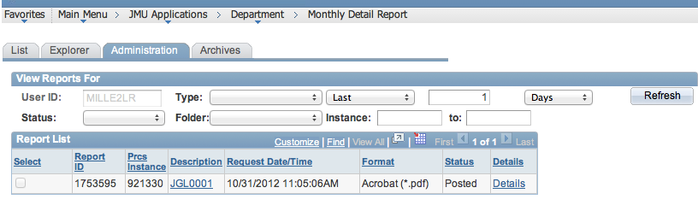

- Click on the Details hyperlink after the report is available

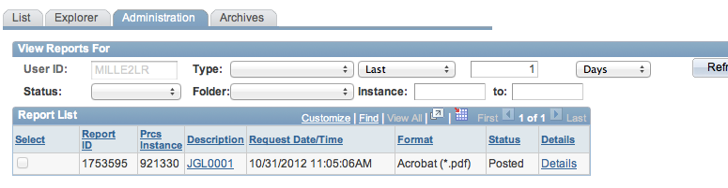

- Press and hold the control key while clicking on the JGL001....PDF hyperlink.

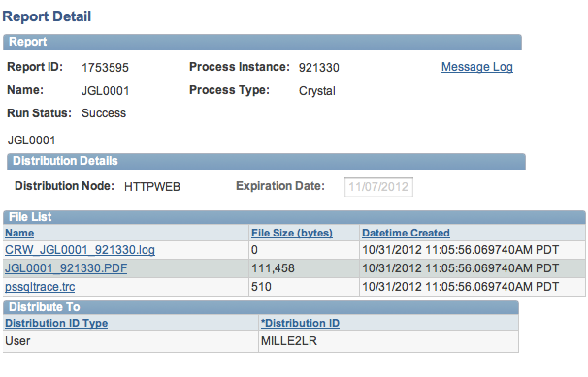

- Choose Save Linked File as… from the menu options

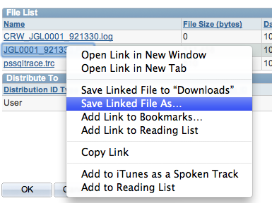

- Enter the desired Export As name and choose the ‘Where’ folder in which to save the file

Click Save.

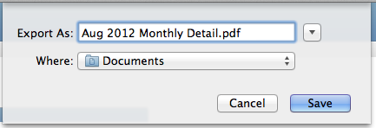

- Navigate to the folder where you saved the file and open the report. You should now be able to view the report and print if needed.

