These instructions were created using Firefox ESR version 10.0.10

You must allow pop-up windows in order to view this report.

Open Firefox and from the menu bar choose Firefox, then Preferences

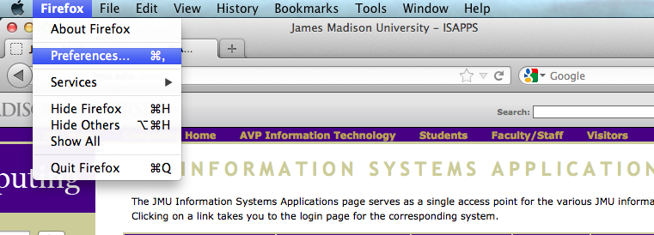

Choose the Content section. Make sure ‘Block pop-up windows’ is NOT checked.

Close the box by clicking the small red circle in the upper left-hand corner.
There is no OK or Save button to press

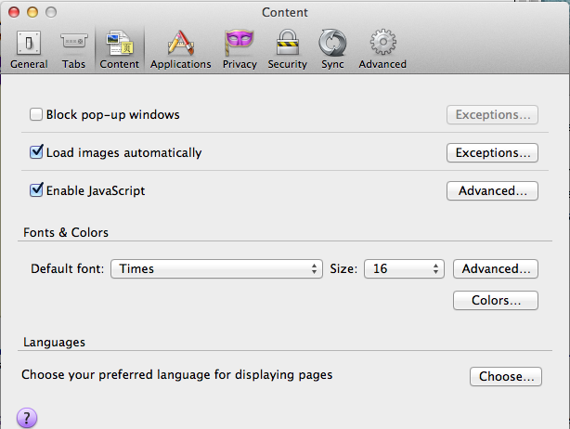
You are now ready to run the Monthly Detail Report.

- Log in to the Finance System and navigate to the Monthly Detail Report via the following path Main Menu > JMU Applications > Department > Monthly Detail Report

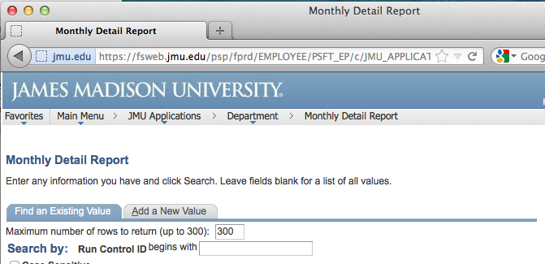

- Click Search to display your Run Control IDs

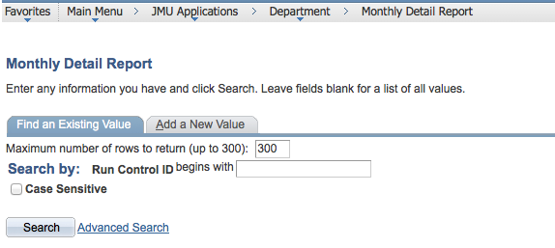

***NOTE: if this is your first time running the Monthly Detail Report you will need to select the ‘Add a New Value’ tab to create your Run Control ID which will remain in the system forever and cannot be changed. You will use this same Run Control every time to run the report. For example, you may name it Monthly_Detail (spaces are not allowed).

- Click the hyperlink for your Run Control ID (Monthly_Detail)

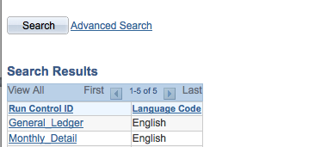

- Enter the following

  - Department Code From/To: the 6 digit Department number (If you are running the report for only one department, enter the same Dept ID in both the From and To boxes)
  - As Of Date: the last day of the month for which you want to run the report

Click Run

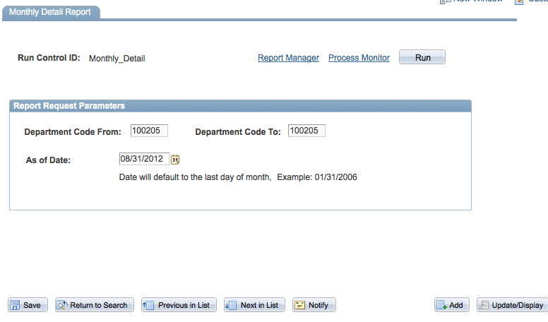

- Choose Server Name PSNT.
Type should default to Web and Format should default to PDF

Click OK

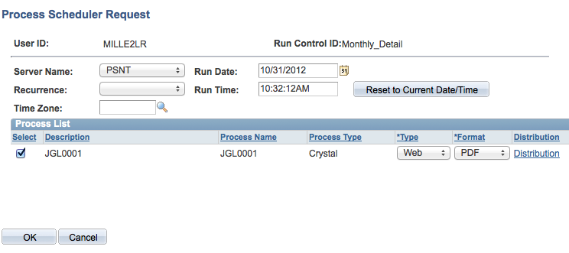

- You are returned to the Monthly Detail Report page. You will now have a Process Instance number. Click the Report Manager hyperlink

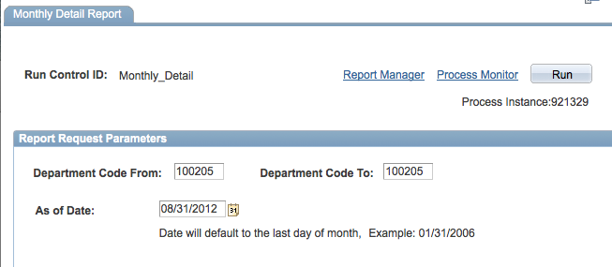

- Click the Administration tab. Click Refresh until the JGL0001 report has a Status of Posted.

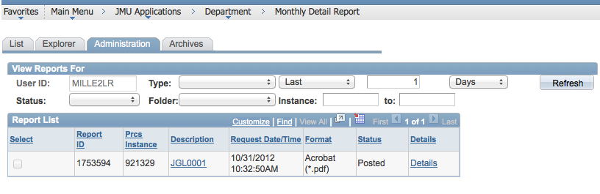

- Click on the JGL0001 hyperlink after the report is available.

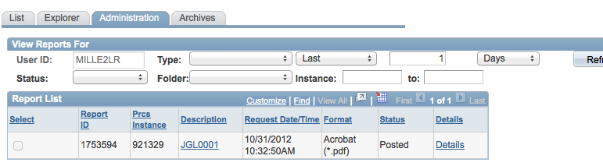

**Note: if you have not allowed Pop-ups you will receive a notification bar at the top of the window. Click Preferences and choose ‘Allow pop-ups…’

You will then have to click the JGL001 hyperlink again

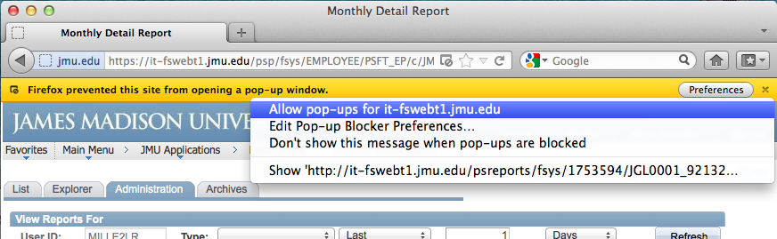

- You may get a pop-up window or the report may automatically open. If you receive the pop-up window. Choose Open with Preview (the Mac PDF reader) and Click OK

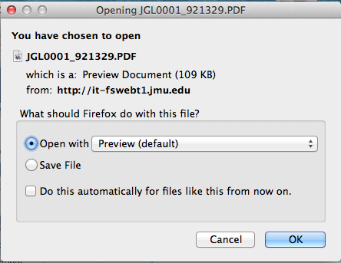

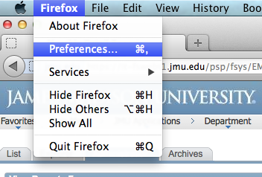
**Note if you do not receive the popup window and the file does not automatically open, you may have set a defualt ‘Save files to’ location.

Select the Firefox drop down menu and choose Preferences.

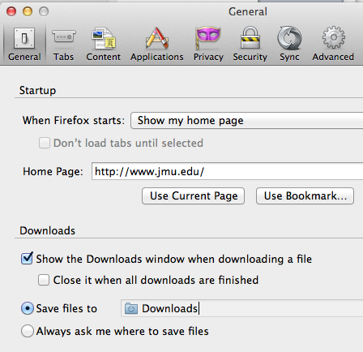

From the General Section review the Downloads settings

- The report should open

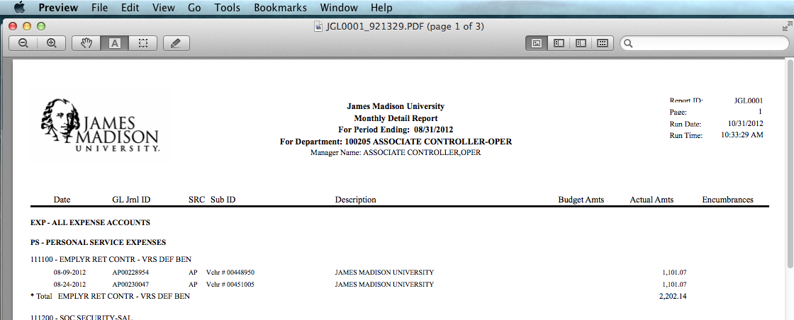

- To save the report, choose the File drop down menu at the top of the screen and
select Export.

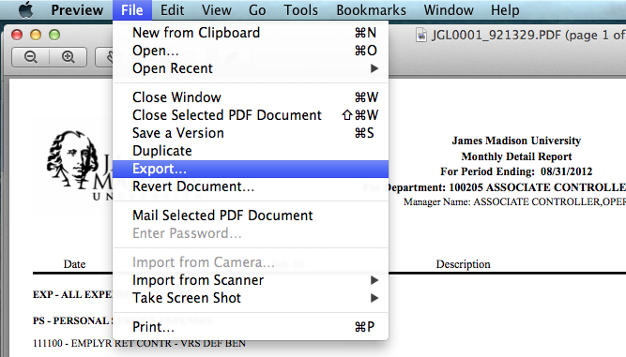

- Enter the Export As name and choose the desired ‘Where’ folder. Click Save

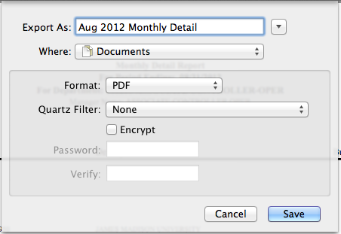

- The report is now saved in the designated folder. You can view or print it if needed.

