In order to drill down from the nVision Summary Report you will need to install an Add-in for Excel.
This can be done with your regular user id and password; you do not need an administrator account.
These instructions are for Mac users with Excel:Mac 2011

- The Add-in file is named ‘DrillToPIA.xla’ and must be saved in a local C drive folder in order for it to be used. Navigate to http://www.jmu.edu/acctgserv/expenditures/usertips.shtml where the DrillToPIA.xla is located, and right click on the file and select ‘Save Target As’.

- You can now paste this file into your C drive Documents folder. Navigate to Documents.

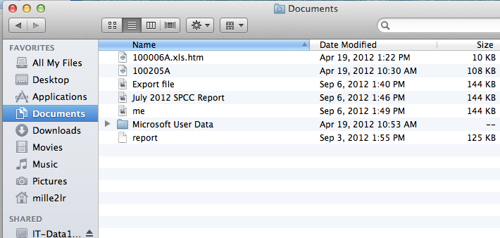

- Press and hold the control key while clicking in the blank space below the file names.
Choose “Paste Item” from the menu options that appear

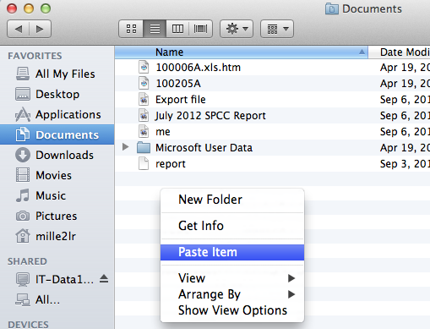

- The DrillToPIA.xla file will now appear in the folder.

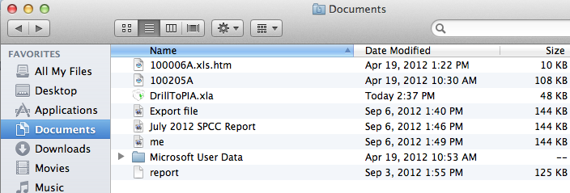

- You are now ready to install this Add-In in Excel. Open Excel and click the Tools drop down menu.

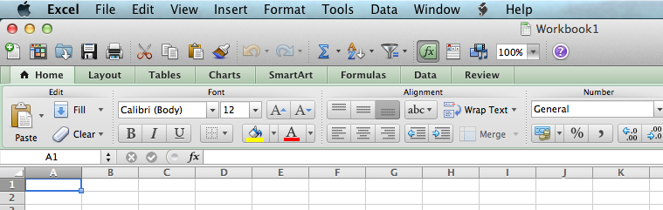

- Select Add-Ins

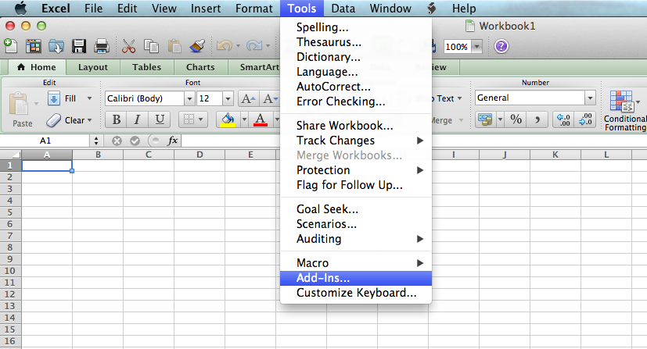
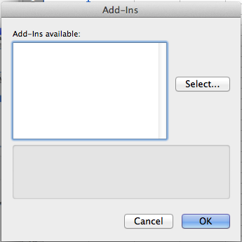
- Click Select

- Navigate to the C drive Documents folder where you saved the file.

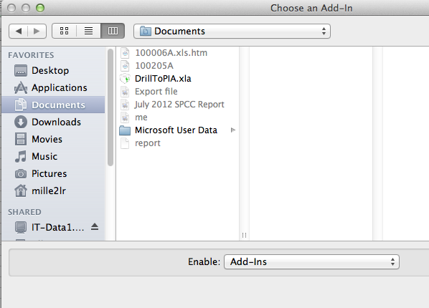

- Double click the DrillToPIA.xla file. Or Select the file name and click Open.

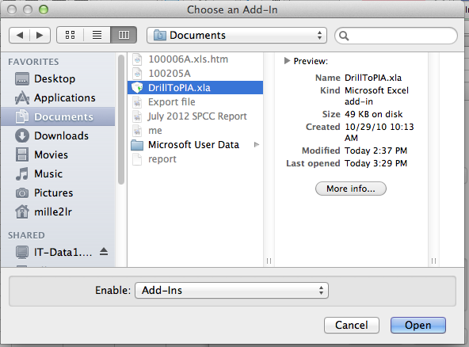

- A message may appear confirming you want to copy the file. Click Yes if needed

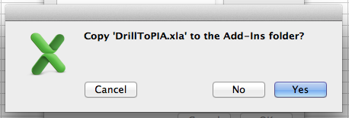
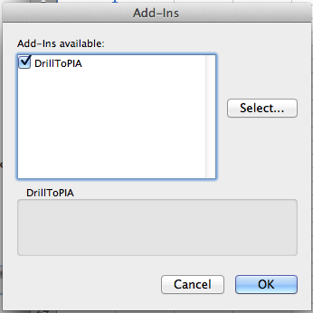

- The DrillToPIA will now appear in the Add-Ins window and should be selected. Click OK

- A new menu option will now appear at the top of the Excel screen labeled ‘nVisionDrill’

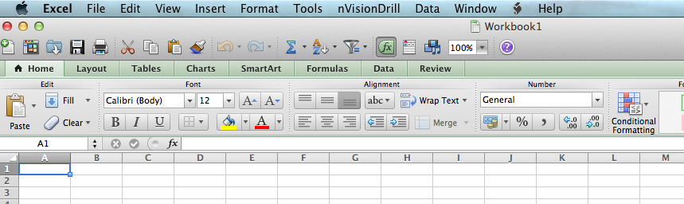

- The nVisionDrill option will allow you to drill down within the nVision Summary report when it is run to Excel

