In order to drill down from the nVision Summary Report you will need to install an Add-in for Excel.
This can be done with your regular user id and password.
These instructions are for PC users with Excel 2007 or Excel 2010.

- Copy the link below:
\\it-sccm2\SoftwareDist\Microsoft\Office2013\Add-ins

- Open the ‘Computer’ folder from your Desktop.
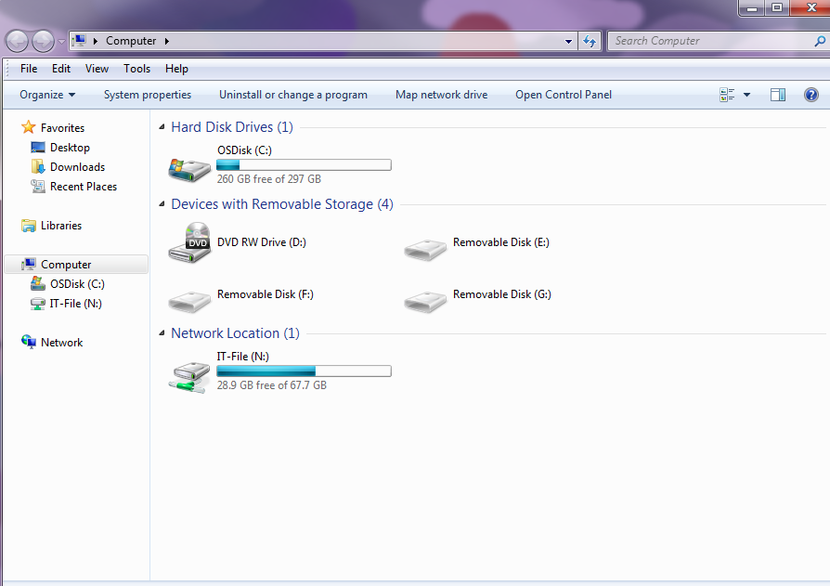

- Delete ‘Computer’ and paste in the link above. Hit Enter.

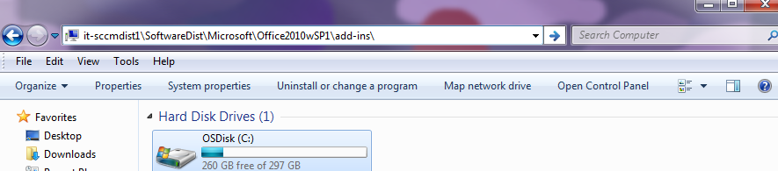

- Select the DrillToPIA.xla. Copy and Paste to a location on your computer.
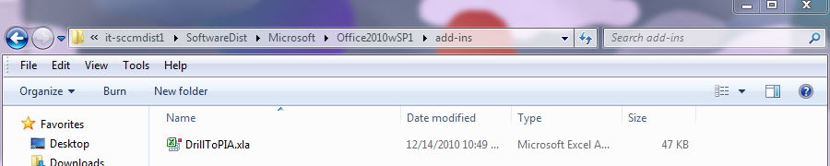

Note: The .xla file is can also be found on the Accounting Operations & Disbursements webpage under User Tips. http://www.jmu.edu/acctgserv/expenditures/usertips.shtml

- Open Excel and click the File tab (in Excel 2010) or the Windows Logo (in Excel 2007)

- Select Options

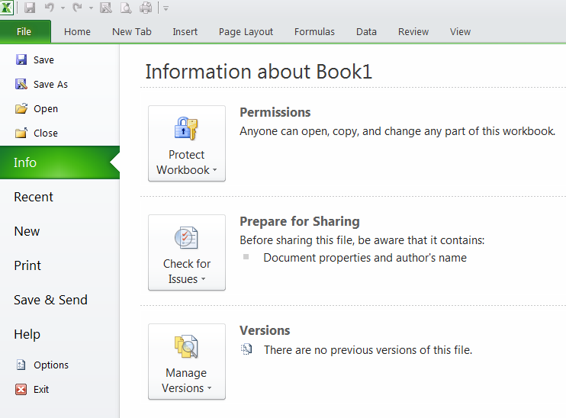

- Select Add-Ins from the list on the left hand side

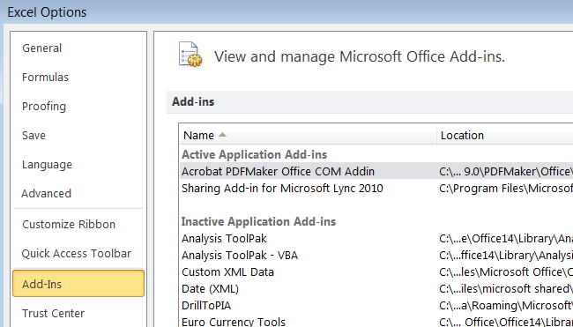

- Select the Go button at the bottom of the screen.

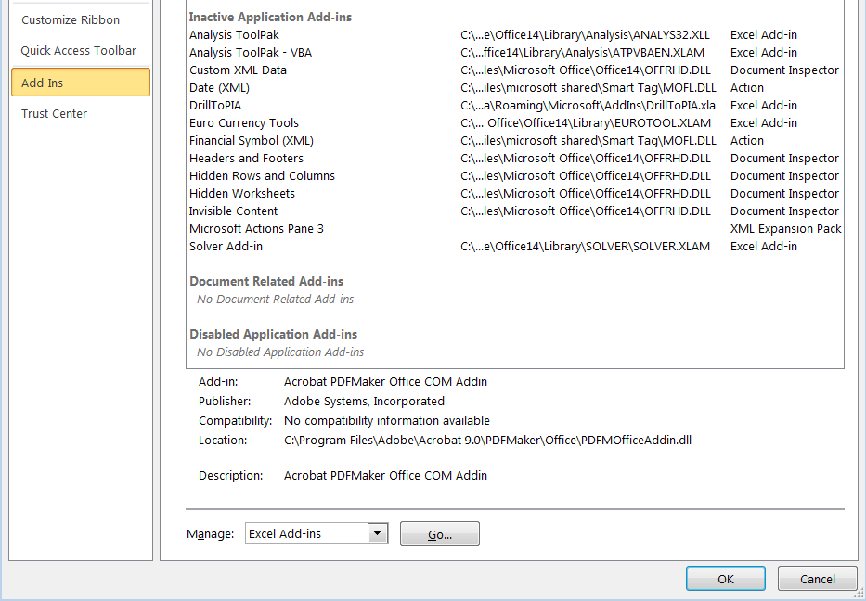

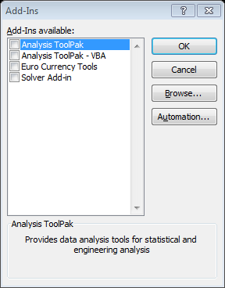
- Click Browse

- Navigate to the folder where the file is saved and double click the DrillToPIA.xla file.

- A message may appear confirming you want to copy the file. Click Yes
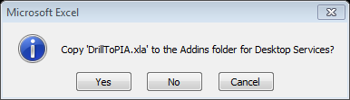

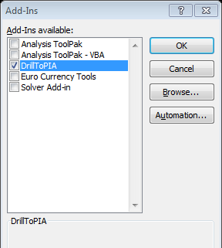
- The DrillToPIA will now appear in the Add-Ins window and should be selected. Click OK

- A new menu option will now appear at the top of the Excel spreadsheet labeled ‘Add-Ins’

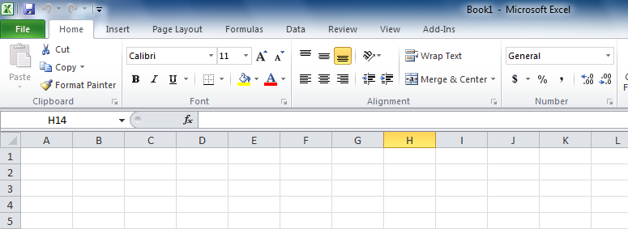

- The nVisionDrill option will allow you to drill down within the nVision Summary report
when run to Excel.

