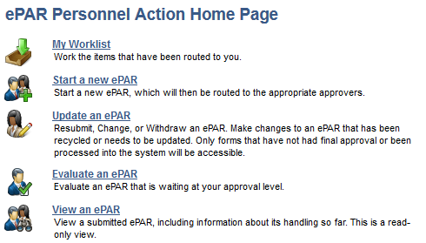

Click ‘Start a new ePAR’

Choose ‘Supplemental Pay Form’

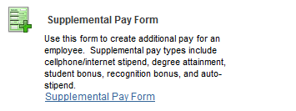

Select ‘MOVE’ as the Supp. Pay Code and complete req’d fields

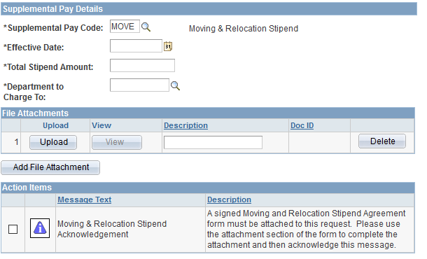

Attach properly approved Stipend Agreement Form