Running Monthly Statement Report in Bank of America WORKS

You will log into the Bank of America WORKS system at: https://payment2.works.com/works/home

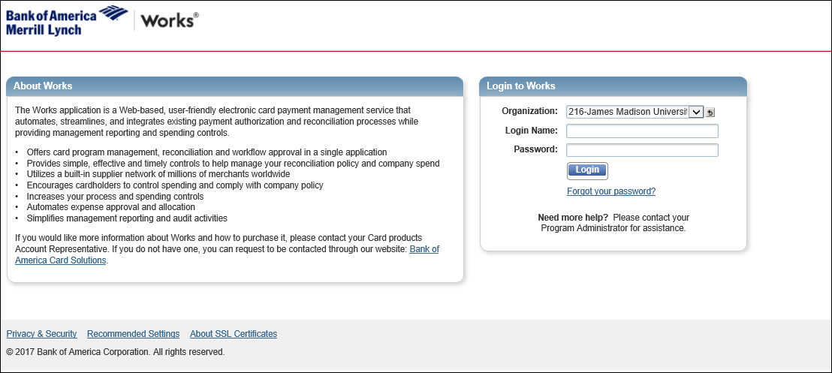

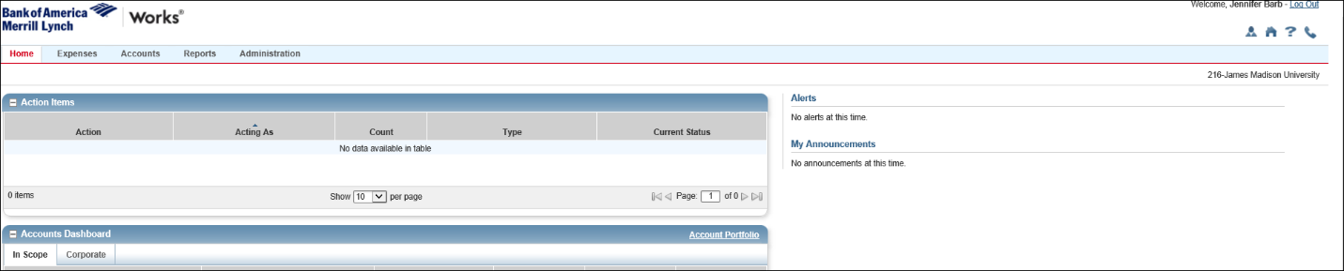
Once you log in the Bank of America WORKS system, you will come up to your homepage:

To run the report to see what charges are on your statement you will go to:
Reports in the Top Ribbon
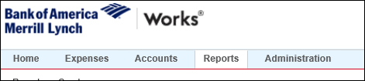
In the Create Report, you will choose:
Category: Spend
Template: GL Memo Statement
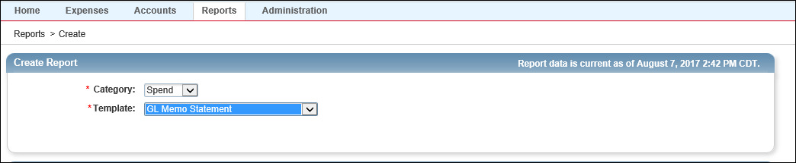
When the Report Options comes up Choose Advanced
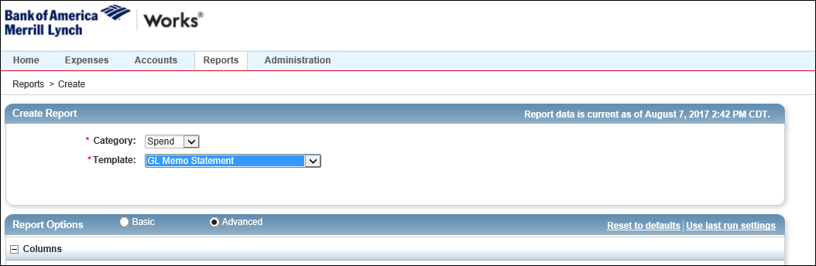

Under the Advanced Tab you will have many options. You will want to check a few things:
Under Filters, you will choose the Post Date:
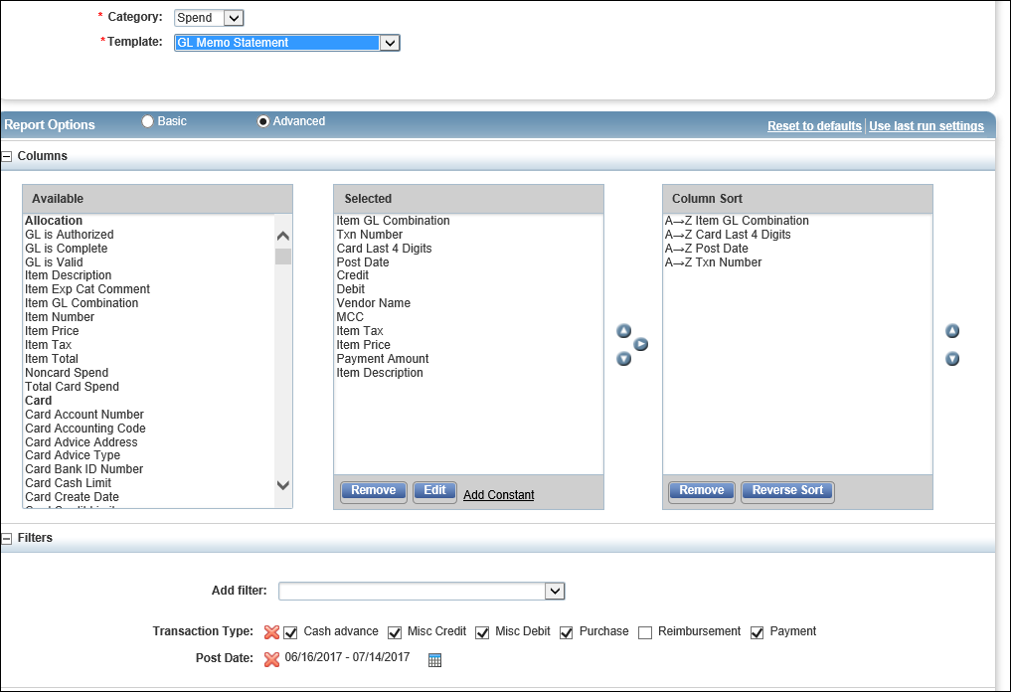
Under Post Date Click on the Calendar Icon

A Select Dates will come up, you will choose Previous Cycle
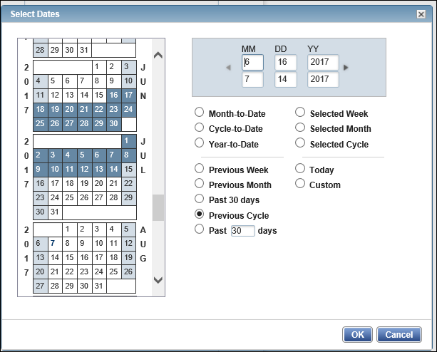
Then click the OK button

For Output Format choose PDF
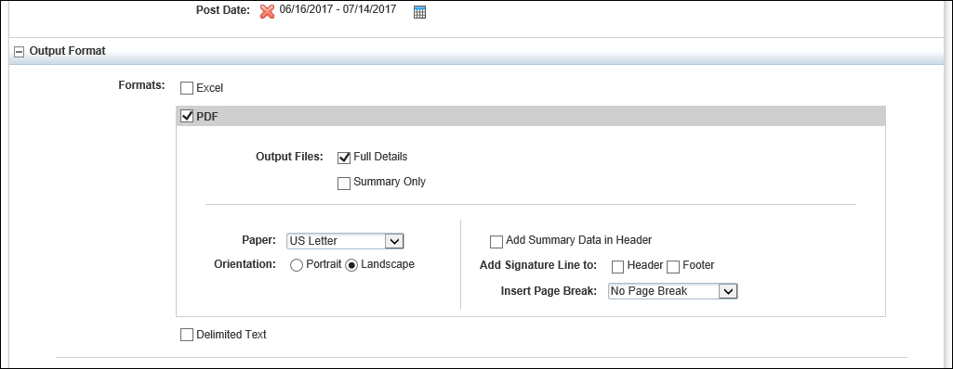
Under Output Files make sure Full Details is checked
You can also set the report so it runs monthly. Under Scheduling and Expiration
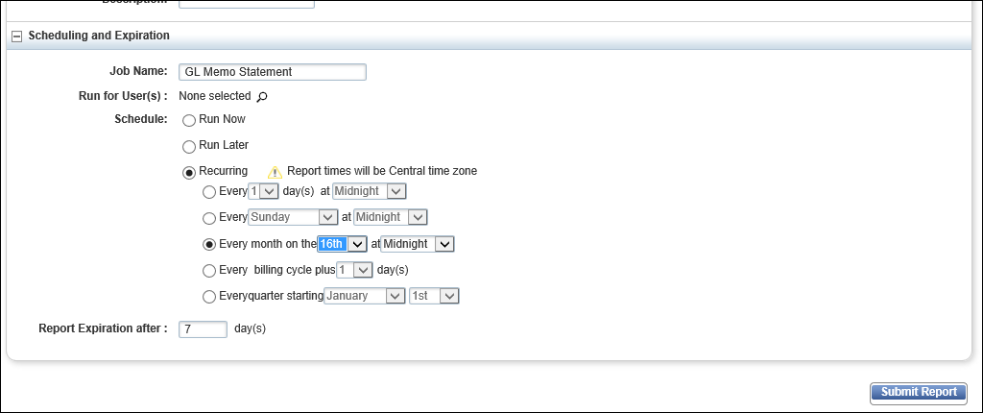
Under Schedule, you will click the Recurring button
Choose the Every month on the change to the 17th at Midnight
Click Submit Report Button

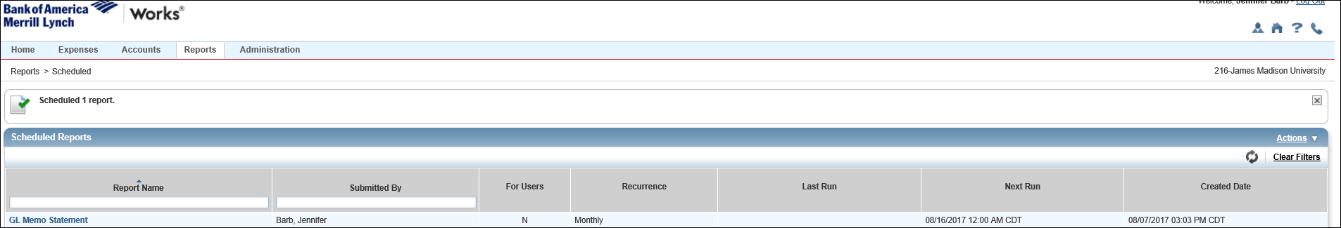
You will be taken the scheduled Reports page; this will show you have a monthly report.
When you log into WORKS on the 17th of each month you will have an Action Item. This is your monthly report.
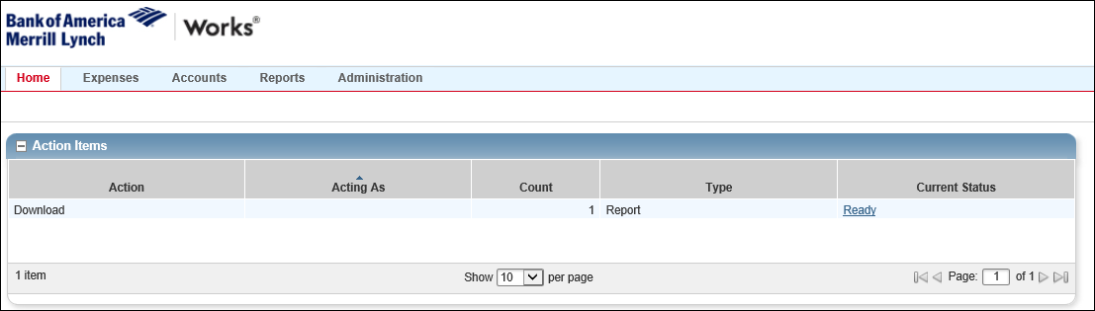
Click on Ready under Current Status
This will take you to the Completed Reports page; choose the PDF beside the report named: GL Memo Statement
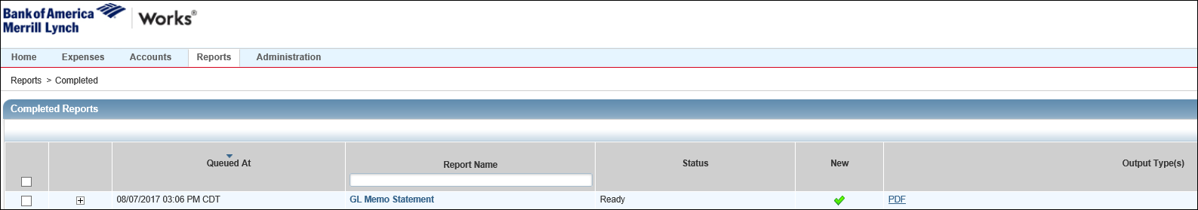

Your report will look like this:
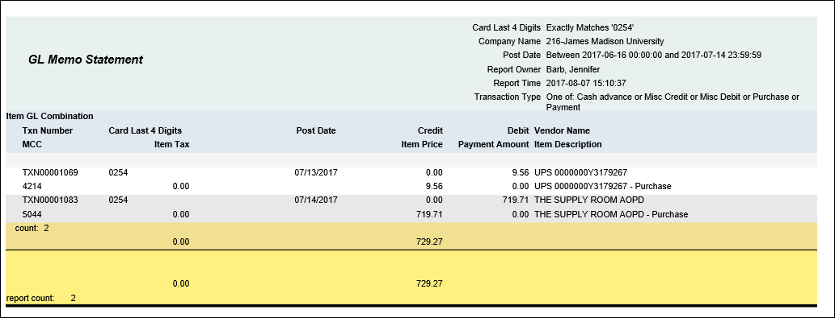
It will show each transaction; as well at the bottom of the page in yellow, you will get a monthly total.
The morning of the 17th day of each month when you log into WORKS your report for the previous month will be waiting on you. You will print it off and it will serve as your monthly statement.

