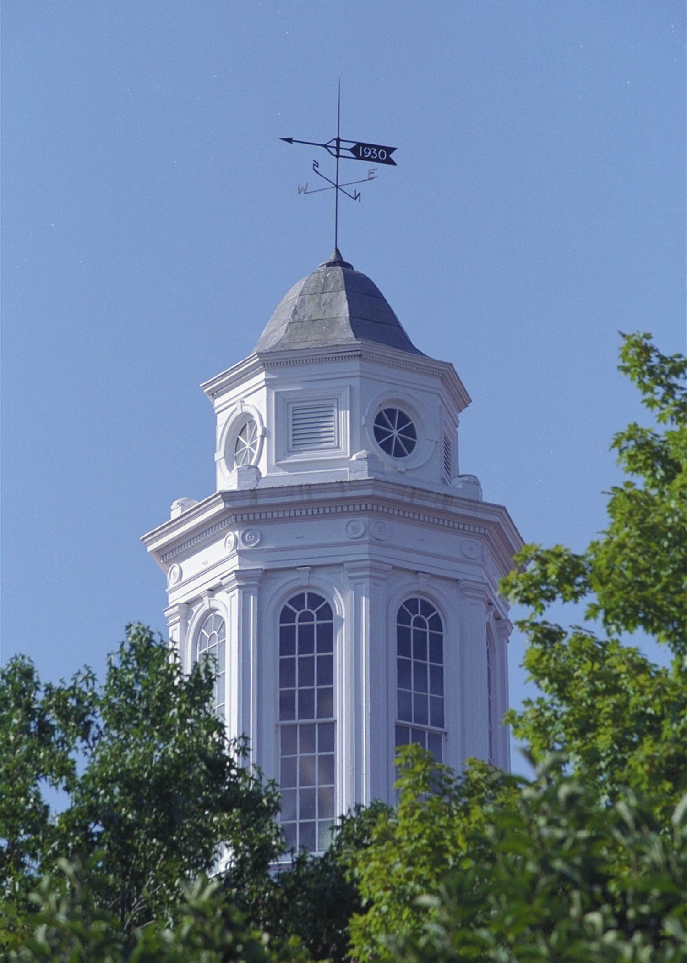

Travel Charge Card Request for ATM/Cash Exception

Date:

Printed Name of Cardholder:

Department:

Department # (Org):

You will only be able to get up to 20% of your travel card limit in cash. You will only be permitted to go to the ATM for cash as it relates to JMU travel. Your travel card is your responsibility to pay back, whether you have been reimbursed for the trip or not. The intention is for the ATM feature to be accessed only for those expenses for which the travel card is not accepted. Travelers MUST use Bank of America ATM’s to avoid transaction fees. Any fees incurred for use of non-Bank of America ATM’s will NOT be reimbursable expenses. This exception is on a fiscal year basis; you must submit this form each fiscal year. Once approved for cash withdrawal it will take up to 10 days for your pin to arrive in the mail at the address on file with Bank of America.

Reason for ATM/Cash Exception Request:

______________________________________________________________________________________

______________________________________________________________________________________

______________________________________________________________________________________

Signature of Cardholder: __________________________________________

Printed Name of Supervisor:

Signature of Supervisor: ____________________________________________

Date:

Please forward this form to acctspayable@jmu.edu or send by intercompany mail to Accounts Payable, MSC 5712 Attention: Travel Card Team. You will be notified by email within 3 business days of the status of your request.

Updated: 1/12/23

