Follow the checklist to complete the SWPPP Template. A SWPPP is required to be developed before submitting a Registration Statement for General Permit Coverage.
- Cover Page
  - Edit “Project Name” at top of page to current project title.
  - Edit “DATE” of estimated start and completion dates.
  - Edit information under “SWPPP Prepared for:”.
- Section 2: Contact Information
  - Section 2.1 Responsible Parties: Edit/provide contact information for listed individuals.
  - Section 2.2 SWPPP Team: Edit/provide contact information for listed individuals.
- Section 3: Site Evaluation
  - Section 3.1 Project/Site Information: Edit/provide information for:
    - Project Name
    - Project Street Address
    - Project City, State, Zip Code
    - Project Latitude/Longitude
    - Method for determining latitude/longitude
    - How precipitation data will be gathered
  - Section 3.3 Nature of the Construction Activity: Provide a narrative description of the project and proposed construction activity.
  - Section 3.4 Sequence of Construction Activities: Edit/provide a basic sequence for construction activities.
  - Section 3.5 Allowable Non-Stormwater Discharges: Edit table for allowable non-stormwater discharges that are likely to be present on-site.
- Section 4: ESC Plan
  - Edit the third paragraph to include the following:
    - Plan Title
    - Design Engineer
    - ESC approval date
- Section 5: SWM Plan
  - Edit the first paragraph to include the following:
    - Plan Title
    - Design Engineer
    - SWM approval date
  - Omit BMP types that are not to be constructed as part of the project.
- Section 6: Pollution Prevention Plan
  - Edit/provide/add information for compliance with requirements of Part II A of the construction general permit.
  - Section 6.3 Hazardous Products: Provide reference location for MSDS.
- References:
  - Provide the following information for the Approved Site Plan.
    - Plan Title
    - Design Engineer
    - Approval dates for ESC and SWM
- Update table of contents by right-clicking at top of the table of contents and selecting “Update Table…” and selecting “Update entire table”, and pressing “OK”.
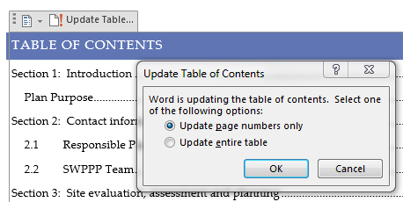
- Print completed SWPPP with appendices.
  - Appendix A: Include signed and dated certifications.
  - Appendix B: Provide a copy of the following documents:
    - Signed copy of Registration Statement
    - Construction General Permit Coverage Letter
    - Construction General Permit
    - Transfer of Ownership Form if applicable
  - Appendix C: Provide Records of Land Disturbance form.
  - Appendix D: Provide Daily Precipitation log and Inspection Report forms or reference to where documentation will be located. (Separate notebook, digital files, etc.)
  - Appendix E: Provide a copy of Site Plan with locations of control measures and documentation for off-site spoils/borrow sites.
  - Appendix F: Provide SWPPP Modifications log.
- Have available onsite and updated as required by the permit.

